**Health at a Glance 2023**

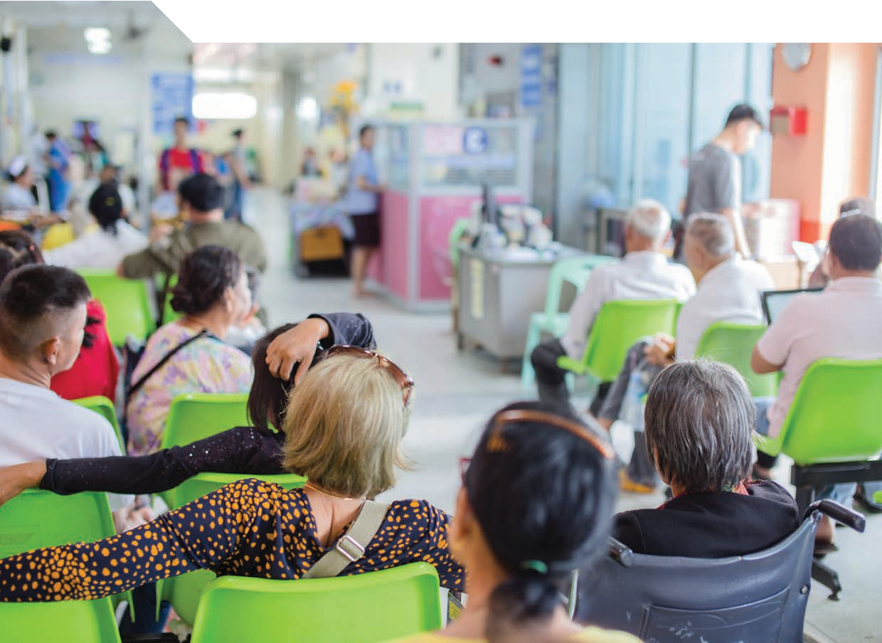

**OECD INDICATORS**

**Health at a Glance 2023**

OECD INDICATORS





This work is published under the responsibility of the Secretary-General of the OECD. The opinions expressed and arguments employed herein do not necessarily reflect the official views of the Member countries of the OECD.

This document, as well as any data and map included herein, are without prejudice to the status of or sovereignty over any territory, to the delimitation of international frontiers and boundaries and to the name of any territory, city or area.

The statistical data for Israel are supplied by and under the responsibility of the relevant Israeli authorities. The use of such data by the OECD is without prejudice to the status of the Golan Heights, East Jerusalem and Israeli settlements in the West Bank under the terms of international law.

**Please cite this publication as:**

OECD (2023), *Health at a Glance 2023: OECD Indicators*, OECD Publishing, Paris, [*https://doi.org/10.1787/7a7afb35-en*](https://doi.org/10.1787/7a7afb35-en).

ISBN 978-92-64-95793-0 (print)

ISBN 978-92-64-94896-9 (pdf)

ISBN 978-92-64-77767-5 (HTML)

ISBN 978-92-64-44682-3 (epub)

Health at a Glance ISSN 1995-3992 (print)

ISSN 1999-1312 (online)

**Photo credits:** Cover © Medical-R/Shutterstock.com; Images - Health status: © Thitiporn taingpan/Shutterstock.com; Risk factors for health:

© CandyRetriever/Shutterstock.com; Access: Affordability, availability and use of services © LightField Studios/Shutterstock.com;

Quality and outcomes of care: © YAKOBCHUK VIACHESLAV/Shutterstock.com; Health expenditure: © Doubletree Studio/Shutterstock.com; Health workforce: © wavebreakmedia/Shutterstock.com; Pharmaceutical sector: © Fahroni/Shutterstock.com; Ageing and long-term care:

© Inside Creative House/Shutterstock.com.

Corrigenda to OECD publications may be found on line at: [*www.oecd.org/about/publishing/corrigenda.htm*](https://www.oecd.org/about/publishing/corrigenda.htm).

© OECD 2023

The use of this work, whether digital or print, is governed by the Terms and Conditions to be found at [*https://www.oecd.org/termsandconditions*](https://www.oecd.org/termsandconditions).

# Foreword

*Health at a Glance* compares key indicators for population health and health system performance across OECD member countries, accession candidates and key partner countries. Analysis draws from the latest comparable official national statistics and other sources. This 2023 edition presents the latest comparable data, illustrating differences across countries and over time in terms of health status, risk factors for health, access to and quality of care, and health resources. This edition includes a thematic chapter on digital health, which measures the digital readiness of OECD countries’ health systems, and outlines what countries need to do to accelerate the digital health transformation.

This publication would not have been possible without the contribution of national data correspondents from the countries covered in this report, who provided most of the data and metadata, as well as detailed feedback to a draft of the report. The OECD also recognises the contribution of other international organisations, notably Eurostat and the World Health Organization, for providing data and comments. The opinions expressed and arguments employed herein do not necessarily reflect the official views of the OECD member countries, the European Union or other international organisations.

*Health at a Glance 2023* was prepared by the OECD Health Division under the co-ordination of Chris James. Chapter 1 was prepared by Chris James, Pauline Fron and Gabriel Di Paolantonio; Chapter 2 by Eric Sutherland, Rishub Keelara and Yukiko Shu; Chapter 3 by Gabriel Di Paolantonio, Tom Raitzik Zonenschein, Joanna Krajewska and Doron Wijker; Chapter 4 by Marion Devaux, Pauline Fron, Antoine Penpenic and Elina Suzuki; Chapter 5 by Chris James, Gaëlle Balestat, Marie-Clémence Canaud, Pauline Fron, Michael Mueller, Caroline Penn, Caroline Berchet and Rishub Keelara; Chapter 6 by Rie Fujisawa, Pauline Fron, Joana Krajewska, Kadri-Ann Kallas, Gabriel Di Paolantonio, Nicolás Larrain, Ekin Dagistan, Melanie Steentjes, Candan Kendir and David Morgan; Chapter 7 by Caroline Penn, Paul Lukong, Michael Mueller, Luca Lorenzoni and David Morgan; Chapter 8 by Gaetan Lafortune, Gaëlle Balestat, Marie-Clémence Canaud and Gabriel Di Paolantonio; Chapter 9 by Suzannah Chapman, Lisbeth Waagstein, Rishub Keelara, Paul Lukong, Michael Mueller and Valérie Paris; Chapter 10 by Elina Suzuki, Lisbeth Waagstein, Gabriel Di Paolantonio, Ricarda Milstein, Michael Mueller, Jose Carlos Ortega Regalado and Paola Sillitti. The OECD databases used in this publication are managed by Gaëlle Balestat, Marie-Clémence Canaud, Gabriel Di Paolantonio, Rie Fujisawa, David Morgan and Michael Mueller. This publication also benefited from comments by Francesca Colombo, Mark Pearson and Stefano Scarpetta. Editorial assistance was provided by Marie-Clémence Canaud, Lucy Hulett and Lydia Wanstall.

**Table of contents**

Foreword 3

Reader’s guide 9

Executive summary 13

1. Indicator overview: Country dashboards and major trends 17

Introduction 18

Health status 20

Risk factors for health 22

Access to care 24

Quality of care 26

Health system capacity and resources 28

To what extent does health spending translate into better health outcomes, access and quality of care? 30

1. Digital health at a glance 33

Introduction 34

Framework for digital health readiness assessment 36

Indicators of digital health readiness 40

Assessing digital health as a determinant of health 54

Concluding thoughts 56

References 56

Notes 58

1. Health status 61

Life expectancy at birth 62

Trends in all-cause mortality 64

Main causes of mortality 66

Avoidable mortality (preventable and treatable) 68

Major public health threats 70

Mortality from circulatory diseases 72

Cancer mortality 74

Chronic conditions 76

Maternal and infant mortality 78

Mental health 80

Self-rated health 82

1. Risk factors for health 85

Smoking 86

Alcohol consumption 88

Illicit drug use 90

Diet and physical activity 92

Overweight and obesity 94

Environment and health 96

1. Access: Affordability, availability and use of services 99

Population coverage for healthcare 100

Unmet needs for healthcare 102

Extent of healthcare coverage 104

Financial hardship and out-of-pocket expenditure 106

Consultations with doctors 108

Digital health 110

Hospital beds and occupancy 112

Hospital activity 114

Diagnostic technologies 116

Hip and knee replacement 118

Ambulatory surgery 120

Waiting times for elective surgery 122

1. Quality and outcomes of care 125

Routine vaccinations 126

Cancer screening 128

Safe prescribing in primary care 130

Avoidable hospital admissions 132

Diabetes care 134

People-centredness of ambulatory care 136

Safe acute care – workplace culture and patient experiences 138

Safe acute care – surgical complications and obstetric trauma 140

Mortality following acute myocardial infarction (AMI) 142

Mortality following ischaemic stroke 144

Patient-reported outcomes in acute care 146

Care for people with mental health disorders 148

Integrated care 150

1. Health expenditure 153

Health expenditure in relation to GDP 154

Health expenditure per capita 156

Prices in the health sector 158

Health expenditure by financing scheme 160

Public funding of health spending 162

Health expenditure by type of service 164

Health expenditure on primary healthcare 166

Health expenditure by provider 168

Capital expenditure in the health sector 170

1. Health workforce 173

Health and social care workforce 174

Doctors (overall number) 176

Doctors (by age, sex and category) 178

Geographic distribution of doctors 180

Remuneration of doctors 182

Nurses 184

Remuneration of nurses 186

Hospital workers 188

Medical graduates 190

Nursing graduates 192

International migration of doctors and nurses 194

1. Pharmaceutical sector 197

Pharmaceutical expenditure 198

Pharmacists and pharmacies 200

Pharmaceutical consumption 202

Generics and biosimilars 204

Pharmaceutical research and development 206

1. Ageing and long-term care 209

Demographic trends 210

Life expectancy and healthy life expectancy at age 65 212

Self-rated health and disability at age 65 and over 214

Dementia 216

Safe long-term care 218

Access to long-term care 220

Informal carers 222

Long-term care workers 224

Long-term care settings 226

Long-term care spending and unit costs 228

End-of-life care 230



**Follow OECD Publications on:**

*https://twitter.com/OECD https://*[*www.facebook.com/theOECD*](http://www.facebook.com/theOECD)

*https://*[*www.linkedin.com/company/organisation-eco-cooperation-*](http://www.linkedin.com/company/organisation-eco-cooperation-) *development-organisation-cooperation-developpement-eco/*

*https://*[*www.youtube.com/user/OECDiLibrary*](http://www.youtube.com/user/OECDiLibrary)

*https://*[*www.oecd.org/newsletters/*](http://www.oecd.org/newsletters/)

**This book has...**

A service that delivers Excel® files from the printed page!

Look for the

*2* at the bottom of the tables or graphs in

this book. To download the matching Excel® spreadsheet, just type the link into your Internet browser or click on the link from the digital version.

# Reader’s guide

*Health at a Glance 2023: OECD Indicators* compares key indicators for population health and health system performance across the 38 OECD member countries. Accession candidates and key partner countries are also included for some indicators – Argentina, Brazil, Bulgaria, People’s Republic of China (China), Croatia, India, Indonesia, Peru, Romania and South Africa.

Data presented in this publication come from official national statistics, unless otherwise stated.

**Conceptual framework**

The conceptual framework underlying *Health at a Glance* assesses health system performance within the context of a broad view of the determinants of health (Figure 1). It draws from the framework endorsed by the OECD workstream on healthcare quality and outcomes, which recognises that the ultimate goal of health systems is to improve people’s health.

**Figure 1. Mapping of Health at a Glance indicators to a conceptual framework for health system performance assessment**

**Sub-sector analysis**

**Pharmaceutical sector** *(Chapter 9)*

**Ageing and long-term care** *(Chapter 10)*

**Health system capacity and resources** *(dashboard 5)* **Health expenditure and financing** *(Chapter 7)* **Health workforce** *(Chapter 8)*

**Quality** *(Chapter 6, dashboard 4)*

**Access** *(Chapter 5, dashboard 3)*

**Demographic, economic & social context**

**Health system performance**

*Is healthcare accessible to all? Is healthcare of high quality (safe, effective)? Is healthcare people-centred?*

*Does the health system offer good value for money? How resilient is the health system?*

**Risk factors for health**

*(Chapter 4, dashboard 2)*

**Health status**

*(Chapter 3, dashboard 1)*

Source: Adapted from and building on Carinci, F. et al. (2015), “Towards Actionable International Comparisons of Health System Performance: Expert Revision of the OECD Framework and Quality Indicators”, *International Journal for Quality in Health Care*, Vol. 27, No. 2, pp. 137-146*.*

The performance of a healthcare system has a strong impact on a population’s health. When health services are of high quality and are accessible to all, people’s health outcomes are better. Achieving access and quality goals, and ultimately better health outcomes, depends on there being sufficient spending on health. Health spending pays for health workers to provide needed care, as well as the goods and services required to prevent and treat illness. Such resources are also critical in ensuring health systems are resilient in the face of COVID-19 and other emerging health threats. However, such spending will only improve health and health system outcomes if they are spent wisely, with value-for-money considerations also important.

At the same time, many factors outside the health system influence health status, notably income, education, and the physical environment in which an individual lives. The demographic, economic and social context also affects the demand for and supply of health services. Finally, the degree to which people adopt healthy lifestyles, a key determinant of health outcomes, depends on both effective health policies and wider socio-economic factors.

**Structure of the publication**

*Health at a Glance 2023* compares OECD countries on each component of this general framework. It is structured around ten chapters. Chapter 1 presents an ***overview of health and health system performance***, based on a subset of core indicators from the report. Chapter 2 offers a more in-depth analysis on a particular theme, which in this edition is on ***digital health***.

The next eight chapters then provide detailed country comparisons across a range of health and health system indicators. Where possible, time trend analysis and data disaggregated by demographic and socio-economic characteristics are included. Chapter 3 on ***health status*** highlights cross-country differences in life expectancy, the main causes of mortality, mental health, self-assessed health, and other indicators of population health. Chapter 4 analyses ***risk factors for health*** such as smoking, alcohol, obesity, and environmental health risks. Chapter 5 on ***access*** investigates the affordability, availability, and use of services, with special attention given to socio-economic inequalities. Chapter 6 assesses ***quality and outcomes of care*** in terms of patient safety, clinical effectiveness, and whether healthcare is responsive to people’s needs. Indicators across the full lifecycle of care are included, from prevention to primary, chronic and acute care. Chapter 7 on ***health expenditure and financing*** compares how much countries spend on health, how such spending is financed, and what funds are spent on. Chapter 8 examines the ***health workforce***, particularly the supply and remuneration of doctors and nurses. Chapter 9 takes a closer look at the ***pharmaceutical sector***. Chapter 10 focuses on ***ageing and long-term care***. This includes factors that influence the demand for long-term care, and the availability of high-quality health services.

**Presentation of indicators**

Except for the first two chapters, indicators are presented in short sections. Each section first defines the indicator set analysed, highlights key findings conveyed by the data and related policy insights, and signals any significant national variation in methodology that might affect data comparability. After this text is a corresponding set of figures. These show current levels of the indicator and, where possible, trends over time. When an OECD average is included in a figure, it is the unweighted average of the OECD countries presented, unless otherwise specified. The number of countries included in this OECD average is indicated in the figure, and for charts showing more than one year this number refers to the latest year. The latest available comparable data is shown, typically from 2020-22. Figures sometimes include data for a few countries that only have earlier pre-pandemic data available. In these cases, the year is indicated in a footnote under the figure.

**Data limitations**

Limitations in data comparability are indicated both in the text (in the box related to “Definition and comparability”), as well as in footnotes underneath the figures.

**Data sources**

Readers interested in using the data presented in this publication are encouraged to consult the online database *OECD Health Statistics* on OECD.Stat at [https://oe.cd/ds/health-statistics.](https://oe.cd/ds/health-statistics) Full documentation of definitions, sources and methods are available online at [https://oe.cd/health-statistics-data-sources-methods.](https://oe.cd/health-statistics-data-sources-methods) More information on *OECD Health Statistics* is available at [www.oecd.org/health/health-data.htm.](http://www.oecd.org/health/health-data.htm)

**Population figures**

The population figures used to calculate rates per capita throughout this publication come from Eurostat for European countries, and from OECD data based on the *UN Demographic Yearbook* and *UN World Population Prospects* (various editions) or national estimates for non-European OECD countries (data extracted as of June 2023). Mid-year estimates are used. Population estimates are subject to revision, so they may differ from the latest population figures released by the national statistical offices of OECD member countries. Note that some countries such as France, the United Kingdom and the United States have overseas territories. These populations are generally excluded. However, the calculation of GDP per capita and other economic measures may be based on a different population in these countries, depending on the data coverage.

**Table 1. OECD country ISO codes**

|  |  |  |  |
| --- | --- | --- | --- |
| Australia | AUS | Japan | JPN |
| Austria | AUT | Korea | KOR |
| Belgium | BEL | Latvia | LVA |
| Canada | CAN | Lithuania | LTU |
| Chile | CHL | Luxembourg | LUX |
| Colombia | COL | Mexico | MEX |
| Costa Rica | CRI | Netherlands | NLD |
| Czech Republic | CZE | New Zealand | NZL |
| Denmark | DNK | Norway | NOR |
| Estonia | EST | Poland | POL |
| Finland | FIN | Portugal | PRT |
| France | FRA | Slovak Republic | SVK |
| Germany | DEU | Slovenia | SVN |
| Greece | GRC | Spain | ESP |
| Hungary | HUN | Sweden | SWE |
| Iceland | ISL | Switzerland | CHE |
| Ireland | IRL | Türkiye | TUR |
| Israel | ISR | United Kingdom | GBR |
| Italy | ITA | United States | USA |

**Table 2. Accession candidate and key partner country ISO codes**

|  |  |  |  |
| --- | --- | --- | --- |
| Argentina | ARG | India | IND |
| Brazil | BRA | Indonesia | IDN |
| Bulgaria | BGR | Peru | PER |
| China | CHN | Romania | ROU |
| Croatia | HRV | South Africa | ZAF |

# Executive summary

**Health systems are under financial pressure. This reflects a challenging economic climate, with competing priorities squeezing the public funds available for health**

* In 2019, prior to the pandemic, OECD countries spent on average 8.8% of GDP on healthcare, a figure relatively unchanged since 2013. By 2021, this proportion had jumped to 9.7%. However, 2022 estimates point to a significant fall in the ratio to 9.2%, reflecting a reduced need for spending to tackle the pandemic but also the impact of inflation.
* Per person, spending on health was just under USD 5 000 on average, ranging from USD 12 555 in the United States, to USD 1 181 in Mexico (adjusted for differences in purchasing power).
* While the health and social care workforce continues to grow, concerns about shortages are becoming even more acute. Population ageing is one reason why demand for healthcare and long-term care workers appears to be outstripping supply, with 18% of the population aged 65 and over on average in 2021.
* High inflation has eroded health sector wages recently in some countries, making it harder to attract and retain health professionals. Analysing longer trends, real wage growth of health workers has varied markedly, with large increases in most Central and Eastern European countries since 2011, whereas Finland, Italy, Portugal, Spain and the United Kingdom had stagnant or declining real wages.

**Core population health indicators show that societies have not yet fully recovered from the pandemic, with many people still struggling mentally and physically**

* Life expectancy fell by 0.7 years on average across OECD countries between 2019 and 2021. While provisional data for 2022 point to a recovery in some countries, life expectancy remains below pre-pandemic levels in 28 countries.
* Heart attack, strokes and other circulatory diseases caused more than one in four deaths; one in five deaths were due to cancer, and COVID-19 caused 7% of all deaths (recorded figures) in 2021. Almost one-third of all deaths could have been avoided through more effective and timely prevention and healthcare interventions.
* More than one-third of people aged 16 and over reported living with a longstanding illness or health problem, on average.

Socio-economic disparities are large: 43% of people in the lowest income quintile reported a longstanding issue on average, compared to 27% in the richest quintile.

* Indicators point to a slight improvement in population mental health as we recover from the pandemic, but mental ill- health remains elevated: the share of the population reporting symptoms of depression in 2022 remains at least 20% higher than pre-pandemic.

**Unhealthy lifestyles and poor environments cause millions of people to die prematurely. Smoking, harmful alcohol use, physical inactivity and obesity are the root cause of many chronic conditions**

* Obesity rates continue to rise in most OECD countries, with 54% of adults overweight or obese, and 18% obese on average. Healthy diet and physical activity are critical, yet on average only 15% of adults consumed five or more portions of fruit and vegetables per day, and only 40% performed at least 150 minutes of moderate-to-vigorous intensity physical activity per week.
* While daily smoking rates continue to fall in most OECD countries, on average 16% of people aged 15 and over still smoke daily and regular use of e-cigarette products (vaping) is on the rise. Smoking rates were over 25% in France and Türkiye, and also in China, Bulgaria and Indonesia.
* Nearly one in five adults (19%) reported heavy episodic drinking at least once a month, on average, with rates over 30% in Germany, Luxembourg, the United Kingdom and Denmark.
* Premature deaths from ambient (outdoor) air pollution have declined by 31% on average between 2000 and 2019, but still cause an estimated 29 deaths per 100 000 people on average.

**Barriers to access persist, despite universal health coverage in most OECD countries. A renewed focus on primary care and prevention is one important way to simultaneously improve accessibility and efficiency**

* Gaps in financial protection make healthcare less affordable. Household out-of-pocket payments make up just under a fifth of health spending on average, and over 40% in Mexico. The least well-off are on average three times more likely than individuals from the highest income quintile to delay or not seek care.
* Primary care accounted for 13% of spending on average in 2021, a similar share to 2019. While large increases in spending on prevention were observed over the same period, much of this growth can be attributed to time-limited, emergency measures related to COVID-19 management rather than long-term planned investments into population health.
* Waiting times, a longstanding issue in many countries, were exacerbated by COVID-19. Waiting times for hip and knee replacements, two common elective surgeries, have generally improved since the height of the pandemic, but remain higher than pre-pandemic levels in most countries.
* Teleconsultations can improve access, particularly in remote areas. Teleconsultations have substantially increased since the pandemic and made up on average 19% of all doctor consultations in 2021.

**Quality of care is improving in terms of safety and effectiveness, with greater attention to making healthcare more people-centred**

* Patient safety indicators show encouraging results: for example, safe prescribing in primary care has improved in most countries over time, with reductions in the average volume of antibiotics, opioids and long-term prescriptions of anticoagulants. Still, patient safety remains a concern, with 57% of hospital physicians and nurses perceiving staff levels and work pace to be unsafe.
* Avoidable hospital admissions have fallen in most OECD countries over the past decade, with large reductions observed in Lithuania, Mexico, Poland and the Slovak Republic. This is an indication that primary care is helping to keep people well and treating uncomplicated cases.
* Acute care services continue to improve in their fundamental task of keeping people alive. In almost every OECD country, 30-day mortality rates following a heart attack or stroke are lower than ten years ago. However, these mortality rates slightly increased between 2019 and 2021 on average, due to treatment delays during the pandemic.
* A deeper understanding of quality of care requires measuring what matters to people. Patient-reported outcomes show, for example, average quality of life 6-12 months after hip surgery improved in all countries, reaching a score equivalent to 80% or higher, up from scores equivalent to 35-50% pre-surgery (based on the Oxford Hip Score).

**Digital health has enormous potential to transform health systems. However, many countries are ill-prepared for a digital health transformation**

* A country’s readiness for the digital transformation depends on strong health data governance, coherent approaches to digital security, and the capacity to responsibly use digital tools (including artificial intelligence) for the public good.
* While 90% of OECD countries have an electronic health portal in place, only 42% reported that the public could both access and interact with all their data through the portal.
* Around one-third (38%) of countries have no clinical standards or vendor certification of electronic health record systems, limiting the interoperability of health data.

**Infographic 1. Key facts and figures**

**Health systems are under financial pressure**

Annual real growth in health expenditure and GDP, per capita, OECD average, 2016 - 2022

10

**Mental health has still not recovered from the pandemic**

National estimates of prevalence of depression or symptoms of depression, %, 2019 - 2022 (or nearest year)

8

6 Health spending

4

2

US

Korea Germany

0 5 10 15 20 25

0

-2

-4 GDP

-6

2016 2018 2020 2022

France Mexico

UK

Belgium

2019

2022

Health spending as a share of GDP fell in 2022 compared to 2021 in 33 of 38 OECD countries.

**Fewer people are smoking tobacco, but vaping is increasing in many countries**

% of regular users of vaping products, 2016 and 2021 (or nearest year)

0 2 4 6 8 10

12

Estonia New Zealand

France

UK

2016

202

Canada

1

2016

202

US

Italy

Vaping has increased in around two-thirds of OECD countries (among countries with available data). It is also more common among young people (6.1% vs. 3.2% overall).

Levels of anxiety and depression have improved slightly in some countries, but still remain much higher than

pre-pandemic levels.

**The least well-off people find it harder to get the healthcare they need**

The least well-off people are... more likely than the highest

3x

earners to delay or not seek care.

Waiting times was the main reason cited for unmet healthcare needs in most countries, with cost also an important barrier.

**Safer prescribing can help combat the looming threat of antimicrobial resistance**

Volume of antibiotics prescribed, 2011 and 2021, Defined daily doses per 1 000 population per day

0 5 10 15 20 25

France Italy Korea

**Many countries are ill-prepared for a digital health transformation**

Almost 90% of responding OECD countries reported having an online health portal in place. However, only 42% reported that the public could both access and interact with all their health data through the portal.

OECD

Finland Slovenia Germany

2021

2011

42%

Antibiotic prescriptions have fallen in 90% of OECD countries, but antimicrobial resistance is still a major concern, and is projected to cost about USD PPP 26 per person annually.



**1** **Indicator overview: Country dashboards and major trends**

This chapter analyses a core set of indicators on health and health systems. Country dashboards and OECD snapshots shed light on how countries compare across five dimensions: health status, risk factors for health, access, quality, and health system capacity and resources. Quadrant charts illustrate how much health spending is associated with health outcomes, access and quality of care.

### Introduction

Health indicators offer an “at a glance” perspective on how healthy populations are, and how well health systems perform. This introductory chapter provides a comparative overview of OECD countries across 20 core indicators, organised around five dimensions of health and health systems (Table 1.1). Indicators are selected based on how relevant and actionable they are from a policy perspective; as well as the more practical consideration of data availability across countries. The extent to which health spending is associated with health outcomes, access and quality of care is also explored.

Such analysis does not indicate which countries have the best-performing health systems, particularly as only a small subset of the many indicators in *Health at a Glance* are included here. Rather, this chapter identifies some relative strengths and weaknesses. This can help policy makers determine priority action areas for their country, with subsequent chapters in *Health at a Glance* providing a more detailed suite of indicators, organised by topic area.

**Table 1.1. Population health and health system performance: Core indicators**

|  |  |
| --- | --- |
| Dimension | Indicator |
| Health status (Chapter 3) | Life expectancy – years of life at birth  Avoidable mortality – preventable and treatable deaths (per 100 000 people, age-standardised) Chronic conditions – diabetes prevalence (% adults, age-standardised)  Self-rated health – population in poor health (% population aged 15+) |
| Risk factors for health (Chapter 4) | Smoking – daily smokers (% population aged 15+)  Alcohol – litres consumed per capita (population aged 15+), based on sales data Obesity – population with body mass index (BMI) ≥30 (% population aged 15+)  Ambient air pollution – deaths due to ambient particulate matter, especially PM2.5 (per 100 000 people) |
| Access to care (Chapter 5) | Population coverage, eligibility – population covered for core set of services (% population)  Population coverage, satisfaction – population satisfied with availability of quality healthcare (% population)  Financial protection – expenditure covered by compulsory prepayment schemes (% total expenditure) Service coverage – population reporting unmet needs for medical care (% population) |
| Quality of care (Chapter 6) | Safe primary care – antibiotics prescribed (defined daily dose per 1 000 people)  Effective primary care – avoidable hospital admissions (per 100 000 people, age- and sex-standardised) Effective preventive care – mammography screening within the past two years (% of women aged 50-69)  Effective secondary care – 30-day mortality following acute myocardial infarction and ischaemic stroke (per 100 admissions for people aged 45 and over, age- and sex-standardised) |
| Health system capacity and resources  (Chapters 5, 7 and 8) | Health spending – total health spending (per capita, USD using purchasing power parities) Health spending – total health spending (% GDP)  Doctors – number of practising physicians (per 1 000 people)  Nurses – number of practising nurses (per 1 000 people) Hospital beds – number of hospital beds (per 1 000 people) |

Note: Avoidable hospital admissions cover asthma, chronic obstructive pulmonary disease, congestive heart failure and diabetes.

Based on these indicators, *country dashboards* are produced. These compare a country’s performance to that of other countries and to the OECD average. Comparisons are made based on the latest year available. For most indicators this refers to 2021, or to the nearest year if 2021 data are not available for a given country.

Country classification for each indicator is into one of three colour-coded groups:

* blue when the country’s performance is close to the OECD average
* green when the country’s performance is considerably better than the OECD average
* red when the country’s performance is considerably worse than the OECD average.

The exception to this grouping is the dashboard on health system capacity and resources, where indicators cannot be easily classified as showing better or worse performance. Here, lighter and darker shades of blue signal whether a country has considerably less or more of a given healthcare resource than the OECD average.

Accompanying these country dashboards are OECD snapshots and quadrant charts. *OECD snapshots* provide summary statistics for each indicator. *Quadrant charts* illustrate simple associations (not causal relationships) between how much countries spend on health and how effectively health systems function. Figure 1.1 shows the interpretation of each quadrant, taking health outcome variables as an example. Further information on the methodology, interpretation and use of these country dashboards, OECD snapshots and quadrant charts is provided in the boxed text below.

**Figure 1.1. Interpretation of quadrant charts: Health expenditure and health outcome variables**

**Lower expenditure Higher life expectancy**

**Higher expenditure Higher life expectancy**

Higher health expenditure →

**Lower expenditure Lower life expectancy**

**Higher expenditure Lower life expectancy**

**Lower expenditure Higher avoidable mortality**

**Higher expenditure Higher avoidable mortality**

Higher health expenditure →

**Lower expenditure Lower avoidable mortality**

**Higher expenditure Lower avoidable mortality**

Higher life expectancy →

Higher avoidable mortality →

**Methodology, interpretation and use**

**Country dashboards**

The classification of countries as being close to, better or worse than the OECD average is based on an indicator’s standard deviation (a common statistical measure of dispersion). Countries are classified as “close to the OECD average” (blue) whenever the value for an indicator is within one standard deviation from the OECD average for the latest year. Particularly large outliers (larger than three standard deviations) are excluded from calculations of the standard deviation to avoid statistical distortions.

For a typical indicator, about 65% of countries will be close to the OECD average, with the remaining 35% performing significantly better (green) or worse (red). When the number of countries that are close to the OECD average is higher (lower), it means that cross-country variation is relatively low (high) for that indicator. Changes over time are also indicated in the dashboard.

**OECD snapshots**

For each indicator, the OECD average, highest and lowest values are shown, as are the three countries with the largest improvements over time in terms of changes to absolute values.

**Quadrant charts**

Quadrant charts plot health expenditure per capita against another indicator of interest (on health outcomes, access and quality of care). They show the percentage difference of each indicator compared to the OECD average. The centre of each quadrant chart is the OECD average. Data from the latest available year are used. A limitation is that lagged effects are not taken into account – for example, it may take some years before higher health spending translates into longer life expectancy.

### Health status

Four health status indicators reflect core aspects of both the quality and quantity of life. Life expectancy is a key indicator for the overall health of a population; avoidable mortality focuses on premature deaths that could have been prevented or treated. Diabetes prevalence shows morbidity for a major chronic condition; self-rated health offers a more holistic measure of mental and physical health. Figure 1.2 presents a snapshot of health status across OECD countries, and Table 1.2 provides more detailed country comparisons.

**Figure 1.2. Health status across the OECD, 2021 (or nearest year)**

**LOW**

**OECD**

**HIGH**

**LARGEST IMPROVEMENT**

**Life expectancy**

Years of life at birth

Latvia Japan

Türkiye +4.3 (6%)

Korea +3.4 (4%)



70 73.1

80.3

84.5 90

Colombia +2.5 (3%)

**Avoidable mortality**

Deaths per 100 000 population

Switzerland Mexico



Korea -74 (34%)

Hungary -62 (13%)

(age-standardised)

0 133

237 665700

Slovak Republic -55 (15%)

**Chronic conditions**

Diabetes prevalence

Ireland Mexico

New Zealand -2.4 (28%)

Ireland -2.2 (42%)



(% adults, age-standardised)

0 3.0

7.0

16.9 20

Poland -2.2 (24%)

**Self-rated health**

Population in poor health

Colombia Korea

Hungary -8.2 (50%)

Israel -7.6 (41%)



(% population aged 15+) 0 1

8 14 20

Lithuania -6.8 (34%)

Note: Largest improvement shows countries with largest changes in absolute value over ten years (% change in brackets). Source: OECD Health Statistics 2023; IDF Diabetes Atlas 2021.

Japan, Switzerland and Korea lead a large group of 27 OECD countries in which life expectancy at birth exceeded 80 years in 2021. A second group, including the United States, had life expectancy between 75 and 80 years. Latvia, Lithuania, Hungary and the Slovak Republic had the lowest life expectancy, at less than 75 years. While life expectancy has increased in most countries over the past decade, many of these gains were wiped out during the pandemic.

Avoidable mortality rates (from preventable and treatable causes) were lowest in Switzerland and Japan, where fewer than 135 per 100 000 people died prematurely. Avoidable mortality rates were also relatively low (under 150 per 100 000 people) in Israel, Korea, Iceland, Australia, Italy and Luxembourg. Mexico, Latvia, Lithuania and Hungary had the highest avoidable mortality rates, at over 400 premature deaths per 100 000 people.

Diabetes prevalence in 2021 was highest in Mexico, Türkiye, Chile and the United States, with over 10% of adults living with diabetes (data age-standardised to the world population). Prevalence rates have been broadly stable over time in many OECD countries, especially in western Europe, but they increased markedly in Türkiye and Iceland. Such upward trends are due in part to rising rates of obesity and physical inactivity.

Almost 8% of adults considered themselves to be in poor health in 2021, on average across OECD countries. This ranged from over 13% in Korea, Japan, Portugal, the Slovak Republic, Latvia and Lithuania to under 3% in Colombia, New Zealand and Canada. However, socio-cultural differences, the share of older people and differences in survey design affect cross-country comparability. People with lower incomes are generally less positive about their health than people on higher incomes in all OECD countries.

Investing more in health systems contributes to gains in health outcomes by offering more accessible and higher-quality care. Differences in risk factors such as smoking, alcohol and obesity also explain cross-country variation in health outcomes. Social determinants of health matter too – notably income levels, better education and improved living environments.

**Table 1.2. Dashboard on health status, 2021 (unless indicated)**

|  |  |  |  |  |  |  |  |  |
| --- | --- | --- | --- | --- | --- | --- | --- | --- |
|  | Life expectancy | | Avoidable mortality | | Chronic conditions | | Self-rated health | |
| Years of life at birth | | Deaths per 100 000 population (age-standardised) | | Diabetes prevalence  (% adults, age-standardised) | | Population in poor health (% population aged 15+) | |
| **OECD** | **80.3** | + | **237** | **+** | **7.0** | **-** | **7.9** | **+** |
| Australia | 83.3 | + | 144 | + | 6.4 | + | 3.7³ | + |
| Austria | 81.3 | + | 198 | + | 4.6 | + | 7.4 | + |
| Belgium | 81.9 | + | 178² | + | 3.6 | + | 8.0 | + |
| Canada | 81.6 | + | 171² | + | 7.7 | + | 2.8 | = |
| Chile | 81.0 | + | 247¹ | - | 10.8 | - | 6.8 | - |
| Colombia | 76.8 | + | 328¹ | - | 8.3 | + | 1.3² | N/A |
| Costa Rica | 80.8 | + | 237¹ | - | 8.8 | + | 3.4² | N/A |
| Czech Republic | 77.2 | - | 335 | - | 7.1 | - | 8.6 | + |
| Denmark | 81.5 | + | 174¹ | + | 5.3 | + | 7.7 | + |
| Estonia | 77.2 | + | 363 | + | 6.5 | + | 12.1 | + |
| Finland | 81.9 | + | 186¹ | + | 6.1 | - | 6.2 | + |
| France | 82.4 | + | 160³ | + | 5.3 | + | 8.9 | - |
| Germany | 80.8 | + | 195¹ | + | 6.9 | - | 12.4 | - |
| Greece | 80.2 | - | 204¹ | - | 6.4 | - | 6.5 | + |
| Hungary | 74.3 | - | 404² | + | 7.0 | - | 8.2 | + |
| Iceland | 83.2 | + | 142 | + | 5.5 | - | 5.9² | + |
| Ireland | 82.4 | + | 172² | + | 3.0 | + | 5.2 | - |
| Israel | 82.6 | + | 141¹ | + | 8.5 | - | 10.9 | + |
| Italy | 82.7 | + | 146³ | + | 6.4 | - | 8.1 | + |
| Japan | 84.5 | + | 134¹ | + | 6.6 | + | 13.6² | + |
| Korea | 83.6 | + | 142¹ | + | 6.8 | + | 13.8¹ | + |
| Latvia | 73.1 | = | 531 | - | 5.9 | + | 13.1 | + |
| Lithuania | 74.2 | + | 481 | + | 5.8 | + | 13.1 | + |
| Luxembourg | 82.7 | + | 147 | + | 5.9 | - | 5.9 | + |
| Mexico | 75.4 | + | 665¹ | - | 16.9 | - | N/A | N/A |
| Netherlands | 81.4 | + | 161¹ | + | 4.5 | + | 5.2 | + |
| New Zealand | 82.3 | + | 179³ | + | 6.2 | + | 2.1 | + |
| Norway | 83.2 | + | 156³ | + | 3.6 | + | 9.0¹ | - |
| Poland | 75.5 | - | 344¹ | - | 6.8 | + | 10.3 | + |
| Portugal | 81.5 | + | 180² | + | 9.1 | + | 13.3 | + |
| Slovak Republic | 74.6 | - | 321² | + | 5.8 | - | 13.2 | + |
| Slovenia | 80.7 | + | 221¹ | + | 5.8 | + | 8.3 | + |
| Spain | 83.3 | + | 163 | + | 10.3 | - | 7.7 | - |
| Sweden | 83.1 | + | 150² | + | 5.0 | - | 6.4 | - |
| Switzerland | 83.9 | + | 133¹ | + | 4.6 | + | 3.9 | - |
| Türkiye | 78.6² | + | 233² | + | 14.5 | - | 8.4 | + |
| United Kingdom | 80.4¹ | = | 222¹ | - | 6.3 | - | 7.4² | - |
| United States | 76.4 | - | 336¹ | - | 10.7 | - | 3.1 | = |

Better than the OECD average. Close to the OECD average. Worse than the OECD average.



1. 2020 data.
2. 2018/19 data.
3. 2016/17 data.

Note: The symbol + indicates an improvement over time, – a deterioration over time, = no change. Latvia, Lithuania and Mexico are excluded from the standard deviation calculation for avoidable mortality, while Mexico and Türkiye are excluded from diabetes prevalence.

### Risk factors for health

Smoking, alcohol consumption and obesity are the three major individual risk factors for non-communicable diseases, contributing to a large share of worldwide deaths. Air pollution is also a critical environmental determinant of health. Figure 1.3 presents a snapshot of risk factors for health across OECD countries, and Table 1.3 provides more detailed country comparisons.

**Figure 1.3. Risk factors for health across the OECD, 2021 (or nearest year)**

|  |  |  |  |  |
| --- | --- | --- | --- | --- |
|  | **LOW** | **OECD** | **HIGH** | **LARGEST IMPROVEMENT** |
| **Smoking**  Daily smokers | Iceland |  | Türkiye | Norway -9.0 (53%)  Estonia -8.3 (32%) |
| (% population aged 15+) | 0 7.2 | 16.0 | 28.0 30 | Ireland -8.0 (33%) |
| **Alcohol** | Türkiye |  | Latvia | Lithuania -2.6 (18%) |
| Litres consumed per capita |  |  |  | Ireland -2.2 (19%) |
| (population aged 15+) | 0 1.4 | 8.6 | 12.2 15 | France -1.9 (15%) |

**Obesity** Population with BMI ≥ 30 (% population aged 15+)

Korea

0 4.3 (7*)



19.5

United States

33.5 (42.8*) 45

Spain -1.7 (10%)

Greece -0.9 (5%)

**Air pollution**

Deaths due to pollution

Iceland Poland

Latvia -30.2 (34%)

United Kingdom -28.4 (57%)



(per 100 000 population) 0 5 29

73 100

Estonia -25.3 (68%)

Note: Largest improvement shows countries with largest changes in absolute value over the past decade (% change in brackets). For obesity, values are self-reported except if marked with an asterisk when measured data are used. Air pollution data from 2019.

Source: OECD Health Statistics 2023; OECD Environment Statistics 2020.

Smoking causes multiple diseases, and the World Health Organization estimates that tobacco smoking kills 8 million people in the world every year. The share of people smoking daily in 2021 ranged from around 25% or more in Türkiye and France to below 10% in Iceland, Costa Rica, Norway, Mexico, Canada, the United States and Sweden. Daily smoking rates have decreased in most OECD countries over the last decade, taking the average from 20.4% in 2011 to 15.9% in 2021. In the Slovak Republic, Luxembourg and Türkiye, however, smoking rates have risen slightly.

Alcohol use is a leading cause of death and disability worldwide, particularly among people of working age. Measured through sales data, Latvia and Lithuania reported the highest levels of consumption in 2021 (above 12 litres of pure alcohol per person per year), followed by the Czech Republic, Estonia and Austria. Türkiye, Costa Rica, Israel and Colombia had comparatively low consumption levels (under 5 litres). Average consumption has fallen in 23 OECD countries since 2011. Still, harmful drinking is a concern among certain population groups, and nearly one in five adults reported heavy episodic drinking at least once a month.

Obesity is a major risk factor for many chronic conditions, including diabetes, cardiovascular diseases and cancer. On average in 2021, 19.5% of the population were obese, and 54% of the population were overweight or obese (based on self-reported data). Obesity rates were highest in Mexico, the United States and New Zealand, and lowest in Japan and Korea (based on a combination of self-reported and measured data). Caution should be used when comparing countries with reporting differences, however, since obesity rates are generally higher when using measured data.

Air pollution is not only a major environmental threat but also causes a wide range of adverse health outcomes. OECD projections estimate that ambient (outdoor) air pollution may cause 6-9 million premature deaths a year worldwide by 2060. Premature deaths attributable to ambient particulate matter ranged from over 70 per 100 000 people in Poland and Hungary to less than 7 per 100 000 people in Iceland, New Zealand and Sweden in 2019. Mortality rates have fallen in a majority of OECD countries since 2000, but they increased in seven: Japan, Costa Rica, Korea, Chile, Mexico, Colombia and Türkiye.

**Table 1.3. Dashboard on risk factors for health, 2021 (unless indicated)**

|  |  |  |  |  |  |  |  |  |
| --- | --- | --- | --- | --- | --- | --- | --- | --- |
|  | Smoking | | Alcohol | | Obesity | | Air pollution (2019) | |
| Daily smokers  (% population aged 15+) | | Litres consumed per capita (population aged 15+) | | Population with BMI≥30  (% population aged 15+) | | Deaths due to pollution (per 100 000 population) | |
| **OECD** | **16.0** | **+** | **8.6** | **+** | **19.5** | **-** | **28.9** | **+** |
| Australia | 11.2² | + | 9.5³ | N/A | 19.5 (30.4*)³ | N/A | 7.1 | + |
| Austria | 20.6² | + | 11.1 | + | 16.6² | - | 26.7 | + |
| Belgium | 15.4² | + | 9.2² | + | 15.9 (21.2*)² | - | 30.3 | + |
| Canada | 8.7 | + | 8.3 | - | 21.6 (24.3*) | - | 10.1 | + |
| Chile | 17.6¹ | N/A | 7.1² | = | 26.4 | - | 30.8 | - |
| Colombia | N/A | N/A | 4.1² | + | N/A | N/A | 26.0 | - |
| Costa Rica | 7.8 | + | 3.1 | + | 31.2* ² | - | 18.6 | - |
| Czech Republic | 17.6 | + | 11.6 | - | 19.3² | - | 58.5 | + |
| Denmark | 13.9 | + | 10.4 | + | 18.5 | - | 22.5 | + |
| Estonia | 17.9¹ | + | 11.1 | + | 21¹ | - | 12.0 | + |
| Finland | 12.0¹ | + | 8.1 | + | 23 (26.8*)¹ | - | 7.0 | + |
| France | 25.3 | + | 10.5 | + | 14.4 (15.6*)² | - | 20.3 | + |
| Germany | 14.6 | + | 10.6² | + | 16.7 | - | 32.4 | + |
| Greece | 24.9² | + | 6.3² | + | 16.4² | + | 54.6 | + |
| Hungary | 24.9² | + | 10.4 | + | 23.9 (33.2*)² | - | 71.7 | + |
| Iceland | 7.2 | + | 7.4¹ | - | 21.4² | - | 4.6 | + |
| Ireland | 16.0 | + | 9.5 | + | 21 (23*)¹ | - | 11.0 | + |
| Israel | 16.4² | + | 3.1² | - | 17¹ | - | 26.8 | + |
| Italy | 19.1 | + | 7.7² | - | 12 | - | 40.8 | + |
| Japan | 16.7² | + | 6.6 | + | 4.6* ² | - | 31.3 | - |
| Korea | 15.4 | + | 7.7 | + | 4.3 (7*)² | - | 42.7 | - |
| Latvia | 22.6² | + | 12.2 | - | 23.9* ¹ | - | 58.6 | + |
| Lithuania | 18.9² | N/A | 12.1 | + | 18.3² | - | 45.7 | + |
| Luxembourg | 19.2 | - | 11² | + | 16.5² | - | 14.8 | + |
| Mexico | 8.6 | + | 5.1 | - | 36* ¹ | - | 28.7 | - |
| Netherlands | 14.7 | + | 8.1 | + | 13.9 | - | 26.7 | + |
| New Zealand | 9.4 | + | 8.8 | + | 34.3* | - | 6.3 | + |
| Norway | 8.0 | + | 7.4 | - | 16¹ | - | 7.3 | + |
| Poland | 17.1² | + | 11 | - | 18.5² | - | 73.3 | + |
| Portugal | 14.2² | + | 10.4² | + | 16.9² | - | 20.4 | + |
| Slovak Republic | 21² | - | 9.6 | + | 19.4² | - | 63.6 | + |
| Slovenia | 17.4² | + | 10.6 | = | 19.4² | - | 39.6 | + |
| Spain | 19.8¹ | + | 10.5 | - | 14.9¹ | + | 19.0 | + |
| Sweden | 9.7 | + | 7.6 | - | 15.3 | - | 6.5 | + |
| Switzerland | 19.1³ | + | 8.5 | + | 11.3³ | - | 16.0 | + |
| Türkiye | 28² | - | 1.4 | + | 21.1 (28.8*)² | - | 49.9 | - |
| United Kingdom | 12.7 | + | 10 | - | 25.9 (28*) | - | 21.4 | + |
| United States | 8.8 | + | 9.5 | - | 33.5 (42.8*) | - | 14.5 | + |

Better than the OECD average. Close to the OECD average. Worse than the OECD average.



1. 2020/22 data.
2. 2019 data.
3. 2017/18 data.

Notes: The symbol + indicates an improvement over time, – a deterioration, and = no change. For obesity, values are self-reported except if marked with an asterisk when measured data are used. Measured data are typically higher and more accurate than self-reported data, but with less country coverage.

### Access to care

Ensuring equitable access is critical for high-performing health systems and more inclusive societies. Population coverage – measured by the share of the population eligible for a core set of services and those satisfied with the availability of quality healthcare – offers an initial assessment of access to care. The proportion of spending covered by prepayment schemes gives further insight into financial protection. The share of populations reporting unmet needs for medical care offers a measure of effective service coverage. Figure 1.4 presents a snapshot of access to care across OECD countries, and Table 1.4 provides more detailed country comparisons.

**Figure 1.4. Access to care across the OECD, 2021 (or nearest year)**

**Population coverage, eligibility**

Population eligible for core services

(% population)

**LOW**

Mexico



70 72.4

**OECD**

**HIGH**

97.9100

**LARGEST IMPROVEMENT**

Lithuania +7.4 (8%)

United States +6.4 (8%)

Estonia +1.9 (2%)

**Population coverage, satisfaction**

Population satisfied with availability of

Chile Switzerland

Estonia +18 (40%)

Greece +15 (52%)



quality health care (% population)

30 39

67 94 100

Poland +9 (21%)

**Financial protection**

Expenditure covered by compulsory

Mexico Czech Republic

United States +35 (71%)

France +9 (12%)



prepayment (% total expenditure)

40 50

76 86

100

Latvia +6 (9%)

**Service coverage** Population reporting unmet needs for medical care (% population)

Netherlands Estonia



00.1 2.3 8.1 10

Poland -10.8 (81%)

Sweden -10.5 (90%)

Hungary -7.7 (87%)

Notes: Largest improvement shows countries with largest change in absolute value over ten years (% change in brackets). Eligibility for population coverage is 100% in 22 countries. Population satisfaction data from 2022.

Source: OECD Health Statistics 2023, Gallup World Poll 2023, Eurostat based on EU-SILC.

In terms of the share of the population eligible for coverage, most OECD countries have achieved universal (or near-universal) coverage for a core set of services. However, in Mexico, population coverage was 72% in 2021, and coverage was below 95% in a further five countries (Costa Rica, the United States, Poland, Chile and Colombia).

Satisfaction with the availability of quality health services offers further insight into effective coverage. On average across OECD countries, 67% of people were satisfied with the availability of quality health services where they live in 2020. Citizens in Switzerland and Belgium were most likely to be satisfied (90% or more), whereas fewer than 50% of citizens were satisfied in Chile, Colombia, Hungary and Greece. On average, satisfaction levels have decreased slightly over time.

The degree of cost sharing applied to those services also affects access to care. Across OECD countries, around 75% of all healthcare costs were covered by government or compulsory health insurance schemes in 2021. However, in Mexico only about 50% of all health spending was covered by publicly mandated schemes, and in Greece, Korea, Chile and Portugal only around 60% of all costs were covered.

In terms of service coverage, on average across 25 OECD countries with comparable data, only 2.3% of the population reported that they had unmet care needs due to cost, distance or waiting times in 2021. However, over 5% of the population reported unmet needs in Estonia and Greece. Socio-economic disparities are significant in most countries, with the income gradient largest in Greece, Latvia and Türkiye.

**Table 1.4. Dashboard on access to care, 2021 (unless indicated)**

|  |  |  |  |  |  |  |  |  |
| --- | --- | --- | --- | --- | --- | --- | --- | --- |
|  | Population coverage, eligibility | | Population coverage, satisfaction (2022) | | Financial protection | | Service coverage | |
|  | Population eligible for core services (% population) | | Population satisfied with availability of quality health care (% population) | | Expenditure covered by compulsory prepayment (% total expenditure) | | Population reporting unmet needs for medical care (% population) | |
| **OECD** | **97.9** | **-** | **66.8** | **-** | **75.9** | **+** | **2.3** | **+** |
| Australia | 100 | = | 71 | - | 71.9¹ | + | N/A | N/A |
| Austria | 99.9 | = | 84 | - | 78.3 | + | 0.2 | + |
| Belgium | 98.6 | - | 90 | + | 77.6 | + | 1.7 | + |
| Canada | 100 | = | 56 | - | 72.9 | + | N/A | N/A |
| Chile | 94.3 | + | 39 | + | 62.7 | + | N/A | N/A |
| Colombia | 94.7² | - | 41 | - | 78.4 | + | N/A | N/A |
| Costa Rica | 90.9 | - | 70 | + | 74.5 | + | N/A | N/A |
| Czech Republic | 100 | = | 77 | + | 86.4 | + | 0.3 | + |
| Denmark | 100 | = | 81 | = | 85.2 | + | 1.2 | + |
| Estonia | 95.9 | + | 63 | + | 76.2 | + | 8.1 | + |
| Finland | 100 | = | 70 | + | 79.8 | + | 4.3 | + |
| France | 99.9 | = | 71 | - | 84.8 | + | 2.8 | + |
| Germany | 99.9 | + | 85 | - | 85.5 | + | 0.1 | + |
| Greece | 100.0 | = | 44 | + | 62.1 | - | 6.4 | + |
| Hungary | 95.0 | - | 44 | - | 72.5 | + | 1.2 | + |
| Iceland | 100 | = | 68 | - | 83.7 | + | 3.4² | + |
| Ireland | 100 | = | 67 | + | 77.4 | + | 2.0 | + |
| Israel | 100 | = | 69 | = | 68.2¹ | + | N/A | N/A |
| Italy | 100 | = | 55 | = | 75.5 | - | 1.8 | + |
| Japan | 100¹ | = | 76 | + | 84.9¹ | + | N/A | N/A |
| Korea | 100 | = | 78 | + | 62.3 | + | N/A | N/A |
| Latvia | 100 | = | 57 | + | 69.5 | + | 4.0 | N/A |
| Lithuania | 98.8 | + | 51 | = | 68.6 | - | 2.4 | N/A |
| Luxembourg | 100 | = | 86 | - | 86.0 | + | 1.1 | + |
| Mexico | 72.4¹ | - | 57 | - | 50.2 | - | N/A | N/A |
| Netherlands | 99.9 | + | 83 | - | 84.9 | + | 0.1 | + |
| New Zealand | 100 | = | 64 | - | 80.3 | - | N/A | N/A |
| Norway | 100 | = | 80 | - | 85.6 | + | 0.9 | + |
| Poland | 94.0 | - | 51 | + | 72.5 | + | 2.6 | + |
| Portugal | 100 | = | 63 | + | 63.2 | - | 2.3 | - |
| Slovak Republic | 95 | - | 54 | - | 79.7 | + | 2.9 | + |
| Slovenia | 100 | = | 68 | - | 73.7 | + | 4.7 | - |
| Spain | 100¹ | + | 64 | - | 71.6 | - | 1.1 | + |
| Sweden | 100 | = | 74 | - | 85.9 | + | 1.2 | + |
| Switzerland | 100 | = | 94 | = | 67.7 | + | 0.5 | + |
| Türkiye | 98.8 | + | 53 | - | 78.8 | - | 2.4 | N/A |
| United Kingdom | 100 | = | 67 | - | 83.0 | + | N/A | N/A |
| United States | 91.3 | + | 75 | + | 83.6 | + | N/A | N/A |

Better than the OECD average. Close to the OECD average. Worse than the OECD average.



1. 2020 data.
2. 2018 data.

Notes: The symbol + indicates an improvement over time, – a deterioration, and = no change. Mexico is excluded from standard deviation calculation for population coverage.

### Quality of care

High-quality care requires health services to be safe, appropriate, clinically effective and responsive to patient needs. Antibiotic prescriptions and avoidable hospital admissions are examples of indicators that measure the safety and appropriateness of primary care. Breast cancer screening is an indicator of the quality of preventive care; 30-day mortality following acute myocardial infarction (AMI) and stroke measures the clinical effectiveness of secondary care. Figure 1.5 presents a snapshot of quality and outcome of care across OECD countries, and Table 1.5 provides more detailed country comparisons.

**Figure 1.5. Quality of care across the OECD, 2021 (or nearest year)**

**Safe primary care**

Antibiotics prescribed (defined daily dose per 1 000 people)

**Effective primary care**

Avoidable hospital admissions (per 100 000 people, age-sex standardised)

**LOW**

Austria



0 7.2

Mexico



0 195

13.1

**OECD**

463

Greece 21.7

**HIGH**

30

Türkiye

827 900

**LARGEST IMPROVEMENT**

Greece -9.8 (31%)

Finland -9.1 (49%)

Luxembourg -8.7 (37%)

Lithuania -802 (59%)

Poland -441 (40%)

Slovak Republic -417 (40%)

**Effective preventive care** Mammography screening within the past two years (% of women aged 50-69 years)

Mexico

0 20.2



55.1

Denmark

83.0

100

Chile +16.5 (85%)

Greece +16.1 (32%)

Lithuania +12.9 (40%)

**Effective secondary care**

30-day mortality following AMI

Iceland Mexico

Chile -4.7 (39%)

Iceland -3.8 (69%)



(per 100 admissions, age-sex standardised rate)

0 1.7

6.8

23.7 30

Japan -3.7 (31%)

Note: Largest improvement shows countries with largest changes in absolute value over ten years (% change in brackets). Source: OECD Health Statistics 2023; ECDC 2023 (for EU/EEA countries on antibiotics prescribed).

The overuse, underuse or misuse of antibiotics and other prescription medicines contribute to increased antimicrobial resistance and represent wasteful spending. The total volumes of antibiotics prescribed in 2021 varied three-fold across countries: Austria, the Netherlands and Germany reported the lowest volumes, whereas Greece, France, Poland and Spain reported the highest volumes. Across OECD countries, the volume of antibiotics prescribed has decreased slightly over time.

Asthma, chronic obstructive pulmonary disease, congestive heart failure and diabetes are all chronic conditions that can largely be treated in primary care – hospital admissions for such conditions may signal quality issues in primary care, with the proviso that very low admission rates may also partly reflect limited access. Aggregated together, such avoidable hospital admissions were highest in Türkiye, Germany and the United States in 2021, among 32 countries with comparable data. In almost all countries, these avoidable hospital admissions have been declining over the past decade.

Breast cancer is the cancer with the highest incidence among women in all OECD countries, and the second most common cause of cancer death among women. Timely mammography screening is critical to identify cases, allowing treatment to start at an early stage of the disease. In 2021, mammography screening rates were highest in Denmark, Finland, Portugal and Sweden (80% or higher among women aged 50-69). Screening rates were lowest in Mexico, Türkiye, the Slovak Republic and Hungary (all under 30%). Despite favourable long-term trends for many countries, COVID-19 had a large impact on screening programmes, and the average screening rate was 5 percentage points lower in 2021 than in 2019.

Mortality following AMI and stroke are long-established indicators of the quality of acute care. Both have been declining steadily in the last decade in most countries, yet important cross-country differences still exist. Taking the two indicators together, Mexico and Latvia had by far the highest 30-day mortality rates in 2021, and rates were also relatively high in Estonia and Lithuania. Iceland, Norway, the Netherlands and Australia had the lowest rates (comparisons based on unlinked data, as defined in Chapter 6).

**Table 1.5. Dashboard on quality of care, 2021 (unless indicated)**

|  |  |  |  |  |  |  |  |  |  |
| --- | --- | --- | --- | --- | --- | --- | --- | --- | --- |
|  | Safe primary care | | Effective primary care | | Effective preventive care | | Effective secondary care | | |
| Antibiotics prescribed (defined daily dose per 1 000 people) | | Avoidable hospital admissions (per 100 000 people, age-sex standardised) | | Mammography screening within the past 2 years (% women aged 50-69) | | AMI | Stroke | |
| 30-day mortality following AMI or stroke (per 100 admissions aged 45 years and over,  age-sex standardised) | | |
| **OECD** | **13.1** | **+** | **463** | **+** | **55.1** | **-** | **6.8** | **7.8** | **+** |
| Australia | 16.8 | - | 654 | + | 47.1 | - | 3.3¹ | 4.8 | + |
| Austria | 7.2 | + | 483 | + | 40.1 | N/A | 5.8 | 6.6 | + |
| Belgium | 16.0 | + | 633² | - | 56.1¹ | - | 4.3 | 8.2 | + |
| Canada | 9.0 | N/A | 388 | + | 59.7² | + | 4.7 | 7.7 | + |
| Chile | N/A | N/A | 220 | + | 35.8 | + | 7.2² | 8.3 | + |
| Colombia | N/A | N/A | N/A | N/A | N/A | N/A | 5.6² | 6.1 | + |
| Costa Rica | N/A | N/A | 278³ | + | 36 | + | N/A | N/A | N/A |
| Czech Republic | 11.5 | N/A | 577 | + | 58.3 | + | 6.2 | 9.4 | = |
| Denmark | 12.6 | + | 538 | + | 83.0 | = | 4.8 | 4.9 | + |
| Estonia | 8.7 | + | 354 | + | 58.7 | + | 11.3 | 9.0 | - |
| Finland | 9.4 | + | 490 | + | 82.2 | - | 7.3 | 9.1 | + |
| France | 19.3 | + | 601⁴ | + | 46.9 | - | 5.5² | 7.3⁴ | + |
| Germany | 8.1 | + | 728 | + | 47.5 | - | 8.6 | 6.6 | + |
| Greece | 21.7 | + | N/A | N/A | 65.7² | + | N/A | N/A | N/A |
| Hungary | 10.8 | + | N/A | N/A | 29.8 | - | N/A | N/A | N/A |
| Iceland | 15.7 | + | 308 | + | 54.0 | - | 1.7 | 3.1 | + |
| Ireland | 16.3 | + | 498 | + | 62.4 | - | 5.4 | 6.3 | + |
| Israel | 14.4 | + | 440 | + | 71.9 | + | 5.2 | 5.4 | + |
| Italy | 15.9 | + | 214 | + | 55.9 | - | 5.3² | 6.6⁴ | + |
| Japan | 12.2² | + | N/A | N/A | 44.6² | + | 8.3¹ | 2.9 | + |
| Korea | 16.0 | + | 375 | + | 69.9 | + | 8.4 | 3.3 | + |
| Latvia | 10.1 | + | N/A | N/A | 30.8 | - | 15.9 | 20.5 | - |
| Lithuania | 11.7 | N/A | 554 | + | 45.5 | + | 10.3 | 15.4 | + |
| Luxembourg | 14.6 | + | 502 | - | 53.8 | - | 9.9 | 6.0 | + |
| Mexico | N/A | N/A | 195 | + | 20.2¹ | + | 23.7 | 17.2 | + |
| Netherlands | 7.6 | + | 318 | + | 72.7 | - | 2.9 | 4.9 | + |
| New Zealand | N/A | N/A | N/A | N/A | 63.3 | - | 4.1 | 5.9 | + |
| Norway | 12.8 | + | 477 | + | 65.5 | - | 2.6 | 3.1 | + |
| Poland | 18.8 | - | 663 | + | 33.2 | N/A | 5.2 | 11.8³ | + |
| Portugal | 13.7 | + | 266 | N/A | 80.2² | - | 8.0 | 10.4 | + |
| Slovak Republic | 14.5 | + | 615 | + | 25.5 | - | 7.4 | 9.9 | + |
| Slovenia | 8.7 | + | 367 | + | 77.2 | + | 5.1 | 12.1 | + |
| Spain | 18.4 | - | 356 | + | 73.8¹ | - | 6.5 | 9.4 | + |
| Sweden | 8.6 | + | 361 | + | 80.0 | N/A | 3.6 | 5.5 | + |
| Switzerland | N/A | N/A | 424 | - | 49³ | + | 5.1⁴ | 5.6⁴ | + |
| Türkiye | 11.3 | + | 827³ | N/A | 20.5 | - | 6.0 | 7.6 | N/A |
| United Kingdom | N/A | N/A | 403 | + | 64.2 | - | 6.7 | 9.0 | + |
| United States | N/A | N/A | 725 | + | 76.1 | - | 5.5¹ | 4.3 | - |

Better than the OECD average. Close to the OECD average. Worse than the OECD average.



1. 2020 data.
2. 2019 data.
3. 2017/18 data.
4. 2014/15 data.

Notes: The symbol + indicates an improvement over time, – a deterioration, and = no change. Latvia and Mexico are excluded from the standard deviation calculation for AMI and stroke mortality. OECD averages shown here differ slightly from those in chapter 6 due to differences in country coverage. Avoidable hospital admissions cover asthma, chronic obstructive pulmonary disease, congestive heart failure and diabetes.

### Health system capacity and resources

Having sufficient healthcare resources is critical to a resilient health system. More resources, though, do not automatically translate into better health outcomes – the effectiveness of spending is also important. Health spending per capita summarises overall resource availability. The number of practising doctors and nurses provide further information on the supply of health workers. The number of hospital beds is an indicator of acute care capacity. Figure 1.6 presents a snapshot of health system capacity and resources across OECD countries, and Table 1.6 provides more detailed country comparisons.

**Figure 1.6. Health system capacity and resources across the OECD, 2021 (or nearest year)**

|  |  |  |  |  |
| --- | --- | --- | --- | --- |
|  | **LOW** | **OECD** | **HIGH** | **LARGEST INCREASE** |
| **Health spending**  Per capita | Mexico |  | United States | United States +4.2K (50%) Germany +3.3K (69%) |

(USD based on PPPs)

**Health spending**

% GDP

1.2K 5.0K 12.5K

Türkiye United States

New Zealand +2.8K (87%)

Korea +3.7 (61%)

Latvia +3.4 (63%)



0 4.3

9.2 16.6 20

Chile +2.0 (28%)

**Doctors**

Practising physicians

Türkiye Greece

Portugal +1.6 (41%)

Chile +1.4 (86%)



(per 1 000 population) 0

2.2

3.7 6.3 8

Ireland +1.4 (51%)

**Nurses**

Practising nurses

Colombia Finland



Korea +4.1 (86%)

Switzerland +3.2 (21%)

(per 1 000 population)



Mexico

**Hospital beds**

Per 1 000 population

Korea

0 1.0

4.3

12.8

15

Korea +3.2 (34%)

Türkiye +0.4 (15%)

Colombia +0.2 (16%)

0 1.6

9.2 18.9 20

Australia +2.6 (26%)

Note: Largest increase shows countries with largest changes in absolute value over ten years (% change in brackets). Health spending data from 2022. Source: OECD Health Statistics 2023.

Overall, countries with higher health spending and higher numbers of health workers and other resources have better health outcomes, access and quality of care. However, the absolute quantity of resources invested is not a perfect predictor of better outcomes – risk factors for health and the wider social determinants of health are also critical, as is the efficient use of healthcare resources.

The United States spent considerably more than any other country (USD 12 555 per person, adjusted for purchasing power) in 2021, and also spent the most when measured as a share of gross domestic product (GDP). Health spending per capita was also relatively high in Switzerland, Germany, Norway, the Netherlands and Austria. Mexico, Colombia, Costa Rica and Türkiye spent the least, at less than USD 2 000 per capita. While health spending has typically grown faster than GDP over the past decade, its share in the overall economy has fallen in most countries since the height of the pandemic, reflecting the challenging current economic climate.

A large part of health spending is translated into wages for the workforce. The number of doctors and nurses is therefore an important indicator to monitor how resources are being used. In 2021, the number of doctors ranged from less than 2.5 per 1 000 population in Türkiye to over 5 per 1 000 in Norway, Austria, Portugal and Greece. However, numbers in Portugal and Greece are overestimated as they include all doctors licensed to practise. On average, there were just over 9 nurses per 1 000 population in OECD countries in 2021, ranging from less than 3 per 1 000 in Colombia, Türkiye and Mexico to over 18 per 1 000 in Finland, Switzerland and Norway. In Switzerland, associate professional nurses explain this high density.

The number of hospital beds provides an indication of resources available for delivering inpatient services. COVID-19 highlighted the need to have sufficient hospital beds (particularly intensive care beds), together with enough doctors and nurses. Still, a surplus of beds may cause unnecessary use and therefore costs – notably for patients whose outcomes may not improve from intensive care. Across OECD countries, there were on average 4.3 hospital beds per 1 000 people in 2021. Over half of OECD countries reported between 3 and 8 hospital beds per 1 000 people. Korea and Japan, however, had far more hospital beds (12-13 per 1 000 people), while Mexico, Costa Rica and Colombia had relatively few.

**Table 1.6 Dashboard on health system capacity and resources, 2021 (unless indicated)**

|  |  |  |  |  |  |  |  |  |  |  |
| --- | --- | --- | --- | --- | --- | --- | --- | --- | --- | --- |
|  | Health Spending (2022) | | | | Doctors | | Nurses | | Hospital beds | |
|  | Per capita (USD based on purchasing power parities) | | % GDP | | Practising physicians (per 1 000 population) | | Practising nurses (per 1 000 population) | | Per 1 000 population | |
| **OECD** | **4 986** | **+** | **9.2** | **+** | **3.7** | **+** | **9.2** | **+** | **4.3** | **-** |
| Australia | 6 372 | + | 9.6 | + | 4.0 | + | 12.8 | + | 3.8³ | + |
| Austria | 7 275 | + | 11.4 | + | 5.4 | + | 10.6 | N/A | 6.9 | - |
| Belgium | 6 600 | + | 10.9 | + | 3.3 | + | 11.1² | + | 5.5 | - |
| Canada | 6 319 | + | 11.2 | + | 2.8 | + | 10.3 | + | 2.6 | - |
| Chile | 2 699 | + | 9.0 | + | 2.9 | + | 3.7 | + | 2.0 | - |
| Colombia | 1 640 | + | 8.1 | + | 2.5 | + | 1.6 | + | 1.7¹ | + |
| Costa Rica | 1 658 | + | 7.2 | - | N/A | N/A | N/A | N/A | 1.2 | - |
| Czech Republic | 4 512 | + | 9.1 | + | 4.3 | + | 9.0 | + | 6.7 | - |
| Denmark | 6 280 | + | 9.5 | - | 4.4¹ | + | 10.2¹ | + | 2.5 | - |
| Estonia | 3 103 | + | 6.9 | + | 3.4 | + | 6.5 | + | 4.4 | - |
| Finland | 5 599 | + | 10.0 | + | 3.6¹ | + | 18.9¹ | + | 2.8 | - |
| France | 6 630 | + | 12.1 | + | 3.2 | + | 9.7 | + | 5.7 | - |
| Germany | 8 011 | + | 12.7 | + | 4.5 | + | 12.0 | + | 7.8 | - |
| Greece | 3 015 | + | 8.6 | - | 6.3 | + | 3.8 | + | 4.3 | - |
| Hungary | 2 840 | + | 6.7 | - | 3.3 | + | 5.3 | N/A | 6.8 | - |
| Iceland | 5 314 | + | 8.6 | + | 4.4 | + | 15.0 | + | 2.8¹ | - |
| Ireland | 6 047 | + | 6.1 | - | 4.0 | + | 12.7 | N/A | 2.9 | N/A |
| Israel | 3 444 | + | 7.4 | + | 3.4 | + | 5.4 | + | 2.9 | - |
| Italy | 4 291 | + | 9.0 | + | 4.1 | + | 6.2 | + | 3.1 | - |
| Japan | 5 251 | + | 11.5 | + | 2.6¹ | + | 12.1¹ | + | 12.6 | - |
| Korea | 4 570 | + | 9.7 | + | 2.6 | + | 8.8 | + | 12.8 | + |
| Latvia | 3 445 | + | 8.8 | + | 3.4 | + | 4.2 | - | 5.2 | - |
| Lithuania | 3 587 | + | 7.5 | + | 4.5 | + | 7.9 | + | 6.1 | - |
| Luxembourg | 6 436 | + | 5.5 | + | 3.0³ | + | 11.7³ | + | 4.1 | - |
| Mexico | 1 181 | + | 5.5 | - | 2.5 | + | 2.9 | + | 1.0 | - |
| Netherlands | 6 729 | + | 10.2 | - | 3.9 | + | 11.4 | + | 3.0 | - |
| New Zealand | 6 061 | + | 11.2 | + | 3.5 | + | 10.9 | + | 2.7 | - |
| Norway | 7 771 | + | 7.9 | - | 5.2 | + | 18.3 | + | 3.4 | - |
| Poland | 2 973 | + | 6.7 | + | 3.4 | N/A | 5.7 | + | 6.3 | - |
| Portugal | 4 162 | + | 10.6 | + | 6 | + | 7.4 | + | 3.5 | + |
| Slovak Republic | 2 756 | + | 7.8 | + | 3.7 | + | 5.7 | - | 5.7 | - |
| Slovenia | 4 114 | + | 8.8 | + | 3.3 | + | 10.5 | + | 4.3 | - |
| Spain | 4 432 | + | 10.4 | + | 4.5 | + | 6.3 | + | 3.0 | - |
| Sweden | 6 438 | + | 10.7 | - | 4.3¹ | + | 10.7¹ | - | 2.0 | - |
| Switzerland | 8 049 | + | 11.3 | + | 4.4 | + | 18.4 | + | 4.4 | - |
| Türkiye | 1 827 | + | 4.3 | - | 2.2 | + | 2.8 | + | 3.0 | + |
| United Kingdom | 5 493 | + | 11.3 | + | 3.2 | + | 8.7 | + | 2.4 | - |
| United States | 12 555 | + | 16.6 | + | 2.7 | + | 12.0 | + | 2.8 | - |

 Above the OECD average. Close to the OECD average. Below the OECD average.



1. 2020 data.
2. 2018 data.
3. 2016/17 data.

Notes: The symbol + indicates an increase over time, – a reduction, and = no change. Japan and Korea are excluded from standard deviation calculation for hospital beds. The United States is excluded from standard deviation calculation for spending per capita and as a share of GDP.

### To what extent does health spending translate into better health outcomes, access and quality of care?

Quadrant charts plot the association between health spending and selected indicators of health system goals. They illustrate the extent to which spending more on health translates into stronger performance across three dimensions: health outcomes, access and quality of care. Note, though, that only a small subset of indicators for these three dimensions are compared against health spending, with quadrant charts showing simple statistical correlations rather than causal links.

#### Health spending and health outcomes

Figure 1.7 and Figure 1.8 illustrate the extent to which countries that spend more on health have better health outcomes (note that such associations do not guarantee a causal relationship).

**Figure 1.7. Life expectancy and health expenditure** **Figure 1.8. Avoidable mortality (preventable and**

**treatable) and health expenditure**

3



▼ Spend ▲LE

▲ Spend ▲LE

JPN

KOR

AUS

SWE

ESP

ISL

CHE

NOR

ISR

NZL

ITA

LUX FRA

PRT CAN BEL FIN NLD

CRI

CHL

SVN

GBR

DNK

AUT

DEU

GRC

TUR

EST

CZE

COL

POL

USA

SVK LTU

HUN

LVA

▼ Spend ▼LE

MEX

▲ Health spending

▼ Life expectancy (LE)

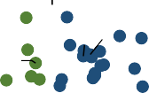

▼ Spend ▲ AM

▲ Spend ▲ AM

MEX

LVA

LTU

HUN

POL

EST

CZE

COL

SVK

CHL

USA

CRI TUR

GRC

SVN

PRT

ESP

ITA

GBR AUT IRLDNK

BEL FRA

ISLNZL NLD

DEU

NOR

ISR KOR

LUX JPN AUS

CHE

▼ Spend ▼ AM

▲ Health spending

▼ Avoidable mortality (AM)

1.05

2.5

2

1

1.5

1

0.95

0.5

0.9

0 0.5 1 1.5 2 2.5

0

0 0.5 1 1.5 2 2.5

There is a clear positive association between health spending per capita and life expectancy at birth (Figure 1.7). Among the 38 OECD countries, 18 spend more and have higher life expectancy than the OECD average (top right quadrant). A further 11 countries spend less and have lower life expectancy than the OECD average (bottom left quadrant).

Of particular interest are countries that deviate from this basic relationship. Eight countries spend less than the OECD average but achieve higher life expectancy overall (top left quadrant). This may indicate relatively good value for money of health systems, notwithstanding the fact that many other factors also have an impact on health outcomes. These eight countries are Korea, Spain, Italy, Israel, Portugal, Chile, Costa Rica and Slovenia. The only country in the bottom right quadrant is the United States, with much higher spending than all other OECD countries but lower life expectancy than the OECD average.

For avoidable mortality, there is also a clear association in the expected direction (Figure 1.8). Among OECD countries, 18 spend more and have lower avoidable mortality rates (bottom right quadrant), and 10 spend less and have more deaths that could have been avoided (top left quadrant). Nine countries spend less than average but have lower avoidable mortality rates – Israel, Korea, Italy, Spain, Portugal, Greece, Slovenia, Türkiye and Costa Rica (bottom left quadrant). The United States spends more than the OECD average and has worse avoidable mortality rates.

#### Health spending, access and quality of care

Figure 1.9 and Figure 1.10 illustrate the extent to which countries that spend more on health deliver more accessible and better- quality care (note that such associations do not guarantee a causal relationship).

**Figure 1.9. Satisfaction with availability of quality services and health expenditure**

**Figure 1.10. Breast cancer screening and health expenditure**

1.5 1.6



▼ Spend ▲Access

pend ▲Access

KOR

USA

CZE

CRI ISR SVN

EST PRT

MEX

ESP

LVA

SVK

ITA

TUR

POL LTU

HUN

GRC

COL

CHL

ing ces)

Health spend on with servi

▲

ss (satisfacti

▼ Acce

Access

▼ Spend ▼

▲ S

CHE

DEU AUT NOR

A

CAN

AUS FR IRL

GBR NZL

ISL

SWE

FIN

BEL

LUX NLD DNK

JPN



▼ Spend ▲ Quality

PRT

▲ Spend ▲ Quality

FIN

DNK

SWE

SVN

ISR ESP NLD

USA

KOR

GRC

GBR

NZL

NOR

EST CZE

ITA

IRL

CAN BEL

ISL

AUS DEU

LTU

JPN

FRA

LUX

CRI

CHL

AUT

POL

LVA

HUN

▼ Spend ▼ Quality

SVK

▲ Health spending

▼ Quality (cancer screening)

1.4

1 1.2

1

0.5 0.8

0.6

0

0 0.5 1 1.5 2 2.5

0.4

0 0.5 1 1.5 2 2.5

In terms of access, Figure 1.9 shows a clear positive correlation between the share of the population satisfied with the availability of quality healthcare where they live and health spending per capita. Among OECD countries, 14 spent more and had a higher share of the population satisfied with availability than the OECD average (top right quadrant). The converse was true in 14 countries (bottom left quadrant). In Canada, health spending was 27% higher than the OECD average, but only 56% of the population were satisfied with the availability of quality healthcare (compared to 67% on average across OECD countries). In Korea and the Czech Republic, health spending per capita was relatively low, but a noticeably greater share of the population were satisfied with the availability of quality healthcare than the OECD average.

In terms of quality of care, Figure 1.10 shows the relationship between health spending and breast cancer screening rates. While there is an overall weak positive correlation between health spending and the share of women screened regularly, nine countries spent less than the OECD average yet had higher cancer screening rates (top left quadrant), while seven countries spent more than the OECD average and had lower cancer screening rates (bottom right quadrant).

1. **Digital health at a glance**

OECD countries are struggling to maximise the value from digital health because technologies and the data environment are often outdated and fragmented. This chapter explores the concept of digital health readiness – assessing the policy, analytic, technical and social environment that enables successful use of digital health.

The concept of readiness is taking on increased urgency with the realisation that digital health is an emerging determinant of health. The chapter first looks at the policy components of an integrated digital health ecosystem to establish dimensions of digital health readiness – analytic, data, technology and human factor readiness. It then compiles and analyses indicators to measure readiness in these dimensions. The chapter concludes with a brief exploration of digital transformation as a determinant of health, providing some examples of the benefits of digital health in acute care to lower costs and improve the patient experience.

### Introduction

Digital tools and the use of health data are transforming how health services are delivered, how public health is protected, and how chronic conditions are managed and prevented. Digital health1 is playing an ever-increasing role in health systems through electronic health records (EHRs), the use of population health data for monitoring and policy, and the integration of digital tools such as telemedicine into routine clinical care. An integrated approach to digital health also supports the responsible use of artificial intelligence (AI) and analytics, by sharing quality health data through secure technical connections across all modes of care and administration. Digital transformation has been described as a determinant of health, as digital technologies, access, and literacy increasingly influence health, well-being and health transformations.

OECD countries are striving to realise the potential of digital health while minimising possible harms. While health has been slower than other sectors of the economy to leverage the potential of digital transformation, the COVID-19 pandemic has accelerated change. However, there are still significant barriers to overcome for countries to be ready for digital transformation. For example, health systems continue to rely on fax machines, with 75% of global fax traffic used for medical services (Gintux, 2023[1]); life-saving innovations are discovered, but it can take 17 years for published leading practice to become common practice (Morris, Wooding and Grant, 2011[2]); health providers express concern over their new digital burden while not receiving benefits from modern technologies (OECD, 2019[3]); and the public cannot engage meaningfully in their care without access to their own health records.

Meanwhile, the digital landscape is complicated by the different stakeholders involved. Alongside public systems, some large multi-national private sector entities offer specific interventions, such as subscription models for integrated care that, without suitable regulation, create data silos. Conflicting, uncoordinated systems of health data use and access risk health systems being unaware of inequities and preventing the utilisation of data for public health protection and health system improvement.

Through the pandemic, the eyes of the public and policy makers were opened to the necessity of timely and quality data to inform evidence-based policy making during the crisis. The public began to engage with their own health data and providers virtually, and learned a new language of statistics, R-values, positive testing rates and vaccinations. The pandemic furthered interest in health data privacy, security and governance, in addition to opportunities for innovative analytics. For example, digital health enabled:

* Canada, Latvia, Spain, the United Kingdom and the United States to scale up remote disease management and monitoring;
* Costa Rica, the Czech Republic, Finland, Latvia, Spain and the United States to improve care co-ordination and integration;
* Australia, Austria, the Czech Republic, Luxembourg and Spain to improve electronic prescribing.

Governance, legal, and regulatory changes are necessary to support adaptation to a digital health future without loss of protections for the public (OECD, 2023[4]). In early 2023, with the backdrop of increased attention to ChatGPT, the potential of AI caught public interest and concern. There are opportunities for AI in health – from automating administrative processes to aiding health professionals in diagnosis, powering medical devices for improved treatment, virtually testing millions of antibiotics for superbugs, and discovering new methods to prevent or better treat chronic conditions. There are also risks with, but not always caused by AI, including biased algorithms that exacerbate inequities, lack of clinical validation that risks patient safety, and potential for privacy breaches.

At the same time, with greater reliance on digital health are growing risks of cyberattacks. Some project that the cost of cyberattacks (across all industries) may reach USD 10.5 trillion by 2025 (Forbes, 2023[5]). Health is a prime target for cybercrime given the sprawl of health technologies, the value of health data, and the risk of disruption in health services from technical outages.

Most countries are pursuing these opportunities while addressing risks through the implementation of digital health strategies. These strategies acknowledge the importance of taking the lessons learned from the COVID-19 pandemic and providing better health services and outcomes for the public, while addressing the digital divide. There is an opportunity for investments in digital strategy to generate potential returns of USD 3 for every USD 1 of investment. These returns come from improved health outcomes, reduction of waste, and minimised duplication, while also supporting more resilient health systems (OECD, 2019[3]).

Countries’ ability to recognise the above factors in health data systems and to develop infrastructure, strategies, and governance frameworks to use in improving health systems is a signal of “digital health readiness”. This is a measure of the ability to make use of analytics, data, and technology for beneficial individual, community, and public health outcomes. Digital health readiness is the foundation from which data can be leveraged for primary and secondary uses to improve well-being, health outcomes, and resilience.

This thematic chapter examines countries’ digital health readiness “at a glance”, with a focus on indicators of readiness to realise benefits from digital health while minimising its harms. These indicators are not exhaustive; nor are all indicators specific to the health sector. The chapter provides the groundwork for a more comprehensive approach to a robust suite of digital health indicators for readiness. While data are not currently available across all dimensions of digital health readiness (Box 2.1), this chapter details the dimensions of a framework and signals the need for more regular data collection and policy discussions about the indicators. Looking forward, it may be appropriate to consider aspects of integration with social data (e.g. social determinants of health, social programme usage) for an overall view of health and well-being.

**Box 2.1. Definition of digital health and dimensions of digital health readiness**



Despite the increased importance of digital health, consistent terminology is elusive; this impairs cross-border collaboration and prevents scaling of innovation for better health outcomes. The scope of digital health can be limited to the type and use of digital technologies; it could be focused on improvement of healthcare delivery; or it could be a strategy for fulsome health system transformation (HIMSS, 2020[6]).

The *Global Strategy on Digital Health 2020-25* of the World Health Organization (WHO) brings together primary uses of digital tools with secondary uses for populations and the public. A connection between secondary generation of insights and their use in healthcare, promotion, and prevention creates a continuous improvement cycle that benefits everyone (WHO, 2021[7]).

As such, digital health readiness provides a foundation for primary uses (e.g. by clinicians and patients for care, and by individuals for their agency) and secondary uses (e.g. for population health, health system continuous improvement, public health, and research and innovation). Building on the WHO definition, this document defines digital health as follows (with added parts in **bold**):

*The field of knowledge and practice associated with the development and use of* ***health data and*** *digital technologies to improve health. Digital health expands the concept of eHealth to include digital consumers, with a wider range of smart devices, connected equipment,* ***and digital therapeutics****. It also encompasses other uses of* ***data and*** *digital technologies for health such as the Internet of things, artificial intelligence, big data and robotics****, and predictive and prescriptive analytics. Analytics can be for health system improvement, public health preparedness, or research and innovation****.*

In this context, the dimensions of digital health readiness include **analytic readiness** (for responsible analytics); **health data readiness** (for integrated health data); **technology readiness** (for robust technology); and **human factor readiness** (for capacity, co-operation, and oversight). Collectively, these need to be designed to work together to optimise health outcomes while minimising harms.

When responsible analytics, integrated health data and reliable technology are brought together, they form an **integrated digital health ecosystem.**

**Figure 2.1. Integrated Digital Health Ecosystem**

Human factors Robust technology

**Primary use** (Information and analytics)

Integrated health data

**Secondary use** (Information and analytics)

Source: Sutherland, E. (forthcoming[8]), “Policy checklist for integrated digital health ecosystems”.

The chapter first outlines the dimensions of digital health readiness across analytics, health data and technology, as well as the human factors that provide trust, coherence, and sustainability. Indicators are mapped to a subset of components – with some proxy measures – to analyse the performance of OECD countries within the framework.

Second, the chapter discusses the indicators and their findings through the dimensions of digital health readiness, which include analytic readiness, data readiness, technology readiness, and human factor readiness. The chapter further identifies countries that perform well consistently across the chosen digital health readiness indicators.

Third, the chapter looks at sample health outcomes and their relationship with dimensions of readiness to explore digital health readiness as a determinant of health. Further, this chapter discusses examples and opportunities to evaluate the relationship between digital health readiness and effects on costs and health outcomes.

Finally, the chapter summarises findings from the first three sections. It concludes with a call for further work on developing measures of digital health readiness to improve understanding of its relationship with positive health outcomes, lower costs, and higher levels of innovation.

### Framework for digital health readiness assessment

The performance of digital health is not as easy to measure as indicators in other chapters in *Health at a Glance*, as it is both a new discipline and one that is constantly changing. The issue is exacerbated by the somewhat elusive definition of digital health (as discussed in Box 2.1).

Digital health readiness is a measure of the ability to make use of analytics, data, and technology for beneficial individual, community, and public health outcomes. Hence, “readiness” is a composite of abilities and structures across analytics, data, and technology. In addition, readiness requires human factors outlined above for capacity, co-operation, and oversight. Dimensions of digital health readiness are categorised as follows:

* **Analytic readiness** assesses the readiness for analytics to be created and used to generate action that improve health outcomes for individuals, communities, and the public. The objective of analytic readiness is responsible analytics that are trusted and inform equitable health outcomes. In health, this includes readiness to develop and deploy responsible AI to help doctors and nurses in their routine tasks (e.g. documenting cases) or diagnostics (e.g. interpreting radiology images).
* **Data readiness** assesses the readiness for data to be collected, accessed, and used in analytics. The objective of data readiness is integrated and quality health data that are available for healthcare, public health, health system improvement, research, and innovation. For example, data readiness includes policies that enable data protection, de-identification, access, and linking to help improve the safety of health systems.
* **Technology readiness** assesses the readiness for technology to support the secure input, storage, and movement of data. The objective of technology readiness is robust technology that is resilient to digital security risks and technology outages while maintaining data integrity. This includes aspects of technical interoperability that, when combined with semantic interoperability, allow health systems to communicate with each other with high data quality and timeliness.
* **Human factor readiness** assesses the readiness of the digital health ecosystem (including analytics, data, culture, and technology) to achieve its objectives with sufficient resources and to be resilient to shocks. The objective of human factor readiness is to foster trust among stakeholders, acquire sufficient financial and human resources, encourage co-operation and re-use for mutual benefit, and adapt to emerging issues and challenges. Included in this is digital health literacy to ensure that the public, providers, and policy makers have the knowledge necessary to use the digital health ecosystem effectively, including its necessary protections.

Collectively, a health system that has high digital health readiness is designed to optimise positive health outcomes while minimising harms from analytic, data, or technology misuse. High digital health readiness is aligned with OECD legal instruments for artificial intelligence (AI), health data governance, and digital security, and digital identity (see Box 2.2).

**Box 2.2. OECD legal instruments and digital health readiness Health data governance**

In 2017, OECD countries endorsed a Recommendation on Health Data Governance that encourages adoption of a national health data governance framework, 12 components of that framework, and co-operation on definition and implementation of interoperability standards.

In practice, the Recommendation covers a broader perspective around digital health, all of which contributes to digital health readiness. The table below maps which parts of the Recommendation apply to which parts of digital health readiness, noting that all areas are ultimately required for digital health.

|  |  |
| --- | --- |
| Recommendation on health data governance | Dimensions of digital  readiness |
| Engagement and participation of stakeholders in the development of a national health data governance framework | Human factors |
| Co-ordination within government and co-operation among organisations processing personal health data to encourage common  data-related policies and standards | Human factors |
| Reviews of the capacity of public sector health data systems to serve and protect public interests | Human factors |
| Clear provision of information to individuals about the processing of their personal health data including notification of any significant data breach or misuse | Technology |
| The processing of personal health data by informed consent and appropriate alternatives | Data |
| The implementation of review and approval procedures to process personal health data for research and other health-related public interest purposes | Data |
| Transparency through public information about the purposes for processing of personal health data and approval criteria | Human factors |
| Maximise the development and use of technology for data processing and data protection | Technology |
| Mechanisms to monitor and evaluate the impact of the national health data governance framework, including health data availability, policies, and practices to manage privacy, protection of personal health data and digital security risks | Human factors |
| Training and skills development of personal health data processors | Human factors |
| Implementation of controls and safeguards within organisations processing personal health data including technological, physical, and organisational measures designed to protect privacy and security | Data Technology |
| Requiring that organisations processing personal health data demonstrate that they meet the expectations set out in the national health data governance framework | Human factors |

Source: OECD (2016[9]), Recommendation of the Council on Health Data Governance, [https://legalinstruments.oecd.org/en/instruments/OECD-LEGAL-0433.](https://legalinstruments.oecd.org/en/instruments/OECD-LEGAL-0433)

**Artificial Intelligence (AI)**

In 2019, the OECD published value-based principles for AI. These apply to the development of AI, although they are appropriate for general practices in analytics.

The principles for AI are consistent with and complementary to the OECD Recommendation on Health Data Governance.

|  |  |  |
| --- | --- | --- |
| Recommendation on artificial intelligence | Description | Dimensions of digital  readiness |
| Inclusive growth, sustainable development, and well-being | Stakeholders should proactively engage in responsible stewardship of trustworthy AI in pursuit of beneficial outcomes for people and the planet | Analytic |
| Human-centred values and fairness | AI actors should respect the rule of law, human rights, and democratic values, throughout the AI system lifecycle | Analytic |
| Transparency and explainability | AI actors should commit to transparency and responsible disclosure regarding AI systems | Analytic |
| Robustness, security, and safety | AI systems should be robust, secure, and safe throughout their entire lifecycle so that – in conditions of normal use, foreseeable use or misuse, or other adverse conditions – they function appropriately and do not pose unreasonable safety risk | Analytic |
| Accountability | AI actors should be accountable for the proper functioning of AI systems and for the respect of the above principles, based on their roles and the context, and  consistent with the state of the art | Analytic |

Source: OECD (2019[10]), Recommendation of the Council on Artificial Intelligence, [https://legalinstruments.oecd.org/en/instruments/OECD-LEGAL-0449.](https://legalinstruments.oecd.org/en/instruments/OECD-LEGAL-0449)

**Digital security**

In 2022, OECD countries endorsed a Recommendation on Digital Security Risk Management that provides a set of nine principles for digital security and encourages OECD countries to adopt national approaches to digital security risk management. These will help to minimise the risk of successful cyberattacks and the impacts if an attack should be successful.

The principles for digital security risk management are consistent with and complementary to the OECD Recommendation on Health Data Governance.

|  |  |  |
| --- | --- | --- |
| Recommendation on digital security risk management | Description | Dimensions of digital readiness |
| Digital security culture: awareness, skills, and empowerment | All stakeholders should create a culture of digital security based on an understanding of digital security risk and how to manage it | Technology |
| Responsibility and liability | All stakeholders should take responsibility for the management of digital security risk based on their roles, the context, and their ability to act | Technology |
| Human rights and fundamental values | All stakeholders should manage digital security risk in a transparent manner and consistently with human rights and fundamental values | Technology |
| Co-operation | All stakeholders should co-operate, including across borders | Technology |
| Strategy and governance | Leaders and decision makers should ensure that digital security risk is integrated in their overall risk management strategy and managed as a strategic risk requiring operational measures | Technology |
| Risk assessment and treatment | Leaders and decision makers should ensure that digital security risk is treated based on continuous risk assessment | Technology |
| Security measures | Leaders and decision makers should ensure that security measures are appropriate to and commensurate with the risk | Technology |
| Resilience, preparedness and continuity | Leaders and decision makers should ensure that a preparedness and continuity plan based on digital security risk assessment is adopted, implemented, and tested, to ensure resilience | Technology |
| Innovation | Leaders and decision makers should ensure that innovation is considered | Technology |

Source: OECD (2022[11]), Recommendation of the Council on Digital Security Risk Management, [https://legalinstruments.oecd.org/en/instruments/OECD-LEGAL-](https://legalinstruments.oecd.org/en/instruments/%E2%80%8COECD-LEGAL-0479) [0479.](https://legalinstruments.oecd.org/en/instruments/%E2%80%8COECD-LEGAL-0479)

**Governance of Digital Identity**

In June of 2023, the OECD adopted Recommendations on the Governance of Digital Identity. These aim to support domestic approaches to digital identity that are user-centred and trusted.

The recommendations on digital identity are consistent with and complementary to the OECD Recommendation on Health Data Governance.

|  |  |  |
| --- | --- | --- |
| Recommendation on digital identity | Description | Dimensions of digital readiness |
| User-centred and inclusive digital identity systems | Designing and implementing digital identity systems that are effective, usable, and responsive to the needs of users and service providers, while prioritising inclusion, reducing barriers to access, and preserving non-digital ways to prove identity | Data |
| Strengthening the governance of digital identity | Defining roles and responsibilities and align legal and regulatory frameworks across the digital identity ecosystem(s). Protecting privacy and prioritising security to ensure trust in digital identity systems | Data |
| Cross-border use of digital identity | Co-operating internationally to establish the basis for trust in other jurisdictions’ digital identity systems and issued identities. Understanding needs of users and service providers in different cross-border scenarios | Data |

Source: OECD (2023[12]), Recommendation of the Council on the Governance of Digital Identity, [https://legalinstruments.oecd.org/en/instruments/OECD-LEGAL-](https://legalinstruments.oecd.org/en/instruments/%E2%80%8COECD-LEGAL-0491) [0491.](https://legalinstruments.oecd.org/en/instruments/%E2%80%8COECD-LEGAL-0491)

Digital health readiness is the foundation for primary and secondary uses of data and technology across all sectors of healthcare delivery and management. When considerations of the links to and from other parts of the digital health ecosystem and the readiness of the environment to support their long-term, sustainable use are lacking, the result is fragmented solutions that cannot be integrated.

Understanding the policies required for a digital health ecosystem will help to guide the selection of indicators for digital health readiness that support the ability to integrate solutions into broader policies for care, safety, and system effectiveness. In systems with high digital health readiness, these policies should be designed together to orchestrate activities across analytics, data, and technology; this also reduces overlap and avoids policy inconsistencies or contradictions. Figure 2.2 represents a checklist of policies for digital health ecosystems.

**Figure 2.2. Checklist of policies for an integrated digital health ecosystem (IDHE)**

|  |  |  |  |  |
| --- | --- | --- | --- | --- |
| **Analytics and use:**  Creates value from data to continuously improve individual and system outcomes | Uses | **Integrated health data:**  Links data across domains with high quality, encouraging re-use with privacy protection in place | Built on | **Robust technology:**  Interfaces between technologies and people optimising for security and user experience |
| Algorithmic integrity  Indicators  Access for primary use  Access for secondary use  Access for commercial use  Analytic risk management | Digital identity  Data life cycle management  Ownership, stewardship and custodianship  Access and privacy risk management  Semantic interoperability  Indigenous and community data | Technology procurement and management  Digital security risk management  Technical interoperability  Information architecture  Interfaces  Telecommunications |
| **Human factors:**  Oversight, engagement, funding, capacity, and capability to sustain the IDHE and adapt | | | | |
| Literacy, capacity and Public, provider, and Strategic governance and capability stakeholder involvement finance  Knowledge management Communication Operational governance and sharing | | | | |

Source: Sutherland, E. (forthcoming[8]), “Policy checklist for integrated digital health ecosystems”.

As digital health readiness is a fundamental component of an efficient and modern health system, efforts should be made to facilitate regular capture and analysis of appropriate indicators to monitor it. Ideally, digital health readiness would have indicators for each of the policy areas in Figure 2.2. These could start by measuring the existence of the relevant policy and evolve into indicators that measure the effectiveness of implementation of that policy. Currently, there is no comprehensive capture of such indicators. Table 2.1 includes a set of initial measures of digital health readiness. Proxies have been used where direct data are not available. Most proxies are not specific to health.

**Table 2.1. Initial indicators for digital health readiness including proxy measures**

|  |  |  |  |
| --- | --- | --- | --- |
| Dimension of  digital health readiness | Associated policy area | Indicator or proxy presented in this chapter | Comment |
| Analytic readiness | Access for primary use  Access for secondary use | Dataset availability, maturity and use score (OECD)  Patient access to their own health data (OECD) |  |
| Algorithmic integrity | Global AI Index (third party) | Proxy measure |
| Data readiness | Data lifecycle management | Dataset governance score (OECD) |  |
| Digital identity | Digital Government Index (OECD) | Proxy measure |
| Semantic interoperability  *Technical interoperability* | Interoperability standard adoption (OECD) | Should extend to semantic data standards |
| Technology readiness | Internet availability | Internet connectivity for individuals (OECD) | For entire population |
| Digital security | Digital security (OECD) |  |
| Technology procurement | Certification of vendors (OECD) |  |
| Human factor readiness | Strategic governance | Digital health strategies (various) |  |
| Literacy, capacity and capability | Digital skills in Europe (third party) | Proxy measure |
| Public, provider and stakeholder involvement | Digital citizen engagement index (third party) | Proxy measure |

These indicators are presented in more depth in the next section.

### Indicators of digital health readiness

Digital health is emerging as an essential component of health systems, with recent literature indicating that digital transformation is a determinant of health (The Lancet Digital Health, 2021[13]). To manage digital health better, it is necessary to measure the effectiveness and efficiency of the creation of analytics, data, and technology. This will help to strengthen the foundations of healthcare for the digital age.

This section reviews each of the dimensions of readiness defined in the above section based on the indicators from Table 2.1. These indicators are an incomplete view of readiness for digital health; however, they may provide inspiration for future work to better define comprehensive indicators and support routine data collection. Such work would also help to identify leaders in digital health (to share expertise) as well as gaps where there is mutual benefit in collaboration.

#### Analytic readiness indicators

Analytics are the part of digital health that generates value for people, communities, and society. This value is generated in diverse ways – for example, by providing better precision healthcare for individuals, addressing health inequities for marginalised communities, protecting the public from health emergencies, supporting more effective health monitoring and financing policies, and discovering new life-saving innovations.

Three areas that are essential for analytic readiness are the ability to access and link data for healthcare and secondary use, the ability for individuals to access their own data, and the ability to apply analytic techniques, as with AI.

##### Ability to access and link data – primary and secondary uses

The readiness to create meaningful analytics and ensure their appropriate use is dependent on timely access to quality data and the ability to link data across datasets. Primary uses of these data are for healthcare whenever and wherever necessary – across primary care, acute care, and individual data use. Secondary uses of data include patient safety, public health preparedness, health service management and planning, health system improvement, and research and innovation.

In 2022, the OECD performed a five-year review of the Recommendation on Health Data Governance (OECD, 2016[9]). This reported on capabilities to link and use data across critical data domains. The score for analytic readiness demonstrated wide variation among OECD countries (see Figure 2.3).

**Figure 2.3. Ability to access and link datasets in healthcare**

Dataset availability score 8

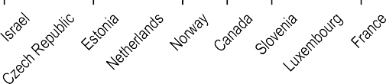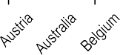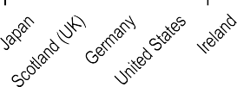

7

6

5

4

3

2

1

0

Note: Lithuania and Spain have reported this capability, but no data were available in the survey when it was conducted.

Source: OECD (2022[14]), *Health Data Governance for the Digital Age: Implementing the OECD Recommendation on Health Data Governance*, [https://doi.org/10.1787/68b60796-en.](https://doi.org/10.1787/68b60796-en)

The dataset availability score is a composite indicator that incorporates eight measures including:

* timely data access that covers the national population across care settings and clinical registries;
* use of interoperable clinical data standards and identifiers that enable linking across datasets;
* use of linked data for primary and secondary health purposes.

In this indicator, Denmark had the highest composite score, followed by Korea, Sweden, Finland and Latvia. Denmark scored highest in seven of the eight measures: the country reported that data were extracted from electronic records for all key datasets, coded using clinical data standards, covering more than 80% of the population, and linkable by a unique patient identifier. Further, linked data were used for healthcare quality, performance, research, and monitoring. Only Latvia scored higher than Denmark on timeliness of data, with a greater percentage of data available for use within one week. Korea performed similarly to Denmark, except for linking a registry for cardiovascular disease with other data. Sweden also performed similarly, except for linking primary care data and only having one dataset available within one week of the original data creation at source.

##### Ability to access and link data – individual use

Both the OECD Recommendation on Health Data Governance (OECD, 2016[9]) and WHO’s Global Strategy on Digital Health 2020-2025 (WHO, 2021[7]) call for individuals to have access to their own health records. With this access, individuals will be more knowledgeable about the state of their well-being. It will facilitate conversations with health providers as the individual will no longer need to remember their prior vaccinations, prescriptions, test results, or medical treatments. In more advanced EHR systems, the individual can contribute information to their health record to report on symptoms, correct errors, or progress with health treatments.

In 2021, the OECD published a Survey of Electronic Health Record System Development, Use and Governance. This showed variation in availability of portals, the ability to access all records, and the ability to interact with data. The findings are summarised in Table 2.2.

Almost 90% of responding OECD countries reported having an electronic portal in place; however, only 42% reported that the public could both access and interact with all their data through the portal. Fewer than half of responding countries indicated that all patients could access their data via portals.

Denmark, Italy, Lithuania, Luxembourg and Türkiye reported having a portal for patients to access their comprehensive health data that was available to their entire population. Further, their portals allowed patients to interact with their data.

**Table 2.2. Patient access to and interaction with their own EHRs through a secure internet portal**

|  |  |  |  |
| --- | --- | --- | --- |
| Access via portal Access to ALL records Interaction with portal | Access via portal Access to SOME records  Interaction with portal | Access via portal Access to ALL records NO interaction with portal | NO access via portal |
| 11 |  |  |  |
| Australia |  |  |  |
| **Denmark** | 9 |  |  |
| Germany | Belgium |  |  |
| **Italy** | Canada |  |  |
| **Lithuania** | Costa Rica |  |  |
| **Luxembourg** | Czech Republic |  |  |
| Netherlands | **Finland** |  |  |
| Slovenia | **Iceland** | 3 | 3 |
| Sweden | **Israel** | **Estonia** | Korea |
| Switzerland | Portugal | Hungary | Mexico |
| **Türkiye** | United States | **Japan** | Norway |

Note: Countries in **bold** reported that 100% of patients are covered. Some OECD countries, like the Netherlands, use multiple EHR portals. Spain also has this capability, but no data was available in this survey.

Source: Slawomirski, L. et al. (2023[15]), “Progress on implementing and using electronic health record systems: Developments in OECD countries as of 2021”, [https://doi.org/10.1787/4f4ce846-en.](https://doi.org/10.1787/4f4ce846-en)

##### Artificial Intelligence (AI) and algorithmic integrity

Readiness of analytics is also dependent on integrity of the methods used to create the analytics. This issue has gained more prominence owing to increased awareness of the potential benefits and risks of AI. AI holds the potential to revolutionise healthcare by improving diagnostics, helping with development of new treatments, supporting providers, and extending healthcare beyond the health facility and to more people. Projections have suggested that the use of AI could lead to vaccines against cancer and cardiovascular and autoimmune diseases by the end of this decade (The Guardian, 2023[16]). AI is already being used to find new antibiotics (McMaster University, 2023[17]). However, AI also has significant risks due to potential biases and lack of transparency of the algorithms created. Implementation of AI has both the potential to help address issues of equity and the potential to expand inequities.

Broad measures of AI are not yet available, although there are indications of which countries are leading AI development and implementation. A Global AI Index (Tortoise, 2023[18]) measures implementation, innovation, and investment in AI across all sectors, including health and private sectors, and provides a country ranking. The Index covers 62 countries, including 36 OECD countries (all except Costa Rica and Latvia). Table 2.3 presents the rankings for the top ten countries.

**Table 2.3. Top ten countries in the Global AI Index**

|  |  |  |  |  |  |  |  |  |
| --- | --- | --- | --- | --- | --- | --- | --- | --- |
| Country | Talent | Infra- structure | Operating environment | Research | Development | Government strategy | Commercial investment | Overall score |
| **United States** | **1** | **1** | **28** | **1** | **1** | **8** | **1** | **1** |
| China | 20 | 2 | 3 | 2 | 2 | 3 | 2 | 2 |
| Singapore | 4 | 3 | 22 | 3 | 5 | 16 | 4 | 3 |
| **United Kingdom** | **5** | **24** | **40** | **5** | **8** | **10** | **5** | **4** |
| **Canada** | **6** | **23** | **8** | **7** | **11** | **5** | **7** | **5** |
| **Korea** | **12** | **7** | **11** | **12** | **3** | **6** | **18** | **6** |
| **Israel** | **7** | **28** | **23** | **11** | **7** | **47** | **3** | **7** |
| **Germany** | **3** | **12** | **13** | **8** | **9** | **2** | **11** | **8** |
| **Switzerland** | **9** | **13** | **30** | **4** | **4** | **56** | **9** | **9** |
| **Finland** | **13** | **8** | **4** | **9** | **14** | **15** | **12** | **10** |

Note: Countries in **bold** are OECD countries.

Source: Tortoise (2023[18]), Global AI Index, [www.tortoisemedia.com/intelligence/global-ai/,](https://www.tortoisemedia.com/intelligence/global-ai/) latest data available from June 2023.

The United States leads the Index overall, with seven other OECD countries in the top ten. The United States leads in five of seven dimensions (talent, infrastructure, research, development, and commercial investment). Denmark leads in operating environment. Germany is the leading OECD country in government strategy (second overall where Saudi Arabia is first).

Given the accelerated growth of AI, it is likely that this will be an area of significant interest – to realise its benefits while protecting against its risks – in years to come. Several entities have started work on regulation of AI, including the European Union (EU) (via the proposed Artificial Intelligence Act), Canada (via the proposed Artificial Intelligence and Data Act), and the United States (via the blueprint for an AI Bill of Rights).

While none of these advances are specific to health, the sector has significant risks and opportunities from AI. Risks include hidden biases and lack of transparency that may result in inappropriate clinical recommendations that lead to patient harm. Security and privacy risks are also associated with training and use of AI, given the breadth of data required for effective training of the algorithms.

Nevertheless, there are also significant benefits of AI use in health, such as:

* **relieving health workforce pressures** by using AI to automate administrative tasks – estimated to improve productivity by 10% (Beamtree, 2023[19]);
* **augmenting clinical diagnoses** by pulling information from unstructured doctor notes to bring issues to the surface, which has led to better diagnoses for breast cancer patients who would otherwise have fallen between the cracks (Petch et al., 2023[20]);
* **detecting public health emergencies** by using AI to scan global health activity to detect unusual patterns of concern so that public health leaders can be informed as quickly as possible to formulate an appropriate response (CNBC, 2020[21]).

Countries are actively working to understand how to achieve benefits from AI across their health systems while minimising risk. A critical area to address in the rollout of AI will be its social acceptance. Studies in the United States and Canada have indicated that patients want doctors to be the face of care and do not want to be diagnosed by a machine (OTV NEWS, 2023[22]; Pew Research Center, 2023[23]). This is consistent with the OECD AI Principle of human-centredness values and fairness (OECD.AI, n.d.[24]).

#### Data readiness indicators

The full value of analytics can only be unlocked if quality data are available, with necessary protections in place to ensure that data are secure and private. Countries that are ready to use data understand that harms may come both from sharing data (e.g. from privacy breaches) and from not sharing data (e.g. missed drug interactions, lack of awareness of growing inequities, inability to manage chronic conditions).

Three areas that are essential for data readiness are governments’ approaches to the governance of health data, digital transformation of systems, and interoperability.

##### Governance of health data (lifecycle management)

The readiness to collect, store, and provide access to quality data is dependent on having clear structures and policies in place that define accountabilities, provide clear guidance for decision making, and support trust among health organisations and the public.

In 2022, the OECD performed a five-year review of the Recommendation on Health Data Governance (OECD, 2016[9]), which included a score for dataset governance (see Figure 2.4).

**Figure 2.4. Dataset governance in healthcare**

Dataset governance score

16

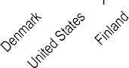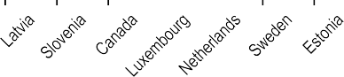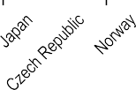

14

12

10

8

6

4

2

0

Note: Score calculated as a sum of proportions of national healthcare datasets with recommended governance elements (see source).

Source: OECD (2022[14]), *Health Data Governance for the Digital Age: Implementing the OECD Recommendation on Health Data Governance*, [https://doi.org/10.1787/68b60796-en.](https://doi.org/10.1787/68b60796-en)

The dataset governance score is a composite indicator that incorporates 15 measures including:

* training and operational controls for privacy and security;
* processes for data-sharing arrangements;
* data catalogues and their contents.

In this indicator, Denmark had the highest composite score, followed by the United States, Finland, France and Scotland (United Kingdom). Denmark scored highest in 14 of 15 measures (including equal scores): the country reported that legislation authorises creation of datasets with data protection officers in place; staff are trained on data protections and their access to data is controlled; standard data-sharing agreements are in place for data sharing within the public sector, with academics, with the private sector and across borders, where data are de-identified/pseudonymised prior to sharing; access may be gained through remote means or through research data centres; and dataset descriptions are made public with their legal basis, along with clear procedures for data linkage. Only the United States scored higher than Denmark on the measure of testing the risk of re-identification. The United States had similar scores to Denmark, scoring highest in 11 of 15 measures, with opportunities to expand cross-border data sharing, to include the legal basis for the dataset publicly and to link long-term care data. Finland scored highest in 13 of 15 measures but had areas of improvement to measure re-identification risk and increase research data centre access.

##### Digital Government Index for digital identity

The readiness of data is also determined through government policies as part of a drive for overall digital transformation. As an input to the OECD’s Going Digital programme, 31 countries were evaluated in a Digital Government Index in 2019 (OECD, 2019[25]). This measured six attributes:

* **Digital by design** assesses the governance and adoption of digital technologies to rethink and re-engineer public processes, simplify procedures, and create new channels of communication and engagement with stakeholders.
* **Data-driven public sector** measures the extent to which governments value data as a strategic asset and establish governance, access, sharing and re-use mechanisms for improved decision making and service delivery.
* **Government as a platform** benchmarks the extent to which governments deploy shared platforms, standards, and services to help teams focus on user needs in public service design and delivery.
* **Open by default** measures the degree of openness of government data and policy-making processes available to the public, within the limits of existing legislation and in balance with national and public interests.
* **User-driven** assesses the extent to which user needs are considered in the design of policies and services, including using inclusive mechanisms (e.g. dedicated service design mechanisms or digital tools to understand users’ needs).
* **Proactiveness** benchmarks the level of anticipation of governments to attend to people’s needs and respond to them rapidly, avoiding the need for cumbersome data and service delivery processes.

The OECD Digital Government Index is presented in Figure 2.5.

**Figure 2.5. OECD Digital Government Index (2019)**

Digital by design User-driven

Proactiveness

Data-driven public sector

Open by default Government as a platform

Index: 1=highest digital government maturity 0.8

0.7



0.6

0.5

0.4

0.3

0.2

0.1

0

Source: OECD (2019[25]), Going Digital Toolkit, [https://goingdigital.oecd.org/indicator/58.](https://goingdigital.oecd.org/indicator/58)

As of 2019, Korea was the leader in the composite Digital Government Index score, followed by the United Kingdom and Colombia. Korea led all countries in two attributes: digital by design and open by default. The United Kingdom led in the attributes data-driven public sector and government as a platform. Colombia led in proactiveness, and Denmark led in being user-driven.

While these attributes are not specific to health, they are indicative of leading practices that will be useful for health. For example, the OECD is leading work on establishment of guidelines for digital identity that allow both authentication of individuals and appropriate use and linking of their data across government services (OECD, 2023[26]).

The OECD Going Digital Toolkit includes a measure of “health data sharing intensity” (OECD, 2019[25]). In this indicator, Denmark, Finland and Norway had the highest level of data sharing – sharing data with other government bodies, universities, healthcare providers, businesses, and foreign governments – while ensuring that appropriate protections are in place (OECD, 2023[27]).

It should be noted that these measures pre-date the COVID-19 pandemic, which may have changed attitudes to health data sharing, protection, and use.

##### Interoperability standards in health systems

Semantic data standards allow the meaning of the data to be maintained as data are transported between systems, regardless of the format, and managing differences in units. For example, sex at birth may be captured as “Male” in one system, whereas another may record it as “M”. Alternatively, a lab result for blood glucose level could be captured in units of mg/dL or mmol/L, depending on the lab. Interpreting current tests and trending results over time requires that the units be measured on the same scale.

Technical data standards support the exchange of data between technologies while the content of the data is protected. Semantic and technical standards work together, so local physical data standards are connected to each other while maintaining data quality and integrity.

There are many semantic and technical data standards in health. The OECD Survey of Electronic Health Record System Development, Use and Governance specifically examined the use of HL7-FHIR (Fast Healthcare Interoperable Resources) – a standard that focuses on technical data exchange – and SMART (Substitutable Medical Applications, Reusable Technologies) – a standard for application interfaces (Slawomirski et al., 2023[15]). A summary of the adoption of FHIR standards is included in Table 2.4.

**Table 2.4. Adoption of recent HL7-FHIR and SMART interoperability standards across OECD countries**

|  |  |  |  |
| --- | --- | --- | --- |
| EHR interoperability Adopting HL7-FHIR Adopting SMART on FHIR | EHR interoperability Adopting HL7-FHIR No SMART on FHIR | EHR interoperability Not adopting HL7-FHIR No SMART on FHIR | No projects for interoperability Not adopting HL7-FHIR No SMART on FHIR |
| **10** |  |  |  |
| **Australia** |  |  |  |
| **Belgium** |  |  |  |
| Czech Republic |  |  |  |
| Estonia | **6** |  |  |
| **Finland** | **Canada** | 5 |  |
| **Korea** | **Denmark** | **Hungary** |  |
| Lithuania | **Iceland** | Japan | 3 |
| **Netherlands** | Israel | Slovenia | Costa Rica |
| **Norway** | **Luxembourg** | Switzerland**1** | **Portugal1** |
| **Sweden** | Italy | United States | **Türkiye2** |

Note: Countries in **bold** also reported working on developing public application programming interfaces (APIs).

1. Additional efforts for EHR interoperability were underway in Portugal (Adopting HL7-FHIR, no SMART on FHIR), Switzerland (Adopting HL7-FHIR and SMART on FHIR) and Spain (Adopting HL7-FHIR) though data were not captured in this survey.
2. Türkiye is implementing SMART on FHIR.

Source: Slawomirski, L. et al. (2023[15]), “Progress on implementing and using electronic health record systems: Developments in OECD countries as of 2021”, [https://doi.org/10.1787/4f4ce846-en.](https://doi.org/10.1787/4f4ce846-en)

Almost 90% of responding OECD countries reported that they were introducing legislation to require standards for interoperability; 66% were adopting HL7-FHIR, and 42% were adopting SMART on FHIR, which simplifies data queries, access, and exchange between systems (Slawomirski et al., 2023[15]). Australia, Belgium, Finland, Korea, the Netherlands, Norway, Spain and Sweden reported advancing a strategy for EHR interoperability, adopting HL7-FHIR standards along with SMART on FHIR, and developing application programming interfaces (API) to simplify data access and support open data.

While HL7-FHIR provides semantic data standards itself, it is compatible with semantic standards such as SNOMED2 or ICD3 for clinical data coding. In parallel, there are emerging approaches to semantic data standards for primary and secondary uses beyond clinical care. For primary use, the International Patient Summary (IPS) is intended as standard for both presentation of data to individuals and exchange of data across borders. Data domains required by the IPS include prescription history, allergies and intolerances, and medical diagnoses. Additional data domains include immunisation, history of procedures, medical devices, and diagnostic testing results (HealthIT.gov, 2021[28]).

For secondary use, the Observational Medical Outcomes Partnership (OMOP) Common Data Model (CDM) is an open community data standard to help interoperability of data, with a focus on secondary use. The OMOP CDM leverages the Observational Data Standards and Informatics (OHDSI) vocabularies. These models allow for standardisation across data sources for aggregate analysis. Ideally, the standards for the IPS and OMOP would work together so that data can be collected once for primary purposes and used many times for secondary use.

It should be noted that since the time of the survey (2021), interoperability standards have continued to evolve beyond HL7-FHIR and SMART. Current practice would also incorporate semantic interoperability standards, for capture and exchange of information for EHRs, as well as enabling the use of that data for secondary purposes, as discussed above. As there are yet to be surveys of adoption of the IPS or OMOP across health systems to understand the current level of readiness across semantic interoperability, subsequent measurement of interoperability will look at the adoption of policies to establish standards governance and monitor national semantic and technical data standards.

#### Technology readiness

Technologies are intertwined with digital health – be it the user interface for a medical device, electronic medical records in hospitals that capture information, or x-ray machines that capture and share images. Readiness with digital health requires reliable technologies to collect, store, access, share and use data to produce impactful insights.

Three areas for technical readiness are the abilities of individuals to access digital tools via the internet, the security of digital systems and the approach to vendor certification.

##### Internet connectivity for individuals

In an increasingly digitised world, there are calls for access to the internet to be recognised as essential for human well-being. Internet connectivity is particularly important for issues such as universal health coverage reaching remote and rural areas.

The OECD Going Digital programme measured the penetration of mobile and fixed internet connections in OECD countries and the share of individuals who used the internet to contact public authorities. A summary is presented in Figure 2.6.

**Figure 2.6. Internet use across OECD countries and use of the internet for public authorities**

Fixed broadband penetration Mobile broadband penetration Public authorities use

Subscriptions per 100 inhabitants 250



200

150

100

50

0

% of individuals

90

80

70

60

50

40

30

20

10

0

Source: OECD (2019[25]), Going Digital Toolkit, [https://goingdigital.oecd.org/indicator/58,](https://goingdigital.oecd.org/indicator/58) based on the OECD Broadband Portal [www.oecd.org/sti/](http://www.oecd.org/sti/broadband/broadband-statistics) [broadband/broadband-statistics](http://www.oecd.org/sti/broadband/broadband-statistics) and the ITU World Telecommunication/ICT Indicators Database, [www.itu.int/en/ITU-D/Statistics/Pages/publications/wtid.aspx.](http://www.itu.int/en/ITU-D/Statistics/Pages/publications/wtid.aspx)

Globally, mobile technologies are the dominant method of accessing the internet. In Japan and Estonia, there are almost two subscriptions to the internet for every individual, while the number of subscriptions is less than one per person in 12 OECD countries.

The internet is frequently used for public health purposes. In 15 OECD countries, more than 60% of the population used the internet to interact with public authorities.

As an example specific to health, more than half of citizens in Finland reported personally accessing their EHRs regularly online in 2019. They interacted with their records to renew prescriptions, update consent, post living wills, and record organ donation testaments, among other actions (Jormanainen et al., 2019[29]).

##### Digital security

Digital security is a rising concern globally, with the cost of cyberattacks projected to reach USD 10.5 trillion by 2025 (Forbes, 2023[5]). The health sector is a particular target for cyberattacks because of the inherent value of health data and the extremely low tolerance for outages of digital technologies. Given the sensitivity of confidential patient data, digital health readiness requires that connections and storage are secure.

OECD countries endorsed principles for digital security risk management in 2022 that would apply across all industries (OECD, 2022[11]), as summarised in Box 2.2. These principles were used to survey approaches to digital security in health across OECD countries in early 2023. The responses were compared to leading practices and are summarised in Table 2.5.

**Table 2.5. Summary of alignment of countries to leading practices for digital security**

|  |  |  |  |  |  |  |  |  |  |  |
| --- | --- | --- | --- | --- | --- | --- | --- | --- | --- | --- |
|  | | Digital security culture | Responsibility and liability | Human rights and fundamental values | Co-operation | Strategy and governance | Security measures | Risk assessment and treatment | Innovations | Resilience, preparedness and continuity |
| **Digital Security Principles** | | | | | | | |  |
| Digital Security Strategy specific to Health (**bolded** countries identified alignment with a national digital health strategy) | **Australia** | G | G | G | G | G | G | I | G | G |
| Canada | Y | Y | G | G | Y | G | Y | G | G |
| Czech Republic | Y | G | Y | G | Y | G | Y | G | G |
| **France** | I | I | I | I | I | I | I | I | I |
| **Germany** | I | I | I | I | I | I | I | I | I |
| **Ireland** | G | G | G | G | G | G | G | G | G |
| **Israel** | G | G | G | G | Y | G | Y | G | G |
| Netherlands | Y | Y | Y | G | Y | G | G | Y | G |
| **Norway** | Y | Y | G | G | Y | G | Y | G | Y |
| United Kingdom | G | G | Y | G | Y | Y | Y | Y | G |
| **United States** | Y | G | Y | G | Y | G | G | G | Y |
| National Digital Security Strategy | Costa Rica | Y | Y | Y | G | Y | Y | Y | Y | Y |
| Croatia | Y | G | G | G | Y | G | Y | G | Y |
| Italy | Y | G | G | G | Y | G | G | G | G |
| Japan | Y | G | G | G | I | Y | Y | I | Y |
| Korea | G | G | G | G | G | G | G | G | G |
| Lithuania | Y | Y | Y | G | Y | G | Y | G | G |
| Portugal | Y | G | G | G | Y | G | Y | Y | Y |
| Slovenia | Y | Y | Y | G | Y | G | G | G | G |
| Spain | Y | G | G | G | Y | G | Y | Y | G |
| Switzerland | Y | G | Y | G | Y | Y | Y | Y | G |
| No reported Digital Security Strategy | Belgium | Y | Y | Y | G | Y | G | G | G | Y |
| Greece | Y | Y | G | G | Y | G | Y | G | G |
| Luxembourg | Y | Y | G | G | Y | G | Y | G | Y |
| Slovak Republic | Y | Y | G | Y | Y | G | Y | Y | G |

Note: G represents 100% alignment to best practice; Y represents less than 100% alignment; ‘I’ represents incomplete or confidential responses. Source: Sutherland, E. (forthcoming[30]), “Fast-track on digital security in health”.

Overall, 75% of responses were aligned with the proposed leading practices. Respondents that had a specific strategy for digital security specific to health (that was aligned with a national strategy) had higher alignment with leading practices in 6.1 of the 9 principles. Respondents with a national digital security strategy were aligned with leading practices on average in 4.7 of the 9 principles. Countries without a digital security in health strategy were aligned in 4.5 of the 9 principles.

Overall, from this limited survey, it appears that Ireland and Korea are aligned with all leading practices for digital security in health. Australia, Canada, Israel and Italy also responded with strong alignment. The analysis shows some key priority areas for

government action to align with the OECD Digital Security Risk Management Framework and co-operate in areas of mutual benefit.

It is notable that some areas for improvement to mitigate digital security risks are relatively low-cost (such as training staff and monitoring programmes) when compared to extensive interventions such as advanced security solutions, security audits and penetration testing, amongst others. It is estimated that 90% of digital security challenges start with phishing. Hence, these low- cost activities could also be among the most effective.

##### Certification of technology vendors in EHR systems

Technology vendors provide the platforms that collect, store, share, and use health data. The choice of vendor is most often made through a competitive procurement process. When technologies must be procured across a large group, a common method is to create a certification process. For a vendor to be certified, they must demonstrate that they adhere to a determined set of minimum requirements. These certifications simplify the choice of individual organisations.

For digital health readiness, a strategic approach to vendor management will help to minimise diversity of technology implementations that challenge the ability for data to be interoperable and portable. Certification simplifies the ability to share data while maintaining protections.

The OECD 2021 Survey of Electronic Health Record System Development, Use and Governance examined which common requirements were used in the certification process to examine variations in approach to vendor certification (see Table 2.6).

**Table 2.6. Certification requirements of vendors of EHR system software**

|  |  |  |  |
| --- | --- | --- | --- |
| Messaging standards Clinical terminology National EHR requirements | Messaging standards Clinical terminology No EHR requirements | Messaging standards No clinical terminology No EHR requirements | No standards identified |
| 11 |  |  |  |
| Belgium |  |  |  |
| Denmark |  |  | 9 |
| Finland |  |  | Costa Rica |
| Hungary |  |  | Czech Republic |
| Japan |  |  | Estonia |
| Korea |  |  | Iceland |
| Portugal |  |  | Israel |
| Slovenia |  | 3 | Italy |
| Switzerland |  | Australia | Lithuania |
| Türkiye | 1 | Canada | Luxembourg |
| United States | Netherlands | Sweden | Norway |

Notes: EHR requirements refers to standards for national EHR interoperability. Spain also implements standards to facilitate interoperability, but no data were available in this survey. Countries in “No standards identified” might have organisations responsible for the infrastructure of EHR software, but not necessarily setting standards for clinical terminology and electronic messaging.

Source: Slawomirski, L. et al. (2023[15]), “Progress on implementing and using electronic health record systems: Developments in OECD countries as of 2021”, [https://doi.org/10.1787/4f4ce846-en.](https://doi.org/10.1787/4f4ce846-en)

This survey identified significant variation across OECD countries in their certification processes. Almost 60% of OECD countries reported messaging standards as part of the certification process; however, this dropped to less than 50% for certification requiring messaging, clinical and interoperability standards. Furthermore, 38% of OECD countries reported not having any standards or not having a vendor certification process. In total, 11 countries embedded messaging standards, clinical terminology and EHR requirements in the certification process.

Given the rising importance of interoperable data and advances made during the COVID-19 pandemic, this is an area where improvement would be expected to incorporate additional interoperability standards (as discussed in the section titled Interoperability standards in health systems, and Table 2.4). There may be opportunities for international collaboration to support cross-border interoperability and data sharing for research, public safety, and health system improvement.

#### Human factor readiness

While digital health is considered a technical discipline, human factors are essential for its success. As noted in the OECD publication *Health in the 21st Century* (2019[3]):

The main barriers to building digital health systems of the 21st century are not technological. They are institutional and organisational. Progress depends on an enabling policy environment.

Hence, readiness for digital health relies on the co-ordination and support of multiple actors across the health system. The health workforce and providers must understand how health information is collected and used, and – importantly – that this should support their work, not be an administrative or cultural burden. This also includes engagement and consultation to support the trust and acceptance of patients that their data are secure and private.

This section examines three areas of human factor readiness: digital health strategies, digital literacy, and meaningful public engagement.

##### Digital health strategies and strategic governance

In 2020, the World Health Assembly endorsed WHO’s *Global Strategy on Digital Health 2020-2025* (WHO, 2021[7])*.* The vision of the strategy emphasises equity, person-centric solutions, and integration of primary and secondary uses of data to better prepare and respond to pandemics, drive innovation to improve lives, and achieve better outcomes for everyone.

In parallel, many countries have developed national strategies for digital health to drive action (see Table 2.7).

**Table 2.7. Digital health strategies across OECD countries**

|  |  |  |  |
| --- | --- | --- | --- |
| Digital health-related strategy | | | No digital health-related strategy found |
|  | ← 35 → |  |  |
| Australia | Finland |  |  |
| Austria | Greece | New Zealand |  |
| Belgium | Hungary | Norway |  |
| Canada | Iceland | Poland |  |
| Chile | Ireland | Portugal |  |
| Colombia | Israel | Slovak Republic |  |
| Costa Rica | Italy | Slovenia |  |
| Czech Republic | Japan | Spain |  |
| Denmark | Korea | Sweden | 3 |
| Estonia | Lithuania | Switzerland | Latvia |
| France | Luxembourg | United Kingdom | Mexico |
| Germany | Netherlands | United States | Türkiye |

Source: OECD analysis from publicly available information and published national strategies.

Overall, 35 OECD countries have a strategy related to digital health, including strategies that focus on AI, health data, open data, or digital technology. All strategies address dimensions of digital health readiness (as described in Box 2.1), and the aim of all is to bolster the digital foundation of health systems.

Across these national digital health strategies, 34 articulated clear goals. Note that strategies may have multiple goals, so countries may appear multiple times in the summary in Table 2.8.

**Table 2.8. Summary of country digital health strategy goals**

|  |  |  |  |  |  |  |  |
| --- | --- | --- | --- | --- | --- | --- | --- |
| Ensuring coherence between regions  and operators | Supporting learning health systems | Improving resilience and sustainability | Moving towards people-centric system | Improving security and data protection | Improving productivity of health workforces | Investing in innovation | Focusing on health prevention |
| 24 | 24 |  |  |  |  |  |  |
| Austria | Australia |  |  |  |  |  |  |
| Canada | Belgium |  |  |  |  |  |  |
| Chile | Colombia |  |  |  |  |  |  |
| Colombia | Costa Rica |  |  |  |  |  |  |
| Costa Rica | Denmark |  |  |  |  |  |  |
| Denmark | Estonia |  |  |  |  |  |  |
| Finland | Finland |  |  |  |  |  |  |
| Germany | France |  |  |  |  |  |  |
| Greece | Germany |  |  |  |  |  |  |
| Hungary | Greece | 14 | 14 |  |  |  |  |
| Iceland | Hungary | Austria | Denmark | 13 |  |  |  |
| Ireland | Iceland | Colombia | Germany | Belgium | 12 |  |  |
| Japan | Ireland | Germany | Greece | Czech Republic | Australia |  |  |
| Korea | Israel | Iceland | Hungary | Finland | Austria |  |  |
| Lithuania | Italy | Israel | Iceland | Germany | Belgium |  |  |
| Netherlands | Lithuania | Lithuania | Ireland | Hungary | Czech Republic |  |  |
| Norway | Luxembourg | Luxembourg | Netherlands | Israel | France | 7 | 7 |
| Poland | Netherlands | New Zealand | Norway | Italy | Germany | Colombia | Colombia |
| Portugal | New Zealand | Norway | Poland | Japan | Hungary | Denmark | Ireland |
| Spain | Poland | Poland | Portugal | Lithuania | Netherlands | Ireland | Israel |
| Sweden | Slovak Republic | Slovak Republic | Slovak Republic | Netherlands | Norway | Korea | Netherlands |
| Switzerland | Spain | Spain | Spain | Norway | Poland | Netherlands | Norway |
| United Kingdom | Sweden | Sweden | Sweden | Slovak Republic | Spain | Norway | Portugal |
| United States | United Kingdom | Switzerland | United States | Spain | United States | Spain | Spain |

Source: OECD analysis from publicly available information and published national strategies.

More than 70% of countries identified goals to support learning health systems and improve coherence across their regions and health system operators, while approximately 41% identified improving resilience and sustainability as a priority alongside moving toward people-centric health systems. Furthermore, approximately 38% identified improving security and data protection as a priority, and 35% prioritising efforts to improve productivity of health workforces.

All goals rely on a foundation of digital health, where responsible analytics are created on accessible and quality data that are collected and delivered through robust technology. Notably, these strategies – while focused on digital health – would enable the transformation of the overall health system.

The presence of a comprehensive and integrated strategy signals national co-ordination and a drive to improve digital health readiness.

##### Digital skills of populations and health literacy

Digital skills include the ability to use digital tools for communication and collaboration, problem solving, safety, digital content creation, and the comprehension and use of information. Individuals can have basic or advanced digital skills.

A recent report looked at overall digital skills in Europe(see Figure 2.7) (ILA, 2023[31]).

**Figure 2.7. Digital skills of populations in Europe**

Basic skills Above basic skills

% of persons aged 16 to 74 years old

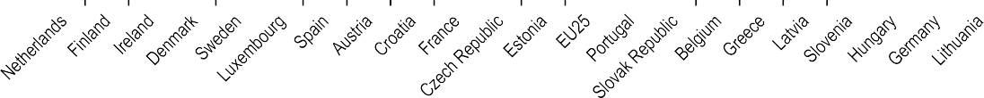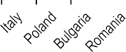

90

80

70

60

50

40

30

20

10

0

Source: CBS, Eurostat, adapted from ILA (2023[31]), *Digital Health Literacy Country Reports*, [www.ilabour.eu/results/digital-health-literacy-country-reports/.](https://www.ilabour.eu/results/digital-health-literacy-country-reports/)

This study shows that almost 80% of people in the Netherlands and Finland have at least basic digital skills, whereas fewer than 50% of people in Hungary, Germany, Lithuania, Italy and Poland have comparable digital skills.

Digital health has the additional complexity of health literacy. Personal health literacy is the degree to which individuals can find, understand and use information and services to inform health-related decisions and actions for themselves and others, whereas organisational health literacy is the degree to which organisations equitably enable individuals to find, understand, and use information and services to inform health-related decisions and actions for themselves and others (CDC, 2023[32]).

Improved health literacy has been shown to improve trust among the public regarding health communications (Paige, Krieger and Stellefson, 2016[33]). Hence, actions to address both digital literacy and health literacy are important parts of digital health readiness.

##### Citizen engagement and public involvement in digital health

People are at the centre of health in the OECD Recommendation on Health Data Governance in at least 41% of national digital health strategies (see Table 2.8 above). People being at the centre means more than ensuring that people have access to their EHRs; it also means ensuring that people are meaningfully engaged in the design, implementation, operation, and management of digital health programmes. Ways in which meaningful public engagement can be achieved include surveys, inclusion in project teams, and implementation of public assemblies.

The World Bank, as part of its work on a Governance in Technology Maturity Index (GTMI), assessed dimensions of governance including a Digital Citizen Engagement Index (see Figure 2.8) (The World Bank, 2022[34]).

**Figure 2.8. Digital Citizen Engagement Index (2022)**

Digital Citizen Engagement Index



1

0.9

0.8

0.7

0.6

0.5

0.4

0.3

0.2

0.1

0

Source: The World Bank (2022[34]), GovTech Maturity Index (GTMI) Data Dashboard, Accessed August 2023, [www.worldbank.org/en/data/interactive/2022/10/21/govtech-maturity-index-gtmi-data-dashboard.](https://www.worldbank.org/en/data/interactive/2022/10/21/govtech-maturity-index-gtmi-data-dashboard)

Estonia and Korea have the highest scores among OECD countries, followed by Latvia, France and Lithuania. Further, 21 OECD countries are considered GovTech Leaders, indicating that these countries have a whole of government approach to public sector modernisation (including digital government transformation approaches, universally accessible public services, and a citizen-centric outlook). Strong digital citizen engagement includes having access to open data, national platforms for citizen participation, government platforms for citizen feedback, and publishing citizen engagement statistics. It should be noted that the index is not necessarily specific to healthcare and might not reflect recent changes following the COVID-19 pandemic.

Within the Digital Citizen Engagement Index, areas where fewer than 50% of OECD countries aligned with leading practices are:

* allowing citizens and businesses to provide anonymous feedback;
* responding to citizen feedback;
* making government responses publicly available;
* using advanced technology (e.g. chatbots) to improve citizen engagement;
* establishing service delivery performance metrics;
* publishing government engagement results;
* improving the representation of vulnerable groups.

There are examples of public involvement in digital health. In Canada, Patients Redefining the Future of Healthcare has created a patient declaration of health data rights that clarifies the expectation for data to be used to benefit individuals and communities while also respecting privacy (Save your skin, 2023[35]). Across the EU, the European Patients Forum has published a paper with expectations for the advancement of AI (Nicholas and del Castillo, n.d.[36]).

A third channel for meaningful public engagement is through public assemblies or citizen councils. These engage a diverse and representative group to provide advice to governments in areas of interest. In health, the United Kingdom established a public assembly in 2014 for the National Health Service (NHS). In Canada, the Health Data Research Network Canada engaged patients to understand their expectations for sharing and use of their health data. The respondents felt that: 1) identifiable health data should be shared across patients’ health providers; 2) de-identified health data should be shared with policy makers for health system safety and improvement; and 3) de-identified health data should be shared with academic researchers to improve discovery and treatment of disease. These directions are helping to inform policy directions in health data sharing, privacy, and protection (HDRN Canada, 2020[37]).

#### Digital health readiness: Monitoring progress

This section presents articulated aspects of readiness for digital health across various dimensions of analytics, data, technology, and related human factors. While this is not an exhaustive list, these initial measures of digital health readiness are helpful to identify pockets of excellence and set the stage for later work in digital readiness evaluation. Leading countries for each indicator are listed in Table 2.9.

**Table 2.9. Leading countries for indicators presented in this chapter**

|  |  |  |
| --- | --- | --- |
| Dimension of digital health readiness | Indicator or proxy presented in this chapter | Leading countries |
| Analytic readiness | Dataset availability, maturity, and use score (OECD) | Denmark, Korea, Sweden, Finland, Latvia |
| Patient access to their own health data (OECD) | Denmark, Italy, Lithuania, Luxembourg, Sweden, Türkiye |
| **Global AI Index (third party)** | United States, the United Kingdom, Canada, Korea, Israel |
| Data readiness | Dataset governance score (OECD) | Denmark, Finland, France, United States, United Kingdom |
| **Digital Government Index (OECD)** | Norway, United Kingdom, Colombia, Denmark, Japan |
| **Interoperability standard adoption (OECD)** | Australia, Belgium, Finland, Korea, Netherlands, Norway, Sweden |
| Technology readiness | **Internet connectivity for individuals (OECD)** | Japan, Estonia, Finland, Denmark, Netherlands |
| Digital security (OECD) | Australia, Canada, Czech Republic, France, Germany, Ireland, Israel, Korea, Netherlands, Norway, United Kingdom,  United States |
| Certification of vendors (OECD) | Belgium, Denmark, Finland, Hungary, Japan, Korea, Portugal, Slovenia, Switzerland, Türkiye, United States |
| Human factor readiness | Strategic governance | *35 countries have a digital health-related strategy* |
| **Literacy, capacity, and capability** | Netherlands, Finland, Ireland, Denmark, Sweden |
| **Public, provider, and stakeholder involvement** | Estonia, Korea, Latvia, France, Lithuania |

Note: Items in **bold** are non-health specific. Leading countries identified in the respective analyses presented earlier in the chapter, listed by ranking or alphabetical when in a top category.

Across all indicators, Denmark appears most frequently as a leading country (in 7 of 12 indicators), followed by Finland, Korea, Sweden, Japan, the United States and the Netherlands. More than 95% of OECD countries are among leading countries in at least one category (all except Mexico). This demonstrates that this is a key priority across the OECD, and that progress is being made.

Nordic countries have strength across all dimensions, appearing as leading countries in 10 of 12 indicators (all except the Global AI Index and digital security). This is bolstered by a region-specific health strategy that emphasises health prevention along with healthcare (Nordic Health 2030, n.d.[38]). Digital health will be a key component of the strategic delivery plan.

A theme in this chapter has been the inadequacy of simple-to-use indicators for digital health readiness. Measuring analytic readiness would benefit from health-specific indicators for measuring the adoption of AI at scale, while managing its risks. Data readiness would benefit from a health-specific scan of interoperability, including semantic and technical data standards as well as policies for access and privacy. Technical readiness would benefit from development of metrics for information architecture and the ability of technologies to be adaptable to change. Human factor readiness would benefit from comparison of governance models, funding mechanisms, resource allocation, digital health literacy, and trust, among other areas.

### Assessing digital health as a determinant of health

While the focus of this chapter is on assessing digital readiness, this section goes one step further by exploring digital health as a determinant of health.

During the pandemic, digital health connected testing results to policy making and measured the effectiveness of public health measures. Digital health also provided channels for providers to connect with their patients at a distance and still provide effective care. Perhaps most significantly, digital health helped to develop vaccines, evaluate their efficacy, monitor their deployment, and support a portable proof of vaccination (OECD, 2023[39]).

The *Lancet* and *Financial Times* published a Commission in 2021, highlighting that weak governance of digital technologies is causing health inequities and compromising human rights (The Lancet Digital Health, 2021[13]). However, there is yet to be a study that shows a causal quantitative relationship between digital transformation and health outcomes.

If digital health readiness is a determinant of health, then better health system performance would result in countries or organisations that have higher degrees of digital health readiness. This section shows limited examples where good digital health readiness also led to better responses to COVID-19 and improved the use of acute care resources, leading to lower costs and better patient experiences.

There are opportunities for more indicators and analysis to explore the relationship between digital health and better health outcomes, lower costs, higher innovation, and improved safety – and ultimately digital health readiness as a determinant of health.

Nevertheless, this section examines statistics for various health outcomes against digital health readiness. For these purposes, digital health readiness is taken as the multiplication of scores for dataset availability, maturity, and use (Figure 2.3) and dataset governance (Figure 2.4).

#### Digital health and harm prevention during COVID-19

Digital health was critical for evidence-informed policy responses during the pandemic. It was used to measure lab results to understand the extent of the disease, to support contact tracing to prevent its spread, and to optimise use of personal protective equipment to protect the most vulnerable groups (OECD, 2020[40]). Evidence-informed policies and the integration of healthcare data with public health surveillance and capacity improved infection control measures and public communication, ultimately mitigating the burden of the pandemic, and saving lives. The readiness of countries to utilise and integrate existing databases were key factors in resilient health systems (OECD, 2023[4]; de Bienassis et al., 2022[41]).

While the effects of the pandemic are still being felt, early evidence demonstrates that higher levels of digital health readiness resulted in fewer lives lost and more stable health systems during key stages of the pandemic. A comprehensive study examined the relationship between country-level digital preparedness, measured by the Digital Adoption Index (DAI), and COVID-19 cases, deaths, and stringency indices of government measures. Using linear regression on the preparedness and outcome patterns, the authors determined that **the more advanced countries’ digital adoption, the lower the number of cases and the faster new cases decline**. Furthermore, gradient tree boosting analysis found the most critical factors in COVID-19 cases and deaths were related to digital infrastructure and telehealth. Overall, digital preparedness had comparable importance to smoking, age, and income on COVID-19 cases and deaths (Heinrichs et al., 2022[42]). It should be noted that the study includes low and middle-income countries who have a wider range in digital preparedness but might also have difficulties in outcomes reporting.

The rationale for this relationship is that with greater digital health readiness, policy makers were able to leverage their digital and data assets to 1) mobilise testing centres; 2) closely monitor the spread and severity of cases; 3) use results to adjust their public health measures for greater impact; 4) communicate those measures effectively; and 5) maintain service delivery through digitally- enabled care (e.g. telehealth). This could translate into reducing harms when policy makers could use results quickly to adjust public health measures for greater impact, detect where new COVID-19 cases were arising to target those areas for vaccination, and assess the efficacy of the new vaccines. Through more detailed, and OECD specific measures of digital health readiness, future analyses can examine how individual policy dimensions impact costs, outcomes, and measures of resilience in OECD countries and settings.

#### Improving patient experience and outcomes with lower costs

Digital health can contribute to reducing care fragmentation by integrating data across care providers. This is a key issue for people with complex health needs, such as those with multiple chronic conditions. Studies show that, without proper care integration, people may try to address unmet needs using additional services in an uncoordinated manner. This creates a sub- optimal experience for the patient and increases the risk of patient harm.

For example, estimates in the United States show that fragmented care increases costs by over USD 4 000 per patient. Further, patients who experienced high levels of fragmentation in their care were less likely to receive care considered clinical best practice (OECD, 2023[43]). In hospitals, digital health can provide a better provider experience that results in reductions in the length of hospital stays. Providers are more likely to view records when returned via electronic means and view them earlier, compared with faxed or paper records. A study (Everson, Kocher and Adler-Milstein, 2016[44]) also found that doctors were less likely to order unnecessary diagnostic tests, and patients were less likely to be admitted to hospitals, when providers reviewed the records by electronic means. Overall, patients spent less time in acute care when providers saved time between requesting and viewing outside records. Digital health contributed to lowering costs by USD 1 187 per patient while achieving better health outcomes.

Another study in the United States of several hundred hospitals correlated their digital health maturity and health outcomes. It showed that digital maturity is associated with significantly higher safety levels, better patient experiences and fewer adverse events (Snowdon, forthcoming[45]).

Finally, the United Kingdom provides an example of seeking to improve patient experiences and lower acute care utilisation. The Norfolk Community Health and Care Trust is implementing a remote-monitoring service for people living with heart and lung diseases. Patients report high satisfaction with the programme as it saves time waiting for doctors. The programme also reported a reduction in acute care admissions (NHS, n.d.[46]). More time is required to quantify the opportunity; however, preliminary results are promising.

These examples show that digital health can be a significant contributor to improved workflow in acute care settings, resulting in lower costs and better outcomes.

### Concluding thoughts

This chapter started by presenting an expanded view of digital health that includes analytics, data, and technology alongside the human factors that help to achieve sustained success. The outline of a checklist for digital health policies was used to consider measures of digital health readiness.

Indicators of digital health readiness were presented to understand the current landscape. Denmark was identified as a leader in digital health readiness, followed by Finland, Korea, Sweden, Japan, the United States and the Netherlands. Over 95% of OECD countries were a leader in at least one of the indicators shown.

The premise that digital health readiness is a determinant of health was explored, with limited – albeit interesting – findings. More indicators and analysis are necessary to qualify and quantify relationships between high digital health readiness and health outcomes. This work could be extended to consider social data (e.g. social determinants of health, social programme usage) to provide perspective on overall health and well-being.

Overall, this chapter has demonstrated that significant work is needed to better define and measure digital health readiness. With the potential benefits and risks of AI – and its reliance on all aspects of digital health – the urgency for health systems to improve their digital health readiness is clear.

Countries are “data rich and insights poor” (OECD, 2022[14]). While progress is being made to improve the use and governance of health data, there is still significant work to be done. The capacity to measure digital health readiness reliably will help policy makers identify issues that can be addressed together, evaluate the benefit of investments in digital health, and promote the urgency of digital transformation of health systems.

### References

Beamtree (2023), *More Time To Care: Automation, Digitisation and the Workforce*, Global Impact Committee, https://beamtree.com.au/papers-publications/more-time-to-care/.

[19]

CDC (2023), *What Is Health Literacy?*, https://[www.cdc.gov/healthliteracy/learn/index.html.](http://www.cdc.gov/healthliteracy/learn/index.html) [32]

CNBC (2020), *How this Canadian start-up spotted coronavirus before everyone else knew about it*, https://[www.cnbc.com/2020/03/03/bluedot-used-artificial-intelligence-to-predict-coronavirus-spread.html.](http://www.cnbc.com/2020/03/03/bluedot-used-artificial-intelligence-to-predict-coronavirus-spread.html)

de Bienassis, K. et al. (2022), “Health data and governance developments in relation to COVID-19: How OECD countries are adjusting health data systems for the new normal”*, OECD Health Working Papers*, No. 138, OECD Publishing, Paris, https://doi.org/10.1787/aec7c409-en.

Everson, J., K. Kocher and J. Adler-Milstein (2016), “Health information exchange associated with improved emergency department care through faster accessing of patient information from outside organizations”, *Journal of the American Medical Informatics Association*, Vol. 24/e1, pp. e103-e110, https://doi.org/10.1093/jamia/ocw116.

Forbes (2023), *10.5 Trillion Reasons Why We Need A United Response To Cyber Risk*, https://[www.forbes.com/sites/forbestechcouncil/2023/02/22/105-trillion-reasons-why-we-need-a-united-response-to-](http://www.forbes.com/sites/forbestechcouncil/2023/02/22/105-trillion-reasons-why-we-need-a-united-response-to-) cyber-risk/?sh=1a085acd3b0c.

Gintux (2023), *The Most Surprising Fax Machine Usage Statistics And Trends in 2023*, https://blog.gitnux.com/fax- machine-usage-statistics/.

HDRN Canada (2020), *Social Licence for uses of Health Data: A report on public perspectives*, Health Data Research Network Canada, https://[www.hdrn.ca/en/reports/social-licence-uses-health-data-report-public-perspectives.](http://www.hdrn.ca/en/reports/social-licence-uses-health-data-report-public-perspectives)

HealthIT.gov (2021), *International Patient Summary*, https[://www.healthit.gov/topic/global-digital-health-](http://www.healthit.gov/topic/global-digital-health-) partnership/international-patient-summary.

Heinrichs, H. et al. (2022), “Digitalization impacts the COVID-19 pandemic and the stringency of government measures”, *Scientific Reports*, Vol. 12/1, p. 21628, https://doi.org/10.1038/s41598-022-24726-0.

HIMSS (2020), *HIMSS Defines Digital Health for the Global Healthcare Industry*, Healthcare Information and Management Systems Society, https[://www.himss.org/news/himss-defines-digital-health-global-healthcare-industry](http://www.himss.org/news/himss-defines-digital-health-global-healthcare-industry) (accessed on 25 September 2023).

ILA (2023), *Country Reports: Digital Health Literacy to Increase the Resilience of the Disadvantaged Group*, International Labour Association, https://[www.ilabour.eu/results/digital-health-literacy-country-reports/.](http://www.ilabour.eu/results/digital-health-literacy-country-reports/)

[21]

[41]

[44]

[5]

[1]

[37]

[28]

[42]

[6]

[31]

Jormanainen, V. et al. (2019), “Half of the Finnish population accessed their own data: comprehensive access to personal health information online is a corner-stone of digital revolution in Finnish health and social care”, *Finnish Journal of eHealth and eWelfare*, Vol. 11/4, https://doi.org/10.23996/fjhw.83323.

McMaster University (2023), *Scientists use AI to find promising new antibiotic to fight evasive hospital superbug*, https://brighterworld.mcmaster.ca/articles/artificial-intelligence-new-antibiotic-drug-resistant-pathogen-acinetobacter- baumannii/.

Morris, Z., S. Wooding and J. Grant (2011), “The answer is 17 years, what is the question: understanding time lags in translational research”, *Journal of the Royal Society of Medicine*, Vol. 104/12, pp. 510-520, https://doi.org/10.1258/jrsm.2011.110180.

NHS (n.d.), *Remote-monitoring service for people living with heart and lung diseases reduces A&E admissions in Norfolk*, https://[www.longtermplan.nhs.uk/case-studies/remote-monitoring/.](http://www.longtermplan.nhs.uk/case-studies/remote-monitoring/)

Nicholas, L. and J. del Castillo (n.d.), *Artificial Intelligence in Healthcare from a Patient’s Perspective*, https://www.eu- patient.eu/globalassets/report-ai-1612---del-castillo-and-nicholas-2.pdf.

[29]

[17]

[2]

[46]

[36]

Nordic Health 2030 (n.d.), *Nordic Health 2030*, [http://nordichealth2030.org/.](http://nordichealth2030.org/) [38]

OECD (2023), “Health data sharing intensity”*, OECD Going Digital Toolkit*, OECD, Paris, https://goingdigital.oecd.org/indicator/64.

OECD (2023), *Integrating Care to Prevent and Manage Chronic Diseases: Best Practices in Public Health*, OECD Publishing, Paris, https://doi.org/10.1787/9acc1b1d-en.

OECD (2023), *Online public consultation on the draft OECD Recommendation on the Governance of Digital Identity*, OECD, Paris, https://[www.oecd.org/governance/digital-government/online-public-consultation-draft-oecd-](http://www.oecd.org/governance/digital-government/online-public-consultation-draft-oecd-) recommendation-on-the-governance-of-digital-identity.htm.

OECD (2023), *Ready for the Next Crisis? Investing in Health System Resilience*, OECD Health Policy Studies, OECD Publishing, Paris, https://doi.org/10.1787/1e53cf80-en.

OECD (2023), *Recommendation of the Council on the Governance of Digital Identity*, OECD/LEGAL/0491, https://legalinstruments.oecd.org/en/instruments/OECD-LEGAL-0491.

OECD (2023), *The COVID-19 Pandemic and the Future of Telemedicine*, OECD Health Policy Studies, OECD Publishing, Paris, https://doi.org/10.1787/ac8b0a27-en.

OECD (2022), *Health Data Governance for the Digital Age: Implementing the OECD Recommendation on Health Data Governance*, OECD Publishing, Paris, https://doi.org/10.1787/68b60796-en.

OECD (2022), *Recommendation of the Council on Digital Security Risk Management*, OECD, Paris, https://legalinstruments.oecd.org/en/instruments/OECD-LEGAL-0479.

OECD (2020), “The Covid-19 crisis: A catalyst for government transformation?”*, OECD Policy Responses to Coronavirus (COVID-19)*, OECD Publishing, Paris, https://doi.org/10.1787/1d0c0788-en.

OECD (2019), *Health in the 21st Century: Putting Data to Work for Stronger Health Systems*, OECD Health Policy Studies, OECD Publishing, Paris, https://doi.org/10.1787/e3b23f8e-en.

OECD (2019), “OECD Digital Government Index”*, OECD Going Digital Toolkit*, https://goingdigital.oecd.org/indicator/58.

OECD (2019), *Recommendation of the Council on Artificial Intelligence*, https://legalinstruments.oecd.org/en/instruments/OECD-LEGAL-0449.

OECD (2016), *Recommendation of the Council on Health Data Governance*, OECD, Paris, https://legalinstruments.oecd.org/en/instruments/OECD-LEGAL-0433.

[27]

[43]

[26]

[4]

[12]

[39]

[14]

[11]

[40]

[3]

[25]

[10]

[9]

OECD.AI (n.d.), *AI-Principles Overview*, OECD, Paris, https://oecd.ai/en/ai-principles. [24]

OTV NEWS (2023), *Survey shows what Canadians think about AI tech like ChatGPT, Google Bard*, https[://www.ctvnews.ca/sci-tech/survey-shows-what-canadians-think-about-ai-tech-like-chatgpt-google-bard-](http://www.ctvnews.ca/sci-tech/survey-shows-what-canadians-think-about-ai-tech-like-chatgpt-google-bard-) 1.6289326.

Paige, S., J. Krieger and M. Stellefson (2016), “The Influence of eHealth Literacy on Perceived Trust in Online Health Communication Channels and Sources”, *Journal of Health Communication*, Vol. 22/1, pp. 53-65, https://doi.org/10.1080/10810730.2016.1250846.

Petch, J. et al. (2023), “Developing a Data and Analytics Platform to Enable a Breast Cancer Learning Health System at a Regional Cancer Center”, *JCO Clinical Cancer Informatics* 7, https://doi.org/10.1200/cci.22.00182.

[22]

[33]

[20]

Pew Research Center (2023), *60% of Americans Would Be Uncomfortable With Provider Relying on AI in Their Own Health Care*, https://[www.pewresearch.org/science/2023/02/22/60-of-americans-would-be-uncomfortable-with-](http://www.pewresearch.org/science/2023/02/22/60-of-americans-would-be-uncomfortable-with-) provider-relying-on-ai-in-their-own-health-care/.

Save your skin (2023), *Declaration of Personal Health Data Rights in Canada*, https://saveyourskin.ca/wp- content/uploads/Declaration.pdf.

Slawomirski, L. et al. (2023), “Progress on implementing and using electronic health record systems: Developments in OECD countries as of 2021”*, OECD Health Working Papers*, No. 160, OECD Publishing, Paris, https://doi.org/10.1787/4f4ce846-en.

Snowdon, A. (forthcoming), *Empirical Evidence of Digital Maturity and Patient Safety Outcomes in US Hospitals*, HIMSS.

Sutherland, E. (forthcoming), “Fast-track on digital security in health”*, OECD Health Working Papers*, OECD Publishing, Paris.

Sutherland, E. (forthcoming), “Policy checklist for Integrated Digital Health Ecosystems”*, OECD Health Working Papers*, OECD Publishing, Paris.

The Guardian (2023), *Cancer and heart disease vaccines ‘ready by end of the decade’*, https://[www.theguardian.com/society/2023/apr/07/cancer-and-heart-disease-vaccines-ready-by-end-of-the-decade.](http://www.theguardian.com/society/2023/apr/07/cancer-and-heart-disease-vaccines-ready-by-end-of-the-decade)

The Lancet Digital Health (2021), “Digital technologies: a new determinant of health”, *The Lancet Digital Health*, Vol. 3/11, p. e684, https://doi.org/10.1016/s2589-7500(21)00238-7.

The World Bank (2022), *GovTech Maturity Index (GTMI) Data Dashboard*, https://[www.worldbank.org/en/data/interactive/2022/10/21/govtech-maturity-index-gtmi-data-dashboard.](http://www.worldbank.org/en/data/interactive/2022/10/21/govtech-maturity-index-gtmi-data-dashboard)

[23]

[35]

[15]

[45]

[30]

[8]

[16]

[13]

[34]

Tortoise (2023), *The Global AI Index*, https://[www.tortoisemedia.com/intelligence/global-ai/.](http://www.tortoisemedia.com/intelligence/global-ai/) [18]

WHO (2021), *Global strategy on digital health 2020-2025*, World Health Organization, https://apps.who.int/iris/handle/10665/344249.

[7]

### Notes

1 In this chapter, “digital health” refers to the use of analytics, data and technology in healthcare, prevention and promotion. See Box 2.1 for the full definition.

2 SNOMED CT or Systemised Nomenclature of Medicine – Clinical Terms is a system of medical codes, terms, etc. for clinical documentation and EHR systems. See [www.snomed.org/.](http://www.snomed.org/)

3 ICD or International Classification of Diseases is a widely used categorisation of diseases and medical conditions. See [www.who.int/standards/classifications/classification-of-diseases.](http://www.who.int/standards/classifications/classification-of-diseases)

 **59**

**60** 

1. **Health status**

 **61**

Life expectancy at birth Trends in all-cause mortality Main causes of mortality

Avoidable mortality (preventable and treatable) Major public health threats

Mortality from circulatory diseases Cancer mortality

Chronic conditions

Maternal and infant mortality Mental health

Self-rated health

**Life expectancy at birth**

While life expectancy has increased in all OECD countries over the past half century, progress was stalling in the decade prior to the COVID-19 pandemic, and many countries experienced outright drops in life expectancy during the pandemic. In 2021 life expectancy at birth was 80.3 years on average across OECD countries (Figure 3.1). Japan, Switzerland and Korea led a large group of 27 OECD member countries in which life expectancy at birth exceeded 80 years. A second group, including the United States, had life expectancy between 75 and 80 years. Latvia, Lithuania, Hungary and the Slovak Republic had the lowest life expectancy among OECD countries, at less than 75 years. Provisional Eurostat data for 2022 point to a strong rebound in life expectancy in many Central and Eastern European countries, but a more mixed picture for other European countries, including reductions of half a year or more in Iceland, Finland and Norway.

In all partner countries, life expectancy remained below the OECD average in 2021, with levels lowest in South Africa (65.3 years), Indonesia (68.8) and India (70.2). Still, levels have been converging rapidly in most of these countries in recent decades.

Women continue to live longer than men in all OECD member and partner countries. This gender gap averaged 5.4 years across OECD countries: life expectancy at birth for women was 83 years, compared to 77.6 years for men. These gender differences in life expectancy are due in part to greater exposure to risk factors among men – particularly greater tobacco consumption, excessive alcohol consumption and less healthy diets. Men are also more likely to die from violent deaths, such as suicide and accidents. The gender gap has, however, narrowed over time. Gender differences in life expectancy are especially marked in Central and Eastern European countries: Latvia, Lithuania and Poland in particular have gaps of 8 or more years. In these countries, gains in longevity for men over the past few decades have been much more modest. Gender gaps are relatively narrow in Iceland and Norway, at 3 years or less.

COVID-19 has had a major impact on life expectancy owing to the exceptionally high number of deaths this pandemic has caused. Indeed, OECD countries recorded around 6 million excess deaths in 2020-22, compared to the average number of deaths over the five preceding years (see section on “Trends in all-cause mortality”).

(no recent data available for Türkiye and the United Kingdom). Among accession countries, Bulgaria, Romania and Peru also reported large reductions. Seven OECD countries lost as many – or more – years of life expectancy during the first two years of COVID-19 as they had gained in the past decade: the Czech Republic, Greece, Hungary, Latvia, Poland, the Slovak Republic and the United States. This was also the case in accession countries Argentina, Bulgaria, Croatia and Romania.

However, life expectancy between 2019 and 2021 did not decrease in all OECD countries. Denmark, Luxembourg and Iceland recorded no change, while Australia, Chile, Korea, Costa Rica, Mexico, Colombia, Norway, New Zealand and Japan recorded increases in life expectancy.

Even before COVID-19, gains in life expectancy had been slowing down markedly in a number of OECD countries over the last decade. This slowdown was most marked in the United States, France, the Netherlands, Germany and the United Kingdom. Longevity gains were slower for women than men in almost all OECD countries. The causes of this slowdown in life expectancy gains over time are multi-faceted (Raleigh, 2019[1]). Principal among them is slowing improvements in reducing death rates of heart disease and stroke. Rising levels of obesity and diabetes, as well as population ageing, have made it difficult for countries to maintain previous progress in cutting deaths from such circulatory diseases.

**Definition and comparability**

Life expectancy at birth measures how long, on average, people would live based on a given set of age-specific death rates. However, the actual age-specific death rates of any particular birth cohort cannot be known in advance. If age-specific death rates are falling (as has been the case over the past few decades), actual life spans will be higher than life expectancy calculated with current death rates.

Data for life expectancy at birth come from Eurostat for European Union (EU) countries plus Iceland, Norway and Switzerland, and from national sources elsewhere.

**References**

Prior to the pandemic, life expectancy increased in all OECD member and partner countries between 2010 and 2019, with an average increase of 1.7 years (Figure 3.2). However, many of these gains were wiped out during the pandemic. Between 2019 and 2021, life expectancy decreased by 0.7 years on average across OECD countries. Reductions were highest in Central and Eastern European countries and the United States

Raleigh, V. (2019), “Trends in life expectancy in EU and other OECD countries : Why are improvements slowing?”*, OECD Health Working Papers*, No. 108, OECD Publishing, Paris, https://doi.org/10.1787/223159ab-en.

[1]



-0.5

0.3

-

-1.5

-

-

-2.5

0.3

-

-1.5

-

n.a.

-0.5

.4

-2

0.3

-0.7

1.1

-0.6

-0.8

.4

0

.3

-0

-3.7

-0.7

0.1

0.0

0.2

-0.9

0.1

2.1

-0.7

0.1

-0.7

2.2

-

-0.9

0.2

-

0.2

.4

-0

.4

0

-2.8

-1.9

0.2

-

0.0

.4

-0

1.1

3.2

-

0.0

0.2

.4

0

.3

-2

-2.6

-1.8

.3

-2

8.3

n.a.

.4

-0

 **63**

**Figure 3.1. Life expectancy at birth by sex, 2021 and 2022 (or nearest year)**

Total

Men

Women

Years 90

85

80

75

70

65

60

55

Note: Latest available data for the United Kingdom 2020; and for Türkiye 2019. Provisional 2022 values in brackets. Source: OECD Health Statistics 2023, Eurostat 2023 for EU countries plus Iceland, Norway and Switzerland.

*StatLink 2* https://stat.link/5liuzr

**Figure 3.2. Changes in life expectancy, 2019-21 and 2010-19**

2019-21

2010-19

Years 5

4

3

2

1

0

-1

-2

-3

-4

-5

Note: n.a. = not available.

Source: OECD Health Statistics 2023.

*StatLink 2* https://stat.link/w8rozk

HEALTH AT A GLANCE 2023 © OECD 2023

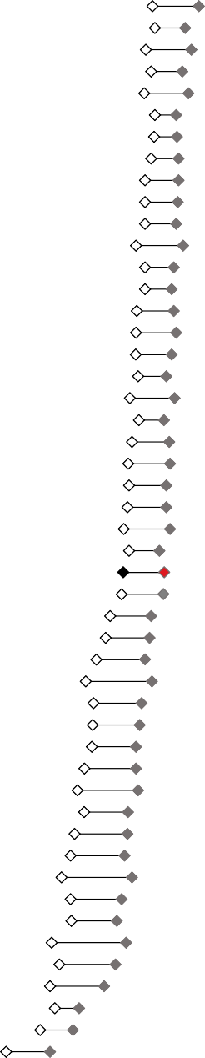

84.5

83.9 (83.5)

83.6

83.3

83.3 (83.2)

83.2 (82.1)

83.2 (82.6)

83.1 (83.1)

82.7 (83.0)

82.7 (83.0)

82.6

82.4 (82.3)

82.4

82.3

81.9 (81.8)

81.9 (81.2)

81.6

81.5 (81.3)

81.5 (81.7)

81.4 (81.7)

81.3 (81.1)

81.0

80.8 (80.7)

80.8

80.7 (81.3)

80.4

80.3

80.2 (80.7)

78.6

78.1

77.2 (79.1)

77.2 (78.2)

76.8

76.7 (77.7)

76.4

75.9

75.5 (77.4)

75.4

74.6 (77.2)

74.3 (76.2)

74.2 (76.0)

74.0

73.7

73.1 (74.8)

72.8 (75.3)

71.4 (74.3)

70.2

68.8

65.3

**Trends in all-cause mortality**

The evolution in all-cause mortality measures whether, and if so to what extent, the total number of deaths from all causes is over and above what could normally be expected for a given period. Here, the numbers of deaths reported in 2022 are compared to the average of the five years prior to the onset of the COVID-19 pandemic (2015 to 2019). The rationale is to create an annual indicator of how all-cause mortality is evolving across countries in relation to mortality before the COVID-19 pandemic, to see any direct or indirect effects on mortality rates, as well as whether any other factors are keeping mortality high in OECD countries. While the evolution in all-cause mortality, and excess mortality, proved particularly useful in providing a better understanding of the impact of COVID-19 across countries (Morgan et al., 2020[1]), it continues to be an insightful indicator for post-COVID-19 measurement of overall mortality trends.

Between 2020 and 2022, OECD countries saw an additional 6 million deaths compared to the years before the pandemic, with more people dying in 2022 than the average of the previous five years in all but nine OECD member countries.

The use of all-cause mortality figures adjusted for national population growth considers the fact that many countries have undergone major changes in population size and structure – as a result of population ageing and migration – that can have a significant bearing on overall mortality. Nearly all OECD countries have gone through these rapid demographic changes, with the size of the population aged 65 and over increasing on average by 19% between 2015 and 2022 (Morgan, forthcoming[2]). Therefore, when unadjusted mortality rates are used, the rates in all countries for which comparable all-cause mortality data are available are significantly overestimated. The OECD average change in total number of deaths in 2022 compared to 2015-19 was an increase of 2.9% when considering the number of deaths adjusted for national population growth, while the increase was 13.2% when using unadjusted mortality rates (Figure 3.3).

The change in the total number of deaths adjusted for national population growth in 2022 was highest in Greece, where an increase above 12.2% in overall mortality was recorded compared to the average for 2015-19. This was driven by high COVID-19 reported deaths in the first part of the year, but also, given a peak during the summer, possibly due to the summer heatwave. By contrast, there were fewer deaths adjusted for national population growth compared to the five-year average in Luxembourg, Sweden, Hungary, Ireland, the Slovak Republic, Belgium, Romania, Israel, Slovenia and the

in the 0-44 age group grew by 1%, but an increase of 20% or more was seen for this age group in countries such as the United States and Canada, perhaps due to a mix of COVID-19 and deaths from substance abuse. This contrasted with a decrease of almost 20% in Lithuania, which continued a strong declining trend beginning before the pandemic for this age group. In contrast, the 45-64 age group exhibited a decrease of 0.6% in 2022 – reversing a growing trend in the first two years of the COVID-19 pandemic. This drop can be attributed to a reduction in mortality of 10% or more when adjusted for population change in this age group in countries such as Hungary and Denmark (Figure 3.4).

**Definition and comparability**

The evolution in all-cause mortality is defined here as the total number of deaths from all causes in 2022, compared to the average annual number of deaths in the five years before the onset of the COVID-19 pandemic (2015-19). Figures are adjusted for population growth in age groups over time. This adjusted baseline could still be considered a somewhat conservative estimate of the expected number of deaths, since an ageing population would also be expected to push up the number of deaths observed each year. The evolution in all-cause mortality is reported as a percentage increase or decrease. When disaggregated by age group (0-44; 45-64; 65+), the change in total number of deaths is calculated using mortality rates that are adjusted for population growth.

National variations in underlying death rates related to various events mean that caution is needed when comparing all-cause mortality at a given point in time. For example, significant country-specific events such as severe flu seasons, heatwaves and natural disasters during the previous five years may have had a large influence on the number of deaths, affecting the underlying average. However, choosing a five-year comparator period (2015-19) helps to mitigate such variations.

For a more detailed explanation on the methodology and sources used for all-cause mortality in OECD Health Statistics, please see the weblink to metadata in the “Reader’s Guide”.

**References**

Czech Republic.

Disaggregating the total number of deaths by age provides insights into the extent to which deaths among people of different age groups were higher than in previous years. Since most deaths naturally occur in the older age groups, countries such as Greece and Germany, with increased mortality in the 65+ age group combined with a large share of the population aged over 65, saw the highest overall evolution in all-cause mortality. The 65+ age group had the highest increase in average mortality rates adjusted for national population growth among OECD countries in 2022, at 3.4% more than 2015-19. Mortality

Morgan, D. (forthcoming), *Excess mortality – Examining recent trends*, OECD, Paris.

Morgan, D. et al. (2020), “Excess

mortality: Measuring the direct and indirect impact of COVID-19”*, OECD Health Working Papers*, No. 122, OECD Publishing, Paris, https://doi.org/10.1787/c5dc0c50-en.

[2]

[1]

Adjusted for population growth Unadjusted

Change in total number of deaths in 2022 compared to average 2015-19, %



35

30

25

20

15

10

5

0

-5

-10

0.0

0.4

0.6

1.7

1.8

1.9

1.9

2.1

2.2

2.3

2.5

2.9

2.9

3.3

3.6

3.9

4.1

4.8

5.4

5.5

5.7

5.9

5.9

6.8

7.5

8.0

8.4

8.9

9.6

12.2

Source: OECD Health Statistics 2023.

-5.3

-2.6

-2.5

-2.1

-1.6

-1.1

-1.1

-1.1

-0.7

-0.3

*StatLink 2* <https://stat.link/rsxo5n>

**Figure 3.4. Evolution in all-cause mortality, by age group, 2022**

Age 0-44 Age 45-64 Age 65+

Change in total number of deaths by age group in 2022 compared to average 2015-19, mortality rates adjusted to population, %



30

25

20

15

10

5

0

-5

-10

-15

-20

Source: OECD Health Statistics 2023.

*StatLink 2* <https://stat.link/foze8a>

**Main causes of mortality**

In 2021, over 12 million people died across OECD countries – equivalent to 932 deaths per 100 000 population (Figure 3.5). This is almost 1.5 million more than in 2019, largely due to COVID-19. Diseases of the circulatory system and cancer remain the two leading causes of death in most countries. There is an ongoing epidemiological transition from communicable to non-communicable diseases in many middle-income countries, which has already taken place in high-income countries (Vos et al., 2020[1]). Across OECD countries in 2021, heart attacks, strokes and other circulatory diseases caused more than one in four deaths; around one in five deaths were related to cancer. Population ageing largely explains the predominance of deaths from circulatory diseases – with deaths rising steadily from age 50.

Respiratory diseases were also a major cause of death, accounting for 9% of deaths across OECD countries. Chronic obstructive pulmonary disease (COPD) alone accounted for 3% of all deaths. Smoking is the main risk factor for COPD, but occupational exposure to dust, fumes and chemicals, and air pollution in general, are also important risk factors.

COVID-19 caused 7% of all deaths in 2021 (based on recorded figures). Since then, its effects have decreased, but it continues to be one of the leading causes of mortality. For example, in the United States, COVID-19 was the fourth leading underlying cause of mortality during 2022 (Ahmad et al., 2023[2]).

External causes were responsible for 6% of deaths across OECD countries – notably road traffic accidents and suicide. Road traffic accidents are a particularly important cause of death among young adults, whereas suicide rates are generally higher among middle-aged and older people. Further, in some countries – notably the United States and

observed before the onset of the COVID-19 pandemic (770 per 100 000 in 2019). Among OECD accession and partner countries, mortality rates were highest in South Africa (1 893 per 100 000 population) and Bulgaria (1 504 per 100 000).

**Definition and comparability**

Mortality rates are based on the number of deaths registered in a country in a year divided by the population. Rates have been age-standardised to the 2015 OECD population (available at <http://oe.cd/mortality>) to remove variations arising from differences in age structures across countries and over time. Note that this results in some age-standardisation differences with other population standards used by, for example, the World Health Organization (WHO) and the EU. The source for mortality rates is the WHO Mortality Database.

Deaths from all causes are classified as International Classification of Diseases, tenth revision (ICD-10) codes A00-Y89, excluding S00-T98. The classification of causes of death defines groups and subgroups. Groups are umbrella terms covering diseases that are related to each other; subgroups refer to specific diseases. For example, the group “diseases of the respiratory system” comprises four subgroups: influenza, pneumonia, COPD and asthma. Charts are based on this grouping, except for Alzheimer’s and other dementias. These were grouped together (Alzheimer’s is classified in group G and other dementias in group F).

**References**

Canada – the opioid crisis has caused more working-age adults to die from drug-related accidental poisoning (see section on “Illicit drug use” in Chapter 4).

Looking at other specific causes, Alzheimer’s and other dementias accounted for 6% of all deaths; they were a more important cause of death among women than men. Diabetes represented 3% of all deaths across OECD countries. The main causes of death differ between socio-economic groups, with social disparities generally larger for the most avoidable diseases. For example, people with the lowest level of education are more likely to smoke in most OECD countries, increasing the risk of developing cancers and diseases of the respiratory system (OECD, 2019[3]).

Across OECD countries, all-cause age-standardised mortality rates in 2021 ranged from under 700 deaths per 100 000 in

Japan, Korea and Australia, to over 1 300 deaths per 100 000 in Lithuania, Latvia and Mexico (Figure 3.6). On average, the total mortality rate across OECD countries was 923 per 100 000 in 2021, which is notably higher than the rate

Ahmad, F. et al. (2023), “Provisional Mortality Data

— United States, 2022”, *MMWR. Morbidity and Mortality Weekly Report*, Vol. 72/18, pp. 488-492, https://doi.org/10.15585/mmwr.mm7218a3.

OECD (2019), *Health for Everyone?: Social Inequalities in Health and Health Systems*, OECD Health Policy Studies, OECD Publishing, Paris, https://doi.org/10.1787/3c8385d0-en.

Vos, T. et al. (2020), “Global burden of 369 diseases and injuries in 204 countries and territories, 1990– 2019: a systematic analysis for the Global Burden of Disease Study 2019”, *The Lancet*, Vol. 396/10258,

pp. 1204-1222, https://doi.org/10.1016/s0140-

6736(20)30925-9.

[2]

[3]

[1]

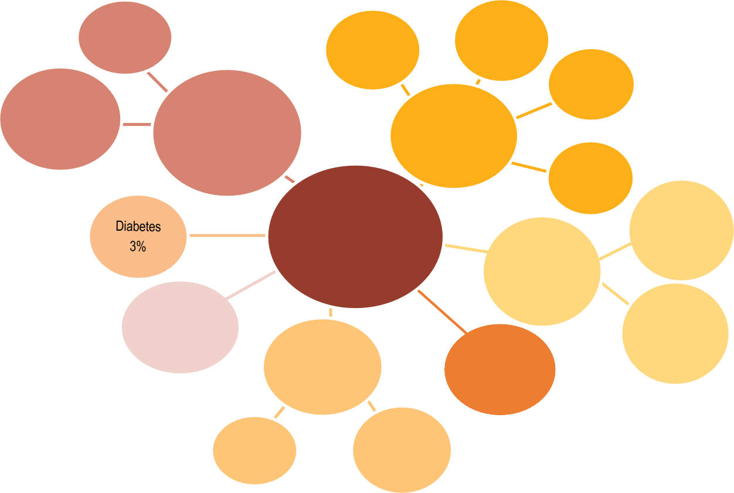

Stroke

6%

Lung cancer

4%

Colorectal cancer

2%

Ischaemic heart diseases

11%

Diseases of circulatory system

28%

Breast cancer (female)

1%

Cancers

21%

Prostate cancer

1%

**All deaths**

**12 818 369**

COPD

3%

Alzheimer's and other dementias

6%

Diseases of the respiratory system

9%

External causes

6%

Pneumonia

3%

COVID-19

7%

Suicide

1%

Accidents

4%

Note: Other causes of death not shown in the figure represent 21% of all deaths. Source: OECD Health Statistics 2023.

*StatLink 2* <https://stat.link/a6xnzp>

**Figure 3.6. Main causes of mortality by country, 2021 (or nearest year)**

Other COVID-19 External causes Respiratory system Cancer Circulatory system

Age-standardised rates by 100 000 population

2 000



587

636

662

703

704

706

712

715

728

729

735

749

762

765

774

776

789

797

815

821

824

829

840

843

850

896

922

923

969

1034

1062

1114

1133

1138

1170

1197

1199

1211

1228

1345

1366

1384

1460

1504

1534

1893

1 800

1 600

1 400

1 200

1 000

800

600

400

200

0

Note: External causes of death include accidents, suicides, homicides, and other causes. 1. Most recent data point corresponds to 2016-19. Source: OECD Health Statistics 2023.

*StatLink 2* <https://stat.link/94o85u>

**Avoidable mortality (preventable and treatable)**

Indicators of avoidable mortality offer a general “starting point” to assess the effectiveness of public health and healthcare systems in reducing deaths from various diseases and injuries. Avoidable mortality includes both preventable deaths that can be avoided through effective public health and prevention interventions, and treatable deaths that can be avoided through timely and effective healthcare interventions. COVID-19 is categorised as a preventable disease in the “infectious diseases” category, on the basis that most deaths could be prevented through measures such as vaccination and the use of protective equipment.

Across 26 OECD countries with available data for 2020 or 2021, over 3 million premature deaths among people aged under 75 years could have been avoided through better prevention and healthcare interventions. This amounts to almost one-third of all deaths. Of these, about 2.1 million were considered preventable through effective primary prevention and other public health measures, and almost 1 million were considered treatable through more effective and timely healthcare interventions.

Infectious diseases were the main cause of preventable mortality in 2021 (22% of all preventable deaths). Noting that this category only accounted for 2% of preventable deaths in 2019, the increase is strongly associated with COVID-19. Some cancers that are preventable through public health measures were also among the main causes of preventable mortality in 2021. Other major causes were injuries, such as road accidents and suicide (17%); heart attack, stroke and other circulatory diseases (16%); alcohol and drug-related deaths (13%); and some respiratory diseases such as influenza and COPD (6%) (Figure 3.7).

The main treatable cause of mortality in 2021 was circulatory diseases (mainly heart attack and stroke), which accounted for 37% of premature deaths amenable to treatment. Effective, timely treatment for cancer, such as colorectal and breast cancers, could have averted a further 23% of all deaths from treatable causes. Respiratory diseases such as pneumonia and asthma (11%), as well as diabetes and other diseases of the endocrine system (10%) are other major causes of premature death that are amenable to treatment (Figure 3.7).

The average age-standardised mortality rate from preventable causes was 158 deaths per 100 000 people across OECD countries. It ranged from under 100 per 100 000 in Israel, Japan, Italy, Iceland, Switzerland, Sweden, Australia and Korea, to over 300 in Mexico, Latvia and Lithuania

Ischaemic heart diseases, stroke, and some types of treatable cancers (including colorectal, cervix uteri and breast cancers) were the main drivers in the countries with the highest rates. Treatable mortality was also high in Mexico (which had high rates of mortality from diabetes in addition to the other main drivers), and in accession and partner countries South Africa, Bulgaria and Romania.

**Definition and comparability**

Based on the 2022 OECD/Eurostat definitions, preventable mortality is defined as causes of death among people aged under 75 years that can be mainly avoided through effective public health and primary prevention interventions (i.e. before the onset of disease/injury, to reduce incidence). Treatable (or amenable) mortality is defined as causes of death that can be mainly avoided through timely and effective healthcare interventions, including secondary prevention and treatment (i.e. after the onset of disease, to reduce case fatality).

The two current lists of preventable and treatable mortality were adopted by the OECD and Eurostat in 2022. The attribution of each cause of death to the preventable or treatable mortality category was based on the criterion of whether it is predominantly prevention or healthcare interventions that can reduce it. Causes of death that can be both largely prevented and treated once they have occurred were attributed to the preventable category on the rationale that if these diseases are prevented, there would be no need for treatment. In cases when there was no strong evidence of predominance of preventability or treatability (as with ischaemic heart disease, stroke and diabetes), the causes were allocated on a 50:50 basis to the two categories to avoid double-counting of the same cause of death in both lists. The age threshold of premature mortality is set at 74 years for all causes. COVID-19 was categorised as a preventable disease, as most deaths can be prevented through prophylaxis, such as vaccination or use of protective facemasks (OECD/Eurostat, 2019[1]).

Data come from the WHO Mortality Database, and the mortality rates are age-standardised to the 2015 OECD population (available at <http://oe.cd/mortality>).

**References**

(Figure 3.8). Preventable mortality was also high in accession and partner countries Peru and South Africa. Higher rates of premature death in these countries were mainly due to COVID-19, but also due to higher mortality from ischaemic heart disease, accidents and alcohol-related deaths, as well as endocrine and metabolic diseases in Mexico.

Mortality rates from treatable causes across OECD countries were much lower, at an average of 79 per 100 000 population. They ranged from fewer than 50 deaths per 100 000 people in Switzerland, Luxembourg, Korea, Australia, the Netherlands, Japan and Iceland to over 150 in Mexico, Latvia and Lithuania.

OECD/Eurostat (2019), “Avoidable mortality: OECD/Eurostat lists of preventable and treatable causes of death”, OECD, Paris, <http://www.oecd.org/health/health-> systems/Avoidable-mortality-2019-Joint-OECD- Eurostat-List-preventable-treatable-causes-of- death.pdf.

[1]

**Preventable causes of mortality Treatable causes of mortality**

2 077 973 premature deaths 975 710 premature deaths

Others, Respiratory 5%

system, 6%

Alcohol and drugs effects, 13%

Infections (including COVID-19), 22%

Circulatory system diseases, 16%

Cancer, 21%

Injuries, 17%

Others, 18%

Diabetes and other endocrine diseases, 10%

Respiratory system, 11%

Circulatory system diseases, 37%

Cancer, 23%

Note: The 2022 OECD/Eurostat list of preventable and treatable causes of death classifies specific diseases and injuries as preventable and/or treatable. For example, lung cancer is classified as preventable, whereas breast and colorectal cancers are classified as treatable.

Source: OECD calculations, based on the WHO Mortality Database.

*StatLink 2* <https://stat.link/okh2rt>

**Figure 3.8. Mortality rates from avoidable causes, 2021 (or nearest year)**

Israel Japan Italy¹ Iceland

Switzerland Sweden Australia Korea Luxembourg

Norway¹ Ireland¹ France¹ Spain

New Zealand¹ Netherlands Canada¹ Portugal¹ Denmark Belgium¹ Türkiye¹ Greece Germany Finland Austria Costa Rica

United Kingdom

OECD38

Slovenia Chile

Slovak Republic¹

Argentina Croatia Colombia Poland

Czech Republic United States Romania¹ Estonia Brazil Bulgaria Hungary¹ Lithuania South Africa¹

Latvia Peru Mexico

Mortality from preventable causes

|  |  |  |  |  |
| --- | --- | --- | --- | --- |
|  | 83 |  |  |  |
|  | 85 |  |  |  |
|  | 91 |  |  |  |
|  | 93 |  |  |  |
|  | 94 |  |  |  |
|  | 97 |  |  |  |
|  | 97 |  |  |  |
|  | 99 |  |  |  |
|  | 104 |  |  |  |
|  | 105 |  |  |  |
|  | 109 |  |  |  |
|  | 109 |  |  |  |
|  | 112 |  |  |  |
|  | 113 |  |  |  |
|  | 113 |  |  |  |
|  | 113 |  |  |  |
|  | 114 |  |  |  |
|  | 120 |  |  |  |
|  | 121 |  |  |  |
|  | 126 |  |  |  |
|  | 128 |  |  |  |
|  | 129 |  |  |  |
|  | 129 |  |  |  |
|  | 141 |  |  |  |
|  | 148 |  |  |  |
|  | 151 |  |  |  |
|  | 158 |  |  |  |
|  | 164 |  |  |  |
|  | 17 | 1 |  |  |
|  |  | 189 |  |  |
|  |  | 197 |  |  |
|  |  | 216 |  |  |
|  |  | 223 |  |  |
|  |  | 227 |  |  |
|  |  | 233 |  |  |
|  |  | 238 |  |  |
|  |  | 245 |  |  |
|  |  | 253 |  |  |
|  |  | 257 |  |  |
|  |  | 261 |  |  |
|  |  | 262 | 326 |  |
|  |  |  | 335  364 |  |
|  |  |  |  | 405  435 |

0 100 200 300 400 500

Age-standardised rate per 100 000 population

Switzerland Luxembourg

Korea Australia Netherlands

Japan Iceland Spain Norway¹ France¹ Sweden Denmark

Italy¹ Slovenia Finland Belgium¹ Austria Israel Canada¹ Ireland¹ Portugal¹

New Zealand¹

Germany United Kingdom

Greece Chile OECD38

Costa Rica United States

Peru Czech Republic

Colombia Croatia Türkiye¹ Estonia Poland

Slovak Republic¹

Brazil Argentina Hungary¹ Lithuania Latvia Romania¹ Bulgaria Mexico South Africa¹

Mortality from treatable causes

|  |  |  |  |  |  |
| --- | --- | --- | --- | --- | --- |
|  | 39 |  |  |  |  |
|  | 43 |  |  |  |  |
|  | 43 |  |  |  |  |
|  | 47 |  |  |  |  |
|  | 48 |  |  |  |  |
|  | 49 |  |  |  |  |
|  | 49 |  |  |  |  |
|  | 51 |  |  |  |  |
|  | 51 |  |  |  |  |
|  | 51 |  |  |  |  |
|  | 53 |  |  |  |  |
|  | 54 |  |  |  |  |
|  | 55 |  |  |  |  |
|  | 57 |  |  |  |  |
|  | 57 |  |  |  |  |
|  | 57 |  |  |  |  |
|  | 57 |  |  |  |  |
|  | 58 |  |  |  |  |
|  | 58 |  |  |  |  |
|  | 63 |  |  |  |  |
|  | 66 |  |  |  |  |
|  | 66 |  |  |  |  |
|  | 66 |  |  |  |  |
|  | 71 |  |  |  |  |
|  | 76 |  |  |  |  |
|  | 76 |  |  |  |  |
|  | 79 |  |  |  |  |
|  |  | 89 |  |  |  |
|  |  | 98 |  |  |  |
|  |  | 98 |  |  |  |
|  |  | 102 |  |  |  |
|  |  | 105 |  |  |  |
|  |  | 106 |  |  |  |
|  |  | 107 |  |  |  |
|  |  | 110 |  |  |  |
|  |  | 117 |  |  |  |
|  |  | 13 | 2 |  |  |
|  |  | 13 | 2 |  |  |
|  |  | 13 | 3 |  |  |
|  |  |  | 142 |  |  |
|  |  |  | 155 |  |  |
|  |  |  | 167 |  |  |
|  |  |  | 174 |  |  |
|  |  |  | 175 | 23 | 0 |
|  |  |  |  |  | 257 |

0 50 100 150 200 250 300

Age-standardised rate per 100 000 population

1. Most recent data point corresponds to 2016-19.

Source: OECD Health Statistics 2023, based on the WHO Mortality Database.

*StatLink 2* <https://stat.link/gvxat7>

**Major public health threats**

The COVID-19 pandemic has shown the global impact of public health threats. As not all lessons from previous health crises such as the 2009 H1N1 flu pandemic were applied before the COVID-19 pandemic, countries could learn vastly from this experience to be better prepared in the future. Recent OECD work has highlighted three major vulnerabilities that health systems faced during the pandemic – they were underprepared, understaffed, and suffered from underinvestment (OECD, 2023[1]). Addressing these vulnerabilities is critical to strengthening the resilience of health systems to future crises.

As more than three years have passed since the first cases and deaths due to infection from the SARS-CoV-2, it is possible to have a more complete picture of the impact and reach of the pandemic in terms of mortality. Across OECD countries, over 3.2 million people were reported to have died due to COVID-19 between 2020 and 2022 – around 48% of the

6.7 million reported deaths worldwide. However, these mortality figures are underestimated due to differences in reporting among countries and, critically, wide differences in testing capacity and practices. Countries also decided in some cases to stop the regular reporting of COVID-19 deaths in 2023 as the pandemic began to fade. As a result, the figures presented here cover the three-year period from 2020 until the end of 2022.

On average across OECD countries, 225 deaths per 100 000 population were reported during the period 2020-22. Norway, New Zealand, Japan, Iceland, Korea and Australia had the lowest rates, at fewer than 70 reported COVID-19 deaths per 100 000 population. In contrast, Hungary, Slovenia and the Czech Republic had 400 or more COVID-19 deaths per 100 000 population. Reported COVID-19 death rates were also relatively high among many OECD accession countries – notably Peru, Bulgaria and Croatia (Figure 3.9).

Looking ahead, antimicrobial resistance (AMR) – the ability of microbes to resist antimicrobial agents – is amongst the most pressing public health threats. It has the potential for significant health and economic disruption at a global scale. The drivers of AMR are complex, though heavy reliance on antimicrobials in human and animal health remain important contributing factors (OECD, 2023[2]).

The latest OECD estimates suggest that every year, resistant infections claim the lives of nearly 79 000 people across the 29 OECD and 3 OECD accession countries included in the analysis (Figure 3.10). The annual AMR mortality rate is estimated to average 7.1 deaths per 100 000 population across the 29 OECD countries analysed. Across OECD countries, the

to public health, including AMR. These include optimising the use of antimicrobials (see section on “Safe prescribing in primary care” in Chapter 6). Promoting environmental and hand hygiene practices in healthcare facilities are also highly cost-effective. Beyond human health, enhancing food handling practices and improving biosecurity in farms can yield considerable health and economic benefits.

**Definition and comparability**

According to WHO guidelines, a “COVID-19 death is defined for surveillance purposes as a death resulting from a clinically compatible illness in a probable or confirmed COVID-19 case, unless there is a clear alternative cause of death that cannot be related to COVID-19 disease (e.g. trauma)”. Separate codes were issued for cause of death by testing or by clinical or epidemiological diagnosis. COVID-19 deaths figures presented here account for the combined years 2020 to 2022, and are subsequently converted into rates per 100 000 population using 2021 population data from the United Nations 2022 Revision of World Population Prospects. For a more detailed explanation on the methodology and sources used for all-cause mortality in OECD Health Statistics, please see the weblink to metadata in the “Reader’s Guide”.

The OECD Strategic Public Health Planning (SPHeP)-AMR model is a microsimulation model that simulates the natural history of AMR and the evolution of its impact on health and economic outcomes for each country up to 2050. It quantifies the health and economic impact of AMR, and identifies cost-effective interventions to tackle it. The model considers both hospital- and community-acquired infections. Data to model the epidemiology of infections were provided by national governmental agencies or by intergovernmental organisations such as the European Centre for Disease Prevention and Control, and generally reflect national official statistics. Data for countries on the left side of the chart (from Norway to Italy) are from the same source and calculated with a comparable methodology. Results for countries on the right side (from Switzerland to Türkiye) are not directly comparable, due to methodological differences in data collection and data extraction practices. Results for Greece are presented on the right side because data for *Streptococcus pneumoniae* are not available.

**References**

expected average annual AMR mortality rate ranges from 7.3 to

25.9 deaths per 100 000 population, with Türkiye, Italy and Greece estimated to have the highest AMR mortality rates. Results also show that the annual cost of AMR to the health systems of the countries analysed is expected to average around USD PPP 28.9 billion up to 2050, corresponding to almost USD PPP 26 per capita. In addition, AMR leads to losses in labour market participation and productivity at work, with these losses expected to amount to nearly USD PPP 36.9 billion.

Countries can consider a wide range of cost-effective strategies to tackle AMR, in line with the One Health approach – a multidisciplinary and multi-sectoral approach that promotes co-ordination and collaboration across human and animal health, agri-food systems and the environment to tackle threats

OECD (2023), *Embracing a One Health Framework to Fight Antimicrobial Resistance*, OECD Health Policy Studies, OECD Publishing, Paris, https://doi.org/10.1787/ce44c755-en.

OECD (2023), *Ready for the next crisis? Investing in Resilient Health Systems*, OECD Health Policy Studies, OECD Publishing, Paris, https://doi.org/10.1787/5971a279-en.

UN (2022), *The 2022 Revision of World Population Prospects*, https://population.un.org/wpp/.

[2]

[1]

[3]

**Figure 3.9. COVID-19 mortality for 2020-22**

Deaths per 100 000 population

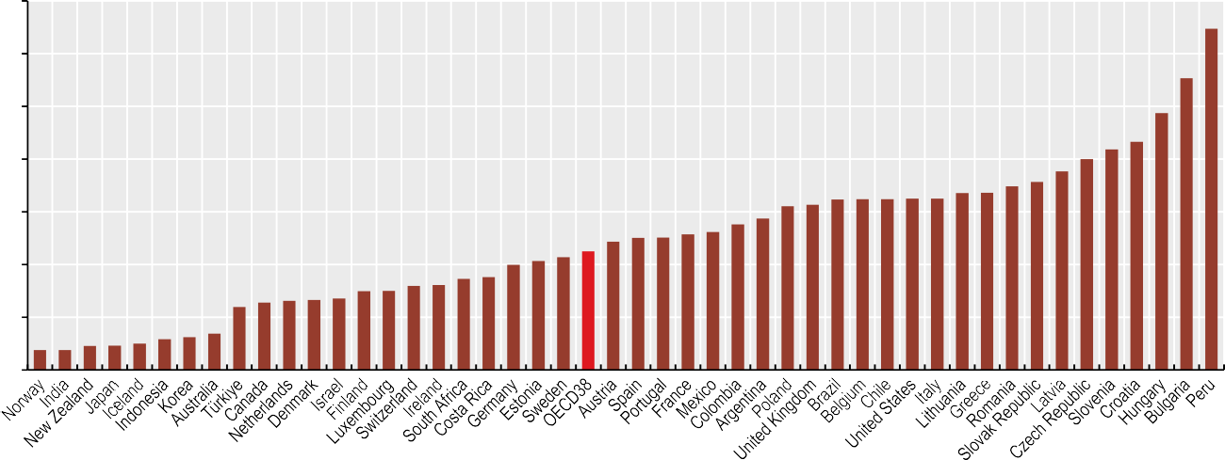

700

600

500

400

300

200

100

0

120

128

131

133

136

150

150

160

161

173

176

200

207

214

225

244

251

251

257

262

276

287

310

313

324

324

324

325

325

336

336

349

357

377

400

419

433

487

553

647

Sources: OECD Health Statistics 2023; UNWPP (2022[3]), The 2022 Revision of World Population Prospects.

38

38

45

46

50

59

62

69

*StatLink 2* <https://stat.link/f5ed2m>

**Figure 3.10. Average annual number of deaths and mortality rate due to AMR up to 2050**

Deaths per 100 000 population



Total number of deaths Mortality rate

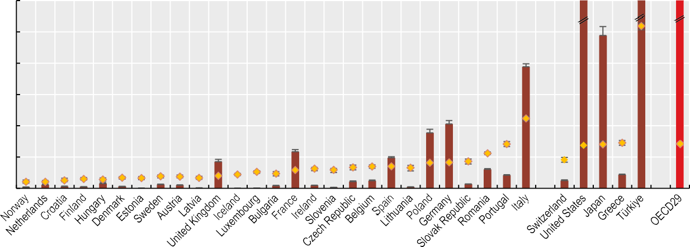30

Number of deaths per year

10 000

24 052

25

20

15

10

5

0

23 281

77 690

9 000

8 000

7 000

6 000

5 000

4 000

3 000

2 000

1 000

0

Note: Results based on the conservative “Elimination scenario”, which assumes the elimination of all resistant infections. OECD29 values reflect the aggregate deaths and mortality rate across OECD countries.

Source: OECD (2023[2]), *Embracing a One Health Approach to Fight Antimicrobial Resistance*, [https://doi.org/10.1787/ce44c755-en.](https://doi.org/10.1787/ce44c755-en)

*StatLink 2* <https://stat.link/7ynlif>

**Mortality from circulatory diseases**

Circulatory diseases – notably heart attack and stroke – were the main cause of mortality in most OECD countries in 2021, accounting for 28% of all deaths across OECD countries (see Figure 4.5 in section on “Main causes of mortality”). While mortality rates have declined in most OECD countries over time, population ageing, rising obesity and diabetes rates, and delays in diagnoses may hamper further reductions (OECD, 2015[1]). Indeed, prior to the COVID-19 pandemic, slowing improvements in heart disease and stroke were one of the principal causes of a slowdown in life expectancy gains in many countries (Raleigh, 2019[2]). Furthermore, COVID-19 may have contributed indirectly to higher death rates from circulatory diseases in some countries, owing to disruptions to acute, primary and preventive care.

In 2021, heart attacks and other ischaemic heart diseases (IHDs) accounted for 11% of all deaths in OECD countries. IHDs are caused by the accumulation of fatty deposits lining the inner wall of a coronary artery, restricting blood flow to the heart. Mortality rates are 83% higher for men than women across OECD countries, primarily because of a greater prevalence of risk factors among men, such as smoking, hypertension and high cholesterol.

Among OECD countries, Central and Eastern European countries had the highest IHD mortality rates – particularly Lithuania, where there were 395 deaths per 100 000 (age-standardised) population. Rates were also relatively high in Latvia, Hungary, Mexico and the Slovak Republic. Korea, Japan, France and the Netherlands had the lowest rates among OECD countries, at about one-third of the OECD average (Figure 3.11).

Between 2011 and 2021, IHD mortality rates declined in nearly all OECD countries, with an average reduction of 20%. Declines were most marked in Estonia (56%), Luxembourg and

risk factors – notably smoking – has contributed to fewer deaths, alongside improved survival rates following an acute episode, reflecting better quality of care (see section on “Mortality following ischaemic stroke” in Chapter 6).

There are wide socio-economic inequalities in mortality from circulatory diseases in most OECD countries, largely reflecting socio-economic differences in major risk factors. Many of these deaths could be prevented, but trends in several risk factors are heading in the wrong direction. While smoking rates have fallen overall, cholesterol, high blood pressure, low physical activity, obesity and diabetes are on the rise in many OECD countries (OECD/The King's Fund, 2020[4]). A number of public health, fiscal and regulatory measures can incentivise citizens to adopt healthier lifestyles, thereby reducing the burden of cardiovascular diseases on societies.

**Definition and comparability**

Mortality rates are based on numbers of deaths registered in a country in a year divided by the size of the corresponding population. The rates have been age-standardised to the 2015 OECD population (available at <http://oe.cd/mortality>) to remove variations arising from differences in age structures across countries and over time. The source is the WHO Mortality Database. In cases where 2020 or older data were used, the year for the time series reference was 2010.

Deaths from IHDs are classified as ICD-10 codes I20-I25, and from cerebrovascular diseases as codes I60-I69.

**References**

Costa Rica (both at 45%). However, three OECD countries – Mexico, Colombia and Türkiye – experienced increases in mortality, as did OECD accession countries Bulgaria and Peru. This is closely linked to increasing obesity rates and diabetes prevalence. It may also be linked to recent increases in acute myocardial infarction mortality rates after admission to hospital: survival rates following a heart attack worsened in Mexico and Türkiye between 2019 and 2021 (see section on “Mortality following acute myocardial infarction” in Chapter 6). This may have been caused by bottlenecks in diagnostic testing, possible misclassification of causes of death and overall lower performance of health systems during the pandemic (Roth, Vaduganathan and Mensah, 2022[3]).

Cerebrovascular diseases (or strokes) were the underlying cause of 6% of deaths across OECD countries in 2021. Disruption of the blood supply to the brain causes a stroke. As well as causing many deaths, strokes have a significant disability burden. Mortality rates were particularly high in Latvia, Lithuania, and Hungary, and in OECD accession and partner countries Bulgaria, Romania and South Africa (Figure 3.12).

Mortality rates from stroke have fallen in almost all OECD member and partner countries since 2011, with an average reduction of 25% across OECD countries. However, small increases in mortality have been observed in Latvia and the United States. For strokes, as for IHDs, a reduction in certain

OECD (2015), *Cardiovascular Disease and Diabetes: Policies for Better Health and Quality of Care*, OECD Health Policy Studies, OECD Publishing, Paris, https://doi.org/10.1787/9789264233010-en.

OECD/The King’s Fund (2020), *Is Cardiovascular Disease Slowing Improvements in Life Expectancy?: OECD and The King’s Fund Workshop Proceedings*, OECD Publishing, Paris, https://doi.org/10.1787/47a04a11-en.

Raleigh, V. (2019), “Trends in life expectancy in EU and other OECD countries : Why are improvements slowing?”*, OECD Health Working Papers*, No. 108, OECD Publishing, Paris, https://doi.org/10.1787/223159ab-en.

Roth, G., M. Vaduganathan and G. Mensah (2022), “Impact of the COVID-19 Pandemic

on Cardiovascular Health in 2020: JACC State-of- the-Art Review.”, *Journal of the American College of Cardiology*, Vol. 80/6, pp. 631-640, https://doi.org/10.1016/j.jacc.2022.06.008.

[1]

[4]

[2]

[3]

**Figure 3.11. Heart attack and other ischaemic heart disease mortality, 2021 and 2011 (or nearest year)**

**Figure 3.12. Stroke mortality, 2021 and 2011 (or nearest year)**

2011 2021

2011 2021

Korea Japan France¹ Netherlands Luxembourg

Spain Denmark Belgium Portugal Chile Israel Costa Rica

Switzerland Australia Slovenia Argentina Norway¹ Italy¹

South Africa

Canada Iceland

United Kingdom

Sweden Greece Brazil Germany

New Zealand¹

Austria Ireland OECD38

United States

Finland Peru Estonia Poland Türkiye Croatia Bulgaria

Czech Republic

Colombia Romania Slovak Republic

Mexico Hungary Latvia Lithuania

29

30

39

39

41

46

50

50

51

53

57

63

64

67

68

70

72

74

78

80

81

84

88

91

96

102

113

113

114

114

117

117

126

128

133

146

151

184

194

226

236

271

276

296

297

395

Switzerland

Israel Canada Luxembourg

33

33

34

35

35

38

38

40

41

43

43

44

45

45

45

45

46

46

46

46

48

49

54

55

55

57

61

60

63

64

64

73

73

74

78

80

86

87

95

98

107

138

148

183

217

266

France¹ Spain Australia Iceland Austria Netherlands

Japan United Kingdom

Germany Denmark Norway¹ Belgium Ireland Peru Sweden Korea Costa Rica

United States Argentina

Chile Finland

New Zealand¹

OECD38

Mexico Czech Republic

Italy¹ Estonia Slovenia Colombia Portugal Greece Poland Türkiye

Slovak Republic

Brazil Croatia Hungary South Africa Lithuania Romania Latvia Bulgaria

0 100 200 300 400 500

Age-standardised rates per 100 000 population

0 100 200 300

Age-standardised rates per 100 000 population

1. Most recent data point corresponds to 2016-17. Source: OECD Health Statistics 2023.

*StatLink 2* <https://stat.link/on5wsq>

1. Most recent data point corresponds to 2016-17. Source: OECD Health Statistics 2023.

*StatLink 2* <https://stat.link/usx7go>

**Cancer mortality**

Cancer was the second leading cause of death in OECD countries after circulatory diseases, accounting for 21% of all deaths in 2021. Leading causes of cancer-related mortality included lung cancer (20%), colorectal cancer (10.9%), breast cancer (14.7% among women) and prostate cancer (10.1% among men). These four represent almost 44% of all cancers diagnosed in OECD countries. Mortality rates from cancer have fallen in all OECD countries since 2000, although on average the decline has been more modest than for circulatory diseases.

Lung cancer is the main cause of death for both men and women, accounting for 23.2% of cancer deaths among men and 16.8% among women (Figure 3.13). Smoking represents the main risk factor for lung cancer. Colorectal cancer is also a major cause of death for both men and women, representing 10.9% of cancer-related deaths for both sexes. Widespread screening programmes for colorectal cancers for older populations have led to declining incidence among older adults. In recent years, however, many OECD countries have observed rising incidence of colorectal cancer among younger patients. Apart from age and genetic factors, exposure to ultraviolet radiation, a diet high in fat and low in fibre, lack of physical activity, obesity, smoking and alcohol consumption all increase the risk of developing the illness.

Breast cancer is the second most common cause of cancer mortality in women (14.7% of deaths). While incidence rates for breast cancer have increased over the past decade, mortality rates have declined or stabilised – indicative of earlier diagnosis and treatment – and consequently survival rates are higher (see section on “Cancer screening” in Chapter 6). Prostate cancer is the third most common cause of cancer mortality among men, accounting for 10.1% of all cancer- related deaths.

Mortality rates from cancer averaged 202 deaths per 100 000 people across OECD countries in 2021, up from 191 in 2019 (Figure 3.14). Among OECD countries, mortality rates were highest in Hungary, the Slovak Republic, Slovenia, Latvia

particularly during the onset of the pandemic and the first rollout of restrictions and lockdowns after March 2020. As a result, diagnosis and treatment of cancer were considerably delayed in early 2020 across most OECD countries (OECD, 2023[3]).

Cancer incidence rates have historically been higher for men than women in OECD member and partner countries. Cancer mortality rates are higher for men in all OECD member countries. The gap is widest in Latvia, Estonia and Lithuania, where cancer mortality is 2.1 times higher for men, while in France male mortality is only 2% higher than female mortality (Figure 3.14). Greater prevalence of risk factors among men – notably smoking and alcohol consumption – drive much of this gender gap in cancer incidence and mortality. Additionally, interventions to reduce socio-economic inequalities in cancer mortality should focus on people with lower levels of education, as this population group has higher cancer mortality rates across most OECD countries (OECD, 2023[3]).

**Definition and comparability**

Cancer mortality rates are based on numbers of cancer deaths registered in a country in a year divided by the size of the corresponding population. The rates have been age-standardised to the 2015 OECD population (available at <http://oe.cd/mortality>) to remove variations arising from differences in age structures across countries and over time. The source is the WHO Mortality Database.

Deaths from all cancers are classified as ICD-10 codes C00-C97. The international comparability of cancer mortality data can be affected by differences in medical training and practices, as well as in death certification across countries.

**References**

and Poland (240 or above) and lowest in Mexico and Türkiye (fewer than 160).

Earlier diagnosis and treatment significantly increase cancer survival rates. This partly explains why, for example, countries such as Australia and Belgium have below-average mortality rates despite having relatively high rates of cancer incidence. Analysis of survival following cancer for 2010-14 found that both Australia and Belgium had higher than average five-year net survival for common cancers (OECD, 2023[1]; OECD, 2021[2]).

The COVID-19 pandemic severely disrupted programmes for cancer diagnosis and treatment across OECD countries. The numbers of cancer screening and treatment services were significantly diminished in almost all OECD countries,

OECD (2023), *EU Country Cancer Profile: Belgium 2023*, EU Country Cancer Profiles, OECD Publishing, Paris, https://doi.org/10.1787/9a976db3- en.

OECD (2023), *EU Country Cancer Profiles 2023*, EU Country Cancer Profiles, OECD Publishing, Paris, https://doi.org/10.1787/55f07000-en.

OECD (2021), *Health at a Glance 2021: OECD Indicators*, OECD Publishing, Paris, https://doi.org/10.1787/ae3016b9-en.

[1]

[3]

[2]

**Figure 3.13. Main causes of cancer mortality across OECD countries, by sex, 2021 (or nearest year)**

**Women Men**

Lung

Breast

16.8%

14.7%



1.0%

1.7%

2.0%

Melanoma of skin Bladder

Cervix uteri 3.2% Leukemia

Lung

23.2%



1.2%

Melanoma of skin 3.5% Leukemia

3.8% Liver

Colorectal

10.8%

3.8%

Bladder

Colorectal

11.1%

8.3%

4.1%

4.7%

Stomach Ovary

Prostate

10.1%

6.9%

5.6%

5.8%

Stomach Liver

Pancreas

Note: Shares of the sum of cancer-related deaths across OECD countries, by sex. Source: OECD Health Statistics 2023.

Pancreas

*StatLink 2* <https://stat.link/jsilue>

**Figure 3.14. Cancer mortality rates by sex, 2021 (or nearest year)**

Total Men Women

Age-standardised rate per 100 000 population

1. Most recent data point corresponds to 2016-17. Source: OECD Health Statistics 2023.

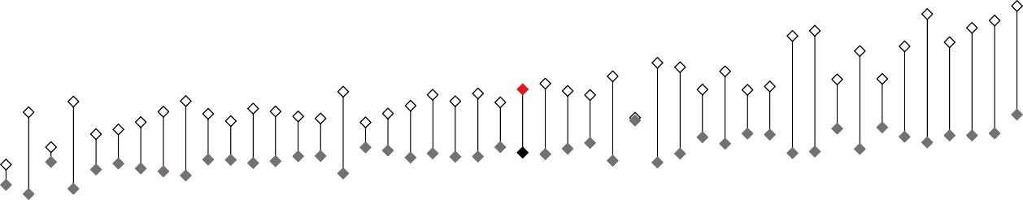

400

350

300

250

200

150

100

50

0

126

154

157

160

160

166

168

171

175 177

177 178

181

182

182

184

186

189 191

192

192

197

200

202

205

206 207

208

210

211 215

217

221

221

222

226 228

231 232

234 240

246

247 253

262 286

*StatLink 2* <https://stat.link/b79oz8>

**Chronic conditions**

Chronic conditions such as cancer, chronic respiratory problems and diabetes are not only the leading causes of death across OECD countries but also represent a major disability burden among the living. Many chronic conditions are preventable, by modifying major risk factors such as smoking, alcohol use, obesity and physical inactivity. The COVID-19 pandemic further underscored the impact of chronic conditions on health outcomes from other diseases, as data show that people with underlying health conditions are at higher risk of dying from COVID-19 (OECD, 2023[1]). The pandemic also contributed to the increase in multimorbidity of chronic conditions and to their late diagnosis and control.

More than one-third of people aged 16 and over reported living with a longstanding illness or health problem on average across 24 OECD countries in 2021 (Figure 3.15). This figure ranges from more than one in two in Finland to just under one in four in Italy. As populations age, the prevalence of chronic conditions – including multimorbidity – rises. Health systems increasingly need to be prepared to deliver high-quality chronic care management to meet the needs of ageing populations.

Socio-economic disparities are also large: on average across OECD countries, 43% of people in the lowest income quintile report a longstanding illness or health problem compared to 27% of people in the highest income quintile (Figure 3.15). This income gap is largest in Lithuania, Belgium, Estonia and Ireland, where people in the lowest income quintile are 2 or more times as likely to have at least one longstanding illness or health problem compared to people in the highest income quintile. The income gap is smallest in Italy and Türkiye, where individuals in the lowest income quintile are slightly less likely to report living with a longstanding illness or health problem compared to individuals in the highest income quintile.

One of the most significant chronic conditions is diabetes. It has a particularly large disability burden, causing cardiovascular disease, blindness, kidney failure and lower limb amputation. It occurs when the body is unable to regulate excessive glucose levels in the blood. In 2021, 6.9% of the adult population were living with diabetes on average across OECD countries (age-standardised data). In addition, a further 48 million adults across OECD countries were estimated to

Diabetes is much more common among older people, and slightly more men than women have the condition. It also disproportionately affects those from disadvantaged socio-economic groups. The economic burden of diabetes is substantial: in OECD countries, an estimated USD 650 billion was spent on treating diabetes and preventing complications in 2021 (IDF, 2021[2]).

**Definition and comparability**

Data related to longstanding illnesses or health problems are based on the results of the EU Statistics on Income and Living Conditions instrument (EU-SILC). The comparability of data on longstanding illnesses and health problems is limited by the fact that the indicator is derived from self- reported data, which can be affected by people’s subjective assessment of their health and by social and cultural factors. These data cover people aged 16 and over.

The sources and methods used by the International Diabetes Federation (IDF) are outlined in the Diabetes Atlas, 10th edition (IDF, 2021[2]). The IDF produces estimations based on a variety of sources that met several criteria for reliability. The majority were national health surveys and peer-reviewed articles. Age-standardised rates were calculated using the world population, based on the distribution provided by the WHO. This can lead to an underestimation of prevalence compared to age-standardisation based on the OECD population. Adult population here covers those aged between 20 and 79 with diagnosed type 1 or type 2 diabetes. In addition, methodology and data changes over time may impact comparability of prevalence estimates. IDF prevalence estimates are often higher than OECD countries’ national estimates, due to OECD countries typically having older populations. For example, in Spain the IDF estimate of 10.3% was higher than the latest value of 7.2% reported by the Spanish Ministry of Health.

**References**

have undiagnosed diabetes (IDF, 2021[2]).

Among OECD member countries, diabetes prevalence is highest in Mexico, Türkiye, Chile, the United States and Spain, with over 10% of adults living with diabetes (age-standardised data). For OECD partner countries, diabetes prevalence is also high in South Africa, Indonesia and China, also at around 10% or higher (Figure 3.16).

Age-standardised diabetes prevalence rates have stabilised in many OECD member countries over the last decade, especially in western Europe. However, they have increased markedly in Türkiye, Iceland and Spain, with a rise of 60% or more, as well as in OECD partner countries such as Indonesia and South Africa. Such upward trends are due in part to rising rates of obesity, poor nutrition and physical inactivity, as well as to their interactions with population ageing (Kotwas et al., 2021[3]).

IDF (2021), *IDF Diabetes Atlas, 10th edition*, International Diabetes Federation, Brussels, [http://www.diabetesatlas.org.](http://www.diabetesatlas.org/)

Kotwas, A. et al. (2021), “Epidemiological factors for type 2 diabetes mellitus: evidence from the Global Burden of Disease”, *Archives of Public Health*,

Vol. 79/1, https://doi.org/10.1186/s13690-021- 00632-1.

OECD (2023), *Ready for the next crisis? Investing in Resilient Health Systems*, OECD Health Policy Studies, OECD Publishing, Paris, https://doi.org/10.1787/5971a279-en.

[2]

[3]

[1]

14.5

16.9

**Figure 3.15. People reporting a longstanding illness or health problem, by income quintile, 2021 (or nearest year)**

Total Lowest income quintile Highest income quintile

% 70

60

50

40

30

20

10

0

Source: Eurostat 2023.



*StatLink 2* <https://stat.link/fizjv2>

**Figure 3.16. Type 1 and 2 diabetes prevalence among adults, 2011 and 2021 (or nearest year)**

2011 2021

Age-standardised rates to world population, %

Source: IDF (2021[2]), IDF Diabetes Atlas, 10th edition, [www.diabetesatlas.org.](http://www.diabetesatlas.org/) Estimates may differ from national estimates owing to different age-standardisation approaches.



20

15

10

5

0

3.0

3.6

3.6

4.5

4.6

4.6

4.8

4.8

5.0

5.3

5.3

5.4

5.5

5.8

5.8

5.8

5.9

5.9

6.1

6.2

6.3

6.4

6.4

6.4

6.5

6.5

6.6

6.8

6.8

6.9

7.0

7.0

7.1

7.4

7.7

8.3

8.5

8.8

8.8

9.1

9.6

10.3

10.6

10.6

10.7

10.8

10.8

*StatLink 2* <https://stat.link/ozhi83>

**Maternal and infant mortality**

Maternal mortality – the death of a woman during pregnancy or childbirth, or within 42 days of the termination of pregnancy – is an important indicator of a woman’s health status and to assess health system performance. The Sustainable Development Goals set a target of reducing the global maternal mortality ratio to less than 70 deaths per 100 000 live births by 2030 (WHO, 2023[1]).

In OECD countries, the maternal mortality ratio (MMR) averaged

10.9 deaths per 100 000 live births in 2020, which is substantially lower than the target set by the Sustainable Development Goals. Countries including Norway, Poland, Israel, Iceland and Australia had MMRs of fewer than 3 deaths per 100 000 births. However, Colombia is yet to achieve the SDG target, with an MMR of 72 deaths per 100 000 live births in 2020. Mexico also had a significantly high MMR of 55 deaths per 100 000 births. Many OECD accession and partner countries also had high MMRs, ranging from 69 deaths per 100 000 births for Peru to 173 deaths

per 100 000 births for Indonesia (Figure 3.17).

Risks of maternal death can be reduced through family planning, better access to high-quality antenatal care, and delivery and postnatal care delivered by skilled health professionals. Addressing disparities in provision of these essential reproductive health services to underserved populations must be included in any strategy. Furthermore, the broad health system strengthening and universal health coverage agenda, along with multisectoral action (including women’s education and tackling violence), are collaborative efforts that are crucial to reducing maternal deaths (WHO et al., 2018[2]).

Infant mortality – deaths in children aged less than one year – reflects the impact of economic, social and environmental conditions on the health of mothers and infants, as well as the effectiveness of health systems. Factors such as the education of the mother, quality of antenatal and childbirth care, preterm birth and birth weights, immediate newborn care and infant feeding practices are important determinants of infant mortality.

In 2021, infant mortality was on average at 4 deaths per 1 000 live births in OECD countries, down from 4.7 deaths per 1 000 live births in 2011. Finland, Japan, Norway, Iceland and Slovenia all had infant mortality rates of fewer than 2 deaths per 1 000 live births in 2021. However, infant mortality rates are still relatively high in Colombia (16.5 deaths per 100 000 births) and Mexico (12.7 deaths per 1 000 live births), signalling the correlation that exists between maternal and infant mortality. Among OECD partner countries, infant mortality rates are around 20 deaths or higher per 1 000 live births in India, South Africa and Indonesia – although each of these countries has reduced infant mortality rates considerably since 2011 (Figure 3.18).

Infant mortality can be reduced through cost-effective and appropriate interventions. These include immediate skin-to- skin contact between mothers and newborns after delivery, early and exclusive breastfeeding for the first six months of life, and kangaroo parent care for babies weighing 2 000 g or less. Postnatal care for mothers and newborns within 48 hours of birth, delayed bathing until after 24 hours of childbirth, and dry cord care are important in reducing infant deaths. Management and treatment of neonatal infections, pneumonia, diarrhoea, and malaria are also critical.

**References**

**Definition and comparability**

Maternal mortality is defined as the death of a woman while pregnant or during childbirth or within 42 days of termination of pregnancy, irrespective of the duration and site of the pregnancy, from any cause related to or aggravated by the pregnancy or its management but not from unintentional or incidental causes. This includes direct deaths from obstetric complications of pregnancy, interventions, omissions or incorrect treatment. It also includes indirect deaths due to previously existing diseases, or diseases that developed during pregnancy, where these were aggravated by the effects of pregnancy. Maternal mortality is here measured using the MMR, which is the number of maternal deaths during a given time per 100 000 live births during the same time. Data presented for this indicator are estimates extracted from the WHO Global Health Observatory (WHO GHO) and produced by the UN Maternal Mortality Estimation Interagency Group (MMEIG) composed of the WHO, the United Nations Children’s Fund (UNICEF), the United Nations Population Fund (UNFPA), the United Nations Department of Economic and Social Affairs – Population Division (UNDESA/Population Division), and the World Bank Group. There are difficulties in identifying maternal deaths precisely. Many countries do not have accurate or complete vital registration systems, and so the MMR is derived from other sources including censuses, household surveys, sibling histories, verbal autopsies and statistical studies. Estimates should therefore be treated cautiously.

The infant mortality rate is defined as the number of children who die before reaching their first birthday in a given year, expressed per 1 000 live births, with no minimum threshold of gestation period or birthweight. Some countries base their infant mortality rates on estimates derived from censuses, surveys and sample registration systems, and not on accurate and complete registration of births and deaths. Differences among countries in registering practices for premature infants may also add slightly to international variations in rates.

WHO (2023), *Maternal mortality*, World Health Organization, https[://www.who.int/news-room/fact-](http://www.who.int/news-room/fact-) sheets/detail/maternal-mortality.

WHO et al. (2018), *Survive, Thrive, Transform. Global Strategy for Women’s, Children’s and Adolescents’ Health: 2018 report on progress towards 2030 targets*, World Health Organization, https://[www.everywomaneverychild.org/wp-](http://www.everywomaneverychild.org/wp-) content/uploads/2018/05/EWECGSMonitoringReport 2018.pdf.

[1]

[2]

16.5

19.5

25.8

27.0

**Figure 3.17. Maternal mortality ratio estimates, 2020**

Deaths per 100 000 live births



100

80

60

40

20

0

44.9

59.1

68.5

72.2

74.8

102.7

126.8

1. Three-year averages.

1.7

2.0

2.8

2.9

2.9

3.4

3.4

4.3

4.3

4.4

4.5

4.5

4.6

4.7

4.8

4.8

4.8

5.0

5.2

5.2

6.5

7.0

7.1

7.4

7.7

7.9

8.1

8.3

8.7

9.8

10.1

10.9

11.0

11.8

15.0

15.1

17.3

18.3

21.1

22.0

23.1

Source: WHO Global Health Observatory (WHO GHO) 2023.

*StatLink 2* <https://stat.link/bcqmh9>

**Figure 3.18. Infant mortality, 2021 and 2011 (or nearest years)**

2011 2021

Deaths per 1 000 live births

1. Three-year averages.



35

30

25

20

15

10

5

0

1.6

1.7

1.7

1.9

1.9

2.2

2.2

2.4

2.4

2.4

2.4

2.4

2.5

2.7

2.7

2.8

3.0

3.1

3.1

3.1

3.3

3.3

3.3

3.3

3.5

3.6

3.8

3.9

4.0

4.0

4.3

4.5

4.6

4.9

5.1

5.2

5.4

5.5

5.8

7.6

8.7

9.1

10.0

12.5

12.7

Source: OECD Health Statistics 2023.

*StatLink 2* <https://stat.link/rv5f9b>

**Mental health**

Good mental health is essential for healthy populations and economies: when people live with poor mental health, they have a harder time succeeding in school, being productive at work, and staying physically healthy (OECD, 2021[1]). The COVID-19 pandemic seriously disrupted the way people live, work and learn, and fuelled significant increases in mental distress. At the start of the pandemic, the share of the population reporting symptoms of anxiety and depression increased in all OECD countries with available data, and as much as doubled in some countries (Figure 3.19 and Figure 3.20). OECD analysis has shown that population mental health went up and down over the course of the pandemic – typically worsening during periods when infection and death rates were high, or when stringent containment measures were in place. Available data point to some recovery in population mental health as the pandemic situation improved, but also suggest that mental ill-health remains elevated. In Belgium, Korea, the United Kingdom and the United States, data from 2022 typically show small decreases in the share of the population reporting symptoms of depression, compared to 2020. However, the prevalence for 2022 remains at least 20% higher than pre-pandemic, and in some cases over double or triple the pre-pandemic rate (Figure 3.19). Persistently high levels of mental distress “beyond” the pandemic could reflect the confluence of multiple crises: the cost-of-living crisis, climate crisis and geopolitical tensions.

Shocks such as pandemics, severe weather events and financial crises can also heighten the risk of suicidal behaviour. While complex social and cultural factors affect suicidal behaviour, mental ill-health increases the risk of dying by suicide. Rates of death by suicide currently vary almost six-fold across OECD countries, and are over three times higher for men than women. Deaths by suicide were generally trending downward prior to the pandemic, falling by 28.4% on average in the period between 2000 and 2019 (Figure 4.21). There were concerns that the COVID-19 crisis would lead to more suicides, and significant increases in suicidal ideation have been observed in some countries, particularly among young people (OECD/European Union, 2022[2]). To some extent, these concerns were not realised in the first year of the pandemic: in the 27 OECD countries for which data are available, rates of death by suicide decreased by 2.4% on average between 2019 and 2020. However, this change varied across countries. In a third of countries with available data, suicides increased between 2019 and 2020 whereas for another third of the countries it decreased by 5% or more. Between 2019 and 2020 the rate of death by suicide respectively increased by 13.4% and 10.5% in Iceland and Mexico, and it decreased by 16.8% and 15.2% in Chile and Greece.

OECD countries took rapid action to step up mental health support in response to the pandemic. In a policy questionnaire in 2022, all 26 replying OECD countries reported having introduced emergency mental health services in response to the pandemic, and almost all (25 out of 26) reported that they had permanently increased mental health care support or capacity (OECD, 2023[3]). However, increases in capacity or support have not always been commensurate with need. This is not a new challenge, but one that has been exacerbated: even before the pandemic, two out of three people seeking mental health support reported difficulties in getting it (OECD, 2021[1]).

**References**

**Definition and comparability**

The quality and coverage of mental health data have been variable over the course of the pandemic, meaning that caution is needed when comparing the prevalence of anxiety and depression.

Figure 3.19 and Figure 3.20 use national data sources, and may not be directly comparable across, and in some cases within, countries. Differences include the number and timing of surveys, and the survey instruments used to measure depression and anxiety. In some countries, survey instruments differ across years (in France and Spain for both anxiety and depression; in Germany for anxiety). Pre-pandemic and pandemic data for depression in Italy, Spain, Greece and France have some differences in scoring methods, which could understate the increase in symptoms. Some surveys do not necessarily use nationally representative samples (Australia, Austria, Italy, Japan, Spain for depression and anxiety; Greece for depression; Germany, Korea and Mexico for anxiety). Where possible, surveys using Patient Health Questionnaire (PHQ-9) and General Anxiety Disorder (GAD-7) or similar screening tools were selected to measure depression and anxiety. For countries with regular data collections per year – Belgium, Canada, France, Germany, Korea, the United Kingdom, the United States – multiple data points for each year have been pooled where possible. Data for the “pre-COVID-19” year vary based on national data availability. The most recently available data were selected, up to 2019. Differences in the openness of populations to discussing their mental state also hamper cross-country comparability.

The registration of suicide is a complex procedure, affected by factors such as how intent is ascertained; who is responsible for completing the death certificate; and cultural dimensions, including stigma. Caution is therefore also needed when comparing rates between countries. Age-standardised mortality rates are based on numbers of deaths divided by the size of the corresponding population. The source is the WHO Mortality Database; suicides are classified as ICD-10 codes X60-X84 and Y87.0.

OECD (2023), *Ready for the next crisis? Investing in Resilient Health Systems*, OECD Health Policy Studies, OECD Publishing, Paris, https://doi.org/10.1787/5971a279-en.

OECD (2021), *A New Benchmark for Mental Health Systems: Tackling the Social and Economic Costs of Mental Ill-Health*, OECD Health Policy Studies, OECD Publishing, Paris, https://doi.org/10.1787/4ed890f6-en.

OECD/European Union (2022), *Health at a Glance: Europe 2022: State of Health in the EU Cycle*, OECD Publishing, Paris, https://doi.org/10.1787/507433b0-en.

[3]

[1]

[2]

**Figure 3.19. National estimates of prevalence of depression or symptoms of depression, 2019-22 (or nearest year)**

2019 2020 2022

% 30

20

10

0

|  |  |  |  |  |  |  |  |  |  |  |
| --- | --- | --- | --- | --- | --- | --- | --- | --- | --- | --- |
| Germany Czech Canada France | Italy | Japan | Belgium | Spain | United | Korea | Austria | Greece | Mexico | United |
| Republic |  |  |  |  | Kingdom |  |  |  |  | States |

Note: Survey instruments and population samples differ between countries and in some cases across years within countries, which limits direct comparability. Pre-pandemic data for the Czech Republic 2017; Canada 2015-19; Japan 2013; Belgium 2018; United Kingdom 2019-March 2020; Korea 2016-19.

Source: National data sources – see the Statlink for full details.

*StatLink 2* <https://stat.link/wpe5lh>

**Figure 3.20. National estimates of prevalence of anxiety or symptoms of anxiety, 2019-22 (or nearest year)**

% 50

2019 2020 2022

45

40

35

30

25

20

15

10

5

0

Germany Japan Czech

Republic

Canada New Zealand

France Austria Belgium Italy Spain United

Kingdom

Korea United States

Mexico

Note: Survey instruments and population samples differ between countries and in some cases across years within countries, which limits direct comparability. Pre-pandemic data for the Czech Republic 2017; New Zealand 2016-17; France 2017; Belgium 2018.

Source: National data sources – see the Statlink for full details.

*StatLink 2* <https://stat.link/x1w8sg>

**Figure 3.21. Death by suicide, 2000 and 2020 (or nearest year)**

49.3

2000 2019 2020

Deaths per 100 000 population (age-standardised rates)

Note: Latest available data for Norway and New Zealand 2016; Italy and France 2017; Ireland, Sweden and Belgium 2018; and the Slovak Republic, Portugal, Canada and Hungary 2019.



35

30

25

20

15

10

5

0

Source: OECD Health Statistics 2023.

*StatLink 2* <https://stat.link/972hqf>

**Self-rated health**

How individuals assess their own health provides a holistic overview of both physical and mental health. Adding such a perspective on quality of life complements life expectancy and mortality indicators that only measure survival. Further, despite its subjective nature, self-rated health has proved to be a good predictor of future healthcare needs and mortality (Palladino et al., 2016[1]).

Most OECD countries conduct regular health surveys that include asking respondents how, in general, they would rate their health. For international comparisons, socio-cultural differences across countries complicate cross-country comparisons of self-assessed health. Differences in the formulation of survey questions – notably in the survey scale – can also affect comparability of responses. Finally, since older people generally report poorer health and more chronic conditions than younger people do, countries with a larger proportion of older people are likely to have a lower proportion of people reporting that they are in good health.

With these limitations in mind, around 8% of adults considered themselves to be in poor health, on average across OECD countries in 2021 (Figure 3.22). This ranged from over 13% in Korea, Japan and Portugal to under 3% in Colombia, New Zealand and Canada. However, the response categories used in OECD countries outside Europe and Asia are asymmetrical on the positive side, which introduces a comparative bias to a more positive self-assessment of health (see the “Definition and comparability” box). Korea, Japan and Portugal stand out as countries with high life expectancy but relatively poor self-rated health.

Over time, the share of adults considering themselves to be in poor health has slightly diminished across OECD countries. On average, 8.3% of adults from 34 OECD countries with comparable trend data rated their own health as bad or very bad in 2021, compared to 10.1% in 2011. This improvement was true in 25 of the 34 OECD countries with comparable trend data.

People on lower incomes are on average less positive about their health than those on higher incomes in all OECD countries (Figure 3.23). More than 80% of adults in the highest income quintile rated their health as good or very good in 2021, compared to 60% of adults in the lowest income quintile, on average across OECD countries. Socio-economic disparities are particularly marked in Estonia, Lithuania and Latvia, with an income gap of 40 or more percentage points.

Self-rated health tends to decline with age. In many countries, there is a particularly marked decline in how people rate their health when they reach their mid-40s, with a further decline after reaching retirement age (see section on “Self-rated health and disability at age 65 and over” in Chapter 10). Men are also more likely than women to rate their health as good.

**Definition and comparability**

Self-rated health reflects an individual’s overall perception of his or her health. Survey respondents are typically asked a question such as: “How is your health in general?” Caution is required in making cross-country comparisons of self- rated health for at least three reasons. First, self-rated health is subjective, and responses may be systematically different across and within countries because of socio- cultural differences. Second, as self-rated health generally worsens with age, countries with a greater share of older people are likely to have fewer people reporting that they are in good health. Third, there are variations in the question and answer categories used in survey questions across countries. In particular, the response scale used in the United States, Canada, New Zealand, Australia and Chile is asymmetrical (skewed on the positive side), including the response categories: “Excellent / very good / good / fair / poor”. In most other OECD countries, the response scale is symmetrical, with response categories: “Very good / good / fair / poor / very poor”. This difference in response categories may introduce a comparative bias to a more positive self-assessment of health in those countries that use an asymmetrical scale. In Korea, differences in survey methodology may bias self-rated health downwards compared to other general household surveys.

Self-rated health by income level is reported for the first quintile (the 20% of the population with the lowest income) and the fifth quintile (the 20% with the highest income). Depending on the survey, the income level may relate to either the individual or the household (in which case the income is equivalised to take into account the number of people in the household).

**References**

Differences in smoking, harmful alcohol use and other risk factors are likely to explain much of this disparity. Socio-economic disparities are relatively low in New Zealand, Greece, Luxembourg, Italy and Türkiye, which have a gap of less than 8 percentage points.

Palladino, R. et al. (2016), “Associations between multimorbidity, healthcare utilisation and health status: Evidence from 16 European countries”, *Age and Ageing*, Vol. 45/3, https://doi.org/10.1093/ageing/afw044.

[1]

**Figure 3.22. Adults rating their own health as bad or very bad, 2021 (or latest year)**

% of population aged 15 years and over

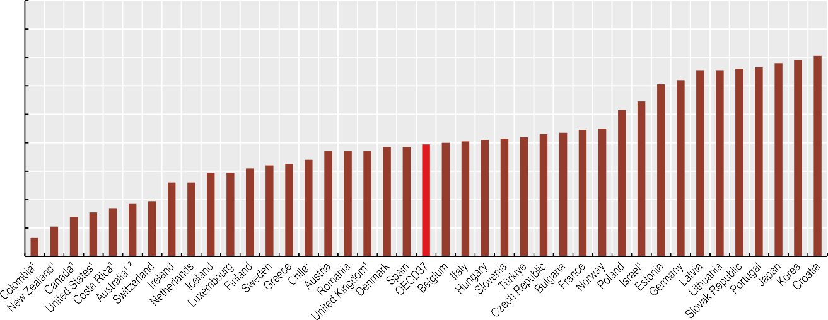

18

16

14

12

10

8

6

4

2

0

5.2

5.2

5.9

5.9

6.2

6.4

6.5

6.8

7.4

7.4

7.4

7.7

7.7

7.9

8.0

8.1

8.2

8.3

8.4

8.6

8.7

8.9

9.0

10.3

10.9

12.1

12.4

13.1

13.1

13.2

13.3

13.6

13.8

14.1

Notes: 1. Results for these countries are not directly comparable with those for other countries owing to methodological differences in the survey questionnaire resulting in a bias towards a more positive self-assessment of health. 2. Most recent data point corresponds to 2017.

1.3

2.1

2.8

3.1

3.4

3.7

3.9

Source: OECD Health Statistics 2023 (EU-SILC for EU countries).

*StatLink 2* <https://stat.link/qf0ej7>

**Figure 3.23. Adults rating their own health as good or very good, by income quintile, 2021 (or nearest year)**



Total Highest income Lowest income

% of population aged 15 years and over reporting to be in good health

Notes: 1. Results for these countries are not directly comparable with those for other countries owing to methodological differences in the survey questionnaire resulting in a bias towards a more positive self-assessment of health. 2. Most recent data point corresponds to 2017.

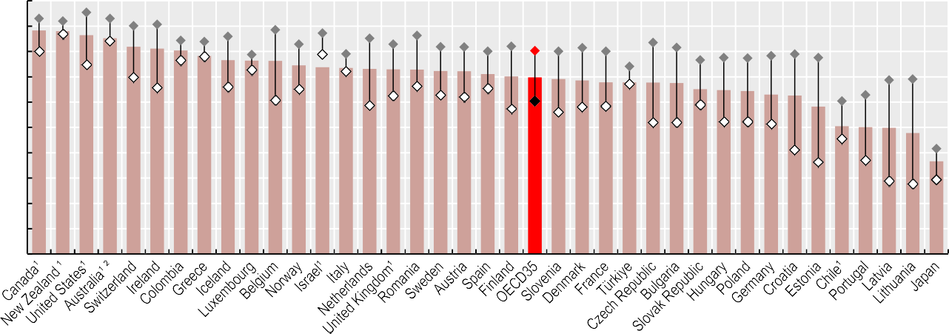

100

90

80

70

60

50

40

30

20

10

0

88.3

88.0

86.4

85.2

81.9

81.1

80.4

78.2

76.6

76.4

76.3

74.5

73.8

73.5

73.1

72.9

72.8

72.3

72.2

71.1

70.1

69.8

69.1

68.6

67.8

67.8

67.7

67.5

65.1

64.7

64.4

63.0

62.6

58.2

50.5

50.1

49.8

47.8

36.6

Source: OECD Health Statistics 2023 (EU-SILC for EU countries).

*StatLink 2* <https://stat.link/hxpom5>

**84** 

1. **Risk factors for health**

## Smoking

Alcohol consumption Illicit drug use

Diet and physical activity Overweight and obesity Environment and health

**Smoking**

Smoking is a leading cause of multiple diseases, including some cancers, heart attacks, strokes and respiratory diseases such as chronic obstructive pulmonary disease. Smoking during pregnancy increases the risk of low birth weight and premature delivery. The World Health Organization (WHO) estimates that tobacco smoking kills 8 million people in the world every year. More than 1.2 million of these deaths are due to second-hand smoke, and 65 000 are among children (WHO, 2020[1]).

Across OECD countries, 15.9% of people aged 15 and over smoked tobacco daily in 2021 (Figure 4.1). Smoking rates ranged from over 25% in France and Türkiye to below 10% in Iceland, Costa Rica, Norway, Mexico, Canada, the United States, New Zealand and Sweden. In accession and partner countries, rates were over 25% in China, Bulgaria and Indonesia, and below 10% in India, Peru and Brazil. Men smoked more than women in all countries except Norway – on average across OECD countries, 19.9% of men smoked daily compared to 12.3% of women. The gender gap in smoking rates was comparatively wide in Korea, Türkiye and Latvia, as well as in Indonesia, China, South Africa and Romania. Among men, rates were highest in Indonesia, China and Türkiye (over 40%) and lowest in Norway, Iceland, Canada, New Zealand and the United States (below 10%). For women, rates were highest in Bulgaria, Hungary and France (over 20%) and lowest in India, China, Indonesia, Peru, Costa Rica, Mexico and Korea (below 5%).

Over the last decade, daily smoking rates decreased in 31 of the 35 OECD countries with available time trend data. On average, they fell from 20.6% in 2011 to 15.9% in 2021 (Figure 4.2). The reductions were largest in Norway, Estonia and Ireland (above 8 percentage points), while they were smaller in Mexico, Hungary and Slovenia (below 2 percentage points). Smoking rates rose slightly in the Slovak Republic, Luxembourg and Türkiye (by 2 percentage points). Among accession and partner countries, smoking rates fell substantially in Peru, but rose slightly in Indonesia. The decreasing trends in tobacco smoking observed prior to COVID-19 remained largely unchanged during the pandemic in most countries. However, the proportion of daily smokers has remained largely unchanged in France, Italy and Mexico, and increased slightly in Ireland and Luxembourg (by 2 percentage points) in 2021 compared to pre-pandemic levels.

Comprehensive tobacco control policy packages – based on tobacco tax increases, health warnings on packages, bans on promotional and misleading information, restricted branding, awareness raising and support for smokers to quit (including

products in 2021. Rates were highest in Estonia and New Zealand (over 8%) and lowest in Sweden, Chile and Austria (below 1%). Between 2016 and 2021, regular use of vaping products increased in 11 of the 16 OECD countries for which time trend data are available (Figure 4.3). Increases were highest in New Zealand and Estonia (above 6 percentage points). At the same time, regular vaping decreased in five OECD countries, with the greatest reduction in Finland (4.8 percentage points). Vaping is more common among young people: 6.1% of those aged 15-24 used vaping products in 2021 on average across OECD countries. Vaping rates among young people were particularly high in Estonia and New Zealand (over 20% in 2022). While vaping can be used as a smoking cessation aid, it is also associated with initiation of tobacco smoking (O’Brien et al., 2021[3]).

Policies to regulate the use of vaping products include age restrictions, taxes on innovative electronic nicotine products, ban on indoor vaping, sales regulation and advertising regulation. For example, Australia recently announced a ban on single-use and disposable e-cigarettes and restrictions on e-cigarette flavours and colours, while making e-cigarettes containing nicotine available only on medical prescription as a smoking cessation aid.

**Definition and comparability**

The proportion of daily smokers is defined as the percentage of the population aged 15 years and over who report smoking tobacco every day. Data for Italy include both daily and occasional smokers. Other forms of smokeless tobacco products, such as snuff in Sweden, Norway, Finland, Denmark and Iceland, are not taken into account. For data sources see the weblink to metadata in the “Reader’s Guide”.

The proportion of regular users of vaping products is defined as the percentage of the population aged 15 years and over who report using vaping devices at least monthly, with or without nicotine. For countries that rely on the European Health Interview Survey (EHIS 2019) data (such as e.g. Germany, Hungary, Latvia, Luxembourg, Portugal, the Slovak Republic and Slovenia), the data refer to vaping daily and occasionally.

**References**

subsidies for nicotine replacement treatment and smoking cessation advice) – reduce tobacco use and are cost-effective. In France, for example, the recently implemented tobacco control policy package is estimated to return EUR 4 for each EUR 1 invested (Devaux et al., 2023[2]). Among recent national initiatives, Canada extended health warnings by printing them directly on individual cigarettes, to reach out to young or new smokers who smoke cigarettes obtained by unit (resold or given away) and may not be exposed to health warnings on packaging. New Zealand passed a world-first law that bans tobacco sales to people born on or after 1 January 2009, so that the age limit increases over time, and aims to reduce the nicotine in tobacco to zero or minimally addictive levels.

While tobacco smoking is on the decline in most countries, regular use of e-cigarette products (vaping) is on the rise, even though vaping rates remain low. Across 32 OECD countries, 3.2% of people aged 15 and over were regular users of vaping

Devaux, M. et al. (2023), “Évaluation du programme national de lutte contre le tabagisme en France”*, OECD Health working papers*, No. 155, OECD Publishing, Paris, https://doi.org/10.1787/b656e9ac- fr.

O’Brien, D. et al. (2021), “Association between electronic cigarette use and tobacco cigarette smoking initiation in adolescents: a systematic review and meta-analysis”, *BMC public health*, Vol. 21/1, https://doi.org/10.1186/S12889-021- 10935-1.

WHO (2020), *Tobacco*, World Health Organization, https[://www.who.int/news-room/fact-](http://www.who.int/news-room/fact-) sheets/detail/tobacco.

[2]

[3]

[1]

**Figure 4.1. Population aged 15 and over smoking daily, by sex, 2021 (or nearest year)**

%

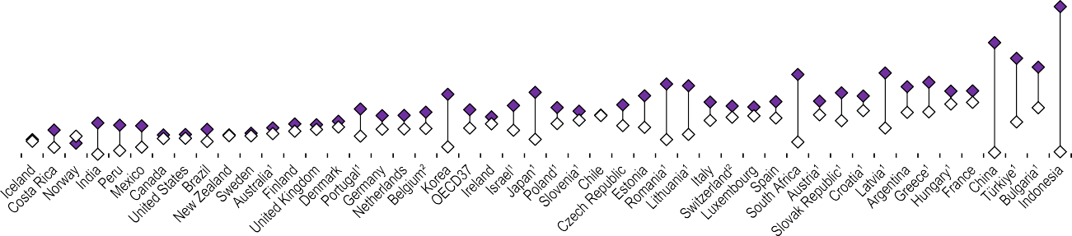

70

60

50

40

30

20

10

0

Total Men Women

1. 2019 data; 2. 2017/18 data.

Source: OECD Health Statistics 2023.

*StatLink 2* <https://stat.link/sj0tyu>

**Figure 4.2. Population aged 15 and over smoking daily, 2011 and 2021 (or nearest years)**

%

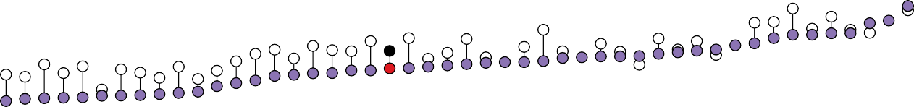

40

35

30

25

20

15

10

5

0

2011 2021

19

20

20

21

21

22

23

24

25

25

25

25

28

29

33

1. 2019 data; 2. 2017/18 data.

7

8

8

8

8

9

9

9

9

9

10

11

12

13

14

14

15

15

15

15

16

16

16

17

17

17

18

18

18

19

19

19

19

Source: OECD Health Statistics 2023.

*StatLink 2* <https://stat.link/sv7hry>

**Figure 4.3. Regular use of vaping products, 2016 and 2021 (or nearest year)**

2016 2021

% of population aged 15 years and over 10

8

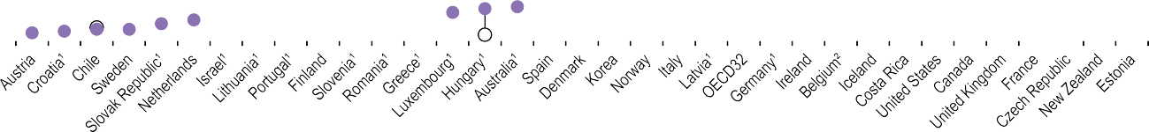

2.8

3.0

3.2

3.3

4.0

4.1

4.3

4.4

4.5

4.7

4.9

5.0

7.4

8.2

10.4

6

4

0.7

0.8

0.9

0.9

1.2

1.4

1.5

1.6

1.6

1.7

1.7

1.8

1.8

2.0

2.1

2.2

2.5

2

1.7

2.3

2.6

0

1. 2019 data; 2. 2018 data.

Source: OECD Health Statistics 2023.

*StatLink 2* <https://stat.link/84evdx>

**Alcohol consumption**

Alcohol use is a leading cause of death and disability worldwide, particularly among those of working age. High alcohol intake is a major risk factor for heart diseases and strokes, liver cirrhosis and certain cancers, but even low and moderate alcohol consumption increases the long-term risk of these diseases. Alcohol also contributes to more car crashes and injuries, violence, homicides, suicides and mental health disorders than any other psychoactive substance, particularly among young people. Alcohol-related diseases and injuries incur a high cost to society. An average of 2.4% of health expenditure is spent on dealing with the harm caused by alcohol consumption, and the figure reaches as high as 4% in some countries (OECD, 2021[1]).

Measured through sales data, overall alcohol consumption averaged 8.6 litres per person across OECD countries in 2021, down from 8.9 litres in 2011 (Figure 4.4). Latvia and Lithuania reported the highest consumption in 2021 (over 12 litres per person), followed by the Czech Republic, Estonia and Austria – all with over 11 litres per person. Türkiye, Costa Rica, Israel and Colombia had comparatively low consumption levels (under 5 litres per person). Among accession and partner countries, consumption was relatively high in Bulgaria and Romania (11 litres and over per person) and low in Indonesia, India and China (under 5 litres). Average consumption fell in 23 OECD countries between 2011 and 2021, with the largest reductions in Lithuania and Ireland (by more than 2 litres). However, alcohol consumption increased by more than 2 litres per person in Latvia, and by about 1 litre per person in Mexico and Norway, as well as in accession countries Bulgaria and Romania.

While national data on overall consumption per capita facilitate the assessment of long-term trends, they do not identify harmful drinking patterns, such as heavy episodic drinking (also called binge drinking). Nearly one in five adults (19%) reported heavy episodic drinking at least once a month, on average across 29 OECD countries in 2019 (Figure 4.5). This proportion varies 10-fold, from less than 3% in Türkiye and Italy to more than 30% in Germany, Luxembourg, the United Kingdom and Denmark, as well as Romania. The data presented herein may differ from estimates derived from other national sources. In all countries, men were more likely than women to report heavy episodic drinking. On average across OECD countries, 26% of men reported heavy episodic drinking at least once a month compared to 12% of women.

Policies to tackle harmful alcohol use include broad-based strategies and those that target heavy drinkers. Comprehensive policy packages built on a “PPPP strategy” – pricing policies to limit affordability of cheap alcohol, policing to

in place in two of the United Kingdom nations (Scotland and Wales), and in some regions in Australia and Canada. The second innovation is legislation mandating the labelling of alcohol products. While warning labels about the dangers of drinking while pregnant already exist in some countries, Ireland became the first country globally to mandate labels with population-wide health warnings on alcohol products (such as alcohol-associated risk of cancers and liver diseases).

**Definition and comparability**

Overall alcohol consumption is defined as annual sales of pure alcohol in litres per person aged 15 and over, with some exceptions (see the weblink to metadata in the “Reader’s Guide”). Data come from national sources. The methodology to convert alcohol drinks to pure alcohol may differ across countries. Official data do not adjust for tourist consumption and unrecorded alcohol consumption, such as domestic or illegal production, with some exceptions. In particular, data for Estonia and Latvia are adjusted downward to account for tourist consumption; and alcohol consumption in Luxembourg is estimated as the average consumption in France and Germany.

The proportion of heavy episodic drinkers is defined as the share of adults aged 18 years and over who reported having had 60 g or more of pure ethanol (equivalent to 6 drinks or more) in a single occasion in the past 30 days. The data come from EHIS 2019, compiled by Eurostat, and are complemented with national sources for non-EU/European Economic Area (EEA) countries. The Australian National Drug Strategy Household Survey data refer to the population aged 18 and over; the Brazilian National Health Survey data to people aged 18 and over; the New Zealand Health Survey data to people aged 15 and over; the Norwegian Survey of Alcohol, Tobacco and Drugs data to people aged 16-79; the Swiss Health Survey data to people aged 15 and over; and the US National Survey on Drug Use and Health data to people aged 18 and over. Data for the United Kingdom are processed by the Office for National Statistics based on EHIS. The definition of a standard drink and the threshold number of drinks slightly vary across surveys (4 or more drinks in Australia, 5 or more in Brazil, 6 or more in New Zealand and Norway; and gender-specific thresholds in Switzerland and the United States: 4 or more drinks for women and 5 or more for men).

**References**

counter drink-driving, primary care-based counselling for people with harmful patterns of alcohol use, and protecting children from alcohol promotion – are highly cost-effective in tackling harmful alcohol use (OECD, 2021[1]). Two recent innovative changes are emerging in the alcohol policy landscape. One is the use of minimum unit pricing (MUP), which sets a floor price beneath which alcohol cannot be sold legally. MUP targets cheap alcohol that is consumed by heavy drinkers. MUP was introduced in Ireland in 2022, and is already

OECD (2021), *Preventing Harmful Alcohol Use*, OECD Health Policy Studies, OECD Publishing, Paris, https://doi.org/10.1787/6e4b4ffb-en.

[1]

**Figure 4.4. Recorded alcohol consumption among the population aged 15 and over, 2011 and 2021 (or nearest year)**

2011 2021

Litres per capita (15 years and over) 16

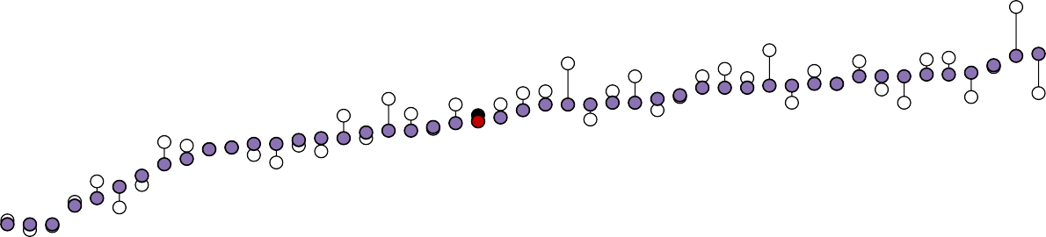14

|  |  |  |  |  |  |  |  |  |  |  |  |  |  |  |  |  |  |  |  |  |  |  |  |  |  |  |  |  |  |  |  |  |  |  |  |  |  |  |  |  |  |  |  |  |  |  |  |  |
| --- | --- | --- | --- | --- | --- | --- | --- | --- | --- | --- | --- | --- | --- | --- | --- | --- | --- | --- | --- | --- | --- | --- | --- | --- | --- | --- | --- | --- | --- | --- | --- | --- | --- | --- | --- | --- | --- | --- | --- | --- | --- | --- | --- | --- | --- | --- | --- | --- |
|  |  |  |  |  |  |  |  |  |  |  |  |  |  |  |  |  |  |  |  |  |  |  |  |  |  |  |  |  |  |  |  |  |  |  |  |  |  |  |  |  |  |  |  |  |  |  |  | 2 |
|  |  |  |  |  |  |  |  |  |  |  |  |  |  |  |  |  |  |  |  |  |  |  |  |  |  |  |  |  |  |  |  |  |  |  |  |  | 0.5 |  |  |  | 11.0 | 11.0 |  |  | 11.2 |  |  | 12. |
|  |  |  |  |  |  |  |  |  |  |  |  |  |  |  |  |  |  |  |  |  |  |  |  |  |  |  |  | 9.5 |  |  | 9.8 | 10.0 |  |  |  |  | 1 |  |  |  |  |  |  |  |  | 6 | 12.1 |  |
|  |  |  |  |  |  |  |  |  |  |  |  |  | 7.4 | 7.4 | 7.6 | 7.7 |  | 8.0 |  |  |  |  |  |  | 2 | 5 | 5 |  | 6 | 6 |  |  | 10.4 | 10.4 | 10.4 | 10.5 |  | 10.6 | 10.6 | 11.0 |  |  | 11.1 | 11.1 |  | 11. |  |  |
|  |  |  |  |  |  |  | 5.1 | 5.7 |  |  |  | 2 |  |  |  |  | 7.7 |  | 8.1 | 8.1 | 8.3 | 8.5 | 8.6 | 8.8 | 9. | 9. | 9. |  | 9. | 9. |  |  |  |  |  |  |  |  |  |  |  |  |  |  |  |  |  |  |
|  |  |  | 3.1 | 3.1 |  |  |  |  | 6.3 | 6.6 | 7.1 | 7. |  |  |  |  |  |  |  |  |  |  |  |  |  |  |  |  |  |  |  |  |  |  |  |  |  |  |  |  |  |  |  |  |  |  |  |  |
|  |  |  |  |  | 4.1 | 4.5 |  |  |  |  |  |  |  |  |  |  |  |  |  |  |  |  |  |  |  |  |  |  |  |  |  |  |  |  |  |  |  |  |  |  |  |  |  |  |  |  |  |  |
| 0.1 | 1.4 | 3.1 |  |  |  |  |  |  |  |  |  |  |  |  |  |  |  |  |  |  |  |  |  |  |  |  |  |  |  |  |  |  |  |  |  |  |  |  |  |  |  |  |  |  |  |  |  |  |

12

10

8

6

4

2

0

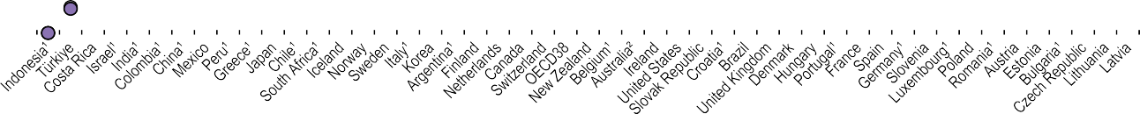1. 2019 data. 2. 2017 data.

Source: OECD Health Statistics 2023.

*StatLink 2* <https://stat.link/qezb0s>

**Figure 4.5. Proportion of adults who reported heavy episodic drinking, by sex, 2019 (or nearest year)**

Total Women Men

% 60

50

40

30

20

10

0

1. 2017 data; 2. 2021/22 data.

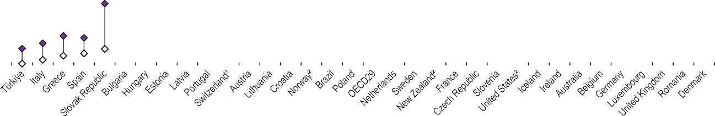

Source: Eurostat, EHIS, complemented with national data sources for non-EU/EEA countries.

*StatLink 2* <https://stat.link/zgofvk>

**Illicit drug use**

Illicit drug use is a major cause of preventable mortality, both directly through overdose and indirectly through drug-related diseases, accidents, violence and suicide (EMCDDA, 2022[1]). The use of illicit drugs, particularly among people who use them regularly and in large quantities, is associated with higher risks of cardiovascular diseases, mental health problems and accidents, as well as infectious diseases such as HIV and hepatitis C when the drug is injected.

Opioids are a narcotic pain medication used for treating moderate to severe pain. However, illicit opioid use (use of opiates such as heroin and opium, and synthetic opioids) for non-medical purposes has spread, creating illegal drug supply markets. Illicit opioid use is responsible for the majority of deaths by drug overdose. In particular, Canada and the United States have experienced an opioid crisis in recent years, fuelled by the growth in the consumption of synthetic opioids such as fentanyl and carfentanil.

Opioid-related deaths accounted for an estimated 30 deaths per million inhabitants in 2019 on average across all OECD countries (Figure 4.6). However, there were a few countries with much higher death rates – notably the United States (223 opioid-related deaths per million), followed by Estonia (130), Canada (76) and Lithuania (73). Opioid- related deaths have increased by about 20% on average in OECD countries since 2010, with large increases (of 70% of more) in Lithuania, Türkiye, the United States and Canada.

Monitoring the prevalence of opioid use is challenging due to the scarcity of data. Countries report the prevalence of use of prescription opioids and opiates (e.g. heroin and opium) by relying on household survey data or indirect estimates. In most OECD countries, prescription opioids and opiates are rarely used, although rates can be high in a few countries. The proportion of people aged 15-64 using opioids in the last 12 months in 2020 was below 0.5% in 11 of the 22 OECD countries with available data (Figure 4.7). This proportion was lowest in Spain and Israel (0.1%). Conversely, rates were highest in the United States (4.6%), Australia and Sweden (2.8%). On average across 22 OECD countries, an estimated 0.9% of people aged 15-64 had used either prescription opioids or opiates in the last 12 months. Opioid use was higher among men than women in most countries. The main opioid used in Europe is still heroin, but there are also concerns in several countries about the use of synthetic opioids (EMCDDA, 2022[1]).

Cocaine is one of the most commonly used illicit stimulant drugs. On average across 36 OECD countries, 1.2% of adults reported having used cocaine in the last year in 2020 (Figure 4.8). Rates of cocaine use ranged from 0.2% or below in Israel, Portugal, Türkiye, the Slovak Republic, Lithuania and

homelessness, youth criminality and the exploitation of vulnerable individuals (EMCDDA, 2022[1]). Comprehensive strategies to address the problematic use of opioids span sectors, covering health, social services, law enforcement, data systems and research. Four key areas for a better approach to dealing with opioid use and harms include: improved prescribing practices and opioid-related literacy; better healthcare with expanded access to treatment and harm minimisation interventions; an integrated approach across the health, social and criminal justice systems; and increased knowledge and research to support decision making at all levels (OECD, 2019[2]).

**Definition and comparability**

Opioid-related death data refer to deaths from opioid overdoses in adults and deaths in neonates attributed to the mother’s opioid use. The data come from estimates of the Global Burden of Disease 2019 carried out by the Institute of Health Metrics and Evaluation (IHME).

Opioid use prevalence data come from the UN Office for Drug and Crime (UNODC) database (available at <https://dataunodc.un.org/>). They refer to opioid use in the last 12 months among people aged 15-64, with some exceptions for age groups as noted in the UNODC data source. Estimates were derived from household survey data or indirect estimations. Opioid use includes both prescription opioids and opiates (e.g. opium and heroin). Data for Australia refer to people aged 18 and over, and come from the 2019 National Drug Strategy Household Survey. The definition can deviate from European countries, notably as data refer to high-risk opioid users, which may underestimate the prevalence of opioid use.

Data on cocaine use come from national population surveys, as gathered by the European Monitoring Centre for Drugs and Drug Addiction (EMCDDA) (for more information see [www.emcdda.europa.eu/data/stats2022/gps_en](https://www.emcdda.europa.eu/data/stats2022/gps_en)). The data focus on the percentage of adults aged 15-64 who report having used cocaine in the last year. The information is based on the last national survey available, with the survey year ranging from 2015 to 2020. EMCDDA collects data for EU countries, Norway, Türkiye and the United Kingdom. Data come from national sources for Japan (2021) and Switzerland (2017). For other OECD and key partner countries, data collected by the UNODC are used.

**References**

Japan to 2% or more in Canada, the Netherlands, Ireland, the United States, Austria, Spain and the United Kingdom, and over 4% in Australia. In accession and partner countries, rates were high in Croatia (1.8%) and below 0.2% in India and Indonesia. Men were more likely to use cocaine than women in all countries except Israel – on average across OECD countries, 1.7% of men had used cocaine in the past 12 months compared to 0.7% of women.

Drug use is linked with, or complicates responses to, a wide range of today’s most pressing health and social issues. Among these are mental health issues, self-harm,

EMCDDA (2022), *European Drug Report 2022: Trends and Developments*, EMCDDA, Lisbon, https://[www.emcdda.europa.eu/publications/edr/tren](http://www.emcdda.europa.eu/publications/edr/tren) ds-developments/2022_en.

OECD (2019), *Addressing Problematic Opioid Use in OECD Countries*, OECD Health Policy Studies, OECD Publishing, Paris, https://doi.org/10.1787/a18286f0-en.

[1]

[2]

**Figure 4.6. Opioid-related death rates, people aged 15-60, 2010 and 2019**

2010 2019

Rate per 1 000 000 population

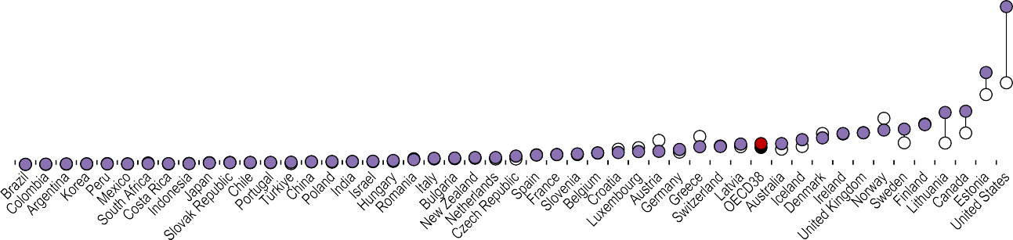250

|  |  |  |  |  |  |  |  |  |  |  |  |  |  |  |  |  |  |  |  |  |  |  |  |  |  |  |  |  |  |  |  |  |  |  |  |  |  |  |  |  |  |  |  |  |  |  |  |  |
| --- | --- | --- | --- | --- | --- | --- | --- | --- | --- | --- | --- | --- | --- | --- | --- | --- | --- | --- | --- | --- | --- | --- | --- | --- | --- | --- | --- | --- | --- | --- | --- | --- | --- | --- | --- | --- | --- | --- | --- | --- | --- | --- | --- | --- | --- | --- | --- | --- |
|  |  |  |  |  |  |  |  |  |  |  |  |  |  |  |  |  |  |  |  |  |  |  |  |  |  |  |  |  |  |  |  |  |  |  |  |  |  |  |  |  |  |  |  |  |  |  |  |  |
|  |  |  |  |  |  |  |  |  |  |  |  |  |  |  |  |  |  |  |  |  |  |  |  |  |  |  |  |  |  |  |  |  |  |  |  |  |  |  |  |  |  |  |  |  |  |  |  |  |
|  |  |  |  |  |  |  |  |  |  |  |  |  |  |  |  |  |  |  |  |  |  |  |  |  |  |  |  |  |  |  |  |  |  |  |  |  |  |  |  |  |  |  |  |  |  |  |  |  |
|  |  |  |  |  |  |  |  |  |  |  |  |  |  |  |  |  |  |  |  |  |  |  |  |  |  |  |  |  |  |  |  |  |  |  |  |  |  |  |  |  |  |  |  |  |  |  |  |  |
|  |  |  |  |  |  |  |  |  |  |  |  |  |  |  |  |  |  |  |  |  |  |  |  |  |  |  |  |  |  |  |  |  |  |  |  |  |  |  |  |  |  |  |  |  |  |  |  |  |

200

150

100

50

0

Source: IHME, 2021.

*StatLink 2* <https://stat.link/e6ky20>

**Figure 4.7. Opioid use in the last 12 months among people aged 15-64, 2020 (or nearest year)**

Total Men Women

%

5

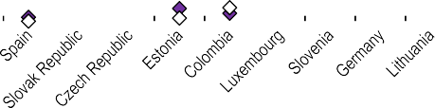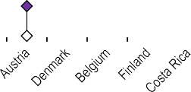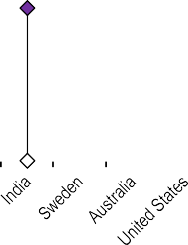

4

3

2

1

0

Source: UNODC, 2023, complemented with national sources for Australia.

*StatLink 2* <https://stat.link/mpac1k>

**Figure 4.8. Cocaine use in the last 12 months among people aged 15-64, 2020 (or nearest year)**

%

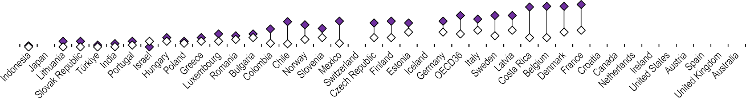

6

5

4

3

2

1

0

Total Men Women

Note: Data for the United Kingdom are for England and Wales only.

Source: EMCDDA, 2022, complemented with UNODC, 2023 and national sources for Japan and Switzerland.

*StatLink 2* <https://stat.link/6d8loa>

**Diet and physical activity**

Regular consumption of fruit and vegetables is associated with improved health outcomes – particularly in lowering the risk of cardiovascular diseases and certain types of cancer. WHO recommends eating at least 400 g, or five or more portions, of fruit and vegetables per day. A healthy diet may also reduce the likelihood of being overweight or obese. In 2019, diets low in fruit, vegetables and legumes were responsible for an estimated total of 2.7 million deaths worldwide (IHME, 2020[1]).

On average across 31 OECD countries, 57% of people aged 15 and over consumed vegetables each day in 2021. Countries with the highest rates of vegetable consumption were Korea, New Zealand and the United States, all of which recorded values greater than 90% (Figure 4.9). At the other end of the spectrum, daily vegetable consumption was below 40% in Luxembourg, the Netherlands and Latvia, as well as in accession country Romania. Daily vegetable consumption was higher among women than men in all OECD countries except Mexico. On average across OECD countries, 62% of women consume at least one portion of vegetables per day compared to 52% of men.

While more than one in two adults consume at least one vegetable per day, only one in seven reported consuming the five or more portions of fruit and vegetables per day recommended by WHO. Specifically, in 2019, 15% of adults reported eating five or more portions of fruit and vegetables per day on average across 30 OECD countries with comparable data. Countries with the highest proportions of adults reporting consuming five or more portions of fruit and vegetables per day were Ireland, the United Kingdom, Korea, Israel and the Netherlands (30% or above). Conversely, the proportion was 5% or less in Türkiye and Slovenia, as well as in accession countries Romania and Bulgaria (Figure 4.10). Women are more likely than men to consume five or more portions of fruit and vegetables per day in all OECD countries except Greece and Korea. The gender gap was widest in Denmark, Finland and Ireland.

Regular physical activity is also important for improving mental and musculoskeletal health and reducing the risk of various non-communicable diseases. WHO recommends that adults perform at least 150 minutes of moderate-intensity aerobic physical activity, or at least 75 minutes of vigorous-intensity aerobic physical activity (or a combination of both) per week, in different settings, and limit the amount of time spent being sedentary.

In 2019, more than one-third (40%) of adults reported performing at least 150 minutes of non-work-related moderate-to-vigorous intensity aerobic physical activity per week, on average across 32 OECD countries (Figure 4.11). This proportion varied from 10% or less in Türkiye and in accession country Romania to more than 50% in Switzerland, Australia, Norway, the Netherlands, England (United Kingdom), Sweden, Iceland, Denmark, Japan and New Zealand. A greater proportion of men reported performing at least 150 minutes of weekly physical activity than women in all countries except Denmark, Sweden and Iceland. The gender gap was largest in the Czech Republic, France, Japan, the Slovak Republic and Spain (above 10 percentage points). It is estimated that increasing physical activity levels to the WHO recommendation would reduce the burden of disease and prevent over 10 000 premature deaths annually across European countries (OECD/WHO, 2023[2]).

**References**

**Definition and comparability**

Vegetable consumption is defined as the proportion of adults who consume at least one vegetable per day, excluding juice and potatoes. Data for New Zealand include potatoes. Most countries report national health survey (self- reported) data for the population aged 15 years and over. Data for Korea and New Zealand are derived from questions on the quantity of vegetables consumed each day (rather than frequency questions, e.g. over past week). Values for these countries may therefore be overestimated. Data for the Netherlands refer only to cooked or baked vegetables, which may underestimate consumption.

The indicator on fruit and vegetables consumption refers to the share of adults (aged 18 and over) who report consuming five or more portions per day, excluding fruit or vegetable juices and potatoes, collected from EHIS 2019. In Belgium, 100% pure fresh fruit or vegetable juices are included. Data were complemented for non-EU/EAA countries with national sources. In Canada, the Canadian Community Health Survey collects data for adults aged 18 and over. The data include pure fruit juice, frozen or canned fruits and vegetables, and dried fruit, but excludes fried potatoes. The Korean National Health and Nutrition Examination Survey collects data for adults aged 19 and over. The Swiss Health Survey collects data for adults aged 15 and over who report eating 5 or more portions per day, at least five days per week. In the United Kingdom, the National Diet and Nutrition Survey collects data for those aged 19-64 years.

The indicator on physical activity refers to time spent on non-work-related moderate-to-vigorous intensity aerobic physical activity, collected from EHIS 2019. In Germany, data collection for EHIS took place in 2019 and 2020. Data were complemented for non-EU/EEA countries using the Australian National Health Survey, the Brazilian National Health Survey, the Canadian Health Measures Survey, the English Active Lives Survey, the Japanese Sasakawa Sports Foundation (SSF) National Sports-Life Survey, the Korean National Health and Nutrition Examination Survey, the New Zealand Health Survey, the Swiss Health Survey, and the US National Health Interview Survey. The data refer to adults aged 18 and over, except in Australia (18-64), Canada (18-79), England (16 and over), Korea (19 and over), New Zealand and Switzerland (15 and over).

IHME (2020), *Diet low in Fruit, Vegetable and Legumes*, Institute for Health Metrics and Evaluation, <http://www.healthdata.org/results/gbd_summaries/20> 19/diet-low-in-legumes-level-3-risk.

OECD/WHO (2023), *Step Up! Tackling the Burden of Insufficient Physical Activity in Europe*, OECD Publishing, Paris, https://doi.org/10.1787/500a9601- en.

[1]

[2]



Total Men Women

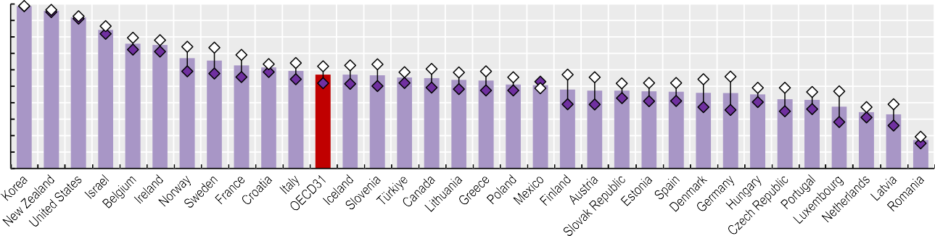% of population aged 15 years and over 100

90

80

70

60

50

99

96

92

84

76

75

67

66

63

40

30

61

59

57

57

57

55

55

54

54

51

51

48

47

47

47

47

46

46

45

42

42

20

38

34

33

17

10

0

Source: OECD Health Statistics 2023.

*StatLink 2* <https://stat.link/rdf54q>

**Figure 4.10. Daily consumption of five or more portions of fruit and vegetables among adults, by sex, 2019 (or nearest year)**



Total Men Women

% of population aged 18 years and over

1. 2016-19 data; 2. 2021 data.

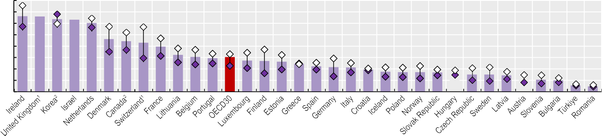

40

35

30

25

20

15

10

5

0

33

33

32

32

30

23

22

22

20

16

15

15

15

14

14

13

12

11

11

11

10

9

9

9

9

8 8

8

7

6

5

5

3

2

Source: Eurostat, EHIS, complemented with national sources for non-EU/EEA countries.

*StatLink 2* <https://stat.link/5u7yv3>

**Figure 4.11. Spending at least 150 minutes per week on physical activity, by sex, 2019 (or nearest year)**



Total Men Women

% of population aged 18 years and over

1. 2017 data; 2. 2020-22 data.

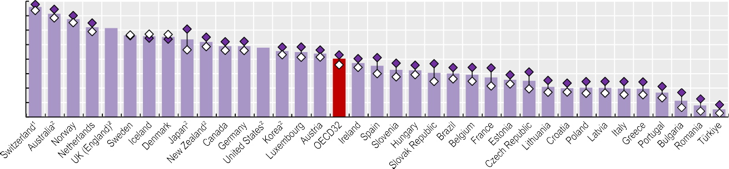

80

70

60

50

40

30

20

10

0

76

71

68

62

61

56

56

55

54

52

49

49

48

46

45

44

40

37

35

33

32

31

30

29

27

26

25

21

20

20

20

20

20

17

11

8

5

Source: Eurostat, EHIS, complemented with national sources for non-EU/EEA countries.

*StatLink 2* <https://stat.link/l5t27k>

**Overweight and obesity**

Being overweight or obese is a major risk factor for various non-communicable diseases, including diabetes, cardiovascular diseases, and certain cancers. During the pandemic, obesity increased the risk of severe symptoms, as well as the risk of COVID-19 related hospitalisation and death (OECD, 2023[1]). Women and men with lower incomes are more likely to be obese, entrenching health inequalities. High consumption of energy-dense food, trans-fats and saturated fats, and increasingly sedentary lifestyles have contributed to growing global obesity rates. Unfavourable shifts in eating behaviours and physical activity patterns were accentuated by the mobility restrictions during the pandemic, potentially counteracting the gains made by policies promoting healthier lifestyles and accentuating the prevalence of obesity (WHO Regional Office for Europe, 2022[2]).

In most OECD countries that collect self-reported body height and weight data, more than half of adults were overweight or obese. On average across 32 OECD countries, 54% of the adult population were overweight or obese, and 18% were obese in 2021. Men were more likely than women to be overweight or obese in all countries. The gender gap was particularly large in Luxembourg, Germany and the Czech Republic (a difference of 19-20 percentage points) (Figure 4.12).

Measured height and weight data are a more reliable indicator but are available for a narrower set of countries. Across the 16 OECD countries with measured data, 60% of adults were overweight or obese, and 26% were obese in 2021 or in the latest available year (Figure 4.13). In 13 of these 16 countries, over half of the adult population was overweight or obese. For Mexico, the United States and Costa Rica, this proportion exceeded 70%. Conversely, in Japan and Korea, fewer than 40% of adults were overweight or obese. Men were more likely than women to be overweight or obese in most countries, except in Latvia, Mexico and Türkiye. The gender gap was relatively wide in Australia, Hungary and Korea (a difference of 14-16 percentage points).

The proportion of overweight and obese adults has increased since the early 2000s in most OECD countries. In most

OECD member countries have implemented a suite of regulatory and non-regulatory initiatives to reduce overweight population rates. Prominent examples include mass media campaigns to promote the benefits of healthy eating; promotion of nutritional education and skills; taxes on energy- dense food and drink items to discourage consumption; simplified food labelling to communicate nutritional value; and agreements with the food industry to improve the nutritional value of products. A number of countries’ “best practice” initiatives, including food labelling, lifestyle counselling, school- and community-based programmes to promote healthy eating and active lifestyles, were evaluated as effective and efficient in reducing overweight and obesity, and were assessed for transferability to other national contexts (OECD, 2022[4]).

**Definition and comparability**

Being overweight is defined as having an abnormal or excessive accumulation of fat, which presents a risk to health. The most frequently used measure is body mass index (BMI), which is a single number that evaluates an individual’s weight in relation to height (dividing weight in kilograms by height in metres squared). Based on WHO classifications, adults over the age of 18 with a BMI greater than or equal to 30 are defined as obese, and those with a BMI greater than or equal to 25 as overweight (including obese). The method for calculation of BMI is the same for men and women and for adults of all ages. BMI data can also be collected using self-reported estimates of body height and weight. BMI estimates based on self-reported data are typically lower and less reliable than those based on measured data. Data refer to 2021 or the nearest available year back to 2017 (see the weblink to metadata in the “Reader’s Guide). Most countries report data for the population aged 15 and over, but there are some exceptions (see weblink to metadata in the “Reader’s Guide”).

**References**

countries where rates were historically low, such as Japan, Korea, Latvia and Belgium, as well as partner country Brazil, overweight and obesity rates grew by 1-2% annually (Figure 4.14, left panel), although in France, overweight and obesity rates decreased slightly between 2006 and 2017. In countries with relatively high proportions of overweight and obese adults, the rates have also increased – by around 1% annually in Hungary, Mexico, New Zealand and the United States (Figure 4.14, right panel). Overweight and obesity rates increased at a relatively slow pace in the United Kingdom.

Overweight and obesity rates among adolescents are also major public health concerns: 18.3% of adolescents aged 15 years were overweight or obese in 2017-18 on average across 27 OECD countries. Social inequalities were visible in all these countries, and boys were always more likely to be overweight than girls. The proportion of 15-year-olds who were overweight or obese has increased in 23 of these 27 countries since 2009-10 based on data from the Health Behaviour in School-aged Children survey (Inchley et al., 2020[3]).

Inchley, J. et al. (eds.) (2020), *Spotlight on adolescent health and well-being. Findings from the 2017/2018 Health Behaviour in School-aged Children (HBSC) survey in Europe and Canada.*

*International report. Volume 2. Key data*, World Health Organization Regional Office for Europe, Copenhagen, https://apps.who.int/iris/handle/10665/332104.

OECD (2023), *Ready for the Next Crisis? Investing in Health System Resilience*, OECD Health Policy Studies, OECD Publishing, Paris, https://doi.org/10.1787/1e53cf80-en.

OECD (2022), *Healthy Eating and Active Lifestyles: Best Practices in Public Health*, OECD

Publishing, Paris, https://doi.org/10.1787/40f65568-en.

WHO Regional Office for Europe (2022), *WHO European Regional Obesity Report 2022*, World Health Organization Regional Office for Europe, https://apps.who.int/iris/handle/10665/353747.

[3]

[1]

[4]

[2]



Overweight (but not obese) Obese Men (overweight including obese) Women (overweight including obese)

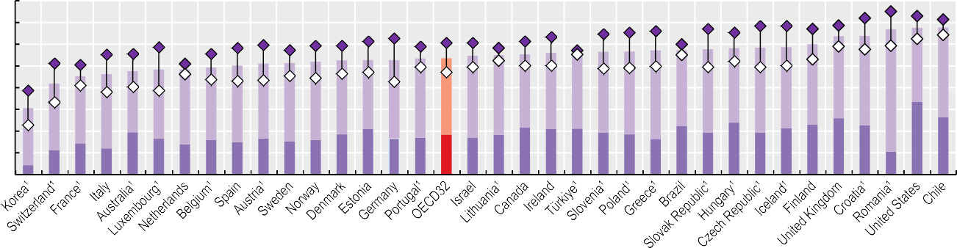% 80

70

60

50

40

30

20

4

11

14

12

20

17

14

16

15

17

15

16

19

21

17

17

18

17

18

22

21

21

19

19

16

22

19

24

19

21

23

26

23

11

34

26

10

0

1. 2017-19 data.

Source: OECD Health Statistics 2023.

*StatLink 2* <https://stat.link/23vcng>

**Figure 4.13. Measured overweight and obesity rates among adults, by sex, 2021 (or nearest year)**



Overweight (but not obese) Obese Men (overweight including obese) Women (overweight including obese)

% 80

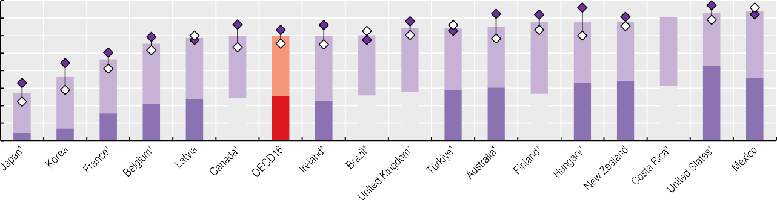70

60

50

40

30

26

28

27

31

20

24

24

26

29

30

33

34

43

36

10

7

16

21

23

0

5

1. 2017-19 data.

Source: OECD Health Statistics 2023.

*StatLink 2* <https://stat.link/ixvkc3>

**Figure 4.14. Evolution of measured overweight (including obesity) rates**

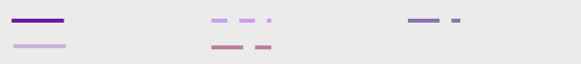

Hungary United States

Mexico

United Kingdom

New Zealand

% 100

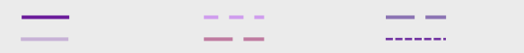

Belgium Japan

Brazil France

Latvia Korea

90

80

70

60

50

40

30

20

10

0

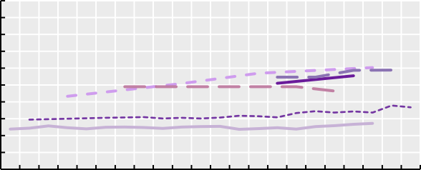

2000 2005 2010 2015 2020

% 100

90

80

70

60

50

40

30

20

10

0

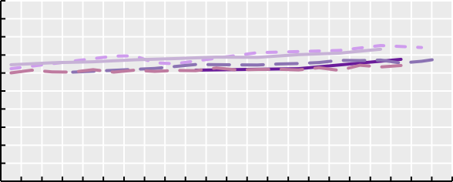

2000 2005 2010 2015 2020

Source: OECD Health Statistics 2023.

*StatLink 2* <https://stat.link/jiaw5y>

**Environment and health**

Climate change is one of the biggest challenges for present and future generations. It is linked to many different types of environment distress, including air pollution and extreme temperatures. Air pollution is already the most significant environmental health risk and a major cause of death and disability, and its future impact is likely to be even greater without adequate policy action. Projections have estimated that outdoor air pollution may cause between 6 million and 9 million premature deaths a year worldwide by 2060, and cost 1% of global gross domestic product (GDP) as a result of sick days, medical bills and reduced agricultural output (OECD, 2015[1]).

Among OECD countries, premature deaths from ambient (outdoor) particulate matter pollution – and especially fine particulate matter (PM2.5) declined by about 31% between 2000 and 2019, from 42 deaths per 100 000 people in 2000 to about

29 deaths per 100 000 in 2019 (Figure 4.15). Over the same period, average population exposure to ambient particulate matter declined by 32% on average across OECD countries. While mortality associated with ambient particulate matter pollution fell in most OECD countries, it increased between 2000 and 2019 in seven: Japan, Costa Rica, Korea, Chile, Mexico, Colombia and Türkiye, including an increase of 20% or more in Japan (30%), Costa Rica (24%) and Korea (20%). Mortality associated with ambient particulate matter pollution fell by more than 50% in ten OECD countries, with the greatest reductions in Norway (72%) and Sweden (70%). While policies to reduce pollution have led to some important reductions in deaths caused by air pollution, they remain a major public health and environmental concern.

Extreme temperatures are also a consequence of climate change. Both extreme heat and extreme cold can cause health problems and lead to death. For OECD countries, extreme cold has generally had a greater impact on mortality than heatwaves – particularly in Central and Eastern Europe and the Nordic countries – although heatwaves have also caused significant numbers of deaths in certain years. The record-warm summer of 2003, for example, caused around 80 000 deaths in Europe, and the heatwaves in the summer of 2015 caused more than 3 000 deaths in France alone. Furthermore, the 2021 heatwave in Western Canada and the United States caused hundreds of deaths, especially among older adults.

On average across the 38 OECD countries, the proportion of

risen by more than two-thirds (68%) between 2000-04 and 2017-21 (Romanello et al., 2022[2]).

Inter-sectoral policies are needed to address the impact of climate change. Countries can start planning to address pollution and its impacts on health, for instance, by creating partnerships with international, national and local stakeholders, including local city authorities and ministries of industry, environment, transport and agriculture. Reducing crop burning and lowering emissions from motor vehicles and industries would lower ambient air pollution. Health systems can also contribute, by preparing for new diseases that can develop with new climate and biodiversity conditions; promoting consumption of sustainably grown and sourced food; and reducing the carbon footprint of health facilities. In addition, health providers can reduce the environmental footprint in hospitals and in nursing homes by encouraging healthier food consumption, waste reduction and efficient energy use (OECD, 2017[3]).

**Definition and comparability**

Ambient (outdoor) particulate matter pollution results from emissions from industrial activity, households, cars and trucks, which are complex mixtures of air pollutants, many of which are harmful to health. Of all these pollutants, PM2.5, even at low levels, has the greatest effect on human health. Polluting fuels include solid fuels such as wood, coal, animal dung, charcoal, crop waste and kerosene. Data on mortality and disability-adjusted life-years from exposure to environmental risks are taken from the Global Burden of Disease (GBD) Study 2019 results.

Data on population exposure to extreme temperatures (hot summer days) present the annual percentage of the population exposed to hot summer days, measured as days where the maximum daily temperature exceeds 35

°C. Five-year averages are calculated. Data are based on indicators prepared by the OECD jointly with the International Energy Agency as part of the OECD International Programme for Action on Climate.

**References**

the population estimated to have been exposed to hot summer days increased from 22% on average from 2000-04, to 29% on average in 2017-21 – a 35% increase across the two periods (Figure 4.16). In ten countries – Chile, Belgium, the Netherlands, Korea, Poland, France, Germany, Canada, Luxembourg and Austria – the proportion of the population who were exposed to hot summer days increased by over 50%, including six countries (Chile, Belgium, the Netherlands, Korea, Poland and France) in which the proportion more than doubled between 2000-04 and 2017-21. In the United Kingdom, the proportion increased from 0% to 7% between the two periods. Increased exposure to hot weather has already led to increases in mortality, with further heat- related deaths and morbidity likely to arise as temperatures continue to increase. Globally, heat-related deaths among older populations (aged 65 and older) are estimated to have

OECD (2017), “Healthy people, Healthy planet: The role of health systems in promoting healthier lifestyles and a greener future”, OECD, Paris, https[://www.oecd.org/health/healthy-people-healthy-](http://www.oecd.org/health/healthy-people-healthy-) planet.htm.

OECD (2015), *The Economic Consequences of Climate Change*, OECD Publishing, Paris, https://doi.org/10.1787/9789264235410-en.

Romanello, M. et al. (2022), “The 2022 report of the Lancet Countdown on health and climate change: health at the mercy of fossil fuels”, *The Lancet*,

Vol. 400/10363, pp. 1619-1654,

https://doi.org/10.1016/s0140-6736(22)01540-9.

[3]

[1]

[2]

**Figure 4.15. Change in premature deaths attributable to ambient particulate matter pollution, 2000-19**

%



100

80

60

40

20

0

-20

-40

-60

-80

-100

Source: OECD Environment Statistics, 2020.

*StatLink 2* <https://stat.link/ukvhzm>

**Figure 4.16. Population exposure to hot summer days (% of population), 2000-04 vs. 2017-21**

% 100

2000-04 2017-21

95

|  |  |  |  |  |  |  |  |  |  |  |  |  |  |  |  |  |  |  |  |  |  |  |  |  |  |  |  |  |  |  |  |  |  |  |  |  |  |  |  |  |  |  |  |  |  |  |  |  |
| --- | --- | --- | --- | --- | --- | --- | --- | --- | --- | --- | --- | --- | --- | --- | --- | --- | --- | --- | --- | --- | --- | --- | --- | --- | --- | --- | --- | --- | --- | --- | --- | --- | --- | --- | --- | --- | --- | --- | --- | --- | --- | --- | --- | --- | --- | --- | --- | --- |
|  |  |  |  |  |  |  |  |  |  |  |  |  |  |  |  |  |  |  |  |  |  |  |  |  |  |  |  |  |  |  |  |  |  |  |  |  |  |  |  |  |  |  |  |  |  |  |  |  |
|  | 8 | 78 | 78 | 76 | 76 |  |  |  |  |  |  |  |  |  |  |  |  |  |  |  |  |  |  |  |  |  |  |  |  |  |  |  |  |  |  |  |  |  |  |  |  |  |  |  |  |  |  |  |
|  |  |  |  |  |  | 66 | 64 |  |  |  |  |  |  |  |  |  |  |  |  |  |  |  |  |  |  |  |  |  |  |  |  |  |  |  |  |  |  |  |  |  |  |  |  |  |  |  |  |  |
|  |  |  |  |  |  |  |  | 6 |  |  |  | 58 |  | 53 | 53 |  |  |  |  |  |  |  |  |  |  |  |  |  |  |  |  |  |  |  |  |  |  |  |  |  |  |  |  |  |  |  |  |  |
|  |  |  |  |  |  |  |  |  |  |  | 60 |  |  |  |  |  |  | 47 |  | 45 |  |  |  |  |  |  |  |  |  |  |  |  |  |  |  |  |  |  |  |  |  |  |  |  |  |  |  |  |
|  |  |  |  |  |  |  |  |  |  |  |  |  | 54 |  |  |  |  |  |  |  | 38 | 33 |  |  |  |  |  |  |  |  |  |  |  |  |  |  |  |  |  |  |  |  |  |  |  |  |  |  |
|  |  |  |  |  |  |  |  |  |  |  |  |  |  |  |  |  | 4 |  | 46 |  |  |  | 3 |  | 29 | 29 | 28 | 25 | 22 |  |  |  |  |  |  |  |  |  |  |  |  |  |  |  |  |  |  |  |
|  |  |  |  |  |  |  |  |  |  |  |  |  |  |  |  |  |  |  |  |  |  |  |  |  |  |  |  |  |  | 2 | 2 | 2 | 17 | 12 |  |  |  |  |  |  |  |  |  |  |  |  |  |  |
|  |  |  |  |  |  |  |  |  |  |  |  |  |  |  |  |  |  |  |  |  |  |  |  |  |  |  |  |  |  |  |  |  |  |  |  |  | 7 | 6 |  |  |  |  |  |  |  |  |  |  |
|  |  |  |  |  |  |  |  |  |  |  |  |  |  |  |  |  |  |  |  |  |  |  |  |  |  |  |  |  |  |  |  |  |  |  |  | 9 |  |  | 0 | 0 | 0 | 0 | 0 | 0 | 0 | 0 | 0 | 0 |

90

1

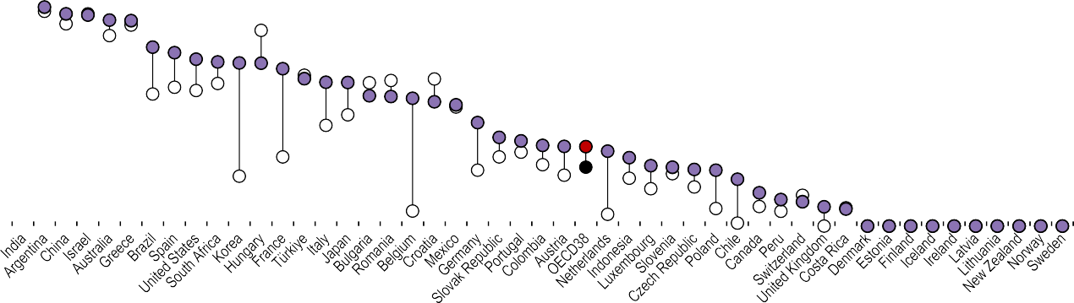80

70

1

60

60

60

50

40

48

8

1

30

30

2

1

1

20

10

10

0

Source: OECD International Programme for Actions on Climate (IPAC), Climate Actions Dashboard, 2023.

*StatLink 2* <https://stat.link/8rtv7w>

**98** 

**5** **Access: Affordability, availability and use of services**

Population coverage for healthcare Unmet needs for healthcare

Extent of healthcare coverage

Financial hardship and out-of-pocket expenditure Consultations with doctors

Digital health

Hospital beds and occupancy Hospital activity

Diagnostic technologies Hip and knee replacement Ambulatory surgery

Waiting times for elective surgery

**Population coverage for healthcare**

The share of a population covered for a core set of health services offers an initial measure of access to care and financial protection. Most OECD countries have achieved universal or near-universal coverage for a core set of health services, which usually include consultations with doctors, tests and examinations, and hospital care (Figure 5.1). National health systems or social health insurance have typically been the financing schemes for achieving universal health coverage. A few countries (such as the Netherlands and Switzerland) have achieved universality through compulsory private health insurance – supported by public subsidies and strong regulation on the scope and depth of coverage.

Population coverage for core services remained below 95% in six OECD countries in 2021, and below 90% in Mexico and the United States. Coverage was also below 90% in Romania. Mexico has expanded coverage since 2004, when it was around 50%, but coverage has fallen in recent years. In the United States, the share of uninsured people decreased following the Affordable Care Act, from about 13% in 2013 to 9% in 2015, with a more gradual reduction in uninsured people since then (United States Census Bureau, 2022[1]). Uninsured people tend to be working-age adults with lower education or income levels. In Ireland, although coverage is universal, fewer than half of the population are covered for the cost of all general practitioner (GP) services, but new eligibility measures introduced in 2023 will increase the proportion covered for GP services.

Beyond population coverage rates, satisfaction with the availability of quality health services offers further insight into effective coverage. The Gallup World Poll collects data on citizens’ satisfaction with health and other public services. While contextual and cultural factors influence survey responses, the poll allows citizens’ opinions to be compared based on the same survey question. Satisfaction with the availability of quality health services averaged 67% across OECD countries in 2022 (Figure 5.2). Swiss and Belgian citizens were most likely to be satisfied (90% or more), while those in Chile, Colombia, Hungary and Greece were least likely to be satisfied (fewer than 50%). While satisfaction levels have decreased slightly on average across OECD countries over the past decade, this masks wide cross-country variation: Hungary, Canada, New Zealand and the United Kingdom all experienced large declines in satisfaction (a drop of around 20 percentage points), whereas in Estonia and Greece satisfaction levels increased by 15 percentage points or more.

In many countries, citizens can purchase additional health

population in 2021 (Figure 5.3). Complementary insurance to cover cost-sharing is widely used in Belgium, France and Slovenia (over 90% of the population). Israel and the Netherlands had the largest supplementary health insurance market (over 80% of the population). Duplicate private health insurance was most widely used in Ireland and Australia. In the United States, around 10% of the population had complementary private health insurance. This is in addition to the 53% of the American population who had primary private health insurance. Over the last decade, the population covered by additional private health insurance has increased in 20 of 24 OECD countries with comparable data. Several factors determine how additional private health insurance evolves – notably the extent of gaps in access to publicly financed services and government interventions directed at private health insurance markets.

**Definition and comparability**

Population coverage for healthcare is defined here as the share of the population eligible for a core set of healthcare services – whether through public programmes or primary private health insurance. The set of services is country- specific, but usually includes consultations with doctors, tests and examinations, and hospital care. Public coverage includes both national health systems and social health insurance. National health systems are largely financed from general taxation, whereas in social health insurance systems, financing typically comes from a combination of payroll contributions and taxation. In both, financing is linked to ability to pay. Primary private health insurance refers to insurance coverage for a core set of services and can be voluntary or mandatory by law, for some or all of the population. Additional (secondary) private health insurance is always voluntary, with insurance premiums generally not income-related, although the purchase of private coverage may be subsidised by the government.

Data from the Gallup World Poll used in Figure 5.2 are generally based on a representative sample of at least 1 000 citizens in each country aged 15 years and older. Respondents were asked: “In the city or area where you live, are you satisfied or dissatisfied with the availability of quality healthcare?”

**References**

coverage through voluntary private health insurance. This can cover any cost-sharing left after basic coverage (complementary insurance), add further services (supplementary insurance), or provide faster access or a wider choice of providers (duplicate insurance). Among 28 OECD countries with recent comparable data, 11 had additional private insurance coverage for over half of the

United States Census Bureau (2022), *Health Insurance Coverage in the United States: 2021*.

[1]

**Figure 5.1. Population coverage for a core set of services, 2021 (or nearest year)**



Total public coverage Primary private health coverage

Percentage of total population

Source: OECD Health Statistics 2023.

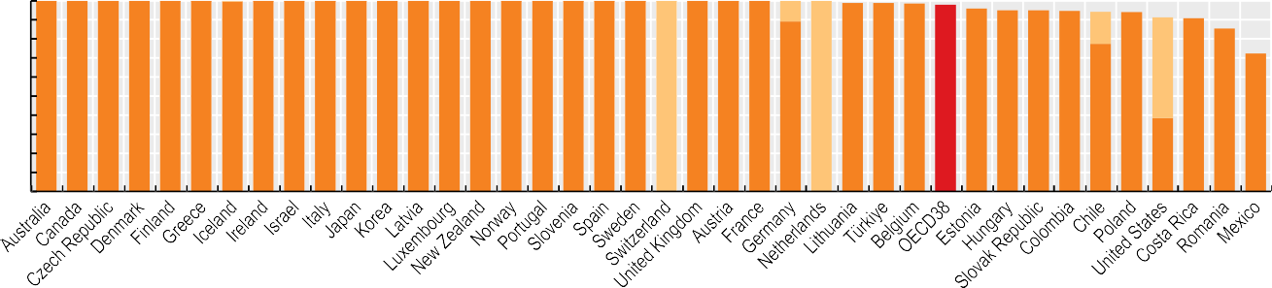

100

90

80

70

60

50

40

30

20

10

0

11

17

53

100 100 100 100 100 100 100 100 100 100 100 100 100 100 100 100 100 100 100 100 100 100 100 100 89 100 99 99 99 98 96 95 95

95

94

77

91 86

38

72

*StatLink 2* <https://stat.link/s15m30>

**Figure 5.2. Population satisfied with the availability of quality healthcare in the area where they live, 2012 and 2022**



2012 2022 (values shown)

Source: Gallup World Poll 2023 (database).

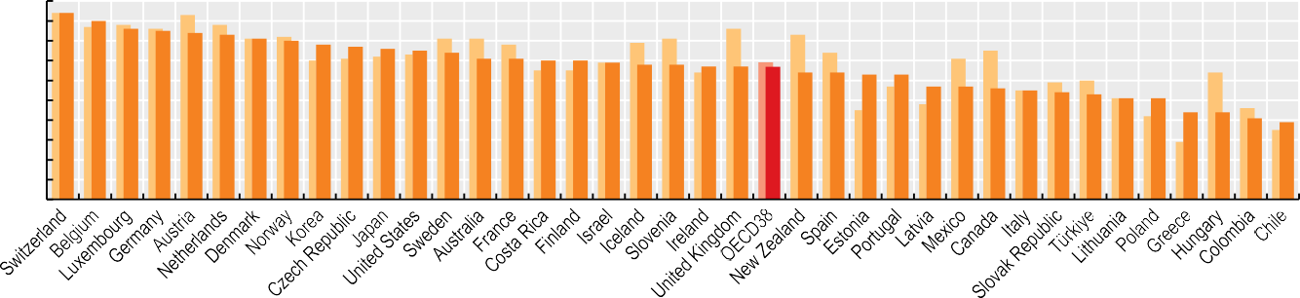

100 Percentage of total population 90

80

70

60

50

40

30

20

10

0

94

90

86

85

84

83

81

80

78

77

76

75

74

71

71

70

70

69

68

68

67

67

67

64

64

63

63

57

57

56

55

54

53

51

51

44

44

41

39

*StatLink 2* <https://stat.link/a4nuld>

**Figure 5.3. Voluntary private health insurance coverage by type, 2021 and 2011 (or nearest years)**



Duplicate (time/choice) Supplementary (services) Complementary (costs) Total (2011)

Percentage of total population

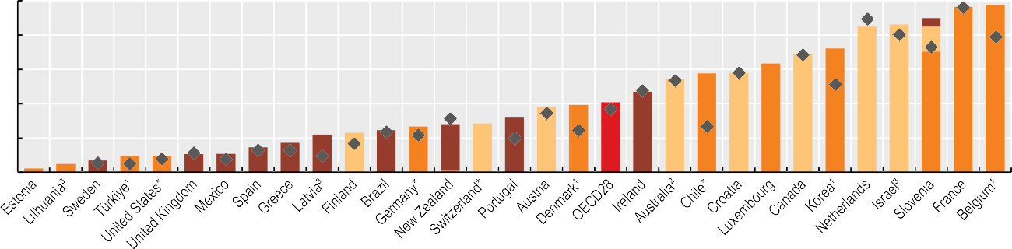

100

85 86 90

80

69

72

58 58 63

60

47

54

41

40

28

32

38

39

17

22

23

25 27

29

20

15

5 7

10

10

11

11

0

2

96 98

Note: Data refer to additional (secondary) voluntary private health insurance. They exclude primary private health insurance coverage, which exists in Chile, Germany, Switzerland and the United States. 1. Can be complementary and supplementary. 2. Can be duplicate and supplementary. 3. Can be complementary, supplementary and duplicate.

Source: OECD Health Statistics 2023.

*StatLink 2* <https://stat.link/94u05o>

**Unmet needs for healthcare**

A fundamental principle underpinning all health systems across OECD countries is to provide access to high-quality care for the whole population, irrespective of their socio-economic circumstances. Yet access can be limited for several reasons, including limited availability or affordability of services. Policies therefore need to ensure an adequate supply and distribution of health workers and healthcare services throughout the country, and address any financial barriers to care (OECD, 2019[1]; 2023[2]).

On average across 26 OECD countries with comparable data, only 2.3% of the population reported that they had unmet medical care needs due to cost, distance or waiting times in 2021 (Figure 5.4). However, over 5% of the population reported unmet care needs in Estonia (8.1%) and Greece (6.4%), while in Germany, the Netherlands, Austria and the Czech Republic, fewer than 0.5% of the population reported unmet needs for medical care. Socio-economic disparities are significant: people in the lowest income quintile were three times more likely to report unmet medical care needs than those in the highest quintile in 2021, on average across 26 OECD countries. This income gradient exists in all analysed countries; it was largest in Greece, Latvia and Türkiye (and accession country Romania), with a difference of over 6 percentage points in the population reporting unmet needs between the lowest and highest income quintiles. In Greece and Estonia, more than one in ten people in the lowest income quintile reported unmet medical care needs.

Reported unmet needs are generally larger for dental care than for medical care (Figure 5.5). This reflects the fact that dental care is less well covered by public schemes than medical care in most OECD countries, so people often must pay out of pocket or purchase additional private health insurance (see section on “Extent of healthcare coverage”). More than 7% of people in Portugal, Latvia, Iceland and Greece reported unmet dental care needs in 2021, compared to fewer than 0.5% in the Netherlands, Germany and Austria. In all analysed countries, the burden of unmet needs for dental care falls disproportionately on people on lower incomes. This was most evident in Portugal and Latvia, where more than 16% of people in the lowest income quintile reported forgoing needed dental care in 2021, compared to fewer than 2% in the highest quintile. Recently, Portugal has aimed to improve access to

now includes a function where patients can select a treatment service and the system automatically searches for an appointment time that matches their preferences. This system should help the government track which health services have longer waiting lists and analyse the reasons (OECD/European Observatory on Health Systems and Policies, forthcoming[3]).

**Definition and comparability**

Questions on unmet healthcare needs are included in the EU Statistics on Income and Living Conditions (EU-SILC) survey compiled by Eurostat. People are asked whether in the previous 12 months they ever felt they needed medical care or dental care but did not receive it, followed by a question on why the need for care was unmet. The data presented here focus on three reasons: healthcare was too expensive, the distance to travel was too far, or waiting times were too long. Note that some other surveys of unmet needs (for example, the European Health Interview Survey) report much higher rates of unmet needs. This is because such surveys exclude people without healthcare needs, while the EU-SILC survey considers the total population surveyed.

In comparing across countries, cultural factors may affect responses to questions about unmet healthcare needs. There are also some variations in the survey questions across countries: while most countries refer to both a medical examination and treatment, the question in some countries (the Czech Republic and Spain) only refers to a medical examination or a doctor consultation, resulting in lower rates of unmet needs.

Income quintile groups are computed based on the total equivalised disposable income attributed to each household member. The first quintile represents the 20% of the population with the lowest income, and the fifth quintile the 20% of the population with the highest income. Data for Iceland refer to 2018, data for Norway refer to 2020; for all other countries data refer to 2021.

**References**

dental care by creating dental health offices within public primary healthcare facilities.

The main reason cited for unmet needs for medical care was typically waiting times, with 1.4% of people reporting this issue in 2021, on average across 26 OECD countries (Figure 5.6). In Estonia, Slovenia and Finland, more than 4% of the population cited waiting times as a barrier. Cost was also cited as an important barrier to access, and was the main reason for unmet needs in Greece, Iceland, Türkiye and Latvia, and accession country Romania. Distance to travel was also cited as a barrier, but less frequently than waiting times or cost.

Unmet medical care needs due to cost have generally fallen in most countries since 2011 (other than in Portugal, Luxembourg and Denmark). However, unmet medical care needs due to waiting times have often increased since 2011 – particularly in Slovenia, Estonia, Ireland and the Slovak Republic. Some of these countries have introduced initiatives to reduce waiting times. In Estonia, for example, the national e-booking system

OECD (2023), *Ready for the Next Crisis? Investing in Health System Resilience*, OECD Health Policy Studies, OECD Publishing, Paris, https://doi.org/10.1787/1e53cf80-en.

OECD (2019), *Health for Everyone?: Social Inequalities in Health and Health Systems*, OECD Health Policy Studies, OECD Publishing, Paris, https://doi.org/10.1787/3c8385d0-en.

OECD/European Observatory on Health Systems and Policies (forthcoming), *Estonia: Country Health Profile 2023*, State of Health in the EU, OECD Publishing, Paris.

[2]

[1]

[3]

**Figure 5.4. Population reporting unmet needs for medical care, by income level, 2021**

Total Lowest quintile Highest quintile

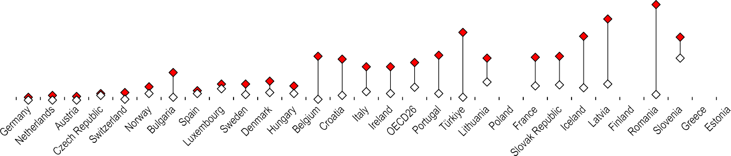

12

10

8

6

4

2

0

% of population who reported unmet needs

Note: Data for Iceland refer to 2018 and data for Norway refer to 2020. Source: Eurostat, based on EU-SILC.

*StatLink 2* <https://stat.link/rpkaci>

**Figure 5.5. Population reporting unmet needs for dental care, by income level, 2021**

Total Lowest quintile Highest quintile

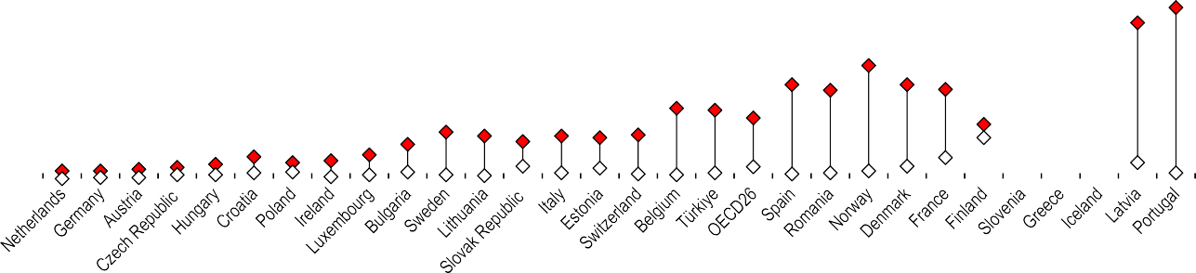

20

18

16

14

12

10

8

6

4

2

0

% of population who reported unmet needs

Note: Data for Iceland refer to 2018 and data for Norway refer to 2020. Source: Eurostat, based on EU-SILC.

*StatLink 2* <https://stat.link/rkcp8e>

**Figure 5.6. Main reason for reporting unmet needs for medical care, 2021**

Waiting list Too expensive Too far to travel



9

8

7

6

5

4

3

2

1

0

% of population who reported unmet needs

Note: Data for Iceland refer to 2018 and data for Norway refer to 2020. Source: Eurostat, based on EU-SILC.

*StatLink 2* <https://stat.link/ujceq3>

**Extent of healthcare coverage**

In addition to the share of the population entitled to core health services, the extent of healthcare coverage is defined by the range of services included in a publicly defined benefit package and the proportion of costs covered. Differences across countries in the extent of coverage can be the result of specific goods and services being included or excluded in the publicly defined benefit package (such as a particular drug or medical treatment), different cost-sharing arrangements or some services only being covered for specific population groups in a country (such as dental treatment).

On average across OECD countries, around three-quarters of all healthcare costs were covered by government or compulsory health insurance schemes in 2021 (see section on “Health expenditure by financing scheme” in Chapter 7), but financial protection is not uniform across all types of healthcare goods and services, and there is considerable variation across countries. In nearly all OECD countries, inpatient services in hospitals were more comprehensively covered than any other type of care, with 90% of all costs borne by government or compulsory insurance schemes in 2021 (Figure 5.7). In many countries, patients have access to free acute inpatient care or only need to make a small co-payment; as a result, coverage rates were near 100% in Sweden, Norway, Iceland and Estonia. In Australia, Greece and Korea, financial coverage for the cost of inpatient care from public sources was only around two-thirds of total costs.

Nearly four out of every five dollars spent (79%) on outpatient medical care in OECD countries were paid by government and compulsory insurance schemes. Financial coverage ranged from under 60% in Portugal and Korea to over 90% in the Czech Republic, the Slovak Republic, Denmark and the United Kingdom. In some of these countries, outpatient primary and specialist care are generally free at the point of service, but user charges may still apply for specific services or if non- contracted private providers are consulted.

Public coverage for the cost of dental care is far more limited across OECD countries due to restricted service packages (frequently limited to children) and higher levels of cost- sharing. On average, less than one-third of dental care costs were borne by government schemes or compulsory insurance

resilience to shocks. Indeed, OECD countries where the entire population had health coverage for a key set of health services experienced better health outcomes (OECD, 2023[1]). During the pandemic, countries tried to ensure that diagnosis, testing and appropriate care for COVID-19 patients were affordable – notably in countries where segments of the population remain without coverage. In Poland, for example, the National Health Fund covered uninsured as well as insured people for health services combatting COVID-19 (OECD, 2021[2]), and in Ireland all COVID-19-related treatment, testing and remote GP assessments during the pandemic were available to all residents free of charge, including those who do not benefit from free regular access to GP visits (OECD/European Observatory on Health Systems and Policies, 2021[3]).

**Definition and comparability**

Healthcare coverage is defined by the share of the population entitled to services, the range of services included in a benefit package and the proportion of costs covered by government schemes and compulsory insurance schemes. Coverage provided by voluntary health insurance and other voluntary schemes such as charities or employers is not considered. The core functions analysed here are defined based on definitions in the System of Health Accounts 2011 (OECD/Eurostat/WHO, 2017[4]). Hospital care refers to inpatient curative and rehabilitative care (which is mainly provided in hospitals); outpatient medical care to all outpatient curative and rehabilitative care excluding dental care; and pharmaceuticals to prescribed and over-the-counter medicines, including medical non-durables.

Comparing the shares of the costs covered for different types of services is a simplification. For example, a country with more restricted population coverage but a very generous benefit package may display a lower share of coverage than a country where the entire population is entitled to services but with a more limited benefit package.

**References**

(Figure 5.7). More than half of dental spending was covered in only three OECD countries (Japan, Germany and France), while the level of compulsory coverage was very low in Greece, Spain and Israel. Voluntary health insurance may play an important role in providing financial protection when dental care is not comprehensively covered in the benefit package – this is the case for adults in the Netherlands, for example.

Coverage for pharmaceuticals is also typically less comprehensive than for inpatient and outpatient care: across OECD countries, 56% of pharmaceutical costs were financed by government or compulsory insurance schemes. The most generous coverage was found in France (83%), Ireland (82%) and Germany (82%). On the other hand, this share was less than two-fifths in Canada, Poland and Chile. In Canada and Poland, over one-third of all pharmaceutical spending was financed via voluntary health insurance schemes, while in Chile, out-of-pocket payments financed nearly 80% of pharmaceutical spending (see section on “Pharmaceutical expenditure” in Chapter 9).

The COVID-19 pandemic made apparent the impact of the degree of coverage for key health services on health systems’

OECD (2023), *Ready for the Next Crisis? Investing in Health System Resilience*, OECD Health Policy Studies, OECD Publishing, Paris, https://doi.org/10.1787/1e53cf80-en.

OECD (2021), “Adaptive Health Financing: Budgetary and Health System Responses to Combat COVID-19”, *OECD Journal on Budgeting*, https://doi.org/10.1787/69b897fb-en.

OECD/European Observatory on Health Systems and Policies (2021), *Ireland: Country Health Profile 2021*, OECD Publishing, Paris, https://doi.org/10.1787/4f7fb3b8-en.

OECD/Eurostat/WHO (2017), *A System of Health Accounts 2011: Revised edition*, OECD Publishing, Paris, https://doi.org/10.1787/9789264270985-en.

[1]

[2]

[3]

[4]

**Figure 5.7. Extent of financial coverage, 2021 (or nearest year)**

Government and compulsory insurance spending as proportion of total health spending by type of care

###### Outpatient

OECD32

Czech Republic Luxembourg

Sweden Norway Croatia Germany Denmark Netherlands

Japan France Iceland

United Kingdom

Finland Slovak Republic

Austria Romania Belgium Ireland Estonia

Italy Slovenia Canada Poland Hungary Australia Spain Latvia Lithuania

Israel Switzerland Bulgaria Portugal

Chile Korea Greece Brazil

###### All services

76%

86%

86%

86%

86%

86%

85%

85%

85%

85%

85%

84%

83%

80%

80%

78%

78%

78%

77%

76%

75%

74%

73%

72%

72%

72%

72%

69%

69%

68%

68%

65%

63%

63%

62%

62%

41%

###### Hospital care

90%

97%

94%

99%

99%

93%

97%

92%

92%

92%

96%

99%

95%

96%

87%

89%

99%

80%

79%

99%

97%

89%

92%

94%

93%

63%

88%

92%

93%

98%

83%

92%

80%

94%

68%

66%

47%

###### medical care

79%

91%

89%

90%

86%

86%

90%

92%

87%

85%

85%

83%

91%

86%

97%

83%

75%

69%

76%

82%

61%

77%

83%

71%

66%

87%

73%

72%

69%

74%

67%

61%

59%

83%

57%

65%

58%

###### Dental care

32%

42%

46%

43%

30%

55%

67%

35%

12%

80%

69%

31%

41%

34%

46%

47%

5%

35%

N/A 29%

N/A

44%

5%

27%

34%

14%

2%

13%

13%

2%

6%

55%

N/A N/A 36%

0%

33%

###### Pharmaceuticals

56%

56%

72%

55%

52%

80%

82%

42%

68%

72%

83%

40%

66%

59%

68%

67%

45%

66%

82%

57%

63%

52%

38%

36%

46%

51%

68%

40%

48%

40%

59%

24%

54%

20%

49%

51%

9%

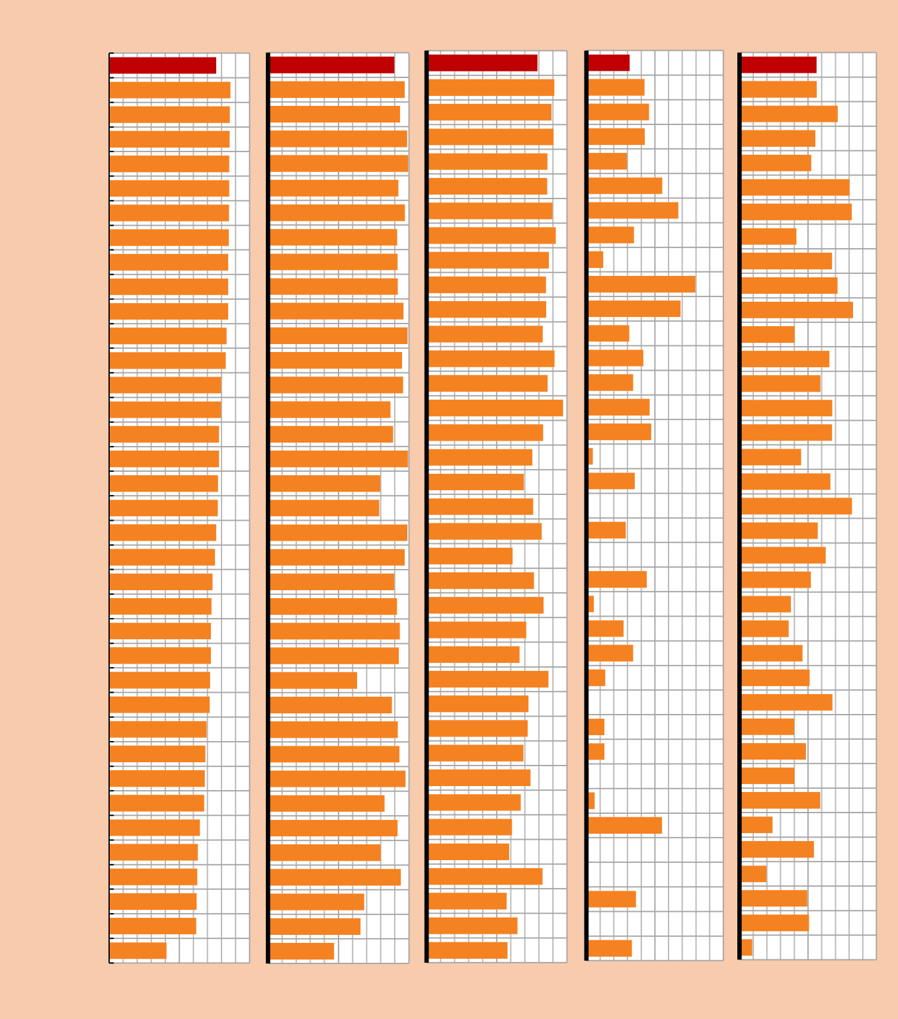

Note: N/A means data not available. Coverage of pharmaceuticals for Israel calculated using spending on medical good (non-specified by function). Source: OECD Health Statistics 2023.

*StatLink 2* <https://stat.link/le6w5g>

**Financial hardship and out-of-pocket expenditure**

Health systems provide adequate financial protection when payments for healthcare do not expose people to financial hardship. A lack of financial protection can reduce access to healthcare, undermine health status, deepen poverty, and exacerbate health and socio-economic inequalities. Exposure to financial hardship for people using health services can also lead to catastrophic health spending, with poorer households and those who must pay for long-term treatment – such as medicines for chronic illness – particularly vulnerable. Financial protection is weakened by a health system’s reliance on out-of-pocket (OOP) payments for healthcare. On average across OECD countries, just under one-fifth of all spending on healthcare comes directly from patients through OOP payments (see section on “Health expenditure by type of financing” in Chapter 7).

The share of household consumption spent on healthcare provides an aggregate assessment of the financial burden of OOP expenditure. Across OECD countries in 2021, around 3% of total household spending was on healthcare goods and services. The share was 2% or less in Luxembourg, Colombia and Türkiye, but stood above 5% in Portugal, Switzerland and Korea (Figure 5.8).

Health systems in OECD countries differ in the degree of coverage for different health goods and services (see section on “Extent of healthcare coverage”). Pharmaceuticals and other medical goods are the main driver of household spending, accounting for 43% of OOP spending on health on average in 2021 (Figure 5.9). In Mexico, the Slovak Republic and Poland, pharmaceuticals accounted for over 60% of OOP spending. Outpatient care accounted for 22% of household spending on healthcare on average, but was especially high in Ireland (40%), Italy (45%) and Portugal (50%) where cost- sharing arrangements for outpatient care are common. Dental care represented 14% of OOP spending on health, and long- term care made up 13% in 2021. Inpatient care played only a minor role (8%) in the composition of OOP spending in OECD countries, with the exception of Greece (32%), which reflects outlays for privately provided hospital services.

The indicator most widely used to measure financial hardship associated with OOP payments for households is incidence of catastrophic spending on health (Cylus, J., Thomson and

The incidence of catastrophic spending is closely connected to a health system’s reliance on OOP payments. Countries can reduce their reliance on OOP payments by increasing public spending on health; however, policy choices around coverage are also important. Population entitlement to publicly financed healthcare is a prerequisite for financial protection, but not a guarantee of it. Countries with a low incidence of catastrophic spending on healthcare mitigate the negative impact of user charges through better copayment policies (notably via exemptions for people on low incomes and annual caps on payments). Moreover, ensuring that primary care treatment is part of the benefits package (not just primary care consultations and diagnoses) is also likely to reduce financial hardship (WHO Regional Office for Europe, 2023[2]).

**Definition and comparability**

OOP payments are expenditures borne directly by a patient where neither public nor private insurance cover the full cost of the health good or service. They include cost-sharing and other expenditure paid directly by private households, and should also ideally include estimations of informal payments to health providers. For countries that do not report spending on dental care, this is typically reported under outpatient care which can affect the coverage rate.

Catastrophic health spending is an indicator of financial protection used to monitor progress towards universal health coverage. It is defined as OOP payments that exceed a predefined percentage of the resources available to a household to pay for healthcare. Household resources available can be defined in different ways, leading to measurement differences. In the data presented here, these resources are defined as household consumption minus a standard amount representing basic spending on food, rent and utilities (water, electricity, gas and other fuels). The threshold used to define households with catastrophic spending is 40%. Microdata from national household budget surveys are used to calculate this indicator.

**References**

Evetovits, 2018[1]). This varies considerably across OECD countries, from fewer than 2% of households experiencing catastrophic health spending in Sweden, Spain, the United Kingdom, Ireland and Slovenia, to over 10% of households in Lithuania, Latvia, Hungary and Portugal (Figure 5.10). Across all countries, the poorest households (those in the lowest consumption quintile) are most likely to experience catastrophic health spending, even though many countries have put in place policies to safeguard financial protection.

Cylus, J., S. Thomson and T. Evetovits (2018), “Catastrophic health spending in Europe: equity and policy implications of different calculation methods”, *Bulletin of the World Helath Organization*, Vol. 96/9, https://doi.org/10.2471/BLT.18.209031.

WHO Regional Office for Europe (2023), *Can people afford to pay for health care? New evidence on financial protection in Europe*, WHO Regional Office for Europe, Copenhagen.

[1]

[2]

**Figure 5.8. Out-of-pocket spending as share of final household consumption, 2021 (or nearest year)**

%

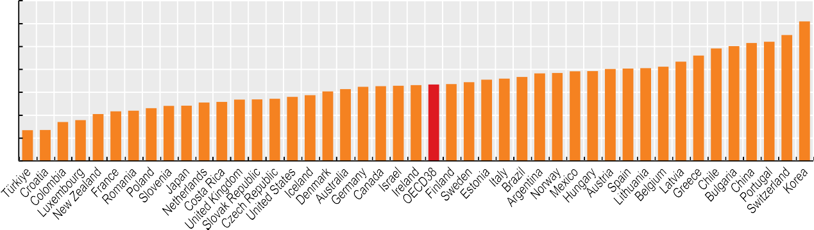

7

6

5

4

3

2

1

0

1.4

1.4

1.7

1.8

2.1

2.2

2.2

2.3

2.4

2.4

2.6

2.6

2.7

2.7

2.7

2.8

2.9

3.0

3.1

3.2

3.3

3.3

3.3

3.3

3.4

3.4

3.6

3.6

3.7

3.8

3.8

3.9

3.9

4.0

4.0

4.1

4.1

4.3

4.6

4.9

5.0

5.2

5.2

5.5

6.1

Source: OECD Health Statistics 2023, OECD National Accounts Database.

*StatLink 2* <https://stat.link/xfcyaz>

**Figure 5.9. Composition of out-of-pocket spending on health, by type of service, 2021 (or nearest year)**

%



Medical Goods Outpatient Dental Inpatient LTC Other

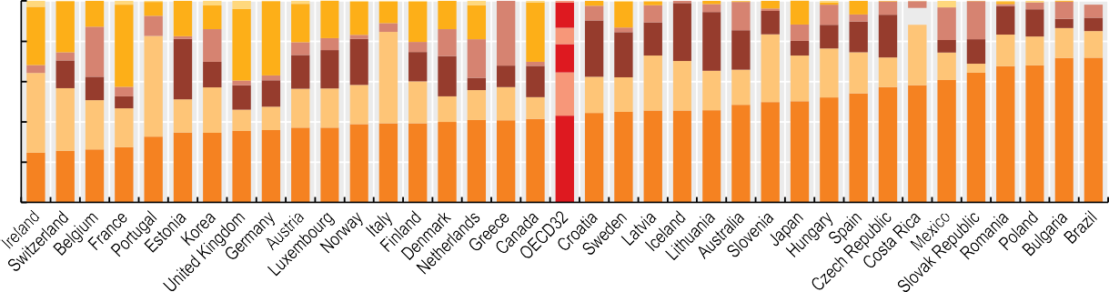

100

80

3

29 25

4

13

2

7

10

2

18 12

4

1 2

18 17 11 20 14 17

25 41

1

16 36

19

37

1

32 29

13 13

1

2 2 2

1

4

1

7

9

4

14

1

12

6

6

2

4

5

13

19

8

2

12

8

7

10

7

4 7 83

16 29

3

16

6

14

1 3

19 14

14 5

9 1

6

7

29 20

12 15 21

60

4

14

30 13

12

5

50

2

2

13

17 19 23 45 14 20

6

11

2

14 28 22

30

6

16 27 25 20 17

22 18 17

34 23 24 20 15

12 16 14 15 13

4

40

40

31 24 19

17

12

23

10 12

19 19 19 21 13 15 16 11

20

50 50 52 54 57 58 61 64 68

68 72 72

25 26 26 27

33 35 35 36 36 37 37 39 39 39 40 41 41 41 43 44 45 46 46 46 48

0

Note: The “Medical goods” category includes pharmaceuticals and therapeutic appliances. LTC refers to long-term care. The “Other” category includes preventive care, administrative services and services unknown.

Source: OECD Health Statistics 2023.

*StatLink 2* <https://stat.link/glvikb>

**Figure 5.10. Share of households with catastrophic health spending by consumption quintile, latest year available**

0.8

1.2

1.5

1.6

1.6

2.1

2.4

2.6

2.6

2.7

3.1

3.2

3.2

3.3

3.6

3.8

3.8

4.2

4.3

4.3

5.1

5.3

5.5

5.7

7.2

7.4

7.5

8.9

8.6

9.4

10.6

11.6

12.5

15.0

15.2

19.2



Richest 4th quintile 3rd quintile 2nd quintile Poorest

%

Sources: WHO Regional Office for Europe, 2023 (countries in Europe); European Observatory on Health Systems and Policies, 2021 (countries outside Europe).

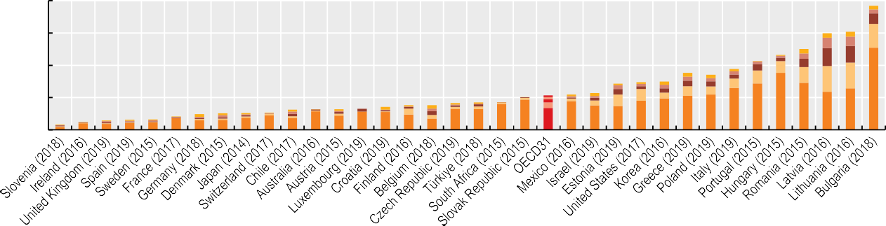

20

15

10

5

0

*StatLink 2* <https://stat.link/gs67wo>

**Consultations with doctors**

Consultations with primary care doctors are for many people the most frequent contact with health services, and often provide an entry point for subsequent medical treatment. Consultations take place in doctors’ clinics, community health centres, hospital outpatient departments or, in some cases, patients’ own homes. Increasingly, teleconsultations are offered to patients, whereby consultations take place online, often through video calls (OECD, 2023[1]).

In 2021, the average number of annual in-person doctor consultations per person among OECD countries ranged from fewer than 3 in Mexico, Costa Rica, Sweden, Chile and Greece to over 15 in Korea (Figure 5.11). The OECD average was 6 consultations per person per year, with most countries reporting between 4 and 10. Differences in service delivery modalities explain some of the cross-country variation. In Canada, Finland, Sweden, the United Kingdom and the United States, the relatively low number of consultations can be explained in part by the enhanced role that nurses and other health professionals play in primary care – notably in management of patients with chronic diseases and in dealing with patients with minor health issues. This lessens the need for doctor consultations (Maier, Aiken and Busse, 2017[2]). In recent years, teleconsultations have also played a greater role in many countries.

Provider payment methods and levels of co-payments also have an impact on the number of doctor consultations. In some countries, doctors are paid predominantly by fee-for-service (as in Germany, Japan, Korea and the Slovak Republic). Such countries tend to have higher consultation rates than those countries where doctors are mainly paid by salaries or capitation (such as Denmark, Finland, Mexico and Sweden). However, in the United States, doctors are paid mainly by fee-for-service, but consultation rates are below average. This may reflect the high co-payments a large proportion of the population face, which can cause patients to not consult a doctor because of the cost of care.

The number and type of doctor consultations can vary among different socio-economic groups. Wealthier individuals are more likely to see a doctor than individuals in the lowest income quintile, for a comparable level of need. Income inequalities in accessing doctors are much more marked for specialists than for GP consultations (OECD, 2019[3]).

While in-person doctor consultations were relatively stable in most OECD countries between 2011 and 2019 (except for large increases in Türkiye and Lithuania), in-person consultations

research and administration. Keeping these comparability issues in mind, the estimated number of consultations per doctor is highest in Korea, Japan and Türkiye (Figure 5.13). Numbers were lowest in Greece and Sweden. In Sweden, consultations with doctors in both primary care and hospital settings tend to be focused on patients with more severe and complex cases.

**Definition and comparability**

In-person consultations with doctors refer to the number of face-to-face contacts with physicians, including both generalists and specialists. There are variations across countries in the coverage of different types of consultations – notably in outpatient departments of hospitals. Data come mainly from administrative sources, although in some countries (including Ireland, the Netherlands, New Zealand and Switzerland) they come from health interview surveys. Data from administrative sources tend to be more accurate (and higher) than those from surveys because of problems with recall and non-response rates.

Figures for the Netherlands exclude contacts for maternal and childcare. In Germany, data include only the number of cases of physician treatment according to reimbursement regulations under the country’s social health insurance scheme (a case only counts the first contact over a three-month period, even if the patient consults a doctor more often, leading to an underestimation). Portugal and Spain exclude (all or part of) consultations at a private physician’s office. Remote consultations cannot be distinguished and are included in a few countries (such as Austria from 2020, Ireland, Japan, Latvia, the Netherlands, the Slovak Republic and Spain from 2019).

The breakdown between in-person consultations and teleconsultations was provided by 20 OECD countries. Teleconsultations cover remote consultations with both generalist and specialist medical practitioners. They cover all technologies used (notably phone or virtual calls), but Denmark excludes email consultations. Data cover public and private providers, except for Spain, which excludes consultations in a private physician’s office, and Chile and Israel, which provide data for public providers only.

**References**

were lower in 2021 than 2019 in all countries. This reflects the substantial impact of COVID-19 in terms of disruption to services and people’s reluctance to visit healthcare facilities due to concerns about catching the virus. It also reflects an increased use of teleconsultations during the pandemic in all countries with available data (see section on “Digital health”). Indeed, 19% of all doctor consultations were teleconsultations in 2021, on average across 20 OECD countries with comparable data (Figure 5.12). In Spain, Portugal, Estonia and Denmark, teleconsultations were particularly important, comprising over 30% of all doctor consultations.

Information on the number of doctor consultations per person can be used to estimate the annual number of consultations per doctor (in-person). This indicator should not be taken as a measure of doctors’ productivity, since consultations vary in length and effectiveness, and because it excludes services doctors deliver for hospital inpatients, as well as time spent on

Maier, C., L. Aiken and R. Busse (2017), “Nurses in advanced roles in primary care: Policy levers for implementation”*, OECD Health Working Papers*, No. 98, OECD Publishing, Paris, https://doi.org/10.1787/a8756593-en.

OECD (2023), *The COVID-19 Pandemic and the Future of Telemedicine*, OECD Health Policy Studies, OECD Publishing, Paris, https://doi.org/10.1787/ac8b0a27-en.

OECD (2019), *Health for Everyone?: Social Inequalities in Health and Health Systems*, OECD Health Policy Studies, OECD Publishing, Paris, https://doi.org/10.1787/3c8385d0-en.

[2]

[1]

[3]

**Figure 5.11. Average number of in-person doctor consultations per person, 2011, 2019 and 2021 (or nearest years)**

2011 2019 2021 (values shown)

Annual consultations per person 18

16



14

12

10

8

6

4

15.7

11.1

11.0

9.6

9.5

8.6

8.0

7.8

7.6

7.2

6.7

6.5

6.5

6.1

6.0

6.0

6.0

5.9

5.7

5.5

5.3

4.9

4.8

4.8

4.7

4.1

4.1

3.9

3.8

3.5

3.4

2.7

2.6

2.3

2.1

1.6

1.5

2

0

1. Latest available data from 2020. Source: OECD Health Statistics 2023.

*StatLink 2* <https://stat.link/40rm5d>

**Figure 5.12. Doctor consultations, in-person vs. remote consultations, 2021 (or nearest year)**

In-person consultations Teleconsultations

Annual consultations per person 18

15

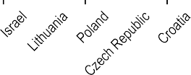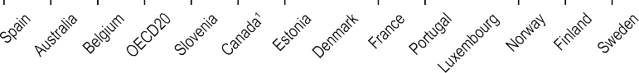

15.7

10.5 10.2

9.2 9.2 9.1

8.2

7.9

7.8 7.6

7.2

6.8 6.5

6.4

5.7 5.7 5.4

5.1

4.8 4.6

3.1

2.4

12

9

6

3

0



1. 2020 data. 2. Public sector only. Source: OECD Health Statistics 2023.

*StatLink 2* <https://stat.link/wmgn6i>

**Figure 5.13. Estimated number of in-person consultations per doctor, 2021 (or nearest year)**

Annual consultations per doctor 7 000

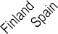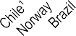

6 113

6 000

4 288

3 667

2 997

2 865

2 209

2 206

2 149

2 119

2 075

1 833

1 788

1 787

1 764

1 736

1 734

1 728

1 611

1 518

1 448

1 396

1 327

1 292

1 291

1 195

1 194

1 119

1 108

1 065

906

888

755

741

618

606

501

428

5 000

4 000

3 000

2 000

1 000

0

1. In Chile, Greece and Portugal, data for the denominator include all doctors licensed to practise. 2. Latest data are from 2019. Source: OECD Health Statistics 2023.

*StatLink 2* <https://stat.link/9i4ged>

**Digital health**

A digital health transformation is reshaping how health services are delivered, public health is protected, and chronic disease is managed and prevented. Through the expanded use of digital tools such as telemedicine and artificial intelligence, as well as utilising health information to monitor population health and manage system performance, countries are investing more in digital health systems. The COVID-19 pandemic demonstrated that the most resilient countries had strong digital systems for collecting and sharing health information. Health systems with robust digital infrastructure and the ability to utilise quality health information were able to inform evidence-based policy making and respond more flexibly and quickly to system shocks (OECD, 2023[1]). As a result, the use of digital tools such as telemedicine and artificial intelligence is expanding. These digital interventions have the potential to reshape patient care, improve workforce productivity, enable equitable access to health services, and achieve better health outcomes.

OECD countries continue to implement and expand the use of electronic medical records (EMRs) in hospitals or physicians’ offices for their patients. In 2021, on average over 93% of primary care practices used EMRs, an increase from 70% in 2012, across OECD countries with comparable data. In 13 OECD countries, all primary care practices used EMRs, whereas in some countries such as Poland, Mexico, Switzerland and Japan, around 40% or fewer had EMR availability (Figure 5.14). Nevertheless, all these countries have had large increases in EMR availability since 2012, with especially significant rises in Denmark, the United States and Canada. These increases in EMR adoption are also seen in the hospital sector for inpatient use, with an increase of nearly 45% from 2012 to 2021, signalling widespread adoption of EMR systems for primary and secondary care in OECD countries.

Alongside the infrastructure and use of digital systems like EMRs, an effective digital transformation also requires good governance to share and utilise health information for both providers and patients in a secure and timely manner. The majority of OECD countries have some capacity to generate and share health information from EMRs. In 16 of 26 OECD countries in 2021, most patients could access an internet portal where they can view the information contained in their EMR. Further, 13 of 26 OECD countries could connect patients with their healthcare providers via a patient portal (Oderkirk, 2021[2]).

In 2019, before the pandemic, remote consultations via phone or video accounted for fewer than 10% of all consultations in Australia, Finland, Lithuania, Norway and Slovenia, with an average of 0.6 teleconsultations per patient per year among OECD countries. However, by 2021 this rate had more than doubled to 1.4 teleconsultations per patient per year, with significant increases in Australia, Lithuania and Slovenia, many of which previously had the lowest rates but by 2021 had near or above the OECD average (Figure 5.16). After realising the benefits through the pandemic, health systems have expanded the use of remote consultations, although financial, legal and operational barriers still exist.

As health systems increasingly harness digital technologies, it is important also to consider essential governance and implementation factors – notably transparency and accountability – and to ensure that the benefits accrue to all.

**Definition and comparability**

An EMR is a computerised medical record created in an organisation that delivers care, such as a hospital or physician’s office, for patients of that organisation. Ideally, EMRs should be shared between providers and settings to provide a detailed history of contact with the healthcare system for individual patients from multiple organisations (Oderkirk, 2021[2]). The figures presented on EMR implementation come from a 2021 survey of OECD countries to which 25 OECD member countries responded. The survey was carried out in 2012, 2016 and 2021.

The Information and Communication Technology (ICT) Access and Usage by Households and Individuals database provides a selection of 92 indicators, based on the second revision of the OECD Model Survey on ICT Access and Usage by Households and Individuals. The indicators originate from both OECD data collection on OECD countries (such as Australia) and partner countries (such as Brazil), and Eurostat statistics on households and individuals for the OECD countries that are part of the European statistical system (such as Germany).

Doctor teleconsultations are defined in the section on “Consultations with doctors”.

**References**

Improvements in infrastructure and health literacy provide more capacity for patients to use online services to seek health information and advice. On average across 32 OECD countries, 60% of individuals aged 16-74 used the internet to seek health information in the three months preceding the survey in 2022 – up from 40% in 2012 (Figure 5.15). When health data and information are understandable and valid for a range of uses and users, new digital health services and applications, such as telemedicine, can enable better access to healthcare and higher patient satisfaction, especially among patients that face the most barriers to traditional face-to-face care services (such as those living in rural areas).

During the COVID-19 pandemic, the use of telemedicine was crucial to delivering care through uncertainty (OECD, 2023[3]).

Oderkirk, J. (2021), “Survey results: National health data infrastructure and governance”*, OECD Health Working Papers*, No. 127, OECD Publishing, Paris, https://doi.org/10.1787/55d24b5d-en.

OECD (2023), *Ready for the Next Crisis? Investing in Health System Resilience*, OECD Health Policy Studies, OECD Publishing, Paris, https://doi.org/10.1787/1e53cf80-en.

OECD (2023), *The COVID-19 Pandemic and the Future of Telemedicine*, OECD Health Policy Studies, OECD Publishing, Paris, https://doi.org/10.1787/ac8b0a27-en.

[2]

[1]

[3]

**Figure 5.14. Proportion of primary care practices using electronic medical records, 2012 and 2021**



2012 2021

%

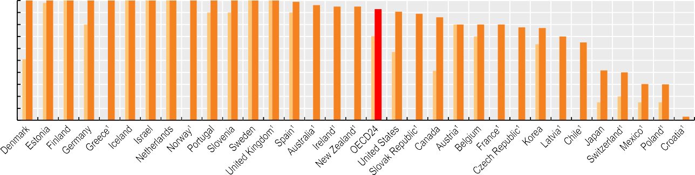100

90

80

70

60

50

40

30

20

10

0

100 100 100 100 100 100 100 100 100 100 100 100 100 99 96 95 95

93 91 89

86 80 80 80

78 77

70

65

42 40

30 30

3

1. Most recent year is 2016 (data not included in the 2021 OECD average).

Source: OECD Survey of Electronic Health Record System Development and Use, 2012, 2016 and 2021.

*StatLink 2* <https://stat.link/dnjmio>

**Figure 5.15. Percentage of individuals aged 16-74 seeking health information online in the last three months, 2012 and 2022**



2012 2022

%

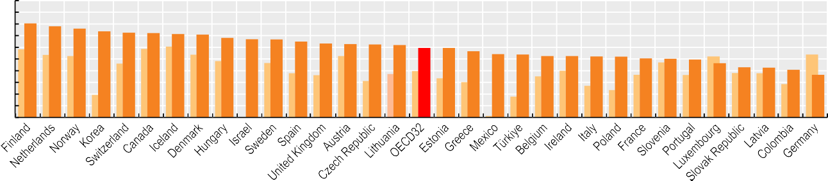

100

90

80

70

60

50

40

30

20

10

0

81

78 76

74

72 72 71 71

68 67

67 65

63 63 62

62

60 59

57

54 54

53 52 52 52

51 50 49

46

43 43

41

37

Source: OECD Dataset on ICT Access and Usage by Households and Individuals.

*StatLink 2* <https://stat.link/5zv0mo>

**Figure 5.16. Doctor teleconsultations per person, 2019 and 2021 (or nearest year)**



2019 2021

Annual teleconsultations per person 3.5

3

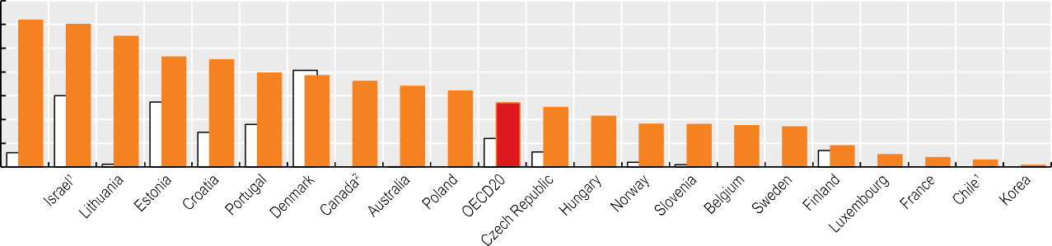

3.1

3.0

2.8

2.3 2.3

2.0 1.9

1.8

1.7

1.6

1.4

1.3

1.1

0.9 0.9 0.9 0.8

0.4

0.3 0.2

0.1

0.0

2.5

2

1.5

1

0.5

n.a.

n.a.

n.a.

n.a.

n.a.

n.a.

n.a.

n.a.

0

1. Public sector only. 2. Latest data from 2020. Source: OECD Health Statistics 2023.

*StatLink 2* <https://stat.link/oewtjq>

**Hospital beds and occupancy**

The COVID-19 pandemic highlighted the need to have sufficient hospital beds and flexibility in their use, to address any unexpected surge in demand for intensive care. Still, adequate staffing was more of a pressing constraint than bed numbers (OECD, 2023[1]). Further, a surplus of hospital beds may lead to overuse and therefore costs, as many patients can be treated effectively on a same-day basis in hospitals or primary healthcare facilities. Therefore, a balance needs to be found between ensuring sufficient bed capacity and value-for- money considerations.

**Definition and comparability**

Hospital beds include all inpatient beds that are regularly maintained and staffed and that are immediately available for use. They include beds in general hospitals, mental health and substance abuse hospitals, and other specialty hospitals. Beds in residential long-term care facilities are excluded. Data for some countries do not cover all hospitals. In the United Kingdom, data are restricted to public hospitals. Data for Sweden exclude private beds that are privately financed. Beds for same-day care may be included in some countries (such as Austria). Cots for healthy infants are included for a few countries (such as Canada and Poland).

The occupancy rate for curative (acute) care beds is calculated as the number of hospital bed-days related to curative care divided by the number of available curative care beds (multiplied by 365).

ICU beds are for critically ill patients who need intensive and specialised medical and nursing care, strong monitoring and physiological organ support to sustain life during a period of acute organ system insufficiency. ICU beds are classified by the level of care provided to the patient. Commonly, this falls into three levels, with Level 3 providing the most intense monitoring and Level 1 the lowest. The data on ICU beds cover the three levels, except in Finland, Ireland, Italy, Latvia, the Netherlands and Spain, which include only critical care beds (Levels 2 and 3). The exact definition of intensive care beds varies across OECD countries, shaped by differences in regulations, specifying requirements such as the patient/nurse ratio, physical properties of the bed (including ventilators, monitoring equipment, infusion equipment and so on) and patient characteristics. The data in Figure 5.19 relate to adult ICU beds for most countries, but a few countries (such as Estonia, Iceland, Mexico and New Zealand) also include neonatal and paediatric ICU beds.

Across OECD countries, there were on average 4.3 hospital beds per 1 000 population in 2021 (Figure 5.17). In Korea

(12.8 beds per 1 000) and Japan (12.6 per 1 000) rates were much higher. Over half of OECD countries reported between 3 and 8 hospital beds per 1 000 population, with the lowest rates in Mexico, Costa Rica and Colombia.

Since 2011, the number of beds per capita has decreased in nearly all OECD countries, due in part to greater use of day care and reductions in the average length of stay. The largest decrease occurred in Finland, with a fall of around 50%, mainly affecting long-term care and psychiatric care beds. Latvia, Lithuania, Luxembourg, Norway and the Netherlands reduced capacity by 1 bed or more per 1 000 population. In contrast, the number of beds increased strongly in Korea, with a significant number of these dedicated to long-term care.

Hospital bed occupancy rates offer complementary information to assess hospital capacity. High occupancy rates of curative (acute) care beds can be symptomatic of a health system under pressure. Some spare bed capacity is necessary to absorb unexpected surges in patients requiring hospitalisation. Although there is no consensus about the “optimal” occupancy rate, a rate of about 85% is often considered a maximum to reduce the risk of bed shortages (NICE, 2018[2]). In 2021, the average bed occupancy rate was 69.8%, but the rate was higher than 85% in 3 of the 28 OECD countries with comparable data: Ireland, Israel and Canada (Figure 5.18). Occupancy rates were comparatively low in Türkiye, Mexico and many Central and Eastern European countries. Compared to 2019, occupancy rates were lower in almost all OECD countries in 2021. This reflects in part the suspension or rationing of non-urgent hospital care during the pandemic (OECD/European Union, 2022[3]).

While general hospital bed capacity matters, intensive care unit (ICU) capacity was an essential resource during the COVID-19 pandemic, delivering care for critically ill patients. Notwithstanding definitional differences, on average across 29 OECD countries there were 16.9 ICU beds per 100 000 population in 2021 (Figure 5.19). Numbers varied markedly from around 40 beds or more per 100 000 population in the Czech Republic, Estonia and Türkiye to below 5 beds per 100 000 in Iceland and Sweden. Compared to the situation pre-pandemic, all countries increased ICU capacity other than Luxembourg (where the absolute number of ICU beds was unchanged). This reflected country efforts to boost surge capacity, such as the temporary transformation of other clinical wards into ICUs and creation of field hospitals with ICUs.

**References**

NICE (2018), *Bed Occupancy*, The National Institute for Health and Care Excellence, https://[www.nice.org.uk/guidance/ng94/evidence/39.](http://www.nice.org.uk/guidance/ng94/evidence/39) bed-occupancy-pdf-172397464704.

OECD (2023), *Ready for the Next Crisis? Investing in Health System Resilience*, OECD Health Policy Studies, OECD Publishing, Paris, https://doi.org/10.1787/1e53cf80-en.

OECD/European Union (2022), *Health at a Glance: Europe 2022*, State of Health in the EU Cycle, OECD Publishing, Paris, https://doi.org/10.1787/507433b0-en.

[2]

[1]

[3]

**Figure 5.17. Hospital beds, 2011 and 2021 (or nearest year)**



2011 2021 (values shown)

Per 1 000 population

1. 2017 data.

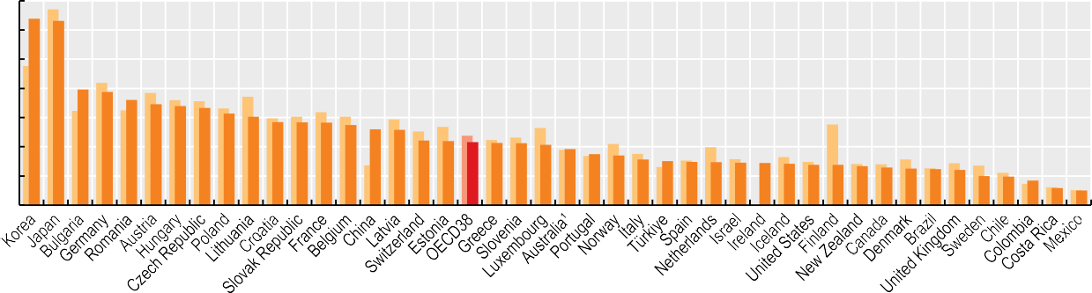

14 12.8 12.6

12

10

8

6

4

2

0

7.9 7.8 7.2 6.9

6.8 6.7 6.3 6.1 5.7 5.7 5.7

5.5 5.2 5.2

4.4 4.4 4.3

4.3 4.3 4.1 3.8 3.5 3.4 3.1

3.0 3.0 3.0 2.9 2.9 2.8 2.8 2.8 2.7 2.6 2.5 2.5 2.4 2.0 2.0

1.7 1.2 1.0

Source: OECD Health Statistics 2023.

*StatLink 2* <https://stat.link/ua2tpn>

**Figure 5.18. Occupancy rate of curative acute care beds, 2011, 2019 and 2021 (or nearest year)**

%



2011 2019 2021 (values shown)

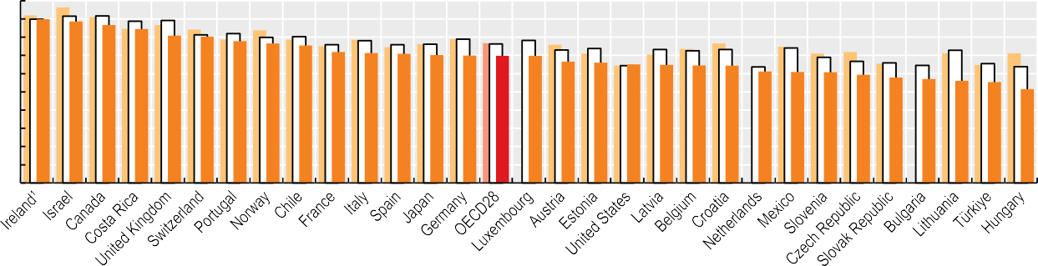

100

90

80

70

60

50

40

30

20

10

0

90

89 87

85

81 80

78

77 76

72 71 71 70 70 70 70

67 66 65 65 65 64

61 61 61 59

58

57 56 55

52

1. Data for Ireland exclude private hospitals (the occupancy rate of curative care beds in both public and private hospitals was 82.8% in 2021). Source: OECD Health Statistics 2023.

*StatLink 2* <https://stat.link/6kgodj>

**Figure 5.19. Adult intensive care beds, 2019 and 2021**



2019 2021 (Values shown)

Per 100 000 population

1. Data include neonatal and paediatric ICU beds. 2. Data cover critical care beds only. Source: OECD Health Statistics 2023.

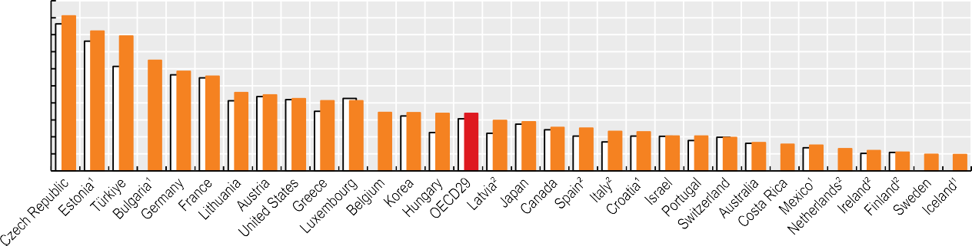

50

45

40

35

30

25

20

15

10

5

0

45.5

41.1 39.6

32.5

29.3 27.8

23.0 22.4 21.2 20.6 20.6

17.2 17.1 16.9 16.9 14.9 14.4 12.8

12.6 11.6 11.5 10.3 10.2 9.9 8.4

7.9 7.6 6.6 6.0 5.5 4.9 4.8

*StatLink 2* <https://stat.link/2j5xh6>

**Hospital activity**

Hospital discharge rates – the number of patients who leave a hospital after staying at least one night – are a core indicator of hospital activity. Improving timely discharge of patients can help the flow of patients through a hospital, freeing up hospital beds and health worker time. Both premature and delayed discharges worsen health outcomes and increase costs: premature discharges can lead to costly readmissions; delayed discharges use up limited hospital resources.

On average across OECD countries, there were 130 hospital discharges per 1 000 population in 2021 (Figure 5.20). Rates were highest in Germany and Austria (over 200 per 1 000 population), and lowest in Mexico, Costa Rica, Chile, Canada, the Netherlands and Italy (fewer than 100 per 1 000 population). Among accession and partner countries, rates were also high in Bulgaria and China, and relatively low in Brazil.

In most OECD countries, the number of hospital discharges fell slightly between 2011 and 2019, with some of the largest reductions in countries where there were also large decreases in the number of beds (as in Estonia, Finland, Iceland, Luxembourg and Sweden). In contrast, hospital discharge rates increased substantially in Korea and Japan. Large increases were also observed in accession and partner countries Bulgaria and China. However, almost all countries experienced large reductions between 2019 and 2021. This reflected both redesigned hospital discharge policies to free up beds for COVID-19 patients and disrupted care for non-COVID-19 patients (OECD, 2021[1]).

The average length of stay in hospital is an indicator of efficiency in health service delivery. All else being equal, a shorter stay reduces the cost per discharge, and shifts care from inpatient to less expensive settings. Longer stays can be a sign of poor care co-ordination, resulting in some patients waiting unnecessarily in hospital until rehabilitation or long- term care can be arranged. At the same time, some patients may be discharged too early, when staying in hospital longer might have improved their health outcomes or reduced the chances of readmission.

In 2021, the average length of stay in hospital was 7.7 days across 36 OECD countries with comparable data (Figure 5.21). Türkiye and Mexico had the shortest hospital stays (about 5 days or less on average); Korea and Japan the longest (averaging 16 days or over per patient). Since 2011, the average length of stay has decreased in most countries; the most significant declines occurred in Finland, New Zealand and Japan. The only country with a large increase was Korea, but this reflects in part an increase in the role of “long-term care

Alongside these two core indicators of overall hospital activity, use of emergency care services is an important measure of frontline hospital services. Across 25 OECD countries with available data, there were an average 27 emergency department (ED) visits per 100 people annually in 2021 (Figure 5.22). Emergency care use was particularly high in Portugal and Spain, at over 50 ED visits per 100 people. While EDs provide a critical service, high use can be indicative of inappropriate and inefficient healthcare – notably if many patients attend EDs for non-urgent conditions that could be better managed in primary and community care settings. While ED visits more often increased between 2011 and 2019 (increasing in 15 of 20 countries with time trend data), they fell for almost all countries between 2019 and 2021 due to COVID-19.

**Definition and comparability**

A discharge is defined as the release of a patient who has stayed at least one night in hospital. It includes deaths in hospital following inpatient care. Same-day discharges are excluded, with the exceptions of Chile, Japan and Norway, which include some same-day discharges. Healthy babies born in hospitals are excluded (or mostly excluded) from hospital discharge rates in several countries. These typically comprise around 3-10% of all discharges. Data for some countries do not cover all hospitals, or only cover curative/acute care, both of which result in some underestimation. Countries with these data exclusions are indicated with footnotes underneath the chart.

Average length of stay refers to the average number of days patients spend in hospital. It is generally measured by dividing the total number of days stayed by all inpatients during a year by the number of admissions or discharges. Day cases are usually excluded. Data cover all inpatient cases (including not only curative/acute care cases) for most countries, except in Canada, Japan and the Netherlands, where data refer to only curative/acute care or acute care hospitals (resulting in an underestimation). The exclusion of healthy babies born in hospitals from hospital discharge data in several countries results in a slight overestimation of the length of stay (for example, the inclusion of healthy newborns would reduce the average length of stay by 0.5 days in Canada).

ED visits comprise both ambulatory and inpatient visits.

**References**

hospitals”, whose function is similar to nursing homes or long- term care facilities.

Hospital payment methods may act as an incentive for how long hospitals keep patients. Prospective payment methods such as global budgets or those based on diagnosis-related groups provide a financial incentive to reduce the cost per hospitalisation, in contrast to payments based on procedure or service. Strengthening access to primary care and community care can reduce hospital stays. Countries such as the Netherlands, France and Norway have increased the capacity of intermediate care facilities and home-based care that can serve as alternatives to hospitals (OECD, 2017[2]).

OECD (2021), “Adaptive Health Financing: Budgetary and Health System Responses to Combat COVID-19”, *OECD Journal on Budgeting*, https://doi.org/10.1787/69b897fb-en.

OECD (2017), *Tackling Wasteful Spending on Health*, OECD Publishing, Paris, https://doi.org/10.1787/9789264266414-en.

[1]

[2]

**Figure 5.20. Hospital discharge rates, 2011, 2019 and 2021 (or nearest year)**



2011 2019 2021

Per 1 000 population

1. Data exclude discharges of healthy babies. 2. Data include only activity in public or publicly funded hospitals (in Ireland, private hospitals account for about 15-20% of hospital discharges). 3. Data include discharges for curative (acute) care only. 4. 2021 data refer to 2020.

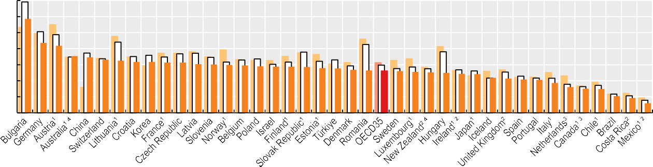

350

300

250

200

150

100

50

0

293

218

209

177

173

165

163

159

159

157

157

152

151

149

148

145

144

144

143

139

139

134

132

130

130

128

126

125

122

121

109

107

104

103

93

80

75

75

52

46

30

Source: OECD Health Statistics 2023.

*StatLink 2* <https://stat.link/38odl2>

**Figure 5.21. Average length of stay in hospital, 2011, 2019 and 2021 (or nearest year)**



2011 2019 2021

Days 20

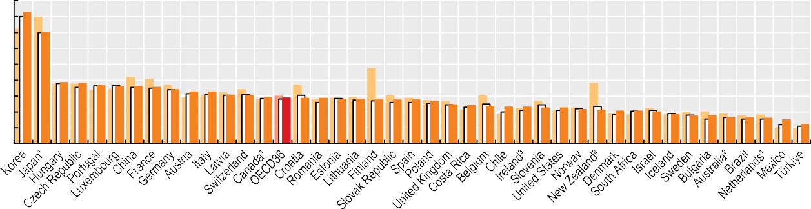18

16

14

12

10

8

6

18.5

16.0

9.7

9.6

9.3

9.2

9.2

9.1

8.8

8.5

8.5

8.1

8.1

7.8

7.7

7.7

7.7

7.6

7.6

7.5

7.5

7.5

7.3

6.9

6.8

6.7

6.6

6.6

6.5

6.5

6.3

6.2

6.1

6.1

6.0

5.7

5.5

5.5

5.3

5.3

5.2

5.0

4.4

4

2

1. Data refer to curative (acute) care only, resulting in an underestimation. In Japan, the average length of stay for all inpatient care was 28 days in 2021. 2. 2021 data refer to 2020.3. Data refer to public hospitals only.

Source: OECD Health Statistics 2023.

*StatLink 2* <https://stat.link/fbl947>

**Figure 5.22. Number of visits to emergency departments per 100 population, 2011, 2019 and 2021**



2011 2019 2021 (values shown)

Per 100 population

Source: National statistical offices.

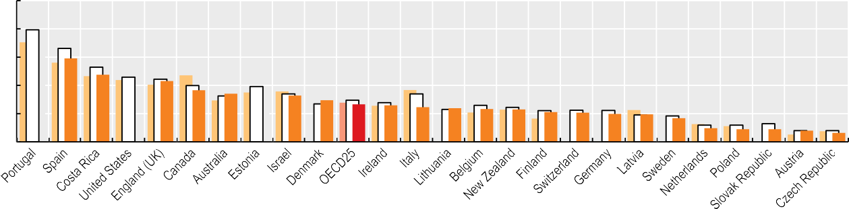

100

80

60

40

20

0

59

43

37

34

33

30

27 26 25 24

23 23

21 21 20 20 17 10 9 9 8 6

33

47

63

*StatLink 2* <https://stat.link/xqmv8a>

**Diagnostic technologies**

Technologies play an important role in medical diagnoses: from physical examination and results processing and sharing, to accessing patients’ health records, to the review of clinical histories. However, new technologies are acknowledged as a major cost driver in health systems (Lorenzoni et al., 2019[1]). This section presents data on the availability and use of three diagnostic imaging technologies: computed tomography (CT), magnetic resonance imaging (MRI) and positron emission tomography (PET). CT and MRI examinations (exams) both show images of internal organs and tissues, while PET scans show other information and problems at the cellular level.

There is no general guideline or international benchmark regarding the ideal numbers of CT scanners, PET scanners or MRI units. Too few units may lead to access problems in terms of geographical proximity or waiting times, while too many may result in overuse of these costly diagnostic procedures, with little if any benefit for patients.

Availability of CT and PET scanners and MRI units has increased rapidly in most OECD countries over the past few decades. Japan had by far the highest number of CT scanners and MRI units, and the third highest number of PET scanners per capita. Australia had the next highest number of CT scanners; the United States the second highest numbers of MRI units and PET scanners; and Denmark the highest number of PET scanners per capita (Figure 5.23). The combined numbers of these three diagnostic technologies were also substantially higher than the OECD average in Korea, Greece, Italy and Germany; and much lower than average in Costa Rica, Colombia and Mexico.

Data on the use of diagnostic scanners are available for 30 OECD countries. Taken together, the use of CT, MRI and PET diagnostic scanners was highest in the United States, Luxembourg, Korea, France and Austria, all of which had a combined total of over 360 exams per 1 000 population in 2021 (Figure 5.24). The use of these three diagnostic exams was lowest in Costa Rica and Chile; and also in OECD accession countries Romania and Bulgaria. There are large

an MRI or CT exam is not necessary. For example, the Royal College of Physicians in the United Kingdom recommends, based on evidence from the National Institute for Health and Care Excellence (NICE), that patients with low back pain or suspected migraine do not routinely need an imaging test (Choosing Wisely UK, 2018[3]).

Despite the general upward trend in the use of diagnostic technologies over time, there were drops across many OECD countries between 2019 and 2020, particularly for MRI exams. Such reductions were due to health providers being forced to delay or cancel diagnostic exams early in the COVID-19 pandemic. In the United States, the reduction was particularly large (over 30%). In 2021, however, diagnostic exams increased, and were typically above 2019 levels.

**Definition and comparability**

The data in most countries cover CT scanners, MRI units and PET scanners installed both in hospitals and the ambulatory sector, but coverage is more limited in some countries. Costa Rica, Portugal, Switzerland (for MRI units) and the United Kingdom report equipment available in hospitals only. For Colombia, Costa Rica and the United Kingdom, the data only cover equipment in the public sector. For Australia and Hungary, the number of CT scanners, MRI units and PET scanners includes only those eligible for public reimbursement.

Similarly, CT, MRI and PET exams performed outside hospital are not included in Portugal, Switzerland and the United Kingdom, while exams performed in hospitals are not covered in Norway. In Australia, the data only include exams for private patients (in or out of hospital), while in Korea and the Netherlands they only include publicly financed exams.

**References**

variations in the use of CT scanners and MRI units, not only across but also within countries – for example, in Belgium, recent analysis showed a 50% variation in use of diagnostic exams of the spine across provinces in 2017, and this variation was even larger across smaller areas (INAMI/RIVIZ, 2019[2]).

Looking at trends over time, large increases in CT and MRI exams per 1 000 population can be seen in a number of countries up to 2019 (Figure 5.25 and Figure 5.26). For example, the number of CT exams more than doubled in Korea, and the number of MRI exams more than doubled in Australia, Korea and Slovenia.

Clinical guidelines exist in several OECD countries to promote more rational use of MRI and CT exams. Through the Choosing Wisely campaign, which began in the United States in 2012 and has since been emulated in a growing number of countries, some medical societies have identified cases when

Choosing Wisely UK (2018), “Clinical

Recommendations: Royal College of Physicians”, [http://www.choosingwisely.co.uk/.](http://www.choosingwisely.co.uk/)

INAMI/RIVIZ (2019), “Medical Practice Variations”, https://[www.healthybelgium.be/en/medical-practice-](http://www.healthybelgium.be/en/medical-practice-) variations.

Lorenzoni, L. et al. (2019), “Health Spending Projections to 2030: New results based on a revised OECD methodology”*, OECD Health Working Papers*, No. 110, OECD Publishing, Paris, https://doi.org/10.1787/5667f23d-en.

[3]

[2]

[1]

**Figure 5.23. CT scanners, MRI units and PET scanners, 2021 (or nearest year)**

CT scanners MRI units PET scanners

Per million population 180

160



178

88 86 81 80 76 74 69 68

63 63 61 58 56 53 52 48 45 44 43 43

41 40 40 40 39 38 36 36 35 34 34 32 30 30 28 26

19 16 16 11 6

4

140

120

100

80

60

40

20

0

1. Data include equipment eligible for public reimbursement only. 2. Data exclude equipment outside hospital (only for MRI units in Switzerland). 3. Data refer to 2017 only. Source: OECD Health Statistics 2023.

*StatLink 2* <https://stat.link/xv92kr>

**Figure 5.24. CT, MRI and PET exams, 2021 (or nearest year)**

CT exams MRI exams PET exams

Per 1 000 population

1. Data exclude privately funded exams. 2. Data exclude exams outside hospital. 3. Data include only exams outside hospital. 4. Data exclude exams on public patients. Source: OECD Health Statistics 2023.



400

350

300

250

200

150

100

50

0

369 367 366 366 364 338 333

320 319 319 301

260 257 254 250 246 231 229 227 226 215

209 206 201 201 197 191 184 171

148 146

102 80

53

**Figure 5.25. Trends in CT exams, selected countries, 2011-21**

Australia Korea Spain

France Slovenia United States

*StatLink 2* <https://stat.link/nw56u4>

**Figure 5.26. Trends in MRI exams, selected countries, 2011-21**

Australia Korea Spain

France Slovenia United States

Per 1 000 population

300

250

200

150

100

50

Per 1 000 population

140

120

100

80

60

40

20

0

2011 2012 2013 2014 2015 2016 2017 2018 2019 2020 2021

0

2011 2012 2013 2014 2015 2016 2017 2018 2019 2020 2021

Source: OECD Health Statistics 2023.

*StatLink 2* <https://stat.link/nvtg0x>

Source: OECD Health Statistics 2023.

*StatLink 2* <https://stat.link/a34xp9>

**Hip and knee replacement**

Hip and knee replacements are some of the most frequently performed and effective surgeries worldwide. The main indication for hip and knee replacement (joint replacement surgery) is osteoarthritis, which leads to reduced function and quality of life.

Osteoarthritis is a degenerative form of arthritis characterised by the wearing down of cartilage that cushions and smooths the movement of joints – most commonly for the hip and knee. It causes pain, swelling and stiffness, resulting in a loss of mobility and function. Osteoarthritis is one of the ten most disabling diseases in developed countries. Worldwide, WHO estimates show that about 528 million people have symptomatic osteoarthritis – an increase of 113% since 1990 (WHO, 2022[1]).

Age is the strongest predictor of the development and progression of osteoarthritis. It is more common in women, increasing after the age of 50, especially in the hand and knee. Other risk factors include obesity, physical inactivity, smoking, excessive alcohol consumption and injuries. While joint replacement surgery is mainly carried out among people aged 60 and over, it can also be performed on people at younger ages.

In 2021, Switzerland, Germany, Finland and Austria had some of the highest rates for hip and knee replacement, among countries with available data (Figure 5.27 and Figure 5.28). The OECD averages are 172 per 100 000 population for hip replacement, and 119 per 100 000 for knee replacement. Mexico, Costa Rica and Chile have relatively low hip and knee replacement rates. Differences in population structure may explain part of this variation across countries, and age standardisation reduces it to some extent. Nevertheless, large differences persist, and research has shown that country

for knee surgery (where rates more than doubled). However, the volume of hip and knee replacements fell sharply in most countries in the first year of the pandemic, and remained below 2019 levels in the majority of countries in 2021. This reflects many countries postponing non-urgent elective surgery, particularly early in the pandemic, leading to marked increases in waiting times on many countries (see section on “Waiting times for elective surgery”).

**Definition and comparability**

Hip replacement is a surgical procedure in which the hip joint is replaced by a prosthetic implant. It is generally conducted to relieve arthritis pain or treat severe physical joint damage following hip fracture.

Knee replacement is a surgical procedure to replace the weight-bearing surfaces of the knee joint in order to relieve the pain and disability of osteoarthritis. It may also be performed for other knee diseases such as rheumatoid arthritis.

Classification systems and registration practices vary across countries, which may affect the comparability of the data. While most countries include both total and partial hip replacement, some countries only include total replacement. In Costa Rica, Mexico, New Zealand, Portugal and the United Kingdom, the data only include activities in publicly funded hospitals, thereby underestimating the number of total procedures presented here.

**References**

rankings do not change significantly after age standardisation (McPherson, Gon and Scott, 2013[2]).

National averages can mask important variation in hip and knee replacement rates within countries. In Australia, Canada, Germany, France and Italy, the rate of knee replacement was more than twice as high in some regions than others, even after age standardisation (OECD, 2014[3]). Alongside the number of operations, the quality of hip and knee surgery (see sections on “Safe acute care – surgical complications” and “Patient-reported outcomes in acute care” in Chapter 6) and waiting times are also critical for patients.

Up to 2019, the number of hip and knee replacements increased in all OECD countries (Figure 5.27 and Figure 5.28). This aligns with the rising incidence and prevalence of osteoarthritis, caused by ageing populations and growing obesity rates in OECD countries. Increases were particularly substantial in Poland, Costa Rica and Latvia for hip surgery (an increase of 70% or more); and Chile, Costa Rica and Poland

McPherson, K., G. Gon and M. Scott (2013), “International Variations in a Selected Number of Surgical Procedures”*, OECD Health Working Papers*, No. 61, OECD Publishing, Paris, https://doi.org/10.1787/5k49h4p5g9mw-en.

OECD (2014), *Geographic Variations in Health Care: What Do We Know and What Can Be Done to Improve Health System Performance?*, OECD Health Policy Studies, OECD Publishing, Paris, https://doi.org/10.1787/9789264216594-en.

WHO (2022), *Chronic Rheumatic Conditions, Fact Sheet*, World Health Organization, [http://www.who.int/chp/topics/rheumatic/en/.](http://www.who.int/chp/topics/rheumatic/en/)

[2]

[3]

[1]

**Figure 5.27. Hip replacement surgery, 2011, 2019 and 2021 (or nearest year)**

2011 2019 2021

Per 100 000 population

1. Latest available data from 2020. Source: OECD Health Statistics 2023.



350

300

250

200

150

100

50

0

323

301

287

284

271

255

246

236

223

222

215

207

198

198

194

188

183

180

175

172

172

153

152

152

147

129

128

108

99

79

73

65

64

55

40

18

7

*StatLink 2* <https://stat.link/9zmhje>

**Figure 5.28. Knee replacement surgery, 2011, 2019 and 2021 (or nearest year)**

2011 2019 2021

Per 100 000 population

1. Latest available data from 2020. Source: OECD Health Statistics 2023.

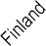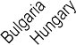

300

250

200

150

100

50

0

273

260

252

201

195

173

168

167

164

152

150

127

122

121

119

119

112

108

108

103

100

94

90

75

74

72

70

65

64

49

32

28

18

15

10

3

*StatLink 2* <https://stat.link/mak2xs>

**Ambulatory surgery**

Over the past few decades, the number of surgical procedures carried out on a same-day basis has increased markedly in OECD countries. Advances in medical technologies – in particular, the diffusion of less invasive surgical interventions – and better anaesthetics have made this development possible. These innovations have improved patient safety and health outcomes. Further, by shortening the treatment episode, ambulatory surgery can save important resources without any adverse effects on quality of care. It also frees up capacity within hospitals to focus on more complex cases or to reduce waiting lists. However, the impact of the rise in same-day surgery on overall health spending may not be straightforward, since the reduction in unit costs (compared to inpatient surgery) may be offset by overall growth in the volume of procedures performed. Any additional costs related to post- acute care and community health services following the interventions also need to be considered.

Cataract surgeries and tonsillectomies provide good examples of high-volume surgeries that are now mainly carried out on a same-day basis in many OECD countries.

Ambulatory surgery accounts for 90% or more of all cataract surgeries in around three-quarters of OECD countries with available data (Figure 5.29). In several countries, nearly all cataract surgeries are performed as day cases; however, the rate is relatively low in Lithuania and Mexico, with fewer than 65% of surgeries performed as ambulatory cases. Ambulatory surgery is also low in accession countries Bulgaria and Romania, comprising under 50% of surgeries. While low rates may be explained in part by limitations in the data coverage of outpatient activities in or outside hospital, it may also reflect higher reimbursement for inpatient stays or constraints on the development of day surgery.

Tonsillectomies are one of the most frequent surgical procedures performed on children – usually those suffering from repeated or chronic infections of the tonsils, breathing problems or obstructive sleep apnoea due to large tonsils. Although the operation is performed under general anaesthesia, it is now carried out predominantly as ambulatory surgery in 12 of 31 OECD countries with comparable data, with children returning home the same day (Figure 5.30). However, the proportion of day cases is not as high as for cataract surgery, at 40% of tonsillectomies versus 94% of cataract surgeries on average across OECD countries with available data. Day tonsillectomy rates are relatively high in Iceland and

of ambulatory surgery may reflect variations in the perceived risks of post-operative complications, or simply clinical traditions of keeping children in hospital for at least one night after the operation.

The number of cataract surgeries and tonsillectomies performed as ambulatory cases has grown significantly over time in many countries, including Austria, Hungary, France and the United Kingdom (Figure 5.31 and Figure 5.32). In Austria, the share of cataract surgeries performed as day cases increased from only 46% in 2011 to 91% in 2021; in Hungary, it increased from 35% to 77%. The share of tonsillectomies performed as ambulatory cases almost doubled between 2011 and 2021 in Sweden (45% to 80%) and the United Kingdom (39% to 70%). The share of same-day surgeries was largely unaffected by the pandemic, with similar shares in 2021 and 2019 for most OECD countries, for both cataract surgeries and tonsillectomies.

Financial incentives can also affect the extent to which minor surgery is conducted on a same-day basis. In Denmark and France, diagnostic-related group systems have been adjusted to incentivise ambulatory surgery. In the United Kingdom, a financial incentive is awarded for selected surgical procedures if the patient is managed on a day-case basis (OECD, 2017[1]).

**Definition and comparability**

Cataract surgery consists of removing the lens of the eye because of the presence of cataracts partially or completely clouding the lens, and replacing it with an artificial lens. It is mainly performed on elderly people. Tonsillectomy consists of removing the tonsils – glands at the back of the throat. It is mainly performed on children.

The data for several countries do not include outpatient cases in hospital or outside hospital (patients who are not formally admitted and discharged), leading to some underestimation. In Costa Rica, Mexico, New Zealand, Portugal and the United Kingdom, the data only include cataract surgeries carried out in public or publicly funded hospitals, excluding any procedures performed in private hospitals.

**References**

Costa Rica (over 90% of cases) but remain lower than 10% of cases in six OECD countries, as well as in accession countries Bulgaria and Romania. In Slovenia, Hungary, the Czech Republic and Austria, practically no tonsillectomies are performed as day cases. These large differences in the share

OECD (2017), *Tackling Wasteful Spending on Health*, OECD Publishing, Paris, https://doi.org/10.1787/9789264266414-en.

[1]

**Figure 5.29. Share of cataract surgeries carried out as ambulatory cases, 2021 (or nearest year)**

**Figure 5.30. Share of tonsillectomies carried out as ambulatory cases, 2021 (or nearest year)**

Netherlands

Canada Iceland Slovenia

United Kingdom

Spain Denmark Costa Rica

Estonia Czech Republic

Portugal Sweden Ireland Luxembourg

Finland Italy Australia New Zealand

France Belgium Norway Korea Israel OECD33

Poland Slovak Republic

Austria Switzerland

Chile Latvia Germany Croatia Hungary Mexico Lithuania Romania Bulgaria

99.9

99.8

99.8

99.7

99.3

99.3

99.1

99.0

99.0

98.9

98.9

98.8

98.4

98.2

98.1

97.9

97.8

97.5

97.2

97.0

96.8

94.7

94.6

93.8

93.6

92.6

91.5

89.6

89.5

89.4

88.0

87.7

76.6

62.9

62.6

45.5

44.7

0 20 40 60 80 100

%

Iceland Costa Rica

Finland Sweden Netherlands

Norway Belgium Canada

United Kingdom

Denmark Portugal Latvia Croatia Mexico France OECD31

New Zealand

Estonia Spain Israel Italy Australia Germany Ireland Korea

Switzerland Luxembourg Romania Lithuania Poland Bulgaria Austria

Czech Republic

Hungary Slovenia

97.9

93.8

81.6

79.6

79.4

76.0

75.5

75.2

70.2

58.2

57.5

54.7

53.7

47.6

45.4

40.0

37.7

37.0

34.9

26.1

18.8

16.1

15.2

15.0

14.4

13.3

13.1

7.2

3.9

2.5

0.8

0.7

0

0

0

0 20 40 60 80 100

%

Source: OECD Health Statistics 2023.

*StatLink 2* <https://stat.link/qoaygp>

Source: OECD Health Statistics 2023.

*StatLink 2* <https://stat.link/69qr7b>

**Figure 5.31. Trends in cataract surgeries carried out as ambulatory cases, selected OECD countries, 2011-21**

Australia Finland Sweden

Canada France

United Kingdom

**Figure 5.32. Trends in tonsillectomies carried out as ambulatory cases, selected OECD countries, 2011-21**

% 100

Austria France Hungary

Canada Germany Lithuania

90

80

70

60

50

40

30

20

10

0

2011 2012 2013 2014 2015 2016 2017 2018 2019 2020 2021

% 100

90

80

70

60

50

40

30

20

10

0

2011 2012 2013 2014 2015 2016 2017 2018 2019 2020 2021

Source: OECD Health Statistics 2023.

*StatLink 2* <https://stat.link/ywcpbk>

Source: OECD Health Statistics 2023.

*StatLink 2* <https://stat.link/p7s5c9>

**Waiting times for elective surgery**

Long waiting times for elective (non-emergency) surgery have been a longstanding issue in a number of OECD countries – one that has been massively exacerbated by the COVID-19 pandemic. By postponing the expected benefits of treatment, it means patients continue living with pain and disability for longer than they need to, and may worsen health outcomes for patients after the intervention.

Waiting times are the result of a complex interaction between the demand and supply of health services. Demand for health services and elective surgeries is determined by the health status of the population, progress in medical technologies (including the simplification of many procedures, such as cataract surgery), patient preferences and the burden of cost- sharing for patients. However, doctors play a crucial role in the decision to operate on a patient or not. On the supply side, the availability of surgeons, anaesthetists and other staff in surgical teams, as well as the supply of the required medical equipment, affects surgical activity rates.

The data presented in this section focus on three high-volume surgical procedures: cataract surgery, hip replacement and knee replacement. Two measures are analysed for each surgery: the share of patients waiting more than three months from specialist assessment to treatment and the median number of days patients are on a waiting list.

Just prior to the pandemic in 2019, over 60% of patients remained on the waiting list for cataract surgery for more than three months in Costa Rica, Norway and Finland (although waiting times in Norway are overestimated compared to other countries for this and the other two surgical procedures – see the “Definition and comparability” box). The proportion of patients waiting for over three months was relatively low (20% or less) in Hungary and Italy (Figure 5.33, left panel). The median number of days a person waited was almost a year in Poland (336 days), and over 100 days in Costa Rica, Slovenia and Ireland (Figure 5.33, right panel). In the first year of the pandemic, waiting times increased in almost all countries with available data, and the median waiting time more than doubled in Costa Rica, Hungary, Spain and Chile. However, initial data for 2022 indicate that waiting times have since fallen in a number of countries, and in many countries rates are close to 2019 levels both in terms of the share of patients waiting more than three months and for median waiting times.

For hip replacement, the share of patients remaining on the waiting list for over three months in 2019 ranged from around

were very high in Poland, Chile, Costa Rica and Slovenia (Figure 5.35, right panel). Early in the pandemic waiting times increased in all countries with available data, although the increases were not as dramatic as for hip replacements. By 2022, waiting times had improved slightly, but were still generally worse than in 2019.

Many countries have taken actions to address the backlogs and longer waiting lists for elective care that were generated by the disruption of services during the pandemic (OECD/European Union, 2022[1]). Even prior to the pandemic, governments implemented various measures to reduce waiting times, with the most common policy being the introduction of a maximum waiting time, supported by additional funds (OECD, 2020[2]). In Poland, for example, additional funding has been provided since 2018, and information on waiting times for different procedures has become more accessible to patients through a dedicated website. These policies have contributed to some marked improvements, at least in terms of the share of people waiting for over three months from specialist assessment to treatment. More Polish people have also been purchasing private health insurance to obtain quicker access to services in private hospitals (OECD, 2020[2]).

**Definition and comparability**

Two measures of waiting times for elective procedures are presented in this section: waiting times from specialist assessment to treatment, reporting data on the share of patients waiting more than three months; and waiting times of patients who are still on the list at a given point in time, showing the median number of days. Compared to the mean, the median is lower as it minimises the influence of outliers – patients with very long waiting times. Waiting times are overestimated in Norway because they start from the date a doctor refers a patient for specialist assessment for the treatment, whereas in other countries they start only when a specialist has assessed the patient and decided to add them to the waiting list for the treatment.

Data come from administrative databases. Patients who refuse to receive the procedure on several occasions are generally removed from the list.

**References**

30% in Sweden and Italy, to almost 90% in Chile and over 70% in Costa Rica and Norway (Figure 5.34, left panel). The median number of days a person waited was 663 days in Poland, and around a year in Costa Rica and Slovenia (Figure 5.34, right panel). The pandemic led to waiting time increases in all countries with available data, and waiting times more than doubled in Chile and England (United Kingdom). Initial data for 2022 indicate an improved situation in most countries, but with waiting times generally still worse than in 2019, particularly in terms of median waiting times.

Knee replacements follow similar patterns to hip replacements (Figure 5.35, left panel). Prior to the pandemic, over 80% of patients remained on the waiting list for over three months in Chile, Costa Rica, Portugal and Norway. Median waiting times

OECD (2020), *Waiting Times for Health*

*Services: Next in Line*, OECD Health Policy Studies, OECD Publishing, Paris, https://doi.org/10.1787/242e3c8c-en.

OECD/European Union (2022), *Health at a Glance: Europe 2022*, State of Health in the EU Cycle, OECD Publishing, Paris, https://doi.org/10.1787/507433b0-en.

[2]

[1]

**Figure 5.33. Waiting times for cataract surgery**



2014 2019 2022



2019 2020 2022

Waiting times from specialist assessment to treatment: % of all patients waiting more than 3 months

53

53

50

49

29

71

Waiting times of patients on the list: Median (days)

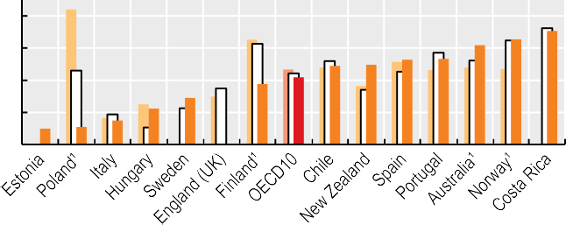80

60

40 22

15

11

10

20

0

38 42

62 66

Note: OECD average based on 10 countries with all years available. 1. No 2022 data available, so 2021 data used. Source: OECD Health Statistics 2023.

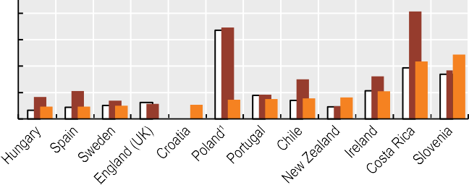

400

300

218 244

200

100

0

47

47 50

54

73

75 78

81

105

*StatLink 2* <https://stat.link/ex0aoz>

**Figure 5.34. Waiting times for hip replacement**



2014 2019 2022



2019 2020 2022

Waiting times from specialist assessment to treatment: % of all patients waiting more than 3 months

91

Waiting times of patients on the list: Median (days)

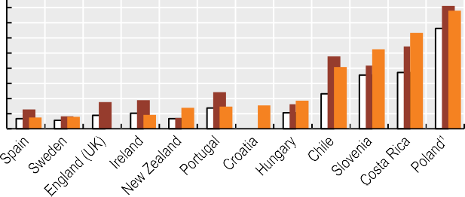800

780

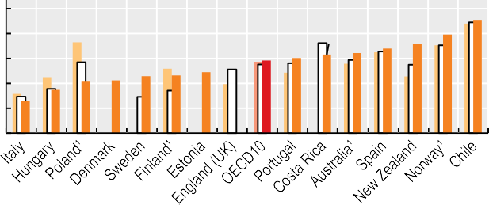100

80

60

40

20

0

26 35

42 42

46 47 49

58 61

63 64

68 72 79

700

600

500

400

300

200

100

0

74 79

92 138 147 154 186

408

525

632

Note: OECD average based on 10 countries with all years available. 1. No 2022 data available, so 2021 data used. Source: OECD Health Statistics 2023.

*StatLink 2* <https://stat.link/w0dbuh>

**Figure 5.35. Waiting times for knee replacement**



2014 2019 2022



2019 2020 2022

Waiting times from specialist assessment to treatment: % of all patients waiting Waiting times of patients on the list: Median (days)

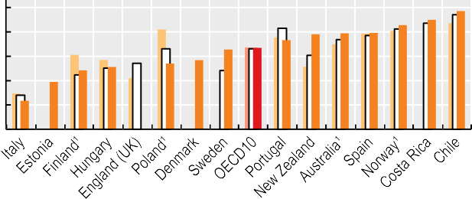more than 3 months 100

80

54 57

66 67 73

78 79 79 86

90 97

900

800

700

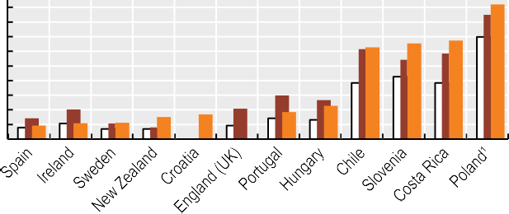

628

653

674

92

108 112

151

169

185 227

921

60

40 23

20

0

39 48 51

600

500

400

300

200

100

0

Note: OECD average based on 10 countries with all years available. 1. No 2022 data available, so 2021 data used. Source: OECD Health Statistics 2023.

*StatLink 2* <https://stat.link/40q36v>

**124** 

1. **Quality and outcomes of care**

Routine vaccinations Cancer screening

Safe prescribing in primary care Avoidable hospital admissions Diabetes care

People-centredness of ambulatory care

Safe acute care – workplace culture and patient experiences Safe acute care – surgical complications and obstetric trauma Mortality following acute myocardial infarction (AMI)

Mortality following ischaemic stroke Patient-reported outcomes in acute care

Care for people with mental health disorders Integrated care

**Routine vaccinations**

Vaccines are a cost-effective tool for protecting against infectious diseases. There is broad agreement within the global scientific community that the most effective way to defeat infectious diseases such as diphtheria, tetanus and pertussis (DTP), measles, hepatitis B, and influenza is through the mass vaccination of populations around the world. High national coverage rates, however, may not be sufficient to stop disease spreading if vaccination rates are uneven within the country, or if take-up is low in specific population groups. Hence, government action to garner trust and public confidence in the safety and efficacy of vaccination across all population groups is essential for the success of vaccination programmes (OECD, 2021[1]).

Figure 6.1 shows vaccination coverage for DTP and measles at 1 year of age. Across OECD countries, vaccination rates are high, with around 93% of children on average receiving the recommended DTP and measles vaccinations in 2022. Despite high overall rates for measles, nearly half of countries fall short of the minimum immunisation levels (95%) recommended by the World Health Organization (WHO) to prevent the spread of the disease. Rates of immunisation for measles, which is often incorporated with rubella and/or mumps vaccination are particularly low in Poland (71%) and Estonia (78%). With regards to DTP, almost one in five OECD countries do not meet the minimum immunisation level recommended by WHO (90%), and the immunisation rate is particularly low in Mexico (83%).

Generally, children’s vaccination rates for DTP and measles declined slightly (by less than 2 percentage points) between 2019 and 2022 across OECD countries. This may reflect wavering public confidence in vaccination during the pandemic. Compared to 2015, rates of population perception of the importance of vaccines for children had declined by more than a third in Korea (reaching 48%) and Japan (54%) by 2022 (UNICEF Innocenti, 2023[2]). In the European Union (EU), the percentage of people with confidence in vaccination against measles, mumps and rubella was 85% in 2022, down from 88% in 2020. In Europe,

Unlike childhood immunisation, influenza vaccination rates for people aged 65 and over increased to 55% on average across OECD countries in 2021, from 48% in 2019, reflecting increasing public confidence in the flu vaccination in recent years – for example, in most European countries (Figueiredo et al., 2022[3]). The increase in vaccination rates is most notable in Denmark and Norway, with around a 20 percentage point increase since 2019. There were some exceptions to this overall trend, however, with vaccination rates decreasing in Costa Rica, Latvia, Korea and Mexico, by around 5 percentage points in recent years.

**Definition and comparability**

Childhood vaccination rates reflect the percentage of children that receive the respective vaccination in the recommended timeframe. The age of complete immunisation differs across countries owing to different immunisation schedules. For countries recommending the first dose of a vaccine after 1 year of age, the indicator is calculated as the proportion of children under 2 years who have received the vaccine. Thus, these indicators are based on the actual policy in each country.

Some countries administer combination vaccines (e.g. DTP), while others administer the vaccines separately. Some countries ascertain whether a vaccination has been received based on surveys, and others based on encounter data; this may influence the results.

Influenza vaccination rates refer to the number of people aged 65 and over who have received an annual influenza vaccination, divided by the total number of people aged over 65. In some countries, the data are for people aged over 60. Unless otherwise stated, the data shown for 2021 refer to the calendar year 2021 or to the flu season 2021/22.

**References**

younger people are becoming less confident about vaccinations, and this could lead to further declines in the uptake of children’s routine immunisation (Figueiredo et al., 2022[3]).

Influenza is a common infectious disease, responsible for 3-5 million severe cases worldwide each year, along with up to 650 000 deaths (WHO, 2019[4]). As with many countries, the United States saw the number of influenza cases drop significantly from the start of the COVID-19 pandemic, with the 2021-22 season recording the lowest level for the last decade. In the EU, however, the 2021-22 season signalled a return to increased influenza virus activity after the low-level circulation during the pandemic. Since older people are at greater risk of developing serious complications from influenza – such as pneumonia and sepsis, which can result in serious illness or death – WHO recommends that 75% of people aged 65 and over should be vaccinated against seasonal influenza.

Figure 6.2 shows that the WHO target of 75% was only attained in the United Kingdom (81%), Korea (80%) and Denmark and Ireland (75%) in 2021, whereas the influenza immunisation rate among this vulnerable group was very low at below 15% in Latvia, Poland and the Slovak Republic, and also in OECD accession country Bulgaria.

Figueiredo, A. et al. (2022), *State of Vaccine Confidence in the European Union 2022*, Publications Office of the European Union, https://data.europa.eu/doi/10.2875/149743.

OECD (2021), “Enhancing public trust in COVID-19 vaccination: The role of governments”*, OECD Policy Responses to Coronavirus (COVID-19)*, OECD Publishing, Paris, https://doi.org/10.1787/eae0ec5a- en.

UNICEF Innocenti (2023), *For every Child, Vaccination, The State of the World’s Children 2023*, UNICEF Innocenti – Global Office of Research and Foresight, https://[www.unicef.org/media/108161/file/SOWC-](http://www.unicef.org/media/108161/file/SOWC-) 2023-full-report-English.pdf (accessed on

16 June 2023).

WHO (2019), *Global Influenza Strategy 2019-2030*, World Health Organization, https://apps.who.int/iris/handle/10665/311184.

[3]

[1]

[2]

[4]

**Figure 6.1. Percentage of children at 1 year vaccinated for measles and diphtheria, tetanus and pertussis, 2022 (or nearest year)**

Measles Diphtheria, tetanus and pertussis

% vaccinated



100

95

90

85

80

75

70

65

60

55

50

1. Data are estimated and refer to 2021. 2 Lines indicate WHO minimum targets of 95% for measles and 90% for DTP. Source: WHO/UNICEF.

*StatLink 2* <https://stat.link/ox41an>

**Figure 6.2. Percentage of population aged 65 and over vaccinated for influenza, 2019 and 2021**

2019 2021

% vaccinated

Note: Unless otherwise stated, data shown for 2021 refers to the calendar year 2021 or the flu season 2021/22. 1. Data refer to the calendar year 2020 or the flu season 2020/21.

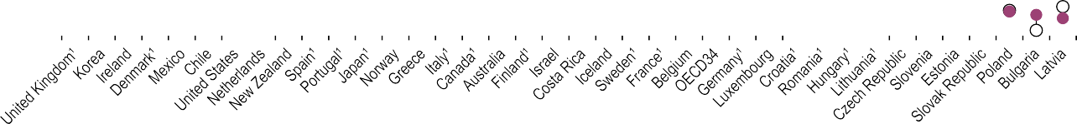

90

80

70

60

50

40

30

20

10

0

Source: OECD Health Statistics 2023.

*StatLink 2* <https://stat.link/yidspm>

**Cancer screening**

Early diagnosis, together with healthy lifestyles (see Chapter 4 “Risk factors for health”), is key to tackling cancer. Screening is considered a cost-effective way to reduce the burden of breast, cervical and colorectal cancer. Most OECD countries have programmes for breast, cervical and colorectal cancer screening in place for target populations, but for each cancer type, the target population, screening frequency and methods can vary across countries.

In the case of breast cancer, WHO recommends organising population-based mammography screening programmes, and emphasises the importance of helping women to make an informed decisions about their participation, based on both benefits and risks (WHO, 2014[1]). OECD countries typically provide screening checks every two years to women aged 50-69.

Figure 6.3 shows the proportion of women aged 50-69 who had a mammography examination in the two years preceding 2011, 2019 and 2021. The screening rate varies widely across OECD countries; for the latest period it reached a high of 83% of the target population in Denmark, and a low in Mexico and Türkiye, where fewer than 25% of women in the target age group had a mammography examination during the past two years.

While cancer screening rates were generally increasing prior to the COVID-19 pandemic, they dropped at its onset. Cancer screening programmes were often paused to prioritise urgent care needs, and many people also delayed seeking healthcare – including cancer screening – to reduce the risk of COVID-19 transmission (OECD, 2021[2]). In most OECD countries, cancer screening rates in 2021 were still lower than those in 2019.

With regards to breast cancer screening, the average screening rate in 2021 was 5 percentage points lower than in 2019 (Figure 6.3). However, this masks variations in screening rate change over time across countries. While most OECD countries saw uptake increase again after the initial phase of the pandemic, and some countries such as Costa Rica, Estonia, Finland and Slovenia attained higher rates in 2021 than in 2019, around one-third of OECD countries continued to see screening rates decrease in 2021.

In OECD countries, cervical cancer screening is often provided every three years to women aged 20-69, although the target

Compared to breast and cervical cancers, fewer OECD countries have nationwide screening programmes for colorectal cancer. Country guidelines typically recommend biennial faecal occult blood tests for people in their 50s and 60s, but some countries use other methods, including colonoscopy exams, leading to differences in recommended screening frequencies, making comparisons of screening coverage across countries challenging.

Figure 6.5 shows coverage rates in colorectal cancer screening programmes based on national screening programme protocols. The proportion varies from a high of 79% in Finland, followed by the United States (73%) and the Netherlands (71%), to a low of less than 3% in Hungary.

Cervical and colorectal cancer screening uptake was also adversely impacted by the COVID-19 pandemic, but delayed screening – and subsequent late diagnosis and treatment – may lead to poorer outcomes for patients. To minimise these consequences, many OECD countries have made additional efforts to increase screening uptake and to reduce the backlog of cancer diagnosis. Trends in screening uptake since the pandemic are not necessarily consistent across different types of cancer screening within the same country, suggesting a need for specific strategies to improve coverage of each cancer screening.

**Definition and comparability**

Screening rates are based on survey or programme data. Programme data are collected to monitor national screening programmes, but differences in target age groups, screening frequency and screening methods may lead to variations in the data reported across countries. Survey data may be affected by recall bias. Survey data on colorectal cancer screening are sourced from the European Health Interview Survey (EHIS) 2019 for countries in Europe that do not report programme data, and refer to people aged 50-74 who report having had faecal occult blood tests over the past two years.

**References**

population and screening frequency may change with the integration of human papillomavirus (HPV) vaccination programmes in most countries. WHO recommends that countries strive to reach an incidence rate lower than four new cases of cervical cancer per 100 000 women each year. To attain this goal, WHO recommends a 90% HPV vaccination coverage rate among girls by the age of 15, 70% coverage of cervical cancer screening at ages 35 and 45, and improvement of treatment coverage (treating 90% of women with pre-cancer and managing 90% of women with invasive cancer) (WHO, 2020[3]).

Figure 6.4 shows wide variations in the proportions of women aged 20-69 who had been screened for cervical cancer within the preceding three years across countries. In 2021, the highest rate was 79% in Sweden, followed by 75% in the Czech Republic, while the lowest rate was 3% in Costa Rica.

OECD (2021), “Strengthening the frontline: How primary health care helps health systems adapt during the COVID-19 pandemic”*, OECD Policy Responses to Coronavirus (COVID-19)*, OECD Publishing, Paris, https://doi.org/10.1787/9a5ae6da- en.

WHO (2020), *Global strategy to accelerate the elimination of cervical cancer as a public health problem*, World Health Organization, https://apps.who.int/iris/handle/10665/336583.

WHO (2014), *WHO position paper on mammography screening*, World Health Organization, https://apps.who.int/iris/handle/10665/137339.

[2]

[3]

[1]

**Figure 6.3. Mammography screening in women aged 50-69 within the past two years, 2011, 2019 and 2021 (or nearest year)**

2011 2019 2021 (values shown)

% of women screened

Note: Data for Belgium, Mexico and Spain refer to 2020 instead of 2021. Data for Portugal refer to 2014 instead of 2011. 1. Programme data. 2. Survey data. Source: OECD Health Statistics 2023.



100

80

60

40

20

0

64 63

21 20

26

30

31

33

36

36

40

46

47

47

48

54

54

54

56

56

58

59

56

62

66

70

72

73

74

76

77

80

82

83

*StatLink 2* <https://stat.link/bo4skr>

**Figure 6.4. Cervical cancer screening in women aged 20-69 within the past three years, 2011 and 2021 (or nearest year)**

2011 2021 (values shown)

% of women screened



100

80

60

40

20

0

79

75 73 72 72 72 70 70

69 68

65 64

61

59 59

55

55 53 53

51

46 45 44

42 39

35 35

33

26

12

3

Note: 1. Programme data. 2. Survey data. 3. Data refer to coverage over the four years 2018-21, Source: OECD Health Statistics 2023.

*StatLink 2* <https://stat.link/bti6lp>

**Figure 6.5. Colorectal cancer screening coverage, 2011 and 2021 (or nearest year)**

2011 2021 (values shown)

% of population aged 50-74 screened 100

80

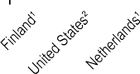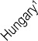

48 48

27 29 25

3

9

19

35

39

40

44

44

50

59

61

64

71

73

79

60

40

20

0

1. Programme data. 2. Survey data.

Source: OECD Health Statistics 2023.

*StatLink 2* <https://stat.link/e5afdz>

**Safe prescribing in primary care**

Safe prescribing of medicines can be used as an indicator of healthcare quality, complementing information on consumption and expenditure on pharmaceuticals (see Chapter 9). The overuse, underuse or misuse of prescription medicines can lead to serious consequences for the health of the patient and wasteful expenditure. This is the case for opioids and antibiotics, for example.

Guidelines recommend that antibiotics should only be prescribed where there is a need that is clearly supported by evidence, to reduce the risk of developing resistant strains of bacteria. The total volume of antibiotics prescribed has been validated as an indicator of quality in the primary care setting, given the rising public health concern caused by antimicrobial resistance across OECD countries (OECD, 2018[1]).

Figure 6.6 shows the overall volume of antibiotics prescribed in 2021, compared to 2019 and 2011. On average, 13 defined daily doses (DDDs) of antibiotics per 1 000 population were prescribed across OECD countries in 2021 – a reduction in the overall volume prescribed from 18 DDDs in 2011 and 17 DDDs in 2019. The total volume of antibiotics prescribed in 2021 varied three-fold across OECD countries, with Austria, the Netherlands and Germany reporting the lowest volumes per population, and Greece, France, Poland and Spain reporting the highest, and with OECD accession countries Romania and Bulgaria higher still. The observed variation might be explained, on the supply side, by differences in the guidelines and incentives that govern primary care prescribers and, on the demand side, by differences in attitudes and expectations regarding optimal treatment of infectious illness. In addition to stricter guidelines and changes in medical practice, in the most recent period, this is probably due to a decrease in cases of infectious diseases thanks to the increased safety measures associated to the COVID-19 pandemic, such as handwashing, use of face masks and a reduction in overall social interaction.

Opioids are used to treat acute pain, such as pain associated with cancer. However, over the last decade opioids have increasingly been used to treat chronic pain, despite the risk of dependence and addiction, leading to serious health risks and often culminating in death. Opioid use is now causing an alarming and rising epidemic of overdose deaths in some OECD countries, such as the United States and Canada (OECD, 2019[2]).

thereby limiting the effect of anticoagulant drugs on preventing strokes. Physicians and policy makers should consequently be aware that people receiving anticoagulating drugs should be protected from the risks of combining them with NSAID prescriptions (Penner et al., 2022[3]).

Figure 6.8 shows the proportion of patients with long-term prescriptions of any anticoagulating drug in combination with an oral NSAID among all those receiving anticoagulating drugs. This proportion varies across countries, from Sweden and Finland at 2.9% and 5.2% to Estonia, Iceland, Italy, Slovenia and Portugal, with a proportion above 15%. Across OECD countries as a whole, this proportion has been decreasing since 2011, when it was at 17%, to 15% in 2019, and more recently to 13% in 2021.

**Definition and comparability**

A DDD is the assumed average maintenance dose per day for a drug used for its main indication in adults. For instance, the DDD for oral aspirin equals 3 grammes – the assumed maintenance daily dose to treat pain in adults. DDDs do not necessarily reflect the average daily dose actually used in a given country. For more detail, see [www.whocc.no/atcddd.](http://www.whocc.no/atcddd)

The denominator for the indicator on the overall volume of antibiotics prescribed includes total population, while the denominator for the indicator on overall volume of opioids prescribed includes only the adult population with at least one prescription (aged 18 and over). Data for EU/EEA countries refers only to antibiotic consumption in the community.

For the indicator on patients with long-term prescriptions of any anticoagulating drug in combination with an oral NSAID, the denominator corresponds to all patients receiving long- term anticoagulating drugs (>270 DDD). This indicator only refers to the safety of prescribing/dispensing, not to the risk patients have, because NSAIDs are also available without a prescription (over the counter).

**References**

Figure 6.7 indicates that, across OECD countries, the average volume of opioids prescribed in primary care settings in 2021 was 13 DDDs per 1 000 adult population. Iceland reported volumes almost three times the OECD average, at 35 DDDs per 1 000 adult population; Türkiye and Korea reported the lowest volumes, at 1 DDD or less. The wide variation can be explained in part by differences in clinical practice in pain management, as well as differences in regulation, legal frameworks for opioids, prescribing policies and treatment guidelines. Most countries providing data reported a slight decrease in the overall volume of opioids prescribed in 2021 compared to 2019, continuing the downward trend observed from 2012. However, deaths from opioid use remain a major public health concern – particularly in the United States (see section on “Illicit drug use” in Chapter 4).

Anticoagulating drugs aim to prevent the formation of blood clots. However, when they are prescribed in combination with oral non-steroidal anti-inflammatory drugs (NSAIDs), the probability of an adverse bleeding event occurring is higher,

OECD (2019), *Addressing Problematic Opioid Use in OECD countries*, OECD Health Policy Studies, OECD Publishing, Paris, https://doi.org/10.1787/a18286f0-en.

OECD (2018), *Stemming the Superbug Tide: Just A Few Dollars More*, OECD Health Policy Studies, OECD Publishing, Paris, https://doi.org/10.1787/9789264307599-en.

Penner, L. et al. (2022), “Does coprescribing nonsteroidal anti‐inflammatory drugs and oral anticoagulants increase the risk of major bleeding, stroke and systemic embolism?”, *British Journal of Clinical Pharmacology*, Vol. 88/11, pp. 4789-4811, https://doi.org/10.1111/bcp.15371.

[2]

[1]

[3]

**Figure 6.6. Overall volume of antibiotics prescribed, 2011, 2019 and 2021 (or nearest years)**

2011 2019 2021 (values shown)

DDDs per 1 000 population per day 35

Note: Data for Canada only from British Columbia, Manitoba and Saskatchewan provinces. Source: ECDC 2023 (for EU/EEA countries); OECD Health Statistics 2023.



30

25

20

15

10

5

0

24

16 16 16 16 16 16 17 18 19 19

22 22

7

8

8

9 9 9

9

9

10

11 11 11

12 13 13 13 14 14 15 15

*StatLink 2* <https://stat.link/cp9ivm>

**Figure 6.7. Overall volume of opioids prescribed in the adult population, 2012, 2019 and 2021 (or nearest years)**

2012 2019 2021 (values shown)

DDDs per 1 000 population aged 18 and over, per day 40

35

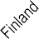

35

13

13

14

15

18

21

21

6

8

8

11

13

13

0

1

30

25

20

15

10

5

0

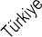   

Note: Excludes products used in the treatment of addiction. Data for Canada only from British Columbia, Manitoba and Saskatchewan provinces. Source: OECD Health Statistics 2023.

*StatLink 2* <https://stat.link/sdxnh4>

**Figure 6.8. Proportion of patients with long-term prescription of any anticoagulating drug in combination with an oral NSAID, 2011, 2019 and 2021 (or nearest years)**

2011 2019 2021 (values shown)

Per 100 patients receiving anticoagulating drugs 60

50

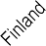

11

14

3

13

11

5

22

22

18

17

16

16

40

30

20

10

0

Source: OECD Health Statistics 2023.

*StatLink 2* <https://stat.link/xrlds8>

**Avoidable hospital admissions**

Asthma, chronic obstructive pulmonary disease (COPD) and congestive heart failure (CHF) are widely prevalent long-term conditions. Common to all three conditions is that the evidence base for effective treatment is well established, and much of it can be delivered by primary care. A high-performing primary care system, where accessible and high-quality services are provided, can reduce acute deterioration in people living with asthma, COPD or CHF. Hospital admissions for these conditions are largely avoidable and are therefore used as a marker of quality and access to primary care, with the proviso that very low admissions rates may also partly reflect reduced access to acute care.

Primary care is often the first contact point that people have with health systems. Yet inadequate access to high quality primary care can lead to hospital admissions for conditions that are largely avoidable. Its functions include promoting health and preventing disease; dealing with new health complaints; treating the majority of uncomplicated cases; managing chronic conditions; and referring patients to specialist or hospital-based services when appropriate. A key aim of primary care is to keep people well by providing a consistent point of care over the long term, treating common conditions, tailoring and co-ordinating care for those with multiple healthcare needs, and supporting patients’ self-management of their conditions. Good primary care, therefore, has the potential to improve health, reduce socio-economic inequalities in health and make healthcare systems people- centred, while making better use of healthcare resources (OECD, 2020[1]). The COVID-19 pandemic also highlighted the importance of strong primary care for disease prevention, since people with chronic conditions have higher risks of adverse health outcomes due to infection.

Figure 6.9 shows that the combined hospital admission rates for asthma and COPD varied 15-fold across OECD countries in 2021, with Mexico, Italy and Chile reporting the lowest rates and Australia and Denmark reporting the highest, at over twice the OECD average. Prior to the pandemic, hospital admission rates for asthma and COPD decreased in nearly all OECD countries – on average by 13% between 2011 and 2019. The decline was most notable in the Slovak Republic and Lithuania, where the rate was high in 2011, thereby

While overall improvements between 2011 and 2019 may represent advances in the quality of primary care, investment in primary care may still not be happening quickly enough, potentially resulting in unnecessary spending on high-cost hospital care (OECD, 2017[2]). The accelerated decline in hospital admissions between 2019 and 2021 is likely to be due to difficulties in accessing healthcare and hesitancy among patients to seek regular care during the COVID-19 pandemic. However, it may also indirectly reflect improved access to and quality of primary care to some extent, since OECD countries adopted telemedicine and digital tools quickly to facilitate access; by early 2021, almost one in two adults had consulted their physician remotely in 22 out of 27 European countries (OECD, 2023[3])]; see section on “Digital health” in Chapter 5). The COVID-19 crisis highlighted the importance of placing primary healthcare at the core of health systems, both to manage an unexpected surge in demand and to maintain continuous access to high-quality care for all, while containing increases in healthcare costs (OECD, 2020[1]).

**Definition and comparability**

The indicators are defined as the number of hospital admissions with a primary diagnosis of asthma or COPD or CHF among people aged 15 years and over per 100 000 population. Rates are age- and sex-standardised to the 2015 OECD population. Admissions resulting from a transfer from another hospital and where the patient dies during admission are excluded from the calculation, as these are considered unlikely to be avoidable.

Disease prevalence and availability of hospital care may explain some, but not all, variations in cross-country rates. Differences in coding practices among countries may also affect the comparability of data. For example, the exclusion of transfers cannot be fully complied with by some countries. Differences in data coverage of the national hospital sector across countries may also influence rates.

**References**

narrowing the cross-country variation. During the pandemic, the decline was more significant, with the average decrease in OECD countries about 40% between 2019 and 2021, but this likely reflects in part more limited access to hospital care at this time.

Hospital admission rates for CHF varied 13-fold across OECD countries, as shown in Figure 6.10. Mexico and Costa Rica had the lowest rates, while Poland reported a rate over twice the OECD average. As with asthma and COPD, the average admission rate across OECD countries decreased (by 6%) between 2011 and 2019. During the pandemic, the rate decreased further in most countries – on average, a decline of about 20% was reported across OECD countries between 2019 and 2021. Only Costa Rica and Norway reported an increase.

OECD (2023), *Ready for the Next Crisis? Investing in Health System Resilience*, OECD Health Policy Studies, OECD Publishing, Paris, https://doi.org/10.1787/1e53cf80-en.

OECD (2020), *Realising the Potential of Primary Health Care*, OECD Health Policy Studies, OECD Publishing, Paris, https://doi.org/10.1787/a92adee4- en.

OECD (2017), *Tackling Wasteful Spending on Health*, OECD Publishing, Paris, https://doi.org/10.1787/9789264266414-en.

[3]

[1]

[2]

**Figure 6.9. Asthma and chronic obstructive pulmonary disease hospital admission in adults, 2011, 2019 and 2021 (or nearest years)**

2011 2019 2021 (values shown)

Age-sex standardised rate per 100 000 population

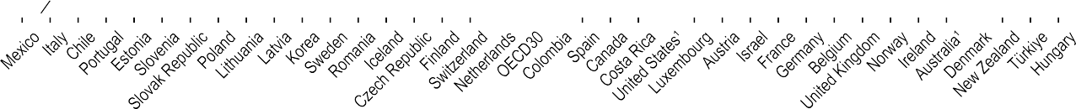

550

500

450

400

350

300

250

200

271 277

248

193 195 211 212

150

100

50

0

96 100 105

109119 119 122 123 125 129

132 132 137138 144 148

66 76 81 83 86

18 23 40 54

1. Latest data refer to 2020 instead of 2021. Source: OECD Health Statistics 2023.

*StatLink 2* <https://stat.link/oful6a>

**Figure 6.10. Congestive heart failure hospital admission in adults, 2011, 2019 and 2021 (or nearest years)**

2011 2019 2021 (values shown)

Age-sex standardised rate per 100 000 population

1. Latest data refer to 2020 (and 2022 for Costa Rica) instead of 2021. Source: OECD Health Statistics 2023.



800

700

600

500

400

363

364

459

266

357357

316

300

195 196 202

203 206 208 217 220 220

227

200

100

0

142 148 156 159 159 159 160 161167

35

44

79

82

83

113

*StatLink 2* <https://stat.link/v07e5d>

**Diabetes care**

Effective management of diabetes is a public health priority, with about 537 million adults estimated to be living with the condition worldwide. The significance of prevention and management of diabetes was also highlighted during the COVID-19 pandemic, as the infection is associated with high risks of hospitalisation and mortality among people with diabetes. Deaths due to diabetes continue to increase globally, reaching 6.7 million deaths in 2021. It is projected that by 2045 approximately 783 million adults will have the condition, and taking into account the impact of COVID-19, the burden of diabetes is likely to become even higher (IDF, 2021[1]).

Diabetes is a leading cause of cardiovascular disease, blindness, kidney failure and lower limb amputation, and ongoing control of diabetes usually involves a considerable amount of self-management; therefore, patient-centred care instruction and education are central to primary care of people with diabetes (OECD, 2020[2]). In most cases, hospital admissions for diabetes can be avoided through high quality primary care. In particular, effective control of blood glucose levels through routine monitoring, dietary modification and regular exercise can reduce the onset of serious complications and the need for hospitalisation. Management of key risk factors such as smoking, blood pressure and lipid levels is also important in reducing complications.

Figure 6.11 shows that in 2021 there was a more than 20-fold variation in hospital admissions for diabetes across OECD countries. Japan, Iceland and Italy reported the lowest rates, while the United States reported rates more than twice the OECD average. Prevalence of diabetes, general access to hospital care may explain some of this variation. As seen for other chronic conditions (see section on “Avoidable hospital admissions”), admissions for diabetes fell in nearly all countries both before and during the pandemic. The average decreases across OECD countries were 19% between 2011 and 2019, and 17% between 2019 and 2021. During the pandemic, the reduction was largest in Mexico and Poland, potentially reflecting reduced use of healthcare services across multiple settings.

In individuals living with diabetes and hypertension, angiotensin-converting enzyme inhibitors or angiotensin receptor blockers are recommended in most national guidelines as first-line medications to reduce blood pressure. Figure 6.12 reveals broad consistency in the proportion of patients with diabetes on recommended antihypertensive

between 2011 and 2019, while it was smaller – at around 6% – during the pandemic.

The relationship between the nature, frequency and duration of primary care provided for diabetes and the rate of admissions to hospital for related complications is complex, and warrants further research. The OECD’s international survey of patients with chronic conditions including diabetes ([www.oecd.org/health/paris.htm](https://www.oecd.org/health/paris.htm)), is likely to uncover differences in primary care performance and outcomes of diabetes care across countries.

**Definition and comparability**

Diabetes hospital admission data are based on the sum of three indicators: admissions for short-term and long-term complications and for uncontrolled diabetes without complications. The indicator is defined as the number of hospital admissions with a primary diagnosis of diabetes among people aged 15 years and over per 100 000 population. Major lower extremity amputation in adults with diabetes is defined as the number of discharges of people aged 15 years and over per 100 000 population. Rates for these indicators have been age-standardised to the 2015 OECD population.

Differences in data definition, diagnostic and coding practices and indicator calculation methods between countries may affect comparability of data. For example, in many countries diabetes is coded as a secondary diagnosis, while a few countries code it as a primary diagnosis. Differences in data coverage of the national hospital sector across countries may also influence indicator rates.

The denominator of people with diabetes who are prescribed recommended antihypertensive medication is based on people with diabetes (i.e. who are long-term users of glucose-regulating medication) who also have one or more prescriptions per year from a range of medications often used in the management of hypertension in a specific year. The numerator is the number of people who have one or more prescriptions of an angiotensin-converting enzyme inhibitor or angiotensin receptor blocker.

**References**

medications, although Türkiye, the Netherlands and Iceland had rates lower than 80%. Changes in the proportion have remained stable over recent years, and the pandemic also did not seem to have much impact on prescribing patterns for individual living with diabetes, possibly due to expanded use of e-prescriptions (OECD, 2023[3]).

High-quality primary care can reduce the risk of amputations among diabetes patients, and the rate of hospital admissions for major lower extremity amputation reflects the long-term quality of diabetes care. Figure 6.13 shows large international variation in rates of amputation among adults with diabetes, with Iceland, Italy and Korea reporting rates lower than 3 per 100 000 population, while the United States reported a rate higher than 30 per 100 000. Admissions for amputation have decreased in recent years; the average decline was about 10%

IDF (2021), *IDF Diabetes Atlas 2021*, International Diabetes Federation, https://diabetesatlas.org/atlas/tenth-edition/.

OECD (2023), *Ready for the Next Crisis? Investing in Health System Resilience*, OECD Health Policy Studies, OECD Publishing, Paris, https://doi.org/10.1787/1e53cf80-en.

OECD (2020), *Realising the Potential of Primary Health Care*, OECD Health Policy Studies, OECD Publishing, Paris, https://doi.org/10.1787/a92adee4- en.

[1]

[3]

[2]

**Figure 6.11. Diabetes hospital admissions in adults, 2011, 2019 and 2021(or nearest year)**

2011 2019 2021 (values shown)

Age-sex standardised rates per 100 000 population 400

1. Latest data refer to 2020 (and 2022 for Costa Rica) instead of 2021. Source: OECD Health Statistics 2023.



300

200

142

147

148 152

157

170 172 196

231

94 94

97100 100 102 102102 102 120 121

100

11 30 31

45

53 57 59

70 80 80 82 88 90

0

*StatLink 2* <https://stat.link/jz6pqy>

**Figure 6.12. People with diabetes prescribed recommended antihypertensive medication, 2011 and 2021 (or nearest year)**

2011 2021 (values shown)

% of patients with diabetes 100

90

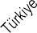

90

90

89

88

86

86

85

84

84

84

84

82

81

79

79

73

80

70

60

50

40

30

20

10

0

1. 2019. 2. Data only from the provinces of British Columbia, Manitoba and Saskatchewan. Source: OECD Health Statistics 2023.

*StatLink 2* <https://stat.link/aey2q1>

**Figure 6.13. Major lower extremity amputation in adults with diabetes, 2011 and 2021 (or nearest year)**

2011 2021 (values shown)

Age-sex standardised rates per 100 000 population



40

33

30

19

20

17

18 19

10

7 8 8 8

8 9

9

10 10 10

11

1

2 3

3 4 4 4

4

5 6

6

6 7

7

0

1. Latest data for Finland refer to 2019, for Australia and the United States to 2020, and for Costa Rica to 2022 instead of 2021. Data for Canada refer to fiscal year 2019-20.

Source: OECD Health Statistics 2023.

*StatLink 2* <https://stat.link/6qir29>

**People-centredness of ambulatory care**

Given the importance of incorporating people’s voices into the development of health systems and improving quality of care, national efforts to develop and monitor patient-reported measures have been intensified in recent years. In many countries, specific organisations have been established, or existing institutions identified, and made responsible for measuring, monitoring and reporting patient experiences of healthcare. This has resulted in more regular collection of patient experience data and standardised procedures for analysis and reporting.

Countries use patient-reported data differently to drive quality improvements in health systems. To promote quality of healthcare through increased provider accountability and transparency, many countries report patient experience data in periodic national health system reports and/or on public websites, showing differences across providers and regions, and over time. Canada, the Czech Republic, Denmark, France and the United Kingdom use patient experience measures to inform healthcare regulators for inspection, regulation and/or accreditation. Patient-reported measures are also used in some Canadian jurisdictions, Denmark, the Netherlands and the United Kingdom, to provide specific feedback for providers to support quality improvement (Fujisawa and Klazinga, 2017[1]).

Across OECD countries, the majority of patients reported positive experiences during their healthcare: that they spent enough time with a regular doctor during consultation (Figure 6.14), and that a regular doctor provided easy- to-understand explanations (Figure 6.15) and involved them in care and treatment decisions (Figure 6.16). Japan reports a particularly low rate of patient perception of sufficient time spent with a doctor, and this probably reflects the high number of consultations per doctor (see section on “Consultations with doctors” in Chapter 5). However, in Korea – which has the highest number of consultations per doctor – four out of five patients reported that doctors spent enough time with them.

was observed in some of these countries in 2020; this may be related to the COVID-19 crisis, to some extent.

The COVID-19 pandemic has also made clear the need to institutionalise mechanisms to incorporate patient voices in policy decisions that have an impact on patient care (OECD, 2021[2]). A growing number of countries are using patient- reported measures to assess how well health systems are serving people’s needs. The OECD’s Patient-Reported Indicator Surveys (PaRIS) initiative aims to collect key people-reported outcomes and experiences to improve the performance of healthcare providers and to drive changes in health systems, based on people’s voices (OECD, 2021[3]) (see [www.oecd.org/health/paris.htm](https://www.oecd.org/health/paris.htm)).

**Definition and comparability**

An increasing number of countries have been collecting patient experience data through nationally representative population surveys, or through nationally representative service user surveys (Japan and Portugal). About half of the countries presented, however, collect data on patient experiences with any doctor, while others collect patient- reported experiences with a regular doctor or regular practice.

For 10 countries, the Commonwealth Fund International Health Policy Surveys 2010 and 2020 were used as a data source, even though there are limitations relating to the survey’s small sample size and low response rates. Data from this survey refer to patient experiences with a general practitioner. For the Netherlands, which participates in the Commonwealth Fund International Health Policy Surveys, a national survey is used as a data source.

**References**

International variations in patient-reported measures may be influenced by various factors, such as survey coverage, response rates and cultural differences in survey response patterns.

Patients’ income level is associated not only with access to care (see section on “Unmet needs for healthcare” in Chapter 5) but also with their experiences of healthcare. On average across the 11 OECD countries that participated in the Commonwealth Fund International Health Policy Surveys 2010 and 2020, patients with above-average income reported better healthcare experience than patients with below-average income across all three measures.

Between 2010 and 2020, patient experiences improved in Estonia and Israel across all three measures. However, the proportion of patients who reported spending enough time with a doctor during consultation decreased significantly in Germany, New Zealand, Sweden, Switzerland and the United Kingdom, and the proportion of patients being involved in care and treatment decisions decreased significantly in France, Sweden, Switzerland and the United Kingdom. A significant reduction in patients reporting positive experiences

Fujisawa, R. and N. Klazinga (2017), “Measuring patient experiences (PREMS): Progress made by the OECD and its member countries between 2006 and 2016”*, OECD Health Working Papers*, No. 102, OECD Publishing, Paris, https://doi.org/10.1787/893a07d2-en.

OECD (2021), *Patient-Reported Indicators Surveys (PaRIS)*, OECD, Paris,

<http://www.oecd.org/health/paris.htm> (accessed on 26 June 2019).

OECD (2021), “Strengthening the frontline: How primary health care helps health systems adapt during the COVID-19 pandemic”*, OECD Policy Responses to Coronavirus (COVID-19)*, OECD Publishing, Paris, https://doi.org/10.1787/9a5ae6da- en.

[1]

[3]

[2]

**Figure 6.14. Doctor spending enough time with patient during consultation, 2010 and 2021 (or nearest year)**

% 100

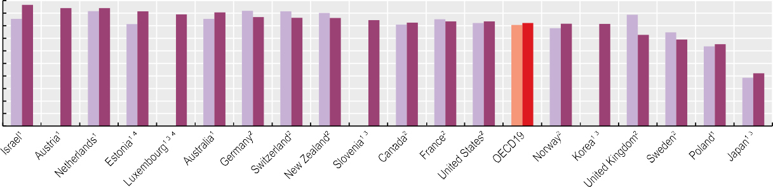

97 94 94 92 89 91

87

86 86 84

82

84 83 82 82 81

73

69

65

42



2010 2021

90

80

70

60

50

40

30

20

10

0

1. Data from national sources. 2. Data from Commonwealth Fund International Health Policy Surveys 2010 and 2020. 3. Data refer to patient experiences with any doctor. 4. 2019 data.

Source: OECD Health Statistics 2023.

*StatLink 2* <https://stat.link/hj1gnp>

**Figure 6.15. Doctor providing easy-to-understand explanations, 2010 and 2021 (or nearest year)**

% 100

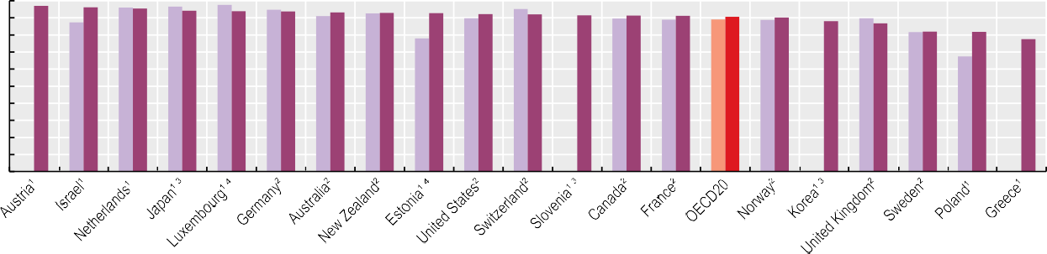

97 96

95

94 94 94 93 93 93

92 92 91

91 91 91

90

88 87

82 82

78



2010 2021

90

80

70

60

50

40

30

20

10

0

1. Data from national sources. 2. Data from Commonwealth Fund International Health Policy Surveys 2010 and 2020. 3. Data refer to patient experiences with any doctor. 4. 2019 data.

Source: OECD Health Statistics 2023.

*StatLink 2* <https://stat.link/vn6hmr>

**Figure 6.16. Doctor involving patient in decisions about care and treatment, 2010 and 2021 (or nearest year)**

% 100

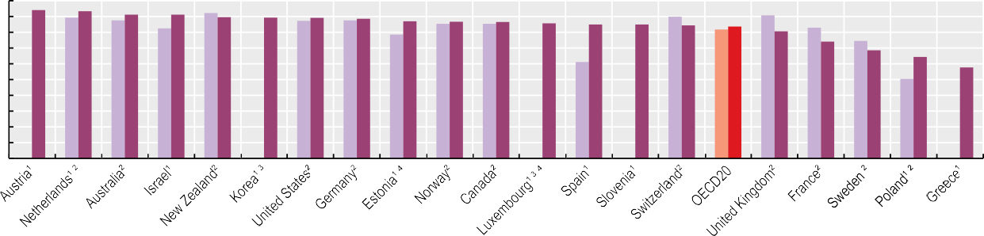

94 93 91 91 90 89 89 89 87 87 87

86

85 85 84 84

81

74

69

64

58



2010 2021

90

80

70

60

50

40

30

20

10

0

1. Data from national sources. 2. Data from Commonwealth Fund International Health Policy Surveys 2010 and 2020. 3. Data refer to patient experiences with any doctor. 4. 2019 data.

Source: OECD Health Statistics 2023.

*StatLink 2* <https://stat.link/8am0wg>

**Safe acute care – workplace culture and patient experiences**

Measures of patient safety culture from the perspective of health workers can be used – along with patient-reported experiences of safety and traditional patient safety indicators (see section on “Safe acute care – surgical complications and obstetric trauma”) – to give a holistic perspective of the state of safety in health systems.

A positive patient safety culture for health workers results in shared perceptions of the importance of safety, increased transparency and trust, and higher levels of shared responsibility, along with improved confidence in organisational and national safety initiatives. A growing body of research has found that a positive patient safety culture is associated with better health outcomes and patient experiences, as well as improved organisational productivity and staff satisfaction. Improved models of patient safety governance and investment in improving the patient safety culture have a substantial and lasting impact on outcomes (G20 Health & Development Partnership, 2021[1]).

Figure 6.17 and Figure 6.18 illustrate two domains of the Hospital Survey on Patient Safety Culture (HSPSC), which asks hospital staff to provide information on aspects of their work environment and whether they are conducive to good patient safety. Figure 6.17 shows staff perceptions of whether important patient care information is transferred across hospital units and during shift changes. Positive perceptions from staff on safety of handoffs and transitions range widely across countries, with an over 20 percentage point difference for HSPSC – both version 1.0 and version 2.0. Figure 6.18 shows staff perceptions that staffing levels and the work pace are adequate. Across all staff types, positive perceptions on staffing and work pace are relatively high in Türkiye, the United States, the Netherlands and Colombia (around 50% or more with positive perceptions across different types) but low in Mexico, Belgium and Switzerland. There is a clear disconnect between perceptions among management and frontline staff in most countries. On average, 57% of physicians and nurses in hospitals perceived staff levels and work pace to

including issues related to behaviours. Hence, caution is needed when interpreting cross-country variations in patient experiences of safety, and further research is needed to improve data comparability.

**Definition and comparability**

Health worker perceptions of patient safety are based on the assessment of workers in the hospital setting (including psychiatric hospitals) using the HSPSC, versions 1.0 and

2.0. There are differences in the average performance between HSPSC 1.0 and 2.0. Several other differences may also influence the compatibility of data shown in Figure 6.17 and Figure 6.18. These relate primarily to differences in the scope and methods used in the patient safety culture measurement, including differences in the total number of survey respondents, types and number of participating hospitals, response rates and required vs. voluntary reporting (OECD, forthcoming[2]). Careful interpretation of patient safety culture indicators is required because of these differences.

International comparisons of patient-reported data are challenging. Data from the Commonwealth Fund International Health Policy Survey 2020 refer to people aged 18 and over who reported having a medical mistake in the past two years. National surveys based on the OECD pilot instrument (OECD, 2019[3]) refer to adult patients who reported experiences of patient safety incidents during hospitalisation that happened in the past few months. Hence, these measures are not directly comparable. Their comparability may also be influenced by other factors, including phrasing of the questions and response categories, and the order of questions in the survey.

**References**

be unsafe, compared to 51% of management staff.

Patient perspectives are also critical to make health systems safer and more people-centred. According to the Commonwealth Fund International Health Policy Survey 2020, the proportion of patients reporting experiences of medical mistakes in the past two years varied between about 6% in France and New Zealand and above 10% in the United States, Germany and Norway in 2020. Among hospitalised patients, the proportion of adult patients who experienced patient safety incidents during their last hospitalisation ranged between 4% in Latvia and 17% in Belgium (Figure 6.19). It should be noted that a larger proportion of patients are likely to have experienced medical mistakes because patients may not report physical harm if they are not immediately recognisable (unlike pain and infection), and if they are not informed of their occurrence by a provider. In Belgium, the high rate based on its pilot data collection could be due to selection bias based on more frequent responses by patients who had experiences of unsafe care than others who received safe care, and higher awareness of patient safety among the population, since patients report a wide range of patient safety incidents,

G20 Health & Development Partnership (2021), *The Overlooked Pandemic: How to Transform Patient Safety and Save Healthcare Systems*, https[://www.ssdhub.org/wp-](http://www.ssdhub.org/wp-) content/uploads/2021/03/1863-Sovereign-Strategy- Patient-Safetly-Report-1.pdf (accessed on

3 June 2021).

OECD (2019), *Patient-Reported Safety Indicators: Question Set and Data Collection Guidance*, OECD, Paris, https://[www.oecd.org/health/health-](http://www.oecd.org/health/health-) systems/Patient-reported-incident-measures- December-2019.pdf.

OECD (forthcoming), “Technical report on Phase II of the OECD data collection on Patient Safety Culture”, *OECD, Paris*.

[1]

[3]

[2]

**Figure 6.17. Health workers’ perceptions of handoffs and transitions, 2021 (or nearest year)**

HSPSC 2.0 HSPSC 1.0

% of staff in hospital settings 80

70

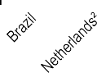

75

70

63

62

62

61

61

53

56

53

49

43

42

36

30

60

50

40

30

20

10

0

  

1. Data refer to a pre-pandemic year 2018-19. 2. Data refer to 2019 and 2020, and data exclude psychiatric hospitals. Source: OECD Pilot Data Collection on Patient Safety Culture, 2020-23.

*StatLink 2* <https://stat.link/kjd2z9>

**Figure 6.18. Health workers’ perceptions of adequate staff levels and work pace, by job category, 2021 (or nearest year)**

Management Physicians Nurses

% of staff in hospital settings 70

60



50

40

30

20

10

0

1. Data from HSPSC 1.0 (data for other countries from HSPSC 2.0). 2. Data refer to 2019 and 2020. Source: OECD Patient Safety Culture Pilot Data Collection, 2020-23.

*StatLink 2* <https://stat.link/cw9unp>

**Figure 6.19. Patients reporting that patient safety incidents occurred during treatment or care, 2020 (or nearest year)**

% 20

17

10

10

10

10

10

10

8

6

6

7

8

8

4

5

General population Hospitalised patients

18

16

14

12

10

8

6

4

2

0

France New

Zealand

Netherlands United

Kingdom

Canada Switzerland Australia Sweden Norway Germany United

States

Latvia Estonia Poland Belgium

Note: Data for the general population are from the Commonwealth Fund International Health Policy Survey 2020. Source: OECD Pilot Data collection on Patient-Reported Experience of Safety, 2020-23.

*StatLink 2* <https://stat.link/h1iftc>

**Safe acute care – surgical complications and obstetric trauma**

Patient safety, relating to prevention of harm during healthcare activities, remains a pressing issue with substantial social and economic costs in OECD countries. It is estimated that up to 13% of healthcare spending goes towards treatment of patients harmed during care, the majority of which could be avoided if appropriate safety protocols and clinical guidelines were adhered to (Slawomirski and Klazinga, 2022[1]). To achieve sustainable progress towards safe care and the goals of WHO’s Global Patient Safety Action Plan 2021-30, a focus on the promotion of patient safety cultures (see section on “Safe acute care – workplace culture and patient experiences”) and improvement in both processes and outcomes (see section on “Patient-reported outcomes in acute care”) is vital (WHO, 2021[2]).

Surgery for hip fracture is usually performed as an emergency procedure; thus, early intervention within the first 48 hours can drastically improve patient outcomes and minimise the risk of complications. Time to surgery is influenced by many factors, including hospitals’ surgical theatre capacity, flow and access, and targeted policy interventions.

Across OECD countries, more than four out of five (80%) patients admitted for hip fracture underwent surgery within 48 hours in 2021, ranging from 99% in Iceland to 47% in Portugal (Figure 6.20). Compared to 2011, the proportion of patients whose surgery was managed in a timely manner increased in 2021 by more than 20% in Israel and Italy, which started monitoring this quality indicator to promote timely intervention of hip fracture, while rates decreased in the same period in Lithuania and Estonia. Türkiye and Lithuania registered substantial drops from 2019 to 2021, associated with capacity constraints during the pandemic (OECD, 2023[3]).

Joint replacement surgery, often recommended as a last-line treatment for osteoarthritis if non-surgical interventions have failed, carries the risks of post-surgery pulmonary embolism (PE) and deep vein thrombosis (DVT). PE and DVT cause unnecessary pain, reduced mobility and – in some cases – death, but can be prevented by anticoagulants and other measures.

Figure 6.21 shows the substantial cross-country variation in

Poland, Lithuania, Costa Rica and Latvia to more than 3% in Denmark, Iceland and Canada. Differences across countries, including completeness and transparency of the patient safety monitoring system, rates of caesarean sections, coding practices, high year-on-year variation in countries with a very small number of cases of instrument-assisted deliveries, and use of administrative versus obstetric registry data influence the rates.

**Definition and comparability**

Figure 6.20 shows the proportion of patients aged 65 and over admitted to hospital with a diagnosis of upper femur fracture who had surgery initiated within two calendar days of admission. Although cases where the hip fracture occurred during the admission should normally be excluded, the capacity to capture time of admission and surgery in hospital administrative data varies across countries, and higher capacity could lead to overestimation.

Rates of PE and DVT using unlinked data refer to cases identified in hospitals where surgery occurred, while linked data account for patients with PE or DVT within 30 days of the surgery in and outside the hospital where surgery was initially conducted. For Latvia, the risk profile of the patients used to calculate these rates may be different from those who accessed care in the private system.

The two obstetric trauma indicators show the rates of third- and fourth-degree tears, using International Classification of Diseases, tenth revision (ICD-10) codes O70.2-O70.3 in any field, after vaginal delivery assisted by an instrument (deliveries using forceps or vacuum extraction) and without an instrument. For Australia, Portugal and the United States, data cover women aged 15 years and above, whereas for all other countries, data are for women aged 18 years and above.

**References**

rates in 2021, ranging from 57 cases of PE or DVT per 100 000 surgical discharges in Italy to 1 192 per 100 000 in Australia. This variation may be due to several factors, such as differences in diagnostic and coding practices. Higher rates may signal more complete patient safety monitoring systems and a transparent patient safety culture rather than worse care. Many countries reported higher rates in 2021 compared to 2019, probably related to changes in the case mix by prioritising joint replacement surgery for patients with higher risks and a decrease in acute care capacity.

Severe tearing of the perineum during vaginal childbirth is a drastic adverse patient safety event that often requires surgical intervention and may lead to complications such as perineal pain and incontinence. Although prevention is not always possible, appropriate labour management and high-quality obstetric care can reduce the occurrence of tears (Wilson and Homer, 2020[4]).

Figure 6.22 shows that rates of obstetric trauma vary between countries for instrument-assisted delivery from less than 2% in Lithuania, Israel and Poland to more than 10% in Canada, the United States and Denmark. The incidence of traumas in births without instrumental assistance ranges from less than 0.5% in

OECD (2023), *Ready for the Next Crisis? Investing in Health System Resilience*, OECD Health Policy Studies, OECD Publishing, Paris, https://doi.org/10.1787/1e53cf80-en.

Slawomirski, L. and N. Klazinga (2022), “The economics of patient safety: From analysis to action”*, OECD Health Working Papers*, No. 145, OECD Publishing, Paris, https://doi.org/10.1787/761f2da8-en.

WHO (2021), *Global patient safety action plan 2021- 2030: towards eliminating avoidable harm in health care*, World Health Organization, https://apps.who.int/iris/handle/10665/343477.

Wilson, A. and C. Homer (2020), “Third‐and fourth‐ degree tears: A review of the current evidence for prevention and management”, *Australian and New Zealand Journal of Obstetrics and Gynaecology*, Vol. 60/2, pp. 175-182,

https://doi.org/10.1111/ajo.13127.

[3]

[1]

[2]

[4]

**Figure 6.20. Hip fracture surgery initiation for patients aged 65+ within two days of hospital admission, 2011 and 2021 (or nearest years)**

2011 2021 (values shown)

% 100

90

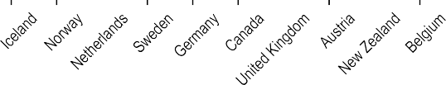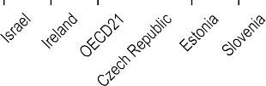

99 98 96

95

94 93 92 91 91 91 90

87

80 79 79

69 67

65

59 58 57

48 47

80

70

60

50

40

30

20

10

0

Source: OECD Health Statistics 2023.

*StatLink 2* <https://stat.link/rh1ud2>

**Figure 6.21. Post-operative pulmonary embolism or deep vein thrombosis in hip and knee surgeries, 2021 (or nearest year)**

DVT (2021) PE (2021)

Per 100 000 hospital discharges for hip and knee surgery Per 100 000 hip and knee surgery patients 1500

1000



1121 1192

57 59

157 162 193

232 245

324 324 369 467 528 528 558 597 637

689 902

659 893

138 219

559 575

346

500

0

Using unlinked data Using linked data

Note: Data for Australia refer to 2020, and to 2022 for Costa Rica instead of 2021. Data labels are shown for 2021 PE + DVT. 1. Data only cover the public system.

2. Data coverage is partial, covering parts of the public and private systems. Source: OECD Health Statistics 2023.

*StatLink 2* <https://stat.link/28m6t9>

**Figure 6.22. Obstetric trauma in vaginal delivery with and without instrument, 2021 (or nearest year)**

With instrument Without instrument

Crude rate per 100 vaginal deliveries with or without instrument

Note: Data for Australia, Denmark, the Netherlands and the United States refer to 2020, and to 2022 for Costa Rica instead of 2021. Source: OECD Health Statistics 2023.

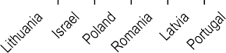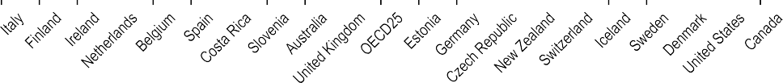

20

18

16

14

12

10

8

6

4

2

0

11.6 11.7

6.0

1.1

0.3

1.4

1.9

0.5

1.7

3.1

0.4

3.2

2.5

1.4

1.5

0.9

1.0

0.8

0.4

0.9

1.0

1.3

1.0

0.7

0.5

0.3

3.5

1.7

3.0

1.6

3.2

2.0

2.0

2.2

2.9

2.6

2.2

1.6

6.1

5.5

5.3

5.1

4.7

4.5

3.7

7.4

7.2

7.2

5.7

5.7

9.2

8.9

15.8

*StatLink 2* <https://stat.link/xdtvpq>

**Mortality following acute myocardial infarction (AMI)**

Mortality due to coronary heart disease has declined substantially over recent decades (see section on “Mortality from circulatory diseases” in Chapter 3). Reductions in smoking (see section on “Smoking” in Chapter 4) and improvements in treatment for heart diseases have contributed to this decline (OECD, 2015[1]). Despite this progress, AMI (heart attack) remains one of the leading causes of death and the main cause of cardiovascular death in many OECD countries, highlighting the need for further reductions in risk factors and care quality improvements (OECD/The King's Fund, 2020[2]).

Metrics of 30‐day mortality after hospital admission for AMI are reflective of processes of care, such as timely transport of patients and effective medical interventions. As such, the indicator is influenced not only by the quality of care provided in hospitals but also by differences in the patterns of hospital transfers, length of stay and AMI severity across countries.

Figure 6.23 shows mortality rates within 30 days of admission to hospital for AMI using unlinked data – that is, only counting deaths that occurred in the hospital where the patient was initially admitted – among patients aged 45 and over. The lowest rates in 2021 were in Iceland, Norway, the Netherlands, Australia and Sweden (less than 4%) while the highest rates were in Latvia (15.9%) and Mexico (23.7%). In Mexico, many hospitals lack the capacity to perform AMI diagnosis, and pharmacological and mechanical reperfusion (Pérez-Cuevas et al., 2020[3]), and this might be associated with high AMI mortality rates.

Figure 6.24 shows the same 30-day mortality rate but calculated based on linked data, whereby the deaths are recorded regardless of where they occurred after hospital admission (in the hospital where the patient was initially admitted, after transfer to another hospital or after being discharged). Based on these linked data, AMI mortality rates in 2021 ranged from 3.2% in the Netherlands to 17.9% in Latvia.

Case fatality rates for AMI decreased substantially between 2011 and 2019. Across OECD countries, the average rate fell from 8.4% to 6.7% for same-hospital deaths (Figure 6.23) and from 10.7% to 8.6% for deaths in and out of hospital (Figure 6.24), and this is reflected in a decrease in rates of

Cross-country analysis of recent 30-day case fatality trends is also challenging because people with underlying cardiovascular conditions tend to be more vulnerable to dying from COVID-19 infection, while at the same time COVID-19 infection itself is associated with an increased risk of different types of cardiovascular disease – both ischaemic heart disease and cerebrovascular diseases. Therefore, COVID-19 prevalence may also have affected changes in mortality rates due to diseases of the circulatory system, with close clinical links with COVID-19 complicating the cause of death coding across countries.

More data and analyses are needed to assess cross-country variations in accessibility and quality of acute care provided to patients with acute cardiovascular events such as AMI during the pandemic. While timely provision of high-quality care is required from the onset of the disease among these patients, 30-day mortality rates only capture the quality of care provided once admitted to hospital. Pre-hospital access to healthcare such as emergency medical services, which is also crucial for outcomes of AMI patients, is not well understood.

**Definition and comparability**

The case fatality rate measures the percentage of people aged 45 and over who die within 30 days following hospital admission for a specific acute condition. Unlinked data include only deaths that occurred in the same hospital as the initial admission; linked data include deaths recorded regardless of where they occurred, including in another hospital or outside the hospital where AMI was first recorded. The linked data-based method is considered more robust than the rates based on unlinked data, and results in much lower variation between countries. However, it requires a unique patient identifier to link the data across the relevant datasets, which is not available in all countries.

Rates are age- and sex-standardised to the 2013 OECD population aged 45 and over admitted to hospital for AMI, using ICD-10 codes I21-I22.

**References**

overall mortality due to AMI over the same period.

Between 2019 and 2021, however, the average rate increased by 4% for both same-hospital deaths and deaths in and out of hospital. The increase was significantly high in Türkiye and Germany for same-hospital deaths and a substantial increase was also observed for deaths in and out of hospital in the Slovak Republic and Poland. A number of subnational studies in OECD countries point out that, during the pandemic, the average severity of AMI patients admitted to hospital increased due to hesitancy in seeking care – particularly among those with milder conditions – and the time from the onset of symptoms to treatment was prolonged due to later patient presentations at hospitals and longer processing time at hospital before initiating a needed procedure. A mix of these factors may have contributed to an increase in 30-day mortality rates during the pandemic.

OECD (2015), *Cardiovascular Disease and Diabetes: Policies for Better Health and Quality of Care*, OECD Health Policy Studies, OECD Publishing, Paris, https://doi.org/10.1787/9789264233010-en.

OECD/The King’s Fund (2020), *Is Cardiovascular Disease Slowing Improvements in Life Expectancy?: OECD and The King’s Fund Workshop Proceedings*, OECD Publishing, Paris, https://doi.org/10.1787/47a04a11-en.

Pérez-Cuevas, R. et al. (2020), “Gaps between supply and demand of acute myocardial infarction treatment in Mexico”, *Salud Pública de México*, Vol. 62/5, Sep-Oct, pp. 540-549, https://doi.org/10.21149/11032.

[1]

[2]

[3]

7.2

7.2

7.2

7.9

8.0

8.1

8.3

8.9

9.0

9.7

10.1

11.0

14.7

14.7

15.4

15.9

23.7

**Figure 6.23. Thirty-day mortality after admission to hospital for acute myocardial infarction based on unlinked data, 2011, 2019 and 2021 (or nearest year)**

2011 2019 2021 (values shown)

Age-sex standardised rate per 100 admissions for people aged 45 years and over

Source: OECD Health Statistics 2023.

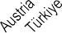

30

25

20

15

10

5

0

1.7

2.6

2.9

3.3

3.6

[4](https://stat.link/4fhut0).1

4.3

4.7

4.8

5.1

5.2

5.2

5.4

5.5

5.8

6

6.2

6.5

6.7

7.0

7.3

7.4

8

8.3

8.4

8.6

8.8

9.9

10.3

11.3

*StatLink 2* <https://stat.link/4fhut0>

**Figure 6.24. Thirty-day mortality after admission to hospital for acute myocardial infarction based on linked data, 2011, 2019 and 2021 (or nearest year)**

17.9

2011 2019 2021 (values shown)

Age-sex standardised rate per 100 patients aged 45 years and over

Source: OECD Health Statistics 2023.

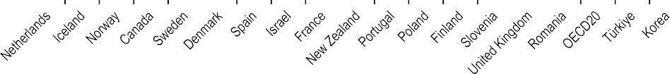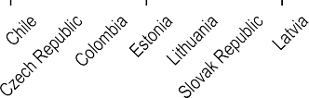

20

15

10

5

0

3.2

5.0

6.0

6.5

6.8

6.9

7.0

*StatLink 2* <https://stat.link/m0apxh>

**Mortality following ischaemic stroke**

Stroke is a leading cause of death, accounting for 6% of all deaths across OECD countries in 2021 (see sections on “Main causes of mortality” and “Mortality from circulatory diseases” in Chapter 3). A stroke occurs when the blood supply to a part of the brain is interrupted, leading to necrosis (cell death) of the affected part. Of the two types of stroke, about 85% are ischaemic (caused by clotting) and 15% are haemorrhagic (caused by bleeding).

Figure 6.25 shows the case fatality rates within 30 days of hospital admission for ischaemic stroke where death occurred in the same hospital as the initial admission (unlinked data). Figure 6.26 shows the case fatality rate where deaths are recorded regardless of where they occurred, including in another hospital or outside the hospital where the stroke was first recorded (linked data). The indicator using linked data is more robust because it captures fatalities more comprehensively than the same-hospital indicator, but it requires a unique patient identifier and the capacity to link data, which are not available in all countries. The results from this indicator are higher than for the same-hospital indicator, as deaths are recorded regardless of where they occurred after hospital admission.

Across OECD countries, almost 8.0% of patients died within 30 days of hospital admission for ischaemic stroke in 2021 using unlinked data (Figure 6.25). The case fatality rates were highest in Latvia, Mexico, Lithuania and Slovenia – all with mortality rates over 11%. Rates were lower than 4% in Japan, Iceland, Norway and Korea. Low rates in Japan are due in part to efforts dedicated to improving the treatment of stroke patients in hospitals, through systematic blood pressure monitoring, major material investment in hospitals and establishment of specialised stroke units (OECD, 2015[1]).

Across 19 OECD countries that reported linked data, 12.3% of patients on average died within 30 days of being admitted to hospital for stroke in 2021 (Figure 6.26). The mortality rate was highest (over 20%) in Türkiye, Lithuania and Latvia, and lowest

9.4% to 7.7% for unlinked data rates and from 13.7% to 11.6% for linked data rates (Figure 6.25 and Figure 6.26). Countries can improve the quality of stroke care further through timely transportation of patients, evidence-based medical interventions and access to high-quality specialised facilities such as stroke units (OECD, 2015[1]). Advances in technology are leading to new models of care to deliver reperfusion therapy even more quickly and efficiently, whether through pre-hospital triage by telephone or administering the therapy in the ambulance.

Between 2019 and 2021, case fatality rates based on unlinked data increased significantly in Lithuania, the Slovak Republic and the Czech Republic, and case fatality rates based on linked data increased substantially in Türkiye, Lithuania, the Slovak Republic and the Czech Republic (Figure 6.25 and Figure 6.26). During this period, hospital admissions following ischaemic stroke also decreased in most OECD countries. As with heart attack (see section on “Mortality following acute myocardial infarction (AMI)”), a number of studies conducted in OECD countries have found that admitted patients showed higher severity of stroke than in the pre-pandemic period, owing to delayed hospital arrival time for stroke patients due to emergency medical services processing time – particularly during the initial phase of the pandemic. Close clinical links with COVID-19 also complicate assessment and monitoring of the resilience of health systems in ensuring access to and quality of acute care.

**Definition and comparability**

National case fatality rates are defined in the section on “Mortality following acute myocardial infarction (AMI)”. Ischaemic stroke refers to ICD-10 codes I63-I64.

**References**

(under 8%) in Korea, the Netherlands and Norway. Korea has attained a low mortality rates through improvements in acute ischaemic stroke management, including an increased number of comprehensive stroke centres supporting high-quality care and thrombectomy, and expansions in health insurance coverage in relation to mechanical thrombectomy (Park et al., 2022[2]).

Treatment for ischaemic stroke has advanced dramatically over recent decades, with systems and processes now in place in many OECD countries to identify suspected ischaemic stroke patients and to deliver acute reperfusion therapy quickly. Between 2011 and 2019, case fatality rates for ischaemic stroke decreased across OECD countries: from

OECD (2015), *OECD Reviews of Health Care Quality: Japan 2015: Raising Standards*, OECD Reviews of Health Care Quality, OECD Publishing, Paris, https://doi.org/10.1787/9789264225817-en.

Park, S. et al. (2022), “Change of mortality of patients with acute ischemic stroke before and after 2015”, *Frontiers in Neurology*, Vol. 13, https://doi.org/10.3389/fneur.2022.947992.

[1]

[2]

**Figure 6.25. Thirty-day mortality after admission to hospital for ischaemic stroke based on unlinked data, 2011, 2019 and 2021 (or nearest year)**

2011 2019 2021 (values shown)

Age-sex standardised rate per 100 admissions for people aged 45 years and over 25

20

15.4

17.2

20.5

15

9.1

9.4

9.4

9.9

10.4

11.4

12.1

10

2.9

3.1

3.1

3.3

4.3

4.8

4.9

4.9

5.4

5.5

5.9

6.0

6.3

6.6

6.6

7.6

7.7

7.9

8.2

9.0

9.0

5

0

Source: OECD Health Statistics 2023.

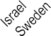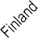

*StatLink 2* <https://stat.link/pzvcdh>

**Figure 6.26. Thirty-day mortality after admission to hospital for ischaemic stroke based on linked data, 2011, 2019 and 2021 (or nearest year)**

2011 2019 2021 (values shown)

Age-sex standardised rate per 100 patients aged 45 and over 35

30

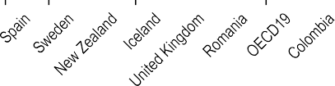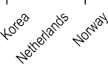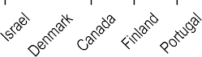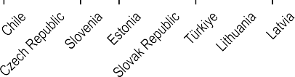

22.4

27.4

25

18.2

20.7

20

12.0

12.3

15.4

15.4

17

15

8.3

8.7

8.8

9.7

9.9

10.2

10.3

10.6

11.5

11.5

10

5.3

5.3

7.3

5

0

Source: OECD Health Statistics 2023.

*StatLink 2* <https://stat.link/e6vb2l>

**Patient-reported outcomes in acute care**

Patient-reported measures have become essential tools to improve healthcare quality and ensure people-centred care. Patient-reported outcome measures (PROMs) are often used as an indicator of the quality of care, including acute care such as hip and knee replacement surgery. They are used to monitor and promote delivery of patient-centred care as they provide information about patients’ perception of the quality of healthcare, such as whether the care they received met their individual goals and needs. Given the increasing importance of measuring PROMs to assess the quality of care in recent years, the number of people responding to PROMs requests in relation to hip and knee replacement surgery has increased across countries, even during the COVID-19 pandemic when the volume of surgeries declined (OECD, forthcoming[1]).

**Definition and comparability**

PROMs results are based on data from national or subnational arthroplasty registries in countries using data on adult patients undergoing elective hip or knee replacement surgery with a principal diagnosis of osteoarthritis, who completed an OHS/OKS and/or HOOS/KOOS-PS questionnaire, and/or an EQ-5D or Short Form 12 (SF-12), version 1 or version 2, both before and after operations. The OHS/OKS and the HOOS/KOOS-PS are among the most common disease-specific PROMs used for hip and knee replacement surgery. Generic instruments including the EQ-5D and SF-12 are also frequently used to assess general quality of life of patients. Post-operative scores are adjusted for pre-operative score, as well as the age and sex of the patient cohort. A higher score denotes better outcomes on all these scales. Post-operative scores for Australia, Ireland and England (United Kingdom) are measured 6 months after the surgery, while others refer to 12 months after surgery, potentially leading to differences in the extent of recall bias. Scores derived from different instruments for the same operation are not comparable.

For OHS and OKS, data for Canada refer to Manitoba and Ontario, while data for Italy refer to Tuscany. For HOOS-PS and KOOS-PS, data for Italy refer to Galeazzi and Rizzoli. Sample sizes for France, Italy and Switzerland for the OKS are below 500 patients.

A mix of tools was also used to measure quality of life. In Canada, EQ-5D was used in Ontario and Alberta but SF-12 was used in Manitoba. In Italy, EQ-5D data are available from Tuscany and Rizzoli but SF-12 was used in Galeazzi. In Switzerland, SF-12 was used in Geneva. Data collected through SF-12 from these regions were converted to EQ-5D, and converted SF-12 scores might result in lower scores. The sample size for Switzerland is below 500 patients (Kendir et al., 2022[2]).

In all measures, data for Switzerland refer to Geneva, while data for the United Kingdom refer to England.

Figure 6.27 shows changes between the pre-operative and post-operative scores on the Oxford Hip Score (OHS) and Hip Disability and Osteoarthritis Outcome Score – Physical Short Form (HOOS-PS) scales reported by patients after elective hip replacement surgery for osteoarthritis, which are available in joint replacement registries across countries. Figure 6.28 shows changes between the pre-operative and post-operative scores reported by patients using the Oxford Knee Score (OKS) and Knee Injury and Osteoarthritis Outcome Score – Physical Short Form (KOOS-PS) after elective knee replacement surgery for osteoarthritis. Figure 6.29 shows quality of life of patients measured by the EuroQol 5-Dimensional tool (EQ-5D) before and after hip or knee replacement surgery.

In all countries, substantial improvements in PROMs scores were observed after operations. For example, average quality of life after hip surgery improved in all countries, reaching a score equivalent to 80% or higher, up from scores equivalent to 35-50% pre-surgery (based on the OHS). Average changes from pre-operative to post-operative scores varied across countries in all scales. The highest change in OHS and OKS scores was observed in Ireland, where the improvement in quality of life measured by EQ-5D was also highest. For HOOS-PS and KOOS-PS, the Netherlands had the highest change from before to after surgery.

It should be noted that variations in post-operative scores reflect not only cross-country differences in the quality of hip and knee replacement surgery but also other factors such as differences in socio-demographic and clinical characteristics of patients reporting PROMs, so caution is needed when interpreting variations across countries.

**References**

Kendir, C. et al. (2022), “International assessment of the use and results of patient-reported outcome measures for hip and knee replacement

surgery: Findings of the OECD Patient-Reported Indicator Surveys (PaRIS) working group on hip and knee replacement surgery”*, OECD Health Working Papers*, No. 148, OECD Publishing, Paris, https://doi.org/10.1787/6da7f06b-en.

OECD (forthcoming), *Findings of the OECD Working Group on Patient-Reported Indicators for Hip and Knee Replacement Surgery: Technical report on data collected from 2018-2021*, OECD, Paris.

[2]

[1]

**Figure 6.27. Patient-reported outcomes before and after hip replacement surgery, disease-specific measure, 2023 (or nearest year)**

Sc 45

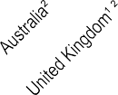

17

Pre-operative score Post-operative score

24

22

23

20

21

20

19

18

19

39

40

40

41

41

42

42

42

42

ale (0-48)

44

40

35

30

25

20

15

10

5

0

**Oxford Hip Score**

Scale (0-100)



88

87

83

58

54

52

Pre-operative score Post-operative score

100

90

80

70

60

50

40

30

20

10

0

**HOOS-PS**

 

1. Data limited to specific localities (as detailed in “Definition and comparability” box). 2. Post-operative scores are measured 6 months after the surgery. Source: OECD PaRIS Hip and Knee PROMs Pilot Data Collection.

*StatLink 2* <https://stat.link/x0s2in>

**Figure 6.28 Patient-reported outcomes before and after knee replacement surgery, disease-specific measure, 2023 (or nearest year)**

Scale (0-48)

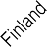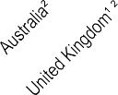

41

40

38

38

38

37

37

36

36

19

18

19

21

19

23

22

23

21

23

35

Pre-operative score Post-operative score

45

40

35

30

25

20

15

10

5

0

**Oxford Knee Score**

**KOOS-PS**

Pre-operative score Post-operative score

Scale (0-100)

100



72

72

48

50

49

59

69

71

90

80

70

60

50

40

30

20

10

0

 

1. Data limited to specific localities (as detailed in “Definition and comparability” box). 2. Post-operative scores are measured 6 months after the surgery. Source: OECD PaRIS Hip and Knee PROMs Pilot Data Collection.

*StatLink 2* <https://stat.link/6izsoh>

**Figure 6.29. Patient-reported quality of life before and after hip and knee replacement surgery, generic measure, 2023 (or nearest year)**

**EQ-5D Scores (hip replacement surgery) EQ-5D Scores (knee replacement surgery)**

Pre-operative score Post-operative score

Pre-operative score Post-operative score

Scale (0-1)

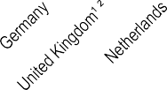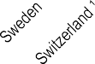

0.89

0.86

0.86

0.82

0.81

0.30

0.36

0.46

0.51

0.57

0.55

0.64

0.60

0.60

0.78

0.79

0.80

0.80

|  |  |  |  |  |  |  |  |  |  |  |  |  |  |  |  |  |
| --- | --- | --- | --- | --- | --- | --- | --- | --- | --- | --- | --- | --- | --- | --- | --- | --- |
|  | |  | |  | | 0.80 | | 0.77 | | 0.77 | | 0.77 | | 0.76 | | 0.76 |
|  |  |  |  |  | |  | |  | |  | |  | |  | |  |
|  |  |  |  |  |  |  |  |  |  |  |  |  |  |  |  |  |
|  |  |  |  |  |  |  |  |  |  |  |  |  |  |  |  |  |
|  | |  | |  | |  | |  |  |  |  |  |  |  |  |  |
| 0.62 | | 0.59 | | 0.60 | | 0.62 | |  | |  |  |  |  |  | | 0.63 |
|  | |  | |  | |  | | 0.56 | |  |  |  | | 0.55 | |  |
|  | |  | |  | |  | |  | |  | | 0.43 | |  | |  |
|  | |  | |  | |  | |  | | 0.37 | |  | |  | |  |
|  | |  | |  | |  | |  | |  | |  | |  | |  |



Scale (0-1)

1

0.9

0.8

0.7

0.6

0.5

0.4

0.3

0.2

0.1

0

1

0.9

0.8

0.7

0.6

0.5

0.4

0.3

0.2

0.1

0

0.83 0.82 0.80

      

     

 

   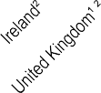 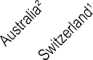

1. Data limited to specific localities (as detailed in “Definition and comparability” box). 2. Post-operative scores are measured 6 months after the surgery. Source: OECD PaRIS Hip and Knee PROMs Pilot Data Collection.

*StatLink 2* <https://stat.link/4r61o3>

**Care for people with mental health disorders**

The burden of mental illness is substantial, affecting one in two people at some point in their lives. During the COVID-19 pandemic, levels of mental distress increased (see section on “Mental health” in Chapter 3), and the prevalence of anxiety and depression doubled in some countries (OECD, 2021[1]). The economic costs due to mental ill health have been estimated to be more than 4.2% of gross domestic product (GDP), covering both the direct costs of treatment and the indirect costs related to lower employment rates and reduced productivity (OECD, 2021[2]). High-quality, timely care has the potential to improve outcomes, and to reduce suicide and excess mortality for individuals with mental disorders.

Data on quality and outcomes of care point to shortcomings in continuity of care and ongoing difficulties with improving outcomes, especially for people with severe mental disorders. Suicide rates after hospital discharge can indicate the quality of care in the community following hospitalisation, as well as co-ordination between inpatient and community settings. Across OECD countries, suicide rates among patients who had been hospitalised in the previous year ranged from 0.4 per 1 000 patients in Iceland to almost 10 per 1 000 in the Netherlands in 2020-21 (Figure 6.30). Differences in suicide rates may also reflect differences in access to mental health care and the severity of patient conditions that are treated in inpatient settings, as hospital discharges vary widely across countries. Between 2011 and 2021, the average suicide rate was stable across OECD countries, but there was a marked decrease in countries including Chile, Finland and Sweden. Following successful implementation of the Suicide Prevention Programme in 1992-96, Finland introduced the National Mental Health Strategy and Suicide Prevention Agenda 2020-30 in 2020. Korea also saw a decreased number of suicides following discharge during the pandemic.

Individuals with a psychiatric illness have a higher mortality rate than the general population. An “excess mortality” value greater

service users reporting that they were treated with courtesy and respect in inpatient mental health services ranged from 49% in New Zealand to 100% in Portugal. In community mental health settings, the lowest share was again in New Zealand (65%), and the highest share was in Belgium (98%).

**Definition and comparability**

Suicide within one year of discharge is established by linking patients discharged following hospitalisation, with a principal diagnosis or first two listed secondary diagnosis code of mental health and behavioural disorders (ICD-10 codes F10-F69 and F90-99), and with suicide recorded in death registries (ICD-10 codes X60-X84).

For excess mortality indicators, the numerator is the overall mortality rate for people aged 15-74 diagnosed with schizophrenia or bipolar disorder. The denominator is the overall mortality rate for the general population in the same age group. The relatively small number of people with schizophrenia or bipolar disorder dying in any given year can cause substantial variations from year to year.

Mental health patient-reported experience measures (PREMs) are based on the assessment of inpatient and community mental health service users. Data refer to people aged 16 and over with a principal diagnosis of mental health and behavioural disorders. Cross-country comparisons of mental health PREMs should be made with caution because there are substantial variations in survey instrument including response categories, sampling methodology, sample size, survey implementation, patient case mix and service mix of users. Data for Belgium are limited to Flanders, for France to Paris, and for Korea to Seoul.

**References**

than one implies that people with mental disorders face a higher risk of death than the rest of the population. Figure 6.31 shows that mortality rates for people with schizophrenia and bipolar disorder are over twice as high as mortality rates for the general population in most countries. In 2021, excess mortality ranged from 2.0 in Lithuania and Sweden to 5.5 in Iceland, 4.6 in Korea

4.2 in Denmark and 4.1 in Canada for people who had lived with schizophrenia, and from 1.1 in Chile to 4.2 in Korea for people who had lived with bipolar disorders. Over the past decade, excess mortality among people with severe mental illness has increased in most countries except the Czech Republic and Sweden. Progress is notable in the Czech Republic, which started implementing mental health care strategies in 2017 focusing on providing multidisciplinary healthcare and social services to people with bipolar disorders and schizophrenia at mental health care centres in the community.

Patient-reported experience measures (PREMs) can help to capture the quality of care provided to individuals living with mental conditions. These metrics are increasingly used in mental health care to understand people’s experience of health services and to provide people-centred mental health care (de Bienassis et al., 2021[3]; OECD, forthcoming[4]). Figure 6.32 shows service users’ perceptions of whether care providers treated them with courtesy and respect, for those in inpatient mental health settings and those using community services. The share of mental health

de Bienassis, K. et al. (2021), “Measuring patient voice matters: setting the scene for patient-reported indicators”, *International Journal for Quality in Health Care*, Vol. 33/1, https://doi.org/10.1093/intqhc/mzab002.

OECD (2021), *A New Benchmark for Mental Health Systems: Tackling the Social and Economic Costs of Mental Ill-Health*, OECD Health Policy Studies, OECD Publishing, Paris, https://doi.org/10.1787/4ed890f6-en.

OECD (2021), “Tackling the mental health impact of the COVID-19 crisis: An integrated, whole-of-society response”*, OECD Policy Responses to Coronavirus (COVID-19)*, OECD Publishing, Paris, https://doi.org/10.1787/9a5ae6da-en.

OECD (forthcoming), “Standards for Assessing Patient Outcomes and Experiences of Mental Health Care in OECD Countries: Findings of the PaRIS Mental Health Working Group Pilot Data Collection”*, OECD Health Working Papers*, OECD Publishing, Paris.

[3]

[2]

[1]

[4]

**Figure 6.30. Suicide following a hospitalisation for a psychiatric disorder, within one year of discharge, 2011 and 2020-21 (or nearest year)**

2011 2020-21 (values shown)

Age-sex standardised rate per 1 000 patients 10

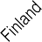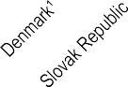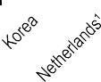

6.8 7.0

5.0 5.2

2.9

2.9

3.0

3.5 3.6

3.8

3.8 3.9

0.4

0.9

1.2

1.2

8

6

4

2

0

9.6

1. Latest available data for Colombia, Denmark and the United Kingdom refer to 2017, for the Netherlands to 2018, and for Canada, Israel and Norway to 2019. 2. Data uses three-year average.

Source: OECD Health Statistics 2023.

*StatLink 2* <https://stat.link/q2ed06>

**Figure 6.31. Excess mortality from bipolar disorder and schizophrenia compared to the general population, 2021 (or nearest available year)**

Bipolar disorder Schizophrenia

Age-sex standardised ratio 6

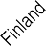

3.5

3.8

3.5

3.9

4.0

4.1

4.2

4.2 4.6

2.5 2.1

2.7

3.0

3.3

2.3

2.8

2.3

2.8

1.4

2.0

2.0

2.1

2.1

2.1

1.3

1.1

5

4

3

2

1

0

  

Note: Latest available data 2019. Source: OECD Health Statistics 2023.

5.5

*StatLink 2* <https://stat.link/9vfpoe>

**Figure 6.32. Share of inpatient and community mental health service users who were treated with courtesy and respect by care providers, 2021-22**

Inpatient mental health service users Community mental health service users

% positive response 100

90

|  |  |  |  |  |  |  |  |  |  |  |  |  |  |  |  |  |  |  |  |  |  |  |  |  |  |  |  |  |  |  |  |  |  |  |
| --- | --- | --- | --- | --- | --- | --- | --- | --- | --- | --- | --- | --- | --- | --- | --- | --- | --- | --- | --- | --- | --- | --- | --- | --- | --- | --- | --- | --- | --- | --- | --- | --- | --- | --- |
|  | 100 |  | |  | 96 |  |  |  | 95 | 98 |  |  | 94 |  |  |  |  | |  | |  |  |  | | | |  | | | |  | | | |
| 95 |
|  | 88 |  |  |  |  |  |  |  |  | 91 |  | |  | 87 | 93 |  |  | | 88 |  |  | |  |  |  | | | |
|  |  |  |  |  |  |  |  |  | 80 |  |  |  |  | 80 |  |  | | 83 |  |  | | | |
|  |  |  |  |  |  |  |  |  |  |  |  |  |  |  | |  |  | |  |  |
|  |  |  |  |  |  |  |  |  |  |  |  |  |  |  | 58 |  |  | |  |
|  |  |  |  |  |  |  |  |  |  |  |  |  |  |  |  |  | 49 | 65 |  |
|  |  |  |  |  |  |  |  |  |  |  |  |  |  |  |  |  |  |
|  |  |  |  |  |  |  |  |  |  |  |  |  |  |  |  |  |  |
|  |  |  |  |  |  |  |  |  |  |  |  |  |  |  |  |  |  |
|  |  |  |  |  |  |  |  |  |  |  |  |  |  |  |  |  |  |

80

70

60

50

40

30

20

10

0

Portugal Korea¹ Belgium France Ireland Canada Australia Japan New Zealand

1. Sample size is less than 100. Source: OECD Health Statistics 2023.

*StatLink 2* <https://stat.link/ci79p3>

**Integrated care**

When patients with chronic conditions require care from multiple providers across different healthcare settings, fragmented care can lead to poor health outcomes, unmet needs, and excessive service utilisation and costs. Recognising the need for care integration, countries are developing new models of care, aiming to enhance population health, improve patient experiences, reduce healthcare costs, support the well-being of healthcare professionals and promote health equity (OECD, 2023[1]).

Optimal integration between different levels of care for stroke and congestive heart failure (CHF) patients minimises unnecessary readmissions to hospitals and reduces mortality, while maximising appropriate prescriptions (Barrenho et al., 2022[2]). For patients with stroke and CHF discharged from hospital, outcomes such as readmission, mortality and compliance with prescription guidelines can measure the performance of health systems in delivering integrated care.

Figure 6.33 shows the proportion of patients with adverse outcomes within a year after discharge for ischaemic stroke and CHF in 2021. For patients discharged after a stroke, on average, 16% of the patient cohort died, while 22% were readmitted. Iceland (30%) and the Netherlands (32%) reported the lowest rates of adverse outcomes – both mortality and readmissions – and they also reported among the lowest rate for each adverse outcome. The highest overall adverse outcome rate was reported in the Czech Republic (53%). For CHF, Lithuania had the lowest rate of overall adverse outcomes (46%); this may reflect recent policy focus on digital health, which facilitated exchanges of medical records, care co-ordination and prevention at the primary level (OECD, 2018[3]), although care integration still has room for improvement. On the other hand, in Israel, 70% of CHF patients had an adverse event, with rates also above the OECD averages for mortality and readmissions separately.

Figure 6.34 shows that in all countries with available data the proportion of stroke or CHF patients who died or were readmitted within a year after discharge decreased in recent years. Between 2013 and 2021, the average rate decreased by 7% for stroke and about 4% for CHF across OECD countries. The largest decreases in this period were observed in Lithuania (by 18%) for stroke and in Japan (by 20%) for CHF. In most countries, the proportion of patients with adverse outcomes was stable during the pandemic.

Ischaemic stroke patients should receive antihypertensive and antithrombotic prescriptions for secondary prevention after hospital discharge. Having at least one prescription of these medicines in the 18 months after discharge provides insight into the quality of integration between hospital and community care (Barrenho et al., 2022[2]). Figure 6.35 shows that the prescription rate for antihypertensives varied from 63% in Austria to 82% in Sweden, while the prescription rate for antithrombotics ranged from 33% in Latvia to 94% in Sweden. The outstanding Swedish performance can be explained by adequate information transfers between levels of care and diagnosis recording (Dahlgren et al., 2017[4]).

**References**

**Definition and comparability**

Indicators refer to people aged 45 years or older on the day of admission presenting an acute non-elective (urgent) episode of care for a first-time event of ischaemic stroke or CHF. A first-time event was defined among patients who had not been admitted to hospitals due to ischaemic stroke or CHF in the previous five years. All countries applied this washout period except Japan, which used a one-year washout period. The year of the indicators refers to the year of the index episode of care, and data cover the next 365 days for mortality and readmissions or 548 days for prescriptions. For all countries, data are nationally representative, except for Japan, which accounted for 30% of the hospital network nationwide. These indicators require hospital data, death registries and prescribing/reimbursement claim data to be linked with unique patient identifiers.

In Figure 6.33 and Figure 6.34, data for the latest year refer to an index episode of care in 2021. Data for Canada and Finland refer to patients with an index episode in 2019. For Korea, the Netherlands, Slovenia, Italy, Estonia, Latvia and Norway, data refer to patients with an index episode in 2020.

Definitions of acute, urgent care vary across countries. Most countries defined acute, urgent care as hospital admission via emergency/unplanned care or immediate necessary curative care.

Barrenho, E. et al. (2022), “International comparisons of the quality and outcomes of integrated care: Findings of the OECD pilot on stroke and chronic heart failure”*, OECD Health Working Papers*, No. 142, OECD Publishing, Paris, https://doi.org/10.1787/480cf8a0-en.

Dahlgren, C. et al. (2017), “Recording a diagnosis of stroke, transient ischaemic attack or myocardial infarction in primary healthcare and the association with dispensation of secondary preventive medication: a registry-based prospective cohort study”, *BMJ Open*, Vol. 7/9, p. e015723, https://doi.org/10.1136/bmjopen-2016-015723.

OECD (2023), *Integrating Care to Prevent and Manage Chronic Diseases: Best Practices in Public Health*, OECD Publishing, Paris, https://doi.org/10.1787/9acc1b1d-en.

OECD (2018), *OECD Reviews of Health Systems: Lithuania 2018*, OECD Reviews of Health Systems, OECD Publishing, Paris, https://doi.org/10.1787/9789264300873-en.

[2]

[4]

[1]

[3]

**Figure 6.33. Patients with adverse outcomes within one year of discharge after ischaemic stroke and CHF, 2021 (or nearest year)**

Patients who died from any cause

Surviving patients readmitted due to primary diagnosis

Surviving patients readmitted due to other cause

Czech Republic

Israel United Kingdom

Latvia Norway Estonia Sweden OECD16

Italy Lithuania Canada Finland Slovenia Netherlands

Iceland Japan Korea

**Ischaemic stroke**

0 20 40 60

Age- and sex-standardised rate per 100 patients

Israel United Kingdom Czech Republic

Norway Latvia Sweden Canada OECD15

Finland Iceland Estonia Slovenia Netherlands

Italy Lithuania Japan

**Congestive Heart Failure**

0 20 40 60

Age- and sex-standardised rate per 100 patients

Source: OECD HCQO Data Collection on Integrated Care 2022-23.

*StatLink 2* <https://stat.link/yfrka7>

**Figure 6.34. Patients who died or were readmitted within one year of discharge after ischaemic stroke and CHF, 2013 and 2021 (or nearest year)**

2013 2021 (or latest available year)

Czech Republic

Israel United Kingdom

Norway Latvia Estonia Sweden OECD15

Lithuania

Italy Canada Finland Slovenia Netherlands

Iceland Japan

**Ischaemic stroke**

|  |  |  |  |
| --- | --- | --- | --- |
|  |  | 53  46  45  44 |  |
|  |  | 45 |  |
|  |  | 41 |  |
|  |  | 40 |  |
|  | 37 | 38  37 |  |
|  | 36 |  |  |
|  | 35 |  |  |
|  | 34 |  |  |
|  | 32 |  |  |
|  | 29 |  |  |
| 15 |  |  |  |

0 20 40 60

Age- and sex- standardised rate per 100 patients

Israel United Kingdom Czech Republic

Norway Latvia Sweden Canada OECD15

Finland Iceland Estonia Slovenia Netherlands

Italy Lithuania Japan

**Congestive Heart Failure**

69

70

66

69

60

64

57

59

55

57

57

51

46

54

52

32

0 20 40 60

Age- and sex-standardised rate per 100 patients

Source: OECD HCQO Data Collection on Integrated Care 2022-23.

*StatLink 2* <https://stat.link/lvmtyk>

**Figure 6.35. Patients receiving at least one antihypertensive and antithrombotic prescription in the 18 months following discharge after ischaemic stroke, 2020 (or nearest year)**

Antihypertensives Antithrombotics

Crude rate per 100 patients 100

80

82

69

89

33

43

51

73

63

77

71

76

79

81

94

60

40

20

0

Sweden Estonia Latvia Portugal Iceland Netherlands Austria

Source: OECD HCQO Pilot Data Collection on Integrated Care 2022-23.

*StatLink 2* <https://stat.link/fo9ges>

**152** 

HEALTH AT A GLANCE 2023 © OECD 2023

1. **Health expenditure**

Health expenditure in relation to GDP Health expenditure per capita

Prices in the health sector

Health expenditure by financing scheme Public funding of health spending Health expenditure by type of service

Health expenditure on primary healthcare Health expenditure by provider

Capital expenditure in the health sector

**Health expenditure in relation to GDP**

The resources that a country allocates to healthcare compared to the size of the overall economy vary over time due to differences in both the growth of health spending and overall economic growth. During the 1990s and 2000s, OECD countries generally saw health spending outpace the rest of the economy, leading to an almost continual rise in the health expenditure to GDP ratio. After the volatility of the 2008 economic and financial crisis, the share remained relatively stable, as growth in health spending broadly matched overall economic performance across the OECD. The arrival of the COVID-19 pandemic in 2020 with a severe slowdown in economic activity and rapidly increasing health spending led to a significant adjustment in the health expenditure to GDP ratio.

In 2019, prior to the pandemic, OECD countries were spending, on average, around 8.8% of their GDP on healthcare, a figure relatively unchanged since 2013. By 2021, this proportion had jumped to 9.7%. However, preliminary estimates for 2022 point to a significant fall in the ratio to 9.2%, reflecting both a reduced need for spending to tackle the pandemic as well as the impact of inflation reducing the value of health spending (OECD, 2023[1]). The United States still spent by far the most, equivalent to 16.6% of its GDP – well above Germany, the next highest spending country, at 12.7% (Figure 7.1). After the United States and Germany, a group of

15 high-income countries, including Canada, France and Japan, all spent more than 10% of their GDP on healthcare. In many of the Central and Eastern European OECD countries, as well as in the newer OECD member countries from Latin America, spending on health accounted for between 6-9% of their GDP. Finally, Luxembourg and Türkiye spent less than 6% of their GDP on healthcare.

An analysis of the trends in per capita health spending and GDP over the last 15 years shows two shocks: the economic and financial crisis in 2008 and the recent impact of COVID-19 in 2020 (Figure 7.2). While OECD economies sharply contracted in 2008 and 2009, health spending growth was maintained in the short term before hovering just above zero as a range of different policy measures to rein in public spending on health were put in place between 2010 and 2012. This was followed by a return to somewhat stronger growth, both in health spending and GDP up until the pandemic. In 2020, widespread lockdowns and other public health

the United Kingdom, for example, have closely followed this trend, with the latter showing an even more pronounced jump in 2021. Germany has seen a rather continual increase in the share of GDP over time. Despite the shocks, health spending as a share of GDP in Korea has seen a continual and steady increase throughout the last 15 years, from 4.8% in 2006 and reaching 9.7% in 2022.

**Definition and comparability**

Expenditure on health gives a measure of the final consumption of health goods and services (i.e. current health expenditure) (OECD/Eurostat/WHO, 2017[2]). This includes spending by all types of financing arrangements on medical services and goods, population health and prevention programmes, as well as administration of the health system. The split of spending combines government and compulsory financing schemes, the latter including private insurance of a mandatory nature. Due to data limitations, private voluntary insurance in the United States is included with employer-based private insurance, which is currently mandated under the Affordable Care Act.

Gross Domestic Product (GDP) is the sum of final consumption, gross capital formation and net exports. Final consumption includes goods and services used by households or the community to satisfy their individual needs. It includes final consumption expenditure of households, general government and non-profit institutions serving households.

In countries such as Ireland and Luxembourg, where a significant proportion of GDP refers to repatriated profits and thus not available for national consumption, Gross National Income (GNI) may be a more meaningful measure than GDP. However, for consistency, GDP is maintained as the denominator for all countries.

Note that data for 2022 are based on provisional figures provided by countries or preliminary estimates made by the OECD Secretariat.

**References**

measures severely restricting economic activity and consumer spending sent many OECD economies into freefall. There was a rebound in 2021 with per capita GDP increasing by 5.8% on average. At the same time, real per capita spending on health accelerated from just over 4% in 2020 to 8% in 2021 as countries allocated additional funding to tackle the pandemic. With countries emerging from the acute stage of the pandemic, health spending per capita is likely to have fallen on average by close to 1.5% in real terms in 2022.

Trends in the health-to-GDP ratio over this period translate into a distinct pattern with significant step increases in 2009 and 2020, and a period of stability in between (Figure 7.3). Italy and

OECD (2023), “Health care financing in times of high inflation”, OECD, Paris, https[://www.oecd.org/health/Health-care-financing-](http://www.oecd.org/health/Health-care-financing-) in-times-of-high-inflation.pdf.

OECD/Eurostat/WHO (2017), *A System of Health Accounts 2011: Revised edition*, OECD Publishing, Paris, https://doi.org/10.1787/9789264270985-en.

[1]

[2]

**Figure 7.1. Health expenditure as a share of GDP, 2022 (or nearest year)**

Government/Compulsory Voluntary/Out-of-pocket

% of GDP

1. OECD estimate for 2022. 2. 2021 data. 3. 2020 data.



20

18

16

14

12

10

8

6

4

2

0

12.7

12.1

11.5

11.4

11.3

11.3

11.2

11.2

10.9

10.7

10.6

10.4

10.2

10.0

10.0

9.8

9.7

9.6

9.5

9.2

9.1

9.0

9.0

8.8

8.8

8.6

8.6

8.6

8.5

8.1

8.1

7.9

7.8

7.5

7.4

7.2

6.9

6.7

6.7

6.5

6.3

6.1

5.7

5.5

5.5

4.3

3.4

2.9

Source: OECD Health Statistics 2023; WHO Global Health Expenditure Database.

*StatLink 2* <https://stat.link/5tof4d>

**Figure 7.2. Annual real growth in per capita health expenditure and GDP, OECD, 2006-22**

OECD

Germany Korea

United Kingdom Portugal

Italy

**Figure 7.3. Health expenditure as a share of GDP, selected countries, 2006-22**

Health GDP

%

10 14

8

6 12

4 10

2

0 8

% of GDP

-2

-4

-6

2006 2008 2010 2012 2014 2016 2018 2020 2022

6

4

2006 2011 2016 2021

Source: OECD Health Statistics 2023.

16.6

*StatLink 2* <https://stat.link/14cu3w>

Source: OECD Health Statistics 2023.

*StatLink 2* <https://stat.link/b3mlj1>

**Health expenditure per capita**

The level of per capita health spending, which captures both individual and population healthcare needs, and how this level changes over time depends on a wide range of demographic, social and economic factors, as well as the financing and organisational arrangements of a country’s health system.

In 2022, average per capita health spending in OECD countries (when adjusted for differences in purchasing power) was estimated to have reached nearly USD 5 000. In the United States, it reached the equivalent of USD 12 555 for every US citizen. Switzerland and Germany were the next highest spenders in the OECD, but at around USD 8 000 this was still less than two-thirds of the level in the United States (Figure 7.4). After Norway and Austria, a further group of western European countries, as well as Australia, Canada and New Zealand all spent between USD 6-7000. Per capita health spending broadly decreased across Southern European countries, Central and Eastern European countries to the Latin American OECD member countries, with spending in Mexico (USD 1 181) at around a quarter of the OECD average.

Figure 7.4 also shows the split of health spending based on the type of healthcare coverage, either organised through government health schemes or compulsory insurance (public or private), or through voluntary arrangements such as private voluntary health insurance or direct payments by households (see also indicator “Health expenditure by financing schemes”). On average across OECD countries, about three-quarters of all health spending is financed through government or compulsory insurance schemes.

The risk of illness and ill-health generally increases with age. A population with an older demographic structure can expect higher mortality rates, greater incidence and prevalence of certain diseases, and thus higher demands for healthcare and, by consequence, higher spending on health. Using a standard age-spending profile, the impact of different population structures on overall health spending across OECD countries can be assessed using indirect standardisation (OECD, forthcoming[1]). Figure 7.5 indicates that countries such as Israel and Ireland, and some of the Latin American OECD member countries could expect higher health spending relative to the OECD average if a standard population structure was applied, whereas those countries with older populations (e.g. Japan, Germany and Italy) could expect lower spending.

In the years leading up to the COVID-19 pandemic, annual average per capita spending on healthcare grew by an average of 2.6% across OECD countries (Figure 7.6). In Latvia, Lithuania as well as Korea, annual spending growth between

However, diverging trends in the pattern of health spending growth across countries during the pandemic could be observed due to the severity of the various waves across different regions, the extent and duration of containment policies, but the variation in how healthcare is financed in countries can also play a role. Of the 38 OECD countries, around two-thirds saw higher growth during the pandemic than in the years immediately preceding the crisis, and only Mexico is expected to have seen overall negative growth during the most recent three-year period. Some countries – Latvia and Türkiye, have seen double-digit growth in health spending between 2019 and 2022, reflecting both the severity and the continuation of the pandemic’s effects into 2022. In the Asia- Pacific region, Korea and New Zealand, have both seen growth of more than 8% on average between 2019 and 2022. Both countries had strong containment policies in place during 2020 and 2021, with a loosening resulting in some upsurge in COVID-19 cases in 2022.

**Definition and comparability**

See indicator “Health expenditure in relation to GDP” for a definition of current expenditure on health.

To compare spending levels between countries, per capita health expenditures are converted to a common currency (USD) and adjusted to take account of the difference in purchasing power of the national currencies. Actual Individual Consumption (AIC) PPPs are used as the most available and reliable conversion rates. For the calculation of growth rates in real terms, AIC deflators are used for all countries, where available.

For an international or temporal comparison of health indicators that are highly influenced by demographic factors, an adjustment to account of differences in the population age-structure can be desirable. While this practice is commonplace for many health outcome variables, it is less widespread for indicators measuring resource use in health. Different methods exist to age-adjust health indicators. Here, an indirect method of standardisation is used.

Note that data for 2022 are based on provisional figures submitted by countries or estimated by the OECD Secretariat.

**References**

2015 and 2019 was between 6 and 8%, while in most Nordic countries and France, growth was much more moderate at less than 1% on average. The emergence of COVID-19 in 2020 led to sharp increases in health spending, particularly from governments as they mobilised funds to slowdown and tackle the effects of the pandemic. Between 2019 and 2022, average per capita spending growth in the OECD accelerated to 3.3% per year, with a peak reached in 2021 before contracting in the most recent year (Figure 7.2).

OECD (forthcoming), “Understanding international measures of health spending: Age-adjusting expenditure on health”, *OECD Health Working Papers*.

[1]

**Figure 7.4. Health expenditure per capita, 2022 (or nearest year)**

12 555



Government/Compulsory Voluntary/Out-of-pocket

USD PPP

1. OECD estimates.

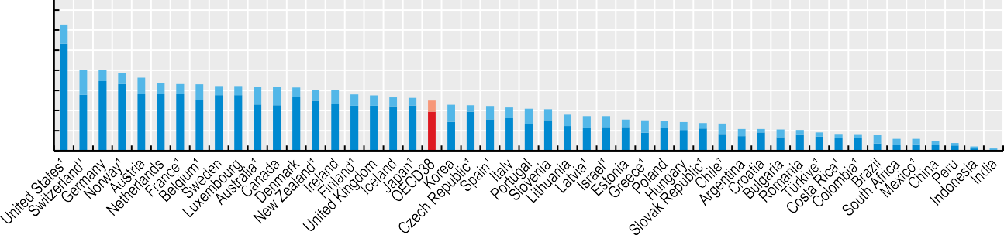

14 000

12 000

10 000

8 000

6 000

4 000

2 000

0

8 049

8 011

7 771

7 275

6 729

6 630

6 600

6 438

6 436

6 372

6 319

6 280

6 061

6 047

5 599

5 493

5 314

5 251

4 986

4 570

4 512

4 432

4 291

4 162

4 114

3 587

3 445

3 444

3 103

3 015

2 973

2 840

2 756

2 699

2 170

2 159

2 123

2 052

1 827

1 658

1 640

1 573

1 184

1 181

979

759

405

212

Source: OECD Health Statistics 2023; WHO Global Health Expenditure Database.

*StatLink 2* <https://stat.link/m6pzqb>

**Figure 7.5. Impact of age-adjusting health expenditure per capita, 2022**

258



Adjusted Non-adjusted

OECD=100

Note: Health spending relative to OECD average (OECD=100) after indirect standardisation based on a derived OECD age-spending profile.

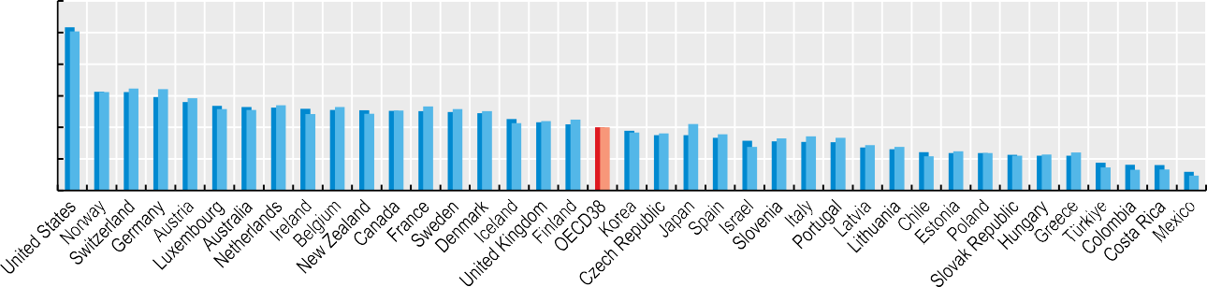

300

250

200

150

100

50

0

156

156

148

140

134

132

131

130

127

127

126

126

124

123

113

108

105

100

95

88

88

83

79

78

77

77

68

66

61

59

59

57

55

55

44

41

40

30

Source: Calculations based on OECD (forthcoming[1]), “Understanding international measures of health spending: Age-adjusting expenditure on health”.

*StatLink 2* <https://stat.link/giu21p>

**Figure 7.6. Average annual growth in per capita health expenditure (real terms), 2015-19 and 2019-22**

%

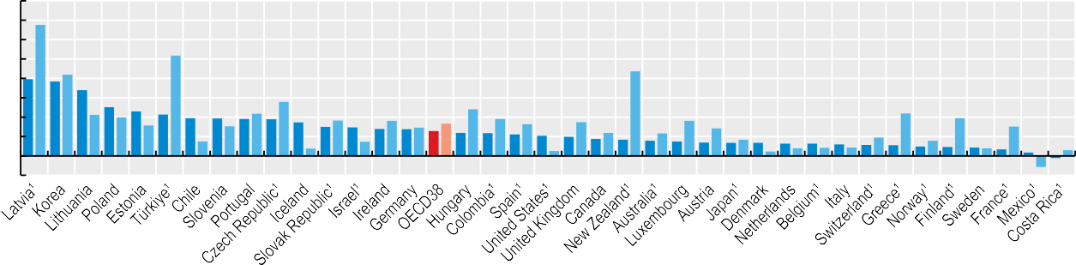

16

14

12

10

8

6

4

2

0

-2



2015-19 2019-22

13.5

8.4

4.3

4.0

3.2

10.4

1.5

3.1

4.4

5.6

0.8

3.6

1.5

3.6

2.9

3.3

4.8

3.8

3.3

0.5

3.5

2.4

8.7

2.3

3.6

2.9

1.7

0.5

0.8

0.9

0.9

1.9

4.4

1.6

3.9

0.8

3.0

-1.1

0.6

1. Based on OECD estimates for 2022. Growth rates and time periods may have been adjusted to take account of breaks in series. Source: OECD Health Statistics 2023.

*StatLink 2* <https://stat.link/rqlj9k>

**Prices in the health sector**

Comparisons of health spending reflect differences in the prices of healthcare goods and services, *and* the quantity of care that individuals are using (“volume”). Decomposing health spending into the two components gives policy makers a better understanding of what is driving spending differences.

Cross-country comparisons require spending to be expressed in a common currency, and the choice of conversion measure can heavily impact the results and interpretation (OECD/Eurostat, 2012[1]). One approach relies on converting local currencies using foreign exchange rates but this is not ideal because of their volatility. Moreover, for goods and services that are not traded internationally such as healthcare, market exchange rates do not reflect the relative purchasing power of currencies in their national markets. Another approach uses purchasing power parities (PPPs) which are available at an economy-wide level, industry level, and for selected spending aggregates. Actual Individual Consumption (AIC) PPPs – comprising *all* goods and services consumed by individuals – are the most widely used conversion rates for health spending (see indicator “Health expenditure per capita). However, using AIC PPPs means that the resulting measures not only reflect variations in the volume of healthcare goods and services, but also any variations in the prices of healthcare goods and services relative to prices of all other consumer goods and services across countries.

Figure 7.7 shows *health-specific* price levels based on a representative basket of healthcare goods and services for each OECD country. Switzerland and Iceland have the highest health prices in the OECD – on average the same basket of goods and services would cost 62% and 50% more than the OECD average, respectively. Healthcare prices also tend to be relatively high in Israel and the United States. In contrast, prices for the same mix of healthcare goods and services in Japan, Portugal and Slovenia are around two-thirds of the OECD average. The lowest healthcare prices in the OECD are in Türkiye, at 18% of the OECD average.

Removing the health price component from expenditure gives a measure of the amount of healthcare goods and services consumed by the population (“the volume of healthcare”). Comparing relative levels of health expenditures and volumes provides a way to look at the contribution of volumes and prices. Volumes of healthcare use vary less than health expenditure (Figure 7.8). The United States remains the highest consumer of healthcare in volume terms, 49% higher

traded goods tend to equalise in price between trading partners, services (such as healthcare) are typically purchased locally, with, for example, higher wages in wealthier countries leading to higher service prices. Comparing price levels in the health sector and in the economy relative to the OECD average, variation in health prices is greater than that in economy-wide prices (Figure 7.9). Countries with relatively low economy-wide prices tend to have health price levels that are even lower than in the general economy, and countries with high economy-wide prices typically having health prices that are higher than in the general economy. Yet not all higher income countries with high general prices have more expensive healthcare. In France and Germany, for example, general price levels are close to the OECD average, but healthcare prices are 30% and 20% lower respectively than the OECD average. This may reflect in part policy decisions to regulate healthcare prices.

**Definition and comparability**

Purchasing power parities (PPPs) are conversion rates that show the ratio of prices in national currencies of the same basket of goods and services in different countries. Thus, they can be used as both currency converters and price deflators. When used to convert expenditure to a common unit, the results are valued at a uniform price level and should reflect only differences in the volumes of goods and services consumed.

To assess differences in health volumes requires health- specific PPPs. Eurostat and the OECD calculate PPPs for GDP and some 50 product groups, including health, on a regular basis. Recently, a number of countries have worked towards output-based measures of prices of healthcare goods and services. This methodology has been used to produce both health and hospital PPPs, which are now incorporated into the overall calculation of GDP PPPs. Such PPPs can be used to calculate health price level indices (PLI) to compare price levels and volumes across countries. These indices are calculated as ratios of health PPPs to exchange rates and indicate the number of units of a common currency needed to purchase the same volume.

**References**

than the OECD average. The lowest per capita healthcare volumes in the OECD are in Costa Rica and Mexico, at around one fifth of the OECD average. Differences in the per capita volume of care is influenced by the age and disease profile of a population, the organisation of service provision, the use of prescribed pharmaceuticals, as well as issues with access leading to lower levels of care being used.

There is a strong correlation between prices in the health sector and economy-wide prices. But while internationally

OECD/Eurostat (2012), *Eurostat-OECD Methodological Manual on Purchasing Power Parities (2012 Edition)*, OECD Publishing, Paris, https://doi.org/10.1787/9789264189232-en.

[1]

**Figure 7.7. Price levels in the healthcare sector, 2021, OECD average = 100**



200 Price level index 150

100

50

0

162

150

144

143

143

132

130

125

120

110

110

105

102

102

101

93

88

86

85

81

77

70

67

65

65

61

57

55

48

44

41

40

35

32

31

25

18

1. For hospitals, PPPs are estimated predominantly by using salaries of medical and non-medical staff (input method). Source: OECD Secretariat estimates, 2023.

*StatLink 2* <https://stat.link/uh51am>

**Figure 7.8. Per capita healthcare volumes, 2021, OECD average = 100**

Volume index



160

140

120

100

80

60

40

20

0

149

143

134

127

123

122

118

118

114

112

111

110

110

103

100

96

95

91

88

82

78

78

75

73

72

70

67

67

66

62

60

53

50

44

41

Note: Volumes are calculated using the PPPs for Health.

19

18

Source: OECD Health Statistics and OECD Secretariat estimates, 2023.

*StatLink 2* <https://stat.link/46vyi1>

**Figure 7.9. Healthcare price levels compared to economy-wide price levels, 2021, OECD average = 100**

Healthcare price levels 180



IRL

SWE

AUS

IS

AUT

NLD

ITA

CANLUX GBR FIN DNK

U

CHLLVA

SVN PRT ESP GRC

BEL

FRA

EST

COL

CZE SVK

TUR

POL HUN

MEX

LT

NZL

JPN

DEU

CRI

R

L

IS

NOR

USA

CHE

160

140

120

100

80

60

40

20

0

0 20 40 60 80 100 120 140 160

Economy-wide price levels

Source: OECD Secretariat estimates, 2023.

*StatLink 2* <https://stat.link/p4uh01>

**Health expenditure by financing scheme**

There is a variety of financing arrangements through which individuals or groups of the population obtain healthcare. Government financing schemes, on a national or sub-national basis or for specific population groups, entitle individuals to healthcare based on residency and form the principal mechanism to cover healthcare costs in close to half of OECD countries. The other main method of financing is some form of compulsory health insurance (managed through public or private entities). Spending by households (out-of-pocket spending), both on a fully discretionary basis and part of some co-payment arrangement, can constitute a significant part of overall health spending. Finally, voluntary health insurance, in its various forms, can also play an important funding role in some countries.

Compulsory or automatic coverage, through government schemes or health insurance, forms the bulk of healthcare financing in OECD countries. Taken together, three-quarters of all healthcare spending in 2021 was covered through these types of mandatory financing schemes (Figure 7.10). Central, regional, or local government schemes in Denmark, Iceland, Norway, Sweden and the United Kingdom accounted for 80% or more of national health spending. In Germany, Japan, France and Luxembourg, three-quarters or more of spending was covered through a type of compulsory health insurance scheme. In the United States, federal and state programmes covered around a third of all US healthcare spending in 2021. Another 50% of expenditure is classified under compulsory insurance schemes, covering very different arrangements including federal health insurance schemes, such as Medicare, but also private health insurance, which is considered compulsory under the Affordable Care Act (ACA).

Out-of-pocket payments financed just under one-fifth of all health spending in 2021 in OECD countries, with this share broadly decreasing as GDP increases. Households accounted for 30% or more of all spending in Mexico (41%), Greece (33%), Chile and Lithuania (both 30%), while in France, the Netherlands and Luxembourg, out-of-pocket spending was below 10%.

In the years preceding the COVID-19 pandemic (2015-19), per capita spending by compulsory health insurance and voluntary health insurance schemes grew by 3.5% and 5.6% on average per year, respectively, above the growth rate of total health expenditure over the same period (2.6%) (Figure 7.11).

COVID-19 vaccination campaigns. The growth in spending by government schemes was particularly high in countries where access to services is generally obtained via health insurance, including Chile, Colombia, Luxembourg, the Netherlands, the Slovak Republic and Slovenia. In those countries, government schemes generally do not play a large purchasing role in the health system, but they have assumed important financing responsibilities during the pandemic. In Colombia, for example, a newly established central government fund to finance COVID-19 response measures allocated approximately 40% of its resources to the health sector for testing, treatment, and vaccination (Vammalle and Córdoba Reyes, 2022[1]).

Meanwhile, spending by voluntary insurance saw a trend reversal in the period between 2019 and 2021 compared to 2015-19, as a result of postponement and reduced demand for elective healthcare services and the partial non-availability of services. In Ireland, for example, private hospitals agreed to provide treatment capacity for public patients during the peak waves of the pandemic, thereby reducing service availability for private payers (including those willing to use voluntary private insurance).

**Definition and comparability**

The financing of healthcare can be analysed from the point of view of financing schemes (financing arrangements through which health services are paid for and obtained by people, e.g. social health insurance), financing agents (organisations managing the financing schemes, e.g. social insurance agencies) and types of revenues of financing schemes (e.g. social insurance contributions). Here, “financing” is used in the sense of financing schemes as defined in the *System of Health Accounts* (OECD/Eurostat/WHO, 2017[2]) and includes government schemes, compulsory health insurance as well as voluntary health insurance and private funds such as households’ out- of-pocket payments, NGOs and private corporations. Out- of-pocket payments are expenditures borne directly by patients. They include cost-sharing and, in certain countries, estimations of informal payments to healthcare providers.

**References**

Meanwhile, spending by government schemes averaged 1.3% annual growth. Moreover, with moves towards universal health coverage, health expenditure financed by out-of-pocket payments (1.8%) grew below the rate of overall health expenditure.

The spending trajectory of the various financing schemes changed with the onset of the COVID-19 pandemic in 2020 (Figure 7.11). While spending growth of compulsory health insurance schemes remained largely unchanged during the 2019-21 period, spending by government schemes increased by an annual average of 26% as significant resources were made available to track the virus, increase system capacity, provide subsidies to health providers and eventually roll out

OECD/Eurostat/WHO (2017), *A System of Health Accounts 2011: Revised edition*, OECD Publishing, Paris, https://doi.org/10.1787/9789264270985-en.

Vammalle, C. and L. Córdoba Reyes (2022), “Health budgeting and governance responses to COVID-19 in Latin America and the Caribbean: Lessons for improving health systems’ resilience”, *OECD Journal on Budgeting*, https://doi.org/10.1787/d62fa6ef-en.

[2]

[1]

**Figure 7.10. Health expenditure by type of financing, 2021 (or nearest year)**

%

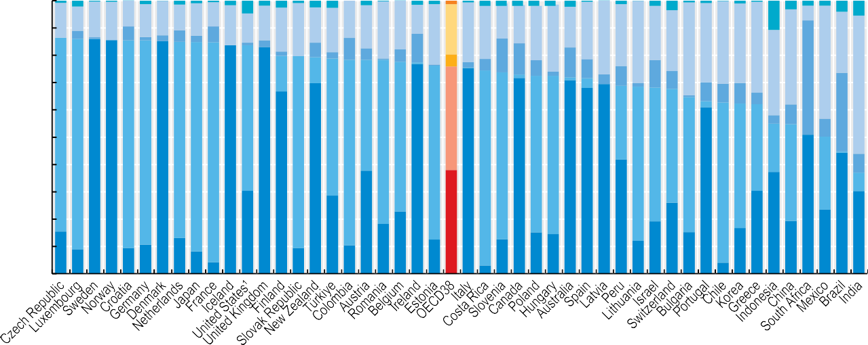

100

90

80

70

60

50

40

30

20

10

0

13 9 13 14 9 12 13 9 12 9 15 11 13 16 19 13

1 2

1

1 1 1 2 5 2 3 1 3 3

2

1 1 1 1 1 1 2 2 1 2

1 2 3 1 1 1

3 1

5 1 2 4 2 6

16

14 16 18 11

21

13 14

3 2 2 4 5

5

15

11

1 2

22

2

13

5 2 8 4

10

5 10

1

18

4

22 21

20 25

21 27 23 30 20 22

34

29 30 29

33

22

2 4

12 11

1 6 2 1 7 4 7

11

35

41

4

1

10

7

31

42

1 7 7 8 4

51

53

71

50

41

2

38

27

3 7

29

77

86 86

76 75

85

72 77

81 84

60 55

7

42

83

70

68

64

32 18

77

67

70

75

61

71

57 58

72

56 49

71 68 69

49

46

35 27

61

59

51

30

29

38

38

42

37

26

30

1

7

7

44

30

15 9

9 11

13 8

18 23

15 15

4

9

10

13

13

3

12 19

15

17

19

24

4



Government schemes Compulsory health insurance Voluntary health insurance Out-of-pocket Other

Note: Category “Other” refers to financing by NGOs, employers, non-resident schemes and unknown schemes. 1. All spending by private health insurance companies reported under compulsory health insurance.

Source: OECD Health Statistics 2023.

*StatLink 2* <https://stat.link/1roc2k>

**Figure 7.11. Average annual growth in per capita health expenditure (real terms) by type of financing, OECD average, 2015-19 and 2019-21**



2015-2019 2019-2021

Annual growth in real terms (%)

10 25.8

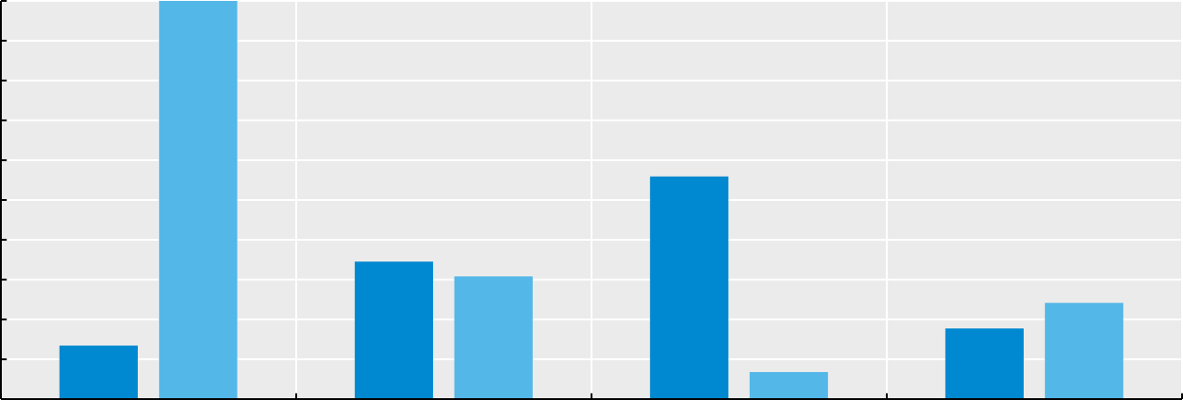

3.5

3.1

2.4

1.8

1.3

0.7

5.6

9

8

7

6

5

4

3

2

1

0

Government schemes Compulsory contributory health insurance

schemes

Voluntary health insurance schemes Household out-of-pocket payments

Source: OECD Health Statistics 2023.

*StatLink 2* <https://stat.link/m9qlvk>

**Public funding of health spending**

While financing schemes purchase healthcare on behalf of individuals and the population (see indicator “Health expenditure by financing scheme”), the revenues to fund this expenditure can originate from different sources. Most funding for government schemes comes from general government revenues (such as taxation), which are channelled through the budget process. However, governments might also contribute to social health insurance, for example, by covering the contributions of specific population groups or providing general budget support to insurance funds. Individuals purchase private health insurance through the payment of regular premiums. However, part of the premium may be paid by the employer, or it may be subsidised by government. Individuals also finance care directly, using household income to pay for services in their entirety or as part of a cost-sharing arrangement with a third-party financing scheme. Other health financing schemes (such as non-profit or enterprise schemes) can receive donations or generate income from investments or other commercial operations. Finally, although limited in most OECD countries, funds can come from non-domestic sources.

Public funding can be defined as the sum of government transfers and all social contributions. In 2021, public sources financed on average 73% of healthcare spending in OECD countries (Figure 7.12). Where government financing schemes are the principal financing mechanism, such as in Norway, Sweden and Denmark, government transfers fund 85% or more of healthcare expenditure. In other countries such as Slovenia or Germany, the majority of public funding refers to social insurance contributions payable by employers and employees. In many countries with social health insurance, government schemes do not purchase many health services directly but provide transfers and subsidies to other schemes. In the Czech Republic, government transfers to social health insurance on behalf of specific population groups are an import funding source, such that 87% of health expenditure overall was publicly financed in 2021.

Governments fund a range of public services, and healthcare is competing with many other sectors including education, defence, and housing for resources. The level of public funding on health is determined by factors such as the type of health system in place, the demographic of the population, shifting budget priorities, and economic conditions. Health spending accounted for an average of 15% of total government expenditure across the OECD in 2021, an increase of

Many OECD countries have a system of compulsory health insurance – either social health insurance or through private coverage – but there is substantial diversity in the composition of revenues for these types of schemes (Figure 7.14). The importance of government transfers as a source of revenue can vary significantly. On average, around two-thirds of financing comes from social contributions (or premiums) – primarily split between employees and employers – but around a quarter still comes from government transfers, either on behalf of certain groups (e.g. the poor or unemployed) or as general support. In Chile and Hungary, government transfers fund over 60% of the health spending of the social health insurance system. Meanwhile, in Poland, Slovenia and Costa Rica the share was 5% or less, with social insurance contributions as the main funding source.

**Definition and comparability**

Health financing schemes have to raise revenues to pay for healthcare for the population they are covering. In general, financing schemes can receive transfers from the government, social insurance contributions, voluntary or compulsory prepayments (e.g. insurance premiums), other domestic revenues, and revenues from abroad (e.g. as part of development aid).

Revenues of a financing scheme are rarely equal to expenses in any given year leading to a surplus or deficit of funds. In practice, most countries use the composition of revenues per scheme to apply on a pro-rata basis to the scheme’s expenditure thus providing a picture of how spending was financed in the accounting period.

Total government expenditure is as defined in the System of National Accounts. Using the methodology of the *System of Health Accounts* (OECD/Eurostat/WHO, 2017[2]) public spending on health is equal to the sum of transfers from government (domestic), transfers from government (foreign), and social insurance contributions. In the absence of information from the revenue side, the sum of spending by government financing schemes and social health insurance is taken as a proxy.

**References**

1 percentage point compared to 2011 (Figure 7.13). While during the initial phase of the pandemic many OECD countries were able to substantially increase the public resources available to healthcare, the economic and geopolitical climate has brought new challenges in 2022 with Russia’s war in Ukraine adding to already rising energy costs with inflationary pressures across much of the OECD. These economic and geo-political developments will affect the resources available to finance both public and private health spending, as well as the costs of health service delivery (OECD, 2023[1]).

OECD (2023), “Health care financing in times of high inflation”, OECD, Paris, https[://www.oecd.org/health/Health-care-financing-](http://www.oecd.org/health/Health-care-financing-) in-times-of-high-inflation.pdf.

OECD/Eurostat/WHO (2017), *A System of Health Accounts 2011: Revised edition*, OECD Publishing, Paris, https://doi.org/10.1787/9789264270985-en.

[1]

[2]

**Figure 7.12. Health expenditure from public sources as share of total health expenditure, 2021 (or nearest year)**

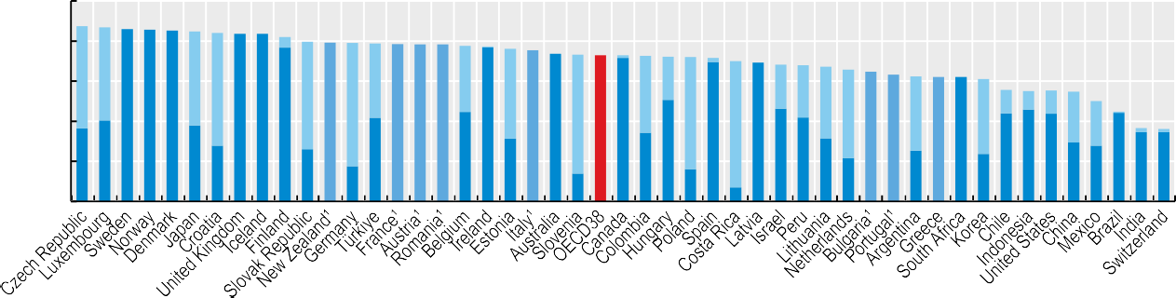

22

28

26

42

45

17

31

14

16

46 42 31

37

65 63 62 62

25

37 12 9 12 25

36 40

1

2 2

51

34

7

22

24

44 46 44 29

28

44 34 35

Public (no breakdown) Government transfers Social insurance contributions

45

100 %

80

5

1

1

60

40

20

0

51 46

2

47 56

54

37

33

38

22

38

22 26

86 86 85 84 84

77

62

79 79 78 78 77

75 74

59

73 72

56

70 63 69

36 44

1. Public is calculated using spending by government schemes and social health insurance. Source: OECD Health Statistics 2023.

*StatLink 2* <https://stat.link/sf7zlw>

**Figure 7.13. Health expenditure from public sources as a share of total government expenditure, 2011 and 2021 (or nearest year)**

%

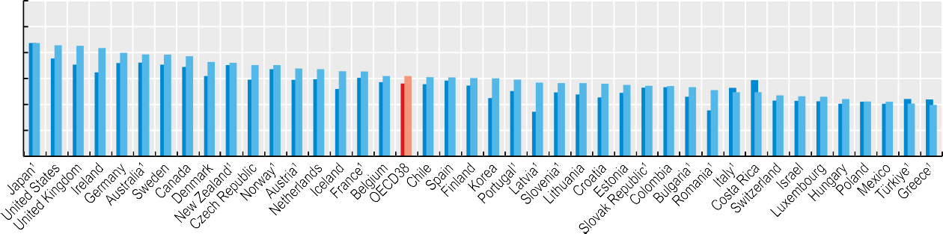

30

25

20

15

10

5

0

17

10

10

11

11

11

11

12

12

12

12

13

13

14

14

14

14

14

14

14

15

15

15

15

15

15

15

16

16

17

18

18

18

18

19

20

20

20

21

21

21

22



2011 2021

1. Public funding is calculated using spending by government schemes and social health insurance. Source: OECD Health Statistics 2023. OECD National Accounts database.

*StatLink 2* <https://stat.link/lfa86e>

**Figure 7.14. Financing sources of compulsory health insurance, 2021 (or nearest year)**

%

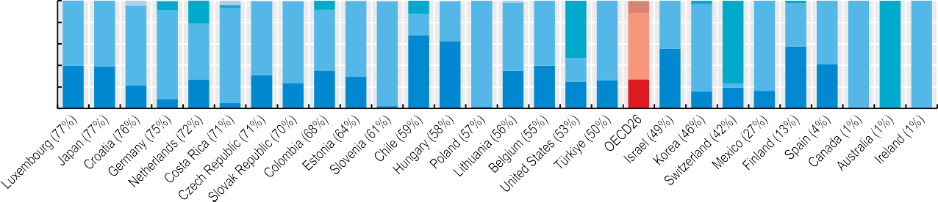

29

81

77

84

100 100 100

68 62

40 39

22

35

40

9

27

31

5

23

62

35

22

25

55

26

27

2

1

16

4

19

57

41

16

Transfers from government Social insurance contributions Compulsory prepayment Other

53

100

80

60

40

20

0

4

9

21

4

2

9

60

61

12

20

1 2

11

3

2

37

98

45

41

74

69

56 70

63

60

59

82

52

76

74

88 97

Note: Numbers in brackets indicate the contribution of compulsory health insurance to total health expenditure. Category “Others” includes other domestic revenues and direct foreign transfers.

Source: OECD Health Statistics 2023.

*StatLink 2* <https://stat.link/6kuin5>

**Health expenditure by type of service**

A variety of factors, from disease burden and system priorities to organisational aspects and costs determine the allocation of resources across the various types of healthcare services. For all OECD countries, curative and rehabilitative care services make up the bulk of health spending and are primarily delivered through inpatient and outpatient services – accounting for 60% of all health spending in 2021 (Figure 7.15). Medical goods (mostly pharmaceuticals) made up a further 18%, followed by long-term care services, which in 2021 averaged around 13% of health spending. Administration and overall governance of the health system, together with preventive care account for the remaining 9% of health spending.

In 2021, Belgium and Greece reported the highest share of total health spending allocated to inpatient services, at around 40%. At the other end of the scale, many of the Nordic countries as well as Switzerland and the Netherlands had a much lower proportion of spending on inpatient services – at around 20% of overall health spending.

Outpatient care forms a broad category covering generalist and specialist outpatient services, dental care, but also homecare and ancillary services. Taking all these categories together, spending on outpatient care services accounted for around 45% of all health spending in Portugal, Latvia and Israel compared to an OECD average of 32%. Given the relative importance of inpatient care delivery, Greece and Belgium allocated a comparably low proportion on outpatient services, with less than a quarter of all health spending.

The third largest health spending category is medical goods. Differences in prices for international goods such as pharmaceuticals tend to show less variation across countries than for locally produced services. As a result, spending on medical goods (including pharmaceuticals) in lower-income countries often accounts for a higher share of health spending relative to services. For example, in 2021, expenditure on medical goods represented around 30% of all health spending in Mexico, the Slovak Republic and Greece. By contrast, with only accounting for one-tenth of overall health spending, these shares were much lower in Denmark, Norway, the Netherlands and the United Kingdom.

Spending on long-term care services accounted for 13% of health spending on average in 2021, but this figure hides big differences across OECD countries. In countries with formal arrangements such as in Norway, Sweden and the Netherlands, a quarter or more of all health spending is for long-term care services. However, a more informal long-term care sector exists in many Southern, Central and Eastern European countries including Hungary, Latvia, Greece and the Slovak Republic, and in Latin American countries such as

The COVID-19 pandemic drastically changed health spending patterns in many countries resulting in notable differences in the average annual spending growth per capita in the years preceding the pandemic (2015-19) compared to during the pandemic (Figure 7.16). Between the years 2015 and 2019, annual per capita spending growth for retail pharmaceuticals (1.2%) and inpatient care (2.2%) was relatively moderate, whereas the average yearly increases for spending on outpatient care, long-term care and administration per capita were more pronounced, standing between 3-3.5%.

The pandemic triggered exceptional spending growth across all healthcare functions (Figure 7.16). Most notably, spending on preventive care increased by nearly 50% per year (up from 2.3% pre-pandemic), with countries dedicating significant resources to testing, tracing, surveillance, and public information campaigns related to the pandemic and the roll-out of the vaccination campaigns in 2020 and 2021. Annual per capita spending growth on inpatient care more than doubled, driven by expenses for additional staff and input costs (e.g. personal protective equipment) and substantial subsidies for hospitals. With around 8% annually, spending on health system administration also recorded strong growth between 2019 and 2021. Some of this increase can be explained by the additional resources required to manage national COVID-19 responses strategies. Preliminary data for 2022 suggests that some of the most recent increases will be short-lived and a normalisation of growth rates can be expected with as countries transition out of the acute phase of the pandemic.

**Definition and comparability**

The *System of Health Accounts* (OECD/Eurostat/WHO, 2017[1]) defines the boundaries of the healthcare system from a functional perspective, with healthcare functions referring to the different types of healthcare services and goods. Current health expenditure comprises personal healthcare (curative care, rehabilitative care, long-term care, ancillary services and medical goods) and collective services (prevention and public health services as well as administration – referring to governance and administration of the overall health system rather than at the health provider level). Curative, rehabilitative and long-term care can also be classified by mode of provision (inpatient, day care, outpatient and home care).

For the calculation of growth rates in real terms, AIC deflators are used.

**References**

Mexico, where spending on long-term care is much lower – typically around 5% or less.

OECD/Eurostat/WHO (2017), *A System of Health Accounts 2011: Revised edition*, OECD Publishing, Paris, https://doi.org/10.1787/9789264270985-en.

[1]

**Figure 7.15. Health expenditure by type of service, 2021 (or nearest year)**

Inpatient care* Outpatient care** Long-term care Medical goods Collective services

%



100

90

80

70

60

50

40

30

20

10

0

5 6

7 8

6

14

6

10

10

6 6

6

13

8 9

8

5

14

8

11

9 11 11

7

13

10

6

10

5

14

13

14

7

12

12

4

11

10

12 11

13

19 17

20

20

21

17

22

18

13

12

10

19

5

7

27

30

25

20

24

21 16

25

32

16

11

19

19 14 18

10

4

3

11

8 9

9

19

20

29

21

2

5

10

7

11 13

13

18

21

20

25

29

4

3

13

17 20

12

16 21

19

28

45 43

44

37 36

31

21

17

38

35 35

41

32

35

30

22

19

34

30

32

32

29

32

25

27

32 30 29

34

30 29 28

32

25

27

42

44

27 27

25

33 33

34

40

26

29

28

22

29

27

31

26

30

28

28

31

37

26

32

30

25 27 28

23

26 27 27

21

26

22

Note: Countries are ranked by curative-rehabilitative care as a share of current expenditure on health. * Refers to curative-rehabilitative care in inpatient and day care settings. ** Includes home care and ancillary services.

Source: OECD Health Statistics 2023.

*StatLink 2* <https://stat.link/b9f8vq>

**Figure 7.16. Average annual growth in health expenditure per capita for selected services (real terms), OECD average, 2015-19 and 2019-21**

2015-2019 2019-2021

Annual growth in real terms (%) 10

8.2

4.8

4.5

4.3

3.3

3.5

3.2

2.6

2.2

2.3

1.2

9

8

7

6

5

4

3

2

1

0

49.7

Inpatient care Outpatient care Long-term care Pharmaceuticals Prevention Administration

Source: OECD Health Statistics 2023.

*StatLink 2* <https://stat.link/2ce5tu>

**Health expenditure on primary healthcare**

Effective primary healthcare is the cornerstone of an efficient, people-centred, and equitable health system. Strengthening primary care has been identified as an effective way to improve care co-ordination and health outcomes and reduce wasteful spending, by limiting unnecessary hospitalisations and associated costs in hospitals and other parts of the health system. Moreover, the COVID-19 pandemic has shown that for health systems to be resilient in the face of health crises, strong primary and community healthcare is essential. However, in many OECD countries, primary care has not yet fully realised this potential (OECD, 2021[1]).

In 2021, primary healthcare accounted for 13% of health spending on average across OECD countries, ranging from 10% or less in Austria, Luxembourg, the Netherlands and Switzerland to nearly 20% in Slovenia and Estonia (Figure 7.17). Compared to 2019, this proportion has remained unchanged suggesting that primary care spending increased in line with overall health spending during the COVID-19 pandemic.

Regarding its composition, half of primary care spending across OECD countries is on general outpatient care services, with a further third related to dental care. Prevention services as well as home visits by GPs or nurses make up a smaller proportion of spending on primary care, although often services related to prevention activities may be hard to distinguish from general outpatient consultations. General outpatient care provided by ambulatory providers was particularly high in Costa Rica, Poland and Mexico, reaching up to 13% of overall health spending. In Austria, Germany, France, Luxembourg and Switzerland, spending on general outpatient care is much lower overall, accounting for 4% or less of health spending.

In Lithuania and Estonia, the large share of primary care in overall health spending can be explained by spending on dental care. In both countries, dental care accounts for over 8% of their total health budget – nearly twice the OECD average. This compares with Mexico, the United Kingdom, Costa Rica and the Netherlands, where dental care spending represents only around 3% of total health spending.

GBP 15 billion allocated to the NHS Test and Trace Programme for COVID-19. OECD analysis suggests additional spending on preventive care is needed to strengthen countries’ health system resilience and their agility to respond to pandemics and other evolving threats (OECD, 2023[2]).

**Definition and comparability**

International comparisons of what is spent on primary healthcare have to date been largely absent due to both the lack of a commonly accepted definition, and an appropriate data collection framework. Working with data and clinical experts and international partners, the OECD has developed a methodological framework to estimate primary healthcare spending (Mueller and Morgan, 2018[3]).

Estimates are based on data submitted using the *System of Health Accounts 2011* framework. The following functions are first identified as basic care services: general outpatient curative care (e.g. routine visits to a GP or nurse for acute or chronic treatment); dental outpatient curative care (e.g. regular control visits as well as more complex oral treatment); home-based curative care mainly refers to home visits by GPs or nurses; preventive care services (e.g. immunisation or health check-ups)

Where basic care services are provided by ambulatory healthcare providers such as medical practitioners, dentists, ambulatory healthcare centres and home healthcare service providers, this may be considered as a proxy for primary healthcare. It should be stressed that this proxy measure is a simplified approach to operationalise a complex multi- dimensional concept.

Comparability for this indicator is still limited and depends on countries’ capacity and methods used to distinguish between general outpatient and specialist services.

**References**

Total spending on prevention (referring to services provided by ambulatory care providers and others) increased significantly across OECD countries with the onset of the COVID-19 crisis (see indicator “Health expenditure by type of service”). As a share of total health expenditure, spending on prevention doubled since 2019 on average across OECD countries (Figure 7.18), reaching more than 5% in 2021. Spending on prevention increased by more than 6 percentage points in Austria, Denmark, the Netherlands and the United Kingdom, reflecting substantial investments in public health measures related to fighting the spread of the COVID-19 pandemic.

An increase in spending on prevention might be welcomed, yet much of the spending growth in 2021 can be attributed to time-limited, emergency measures related to COVID-19 management – such as testing, surveillance, and vaccination campaigns – rather than long-term planned investments into population health. In the United Kingdom, for example, the growth in prevention spending was triggered by the

Mueller, M. and D. Morgan (2018), “Deriving preliminary estimates of primary care spending under the SHA 2011 framework”, OECD, Paris, <http://www.oecd.org/health/health-> systems/Preliminary-Estimates-of-Primary-Care- Spending-under-SHA-2011-Framework.pdf.

OECD (2023), *Ready for the Next Crisis? Investing in Health System Resilience*, OECD Health Policy Studies, OECD Publishing, Paris, https://doi.org/10.1787/1e53cf80-en.

OECD (2021), *Realising the Potential of Primary Health Care, OECD Health Policy Studies*, OECD Publishing, Paris, https://doi.org/10.1787/a92adee4- en.

[3]

[2]

[1]

**Figure 7.17. Spending on primary healthcare services as a share of current health expenditure, 2021 (or nearest year)**

General outpatient curative care Dental outpatient curative care Home-based curative and rehabilitative care Preventive care

%

20 19



18

16

14

12

10

8

6

4

2

0

19 18

17

16 16

15 15 15

15 13

13 13

13 13

13 12

12 12 12

12 11

11 11 10 10

9

9

8

Source: OECD Health Statistics 2023.

*StatLink 2* <https://stat.link/ym6nb4>

**Figure 7.18 Share of spending on prevention in current health expenditure, 2019 and 2021 (or nearest year)**

2021 2019

%

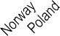

14

12

12

10

10

9 9

9

8

8

8

8

7

7 6

6

6

6 5 5 5

5 5

5 5 5

4

4

4

4

4

3 3

3 3 3 3 3

3 3

3

2

2

2

0

Source: OECD Health Statistics 2023.

*StatLink 2* <https://stat.link/m6xqyg>

**Health expenditure by provider**

Healthcare is delivered by a wide variety of providers ranging from hospitals and medical practices to ambulatory facilities and retailers, which impact expenditure patterns for different goods and services. Analysing health spending by provider can be particularly useful when considered alongside the functional breakdown of health expenditure, giving a fuller picture of the organisation of health systems.

The organisational differences in healthcare delivery across OECD countries can be substantial, resulting in a wide variation in the distribution of health spending across providers. At 39%, activities delivered in hospitals accounted for the largest proportion of health system funding across the OECD. This average was largely exceeded in both Türkiye and Costa Rica where hospital activities received more than half of all financial resources (Figure 7.19). On the other hand, Germany and Mexico spent less than 30% of the total health budget on hospitals.

After hospitals, the largest provider category are ambulatory providers. This category covers a wide range of facilities with most spending related to either medical practices including GPs and specialists (e.g. Austria, France and Germany) or ambulatory healthcare centres (e.g. Finland, Ireland and Sweden). Across OECD countries, care delivered by ambulatory providers accounts for around a quarter of all health spending on average – within this, around two-thirds of all spending relates to GP, specialist practices and ambulatory healthcare centres, and roughly one-fifth relate to dental practices. Overall, spending on ambulatory providers exceeded half of total health spending in Israel in 2021 and reached one-third in Latvia but remained at 10% in Türkiye and below 20% in Greece, the Netherlands and the Slovak Republic.

Other main provider categories include retailers (mainly pharmacies) which accounted for 16% of all health spending and residential long-term care facilities (mainly providing inpatient care to dependent people), to which 8% of the total health spending can be attributed.

Across OECD countries, there is a wide variation in the range of activities that may be performed by the same category of provider, reflecting differences in the structure and organisation of health systems. These cross-country differences are most pronounced in the hospital sector (Figure 7.20). Although inpatient curative and rehabilitative care define the primary activity of hospitals and therefore represent the majority of their expenditure, hospitals can also be important providers of outpatient care in many countries, for example through accident and emergency departments, specialist outpatient units, or laboratory and imaging services. In Finland, Denmark, Sweden and Portugal, outpatient care

care departments aiming at potential efficiency gains and a reduction in waiting times. As a result, day care services account for more than 15% of all hospital expenditures in Belgium, Ireland and Portugal.

Measures taken to address the COVID-19 pandemic have also affected the provider distribution of health spending. In 2020, the proportion of resources allocated to hospitals increased to 40% reflecting higher input costs of inpatient service delivery and important financial support targeted at hospitals. This share dropped again in 2021 with a reduced need for hospital subsidies. Interestingly, while the outbreak of the health emergency has led to major disruptions in the service delivery in hospitals, the spending distribution by type of service remained relatively stable in most countries.

**Definition and comparability**

The universe of healthcare providers is defined in the *System of Health Accounts* (OECD/Eurostat/WHO, 2017[1]) and encompasses primary providers, i.e. organisations and actors that deliver healthcare goods and services as their primary activity, as well as secondary providers for which healthcare provision is only one among a number of activities.

The main categories of primary providers are hospitals (acute and psychiatric), residential long-term care facilities, ambulatory providers (practices of GPs and specialists, dental practices, ambulatory healthcare centres, providers of home healthcare services), providers of ancillary services (e.g. ambulance services, laboratories), retailers (e.g. pharmacies), and providers of preventive care (e.g. public health institutes). Secondary providers include residential care institutions whose main activities might be the provision of accommodation but provide nursing supervision as secondary activity, supermarkets that sell over-the-counter medicines, or facilities that provide healthcare services to a restricted group of the population such as prison health services. Secondary providers also include providers of healthcare system administration and financing and households as providers of home healthcare.

Health facilities are classified into a provider category based on their principal activity. In Portugal, this means that local health units are classified as hospitals although they also include outpatient health centres whose activity cannot be identified separately.

**References**

accounts for over 40% of hospital expenditure since specialists are typically receiving patients in hospital outpatient departments. On the other hand, in Germany and Greece, hospitals are generally mono-functional with the vast majority (around 90%) of spending on inpatient care services, and very little outpatient and day care spending. Over the last decade, many countries have shifted some inpatient services to day

OECD/Eurostat/WHO (2017), *A System of Health Accounts 2011: Revised edition*, OECD Publishing, Paris, https://doi.org/10.1787/9789264270985-en.

[1]

**Figure 7.19. Health expenditure by provider, 2021 (or nearest year)**

%

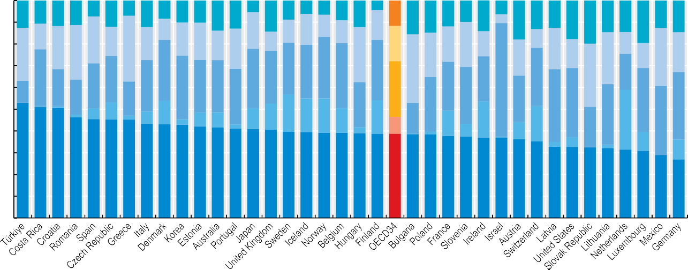

100

90

80

70

60

50

40

30

20

10

0

13 11 12 11

7

12

7

12

8

10

10 10 14 13

5

14

9

6 7

9

12

4

14

12

16 15

12 10 14

6

4

18

13 13

18 20 15 15 20 15

13

24

12

20

26

17

1

17

22 13

15

25

30

15 17 14

11 14 10 11

19

9

16

16 21 12

9

25 20

17

19 13 10

24 11 27 18

28

24 25 28 30

31

10

21 21

24

29 24 24

27 24

28

21 52

27

29

17

16

1

26

23

5

8

16

2

26

26

6

11

21

25

21

33 32

30

31

3 6 7

2

10 12

17

16 16 11 15

14

28 27

3

8

11

17

16

32

1

6

8

19

2 4

2

8

9

53 51 51 46 45 45 45 43 43 43

42 42 41 41 41 40 39 39 39 39 39 39 39 38 38 37 37 37 36 35 33 33 33 32

32 31 29 27



Hospitals LTC facilities Ambulatory providers Retailers Other

Note: “Other” includes ancillary service providers (e.g. patient transport, laboratories); health system administration, public health and prevention agencies; households in cases they provide paid long-term care; and atypical providers where healthcare is a secondary economic activity.

Source: OECD Health Statistics 2023.

*StatLink 2* <https://stat.link/6i1aju>

**Figure 7.20. Hospital expenditure by type of service, 2021 (or nearest year)**



Inpatient Day care Outpatient care¹ Long-term care Other

%

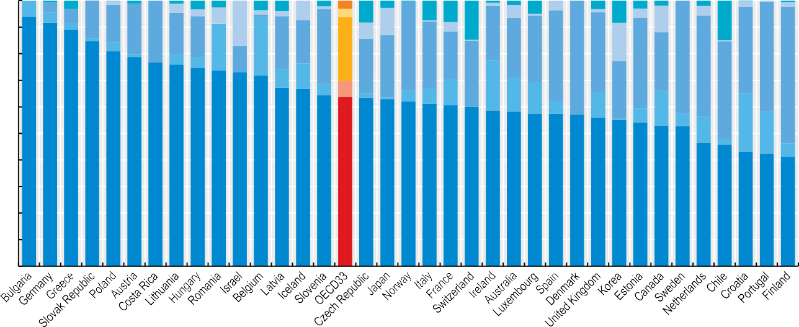

100

90

80

70

60

50

6 4

4

3

6

2

1 1

1 3 3

14

1

3

14 19 23

3 6

17

4

2

1

4

2

7

2

1

3

3

8

6

3

10

7 8

4 15

1

1

20

2

5

5 4

1

3 3

1 8 4

2

10

2

4

2

1

2

15

16 15

3

1

22 20 16

34

14

4

4

17

10

28 24

25 18

20 23

22 25 34 43 30

34 22

43

38

33 42

7 10

4 6

25

19

51

2

1 4

6

10

13 12

22

37

5

10

13

1

5

5

10

22

40

94 92 89 85

2

16

81 79 77 76 75 74 73 72

5

30

67 67 64 64 64 63 62

61 61 60 59 58 57 57 57 56 55 54 53 53

20

10

0

47 46 43 42 41

Note: “Other” includes preventive care activity; pharmaceuticals if dispensed to outpatients; and unknown services. 1. Includes ancillary services. Source: OECD Health Statistics 2023.

*StatLink 2* <https://stat.link/tmoh3u>

**Capital expenditure in the health sector**

While human resources are essential to the health and long- term care sector, physical resources are also a key factor in the production of health services. How much a country invests in new health facilities, diagnostic and therapeutic equipment, and information and communications technology (ICT) can have an important impact on the capacity of a health system to meet the healthcare needs of the population. The COVID-19 crisis has shone a spotlight on some of the infrastructure challenges. Health systems, and hospitals in particular, were placed under immense strain. Some countries lacked the necessary physical resources to respond to the sudden influx of seriously ill COVID-19 patients. Having sufficient equipment in intensive care units and other health settings helps to avoid potentially catastrophic delays in diagnosing and treating patients. Non-medical equipment is also important, notably the IT infrastructure needed to better monitor population health, both in acute situations and in the long term. Investing in capital equipment is therefore a prerequisite to strengthening overall health system resilience.

Capital investment fluctuates from year to year, as investment decisions can be more dependent on economic circumstances and political or business choices as well as reflecting future needs and past levels of investment. As with any industry, a lack of investment spending can lead to an accumulation of problems and bigger costs in the future as current equipment and facilities deteriorate.

In the five years between 2017 and 2021, average annual *capital* expenditure in the health sector in OECD countries was just below 0.6% of GDP. This compares to an average of around 9% of GDP on *current* health spending over the same period (see indicator “Health expenditure as a share of GDP”) (Figure 7.21). Germany was the highest annual spender, consistently allocating around 1.1% of its GDP each year on new construction projects, medical and non-medical equipment, and technology in the health and social sector. Austria, Belgium, Japan, Australia and Norway were the next highest group of capital spenders at around 0.9% of GDP, although spending was more variable over that period in the case of Australia. Of the other G7 countries, the United States was a relatively high spender at around 0.8% of GDP per year, while France invested around 0.6% of its GDP per year. Both Italy and the United Kingdom remained below the average at just over 0.4% of GDP.

Capital spending covers a broad range of investments from construction projects (that is, hospitals and healthcare facilities), equipment (e.g. medical and ICT equipment) to intellectual property (including databases and software).

Figure 7.21 shows that, on average in OECD countries, 45% of capital expenditure went towards construction projects, 40% on equipment, and the remaining 15% on intellectual property. Finland and Portugal both had a similar level of overall investment, but whereas Finland allocated around 70% on the construction of health and social care facilities, Portugal invested the same proportion on equipment and on digital solutions and data, combined.

Figure 7.22 shows an index of capital spending in real terms since 2010 for the OECD and a selection of OECD countries. On average across the OECD, annual investment was more than 40% higher (in real terms) in 2021 compared with the levels of investment reported in 2010. Australia and the United States have closely followed the overall OECD trend and increased their annual capital spending over that period by around 50%. On the other hand, Canada invested at around the same level in 2021 compared with 2010. In Europe (right panel), Germany has seen a steady increase in capital investment over the last ten years or so, even if the growth has been below that of the OECD as a whole. Both France and the United Kingdom saw investment levels drop in the 2010s, but these have recovered in the last few years.

**Definition and comparability**

Gross fixed capital formation (GFCF) in the health sector is measured by the total value of the fixed assets that health providers have acquired during the accounting period (less the value of the disposals of assets) and that are used repeatedly or continuously for more than one year in the production of health services. The breakdown by assets includes infrastructure (e.g. hospitals, clinics, etc.), machinery and equipment (including diagnostic and surgical machinery, ambulances and ICT equipment), as well as software and databases.

Gross fixed capital formation is reported under the National Accounts by industrial sector according to the International Standard Industrial Classification (ISIC) Rev. 4 using section Q: Human health and social work activities. It is also reported by a number of countries under the *System of Health Accounts*. The ISIC section Q is generally broader than the SHA boundary for healthcare. For reasons of comparability and availability, preference has been given to measures of GFCF under the National Accounts.

**Figure 7.21. Annual capital expenditure in health and social work as a share of gross domestic product, average 2017-21 (or nearest year) by type of asset**

Construction Machinery and equipment Interlectual property product Total (no split)

% of GDP

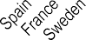

1.2

1.1

1

0.9 0.9 0.9 0.9 0.9

0.9 0.9

0.8

0.8 0.8 0.8

0.6 0.6 0.6 0.6 0.6

0.6

0.6 0.6

0.5

0.5 0.5 0.5 0.5

0.4 0.4 0.4 0.4 0.4 0.4

0.4

0.4 0.4

0.3 0.3 0.3 0.3

0.3 0.3 0.3 0.2

0.2

0.1 0.1

0

1. Refers to gross fixed capital formation in health providers under the System of Health Accounts. Source: OECD National Accounts, OECD Health Statistics 2023.

*StatLink 2* <https://stat.link/7p4etv>

**Figure 7.22. Trends in capital expenditure (real terms), OECD and selected countries, 2010-21**

OECD19 Australia Canada United States

OECD19 France Germany United Kingdom

180 180

160 160

140 140

120 120

100 100

80 80

60

2010 2012 2014 2016 2018 2020

60

2010 2012 2014 2016 2018 2020

Source: OECD National Accounts, OECD Health Statistics 2023.

*StatLink 2* <https://stat.link/vz4i17>

**172** 

1. **Health workforce**

Health and social care workforce Doctors (overall number)

Doctors (by age, sex and category) Geographic distribution of doctors Remuneration of doctors

Nurses

Remuneration of nurses Hospital workers Medical graduates Nursing graduates

International migration of doctors and nurses

**Health and social care workforce**

In OECD countries, health and social care systems employ more workers now than at any other time in history. In 2021, more than one in every ten jobs (10.5%) was in health or social care, up from 9.5% in 2011 (Figure 8.1). In Nordic countries and the Netherlands, more than 16% of all jobs were in health and social work. Between 2011 and 2021, the share of health and social care workers increased particularly rapidly in Korea and Türkiye, although it remained lower than the OECD average in both countries.

Job numbers in the health and social care sector increased much more rapidly than in other sectors over the past decade. On average across OECD countries, employment in health and social work increased by 24% between 2011 and 2021 – over twice the rate of overall employment growth (Figure 8.2).

In most OECD countries, over 75% of workers in the health and social care sector are women (Figure 8.3). While women’s jobs tend to be concentrated more in lower-skilled and lower- paid occupations, half of all doctors on average across OECD countries in 2021 were female (see section on “Doctors by age, sex and category”).

Nurses make up the most numerous category of health and social care workers in most OECD countries, accounting for approximately 20-25% of all workers. Personal care workers

The demand for social care (long-term care) workers is also projected to increase strongly, mainly due to population ageing. Recent OECD projections forecast that growth in demand for long-term care workers over the next decade across OECD countries will be much higher than the actual recorded increase over the past decade. Further efforts will be required to increase the attractiveness of the profession and recruitment and retention of workers in the long-term care sector to avoid a sharp increase in unmet needs and workforce shortages (OECD, 2023[5]).

**Definition and comparability**

Health and social work is one of the economic activities defined according to the major divisions of the International Standard Industrial Classification of All Economic Activities. Health and social work is a sub-component of the services sector, and is defined as a composite of human health activities, residential care activities (including long-term care) and social work activities without accommodation.

**References**

(including healthcare assistants in hospitals and nursing homes and home-based personal care workers) also account for a relatively large share, sometimes exceeding the number of nurses.

During the COVID-19 pandemic, higher national numbers of health and social care workers were significantly associated with lower mortality across OECD countries, based either on registered COVID-19 deaths or the broader measure of excess mortality (OECD, 2023[1]). Unsurprisingly, the strongest increases in job postings during the pandemic in many countries (including Canada, the United Kingdom and the United States) were in the healthcare sector (OECD, 2023[2]).

Population ageing, technological change and rising incomes are expected to continue to boost demand for health workers in the coming years and decades. This is confirmed by national projections that forecast substantial employment growth in the health sector in the years ahead. In the United States, the most recent projections from the Bureau of Labor Statistics forecast that the healthcare and social assistance sector is projected to not only grow more rapidly than any other sector, but it is also projected to create about 45% of all new jobs between 2022 and 2032 (BLS, 2023[3]). In Canada, the health sector is also projected to post the largest increases in employment between 2022 and 2031 (Government of Canada, 2021[4]).

BLS (2023), *Occupational Employment Projections, 2022-32*, U.S. Bureau of Labor Statistics, https[://www.bls.gov/emp/.](http://www.bls.gov/emp/)

Government of Canada (2021), *Industrial Projections (2022-2031)*, Canadian Occupational Projection System (COPS), https://occupations.esdc.gc.ca/sppc- cops/l.3bd.2t.1ilshtml@- eng.jsp?lid=27&fid=1&lang=en.

OECD (2023), *Beyond Applause? Improving Working Conditions in Long-Term Care*, OECD Publishing, Paris, https://doi.org/10.1787/27d33ab3- en.

OECD (2023), *OECD Employment Outlook*

*2023: Artificial Intelligence and the Labour Market*, OECD Publishing, Paris, https://doi.org/10.1787/08785bba-en.

OECD (2023), *Ready for the Next Crisis? Investing in Health System Resilience*, OECD Health Policy Studies, OECD Publishing, Paris, https://doi.org/10.1787/1e53cf80-en.

[3]

[4]

[5]

[2]

[1]

**Figure 8.1. Employment in health and social work as a share of total employment, 2011 and 2021 (or nearest year)**

2011 2021

%

Sources: OECD National Accounts; OECD Annual Labour Force Statistics for Türkiye.

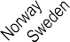

25

20

15

10

5

0

6.9

6.5

6.4

6.2

6.0

6.0

5.9

5.5

4.8

4.1

4.0

3.2

*StatLink 2* <https://stat.link/6xwjmy>

**Figure 8.2. Employment growth by sector, OECD average, 2011-21 (or nearest year)**

2011-2021

**Figure 8.3. Share of women in health and social work, 2021 (or nearest year)**

% 30

13

6

-7

10

24

25

20

15

10

5

0

-5

-10

Estonia 88

Finland 85

Latvia 85

Slovak Republic 83

Korea 82

Poland 82

Netherlands 82

Portugal 81

Denmark 81

Hungary 80

Czech Republic 80

OECD23 79

Norway 79

Slovenia 78

Belgium 78

Iceland 78

Spain 77

Germany 77

Switzerland 76

Sweden 76

Japan 75

Italy 71

Greece 67

Mexico 66

Total Agriculture Industry Services Health and

21.4

19.9

18.2

17.4

16.1

14.5

13.9

13.9

13.7

13.4

13.3

13.3

13.2

12.9

12.9

12.5

11.3

10.8

10.6

10.6

10.5

9.3

8.7

8.3

8.0

7.1

7.0

7.0

social work¹

1. Classified as a sub-component of the services sector. Source: OECD National Accounts.

*StatLink 2* <https://stat.link/qmbvnt>

0 20 40 60 80 100

%

Source: OECD Annual Labour Force Statistics.

*StatLink 2* <https://stat.link/szu19e>

**Doctors (overall number)**

The number of doctors in OECD countries increased from about 2.9 million in 2001 to 3.5 million in 2011 and 4.3 million in 2021. In all OECD countries, the number of doctors increased more rapidly than population size over the past decade, so that, on average, the number of doctors per 1 000 population rose from 3.2 in 2011 to 3.7 in 2021

(Figure 8.4).

In 2021, the number of doctors in OECD member countries ranged from 2.5 or fewer per 1 000 population in Türkiye, Colombia and Mexico to over 5 per 1 000 in Norway, Austria, Portugal and Greece. However, the numbers in Portugal and Greece are overestimated as they include all doctors licensed to practise, not just those actively practising.

Among accession and partner countries, Indonesia, South Africa and India had less than 1 doctor per 1 000 population in 2021. In China, the density of doctors increased rapidly from 1.5 per 1 000 population in 2011 to 2.5 per 1 000 in 2021. In Brazil and Peru, the number of doctors per 1 000 population also grew considerably over the past decade but remained low compared to most OECD countries.

The growing number of doctors in OECD countries has been driven by a number of factors. The main reason is an increase in the number of students admitted to and graduating from domestic medical education and training programmes (see section on “Medical graduates”). Long-held concerns about doctor shortages and the ageing of the medical workforce prompted a large number of OECD countries to increase the number of students in medical education programmes many years ago; as a result, the number of medical students continues to rise in most countries (OECD, 2023[1]). In some countries, immigration of foreign-trained doctors also contributed to the growth of available doctors (see section on “International migration of doctors and nurses”). A third factor that has contributed to this rise is the fact that in several countries a growing number of doctors are extending their

more doctors are expected to retire than enter the profession. This prompted the French government to increase the number of students admitted to medical schools by an additional 20% during 2021-25 compared to the previous five-year period (Ministère des Solidarités et de la Santé, 2021[2]). In Japan, the number of medical students also increased in recent years, resulting in a growing number of graduates (see section on “Medical graduates”). In June 2023, the UK Government announced its plans to increase further the number of medical students to address current and future shortages (NHS England, 2023[3]). However, it takes several years before any decision to increase student intake translates into a higher supply of fully trained doctors.

In many OECD countries, concerns about doctor shortages relate more specifically to shortages of general practitioners (GPs) (see section on “Doctors (by age, sex and category)”) and shortages of doctors in rural and remote regions (see section on “Geographic distribution of doctors”).

**Definition and comparability**

The data for most countries refer to practising doctors, defined as the number of doctors providing care directly to patients. In many countries (but not in Belgium and France), the numbers include interns and residents (doctors in training). Colombia, the Slovak Republic and Türkiye also include doctors who are active in the health sector even though they may not provide direct care to patients, adding another 5-10% of doctors. Chile, Greece and Portugal report the number of physicians entitled to practise, not only those currently practising, resulting in an even larger overestimation of the number of practising doctors.

**References**

careers beyond the previous standard retirement age. In countries like Italy and Israel, about one in four doctors in 2021 were aged over 65 (see section on “Doctors (by age, sex and category)”). While the number of doctors per population has increased in all countries as a total headcount, this may not be the case when measured in full-time equivalents, if reductions in working hours exceed the growth in numbers.

When analysing the increase in the number of doctors, the base level must be considered. Countries such as Korea and the United Kingdom recorded substantial increases over the last decade but had comparably low numbers in 2011. Norway, Germany and Switzerland, on the other hand, also saw strong growth in the number of doctors but already recorded above-average rates in 2011 (Figure 8.5).

Growth has been more modest in Greece. France and Japan also recorded a more limited increase in the number of doctors between 2011 and 2021. In France, the number of doctors was similar to the increase in population growth, and it is projected to fall until 2030 – both in absolute levels and per capita – as

Ministère des Solidarités et de la Santé (2021), *Arrêté du 13 septembre 2021 définissant les objectifs nationaux pluriannuels de professionnels de santé à former pour la période 2021-2025 - Légifrance*, https[://www.legifrance.gouv.fr/jorf/id/JORFTEXT000](http://www.legifrance.gouv.fr/jorf/id/JORFTEXT000) 044053576.

NHS England (2023), *NHS Long Term Workforce Plan*, https[://www.england.nhs.uk/wp-](http://www.england.nhs.uk/wp-) content/uploads/2023/06/nhs-long-term-workforce- plan-v1.1.pdf.

OECD (2023), *Ready for the Next Crisis? Investing in Health System Resilience*, OECD Health Policy Studies, OECD Publishing, Paris, https://doi.org/10.1787/1e53cf80-en.

[2]

[3]

[1]

Per 1 000 population

7

|  |  |  |  |  |  |  |  |  |  |  |  |  |  |  |  |  |  |  |  |  |  |  |  |  |  |  |  |  |  |  |  |  |  |  |  |  |  |  |  |  |  |  |  |  |  |  |  |
| --- | --- | --- | --- | --- | --- | --- | --- | --- | --- | --- | --- | --- | --- | --- | --- | --- | --- | --- | --- | --- | --- | --- | --- | --- | --- | --- | --- | --- | --- | --- | --- | --- | --- | --- | --- | --- | --- | --- | --- | --- | --- | --- | --- | --- | --- | --- | --- |
| 6.3 | 5.6 |  |  |  |  |  |  |  |  |  |  |  |  |  |  |  |  |  |  |  |  |  |  |  |  |  |  |  |  |  |  |  |  |  |  |  |  |  |  |  |  |  |  |  |  |  |  |
|  |  | 5.4 | 5.2 | 4.5 | 4.5 | 4.5 |  |  |  |  |  |  |  |  |  |  |  |  |  |  |  |  |  |  |  |  |  |  |  |  |  |  |  |  |  |  |  |  |  |  |  |  |  |  |  |  |  |
|  |  |  |  |  |  |  | 4.4 | 4.4 | 4.4 | 4.3 | 4.3 | 4.3 | 4.1 | 4.0 | 4.0 | 3.9 | 3.9 | 3.7 | 3.7 | 3.7 | 3.6 | 3.5 | 3.5 |  |  |  |  |  |  |  |  |  |  |  |  |  |  |  |  |  |  |  |  |  |  |  |  |
|  |  |  |  |  |  |  |  |  |  |  |  |  |  |  |  |  |  |  |  |  |  |  |  | 3.4 | 3.4 | 3.4 | 3.4 | 3.3 | 3.3 | 3.3 | 3.2 | 3.2 | 3.0 | 2.9 | 2.8 | 2.7 | 2.6 | 2.6 | 2.5 | 2.5 | 2.5 |  |  |  |  |  |  |
|  |  |  |  |  |  |  |  |  |  |  |  |  |  |  |  |  |  |  |  |  |  |  |  |  |  |  |  |  |  |  |  |  |  |  |  |  |  |  |  |  |  | 2.2 | 2.2 | 1.7 |  |  |  |
|  |  |  |  |  |  |  |  |  |  |  |  |  |  |  |  |  |  |  |  |  |  |  |  |  |  |  |  |  |  |  |  |  |  |  |  |  |  |  |  |  |  |  |  |  | 0.9 | 0.8 | 0.7 |
|  |  |  |  |  |  |  |  |  |  |  |  |  |  |  |  |  |  |  |  |  |  |  |  |  |  |  |  |  |  |  |  |  |  |  |  |  |  |  |  |  |  |  |  |  |  |  |  |

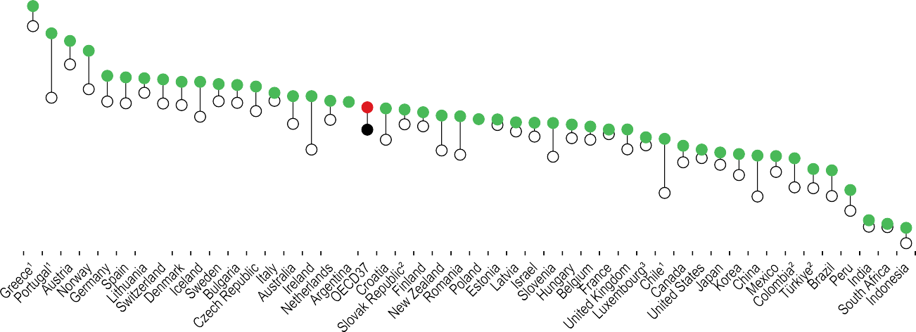

6

5

4

3

2

1

0

1. Refer to all doctors licensed to practise, resulting in a large overestimation of the number of practising doctors (e.g. around 30% in Portugal). 2. Includes not only doctors providing direct care to patients but also those working in the health sector as managers, educators, researchers, etc. (adding another 5-10% of doctors).

3. Latest available data 2017.

Source: OECD Health Statistics 2023.

*StatLink 2* <https://stat.link/k4uhx3>

**Figure 8.5. Evolution in the number of doctors, selected countries, 2011-21**

**Countries above OECD average in doctors per capita in 2021 Countries below OECD average in doctors per capita in 2021**

Australia Norway OECD37

Greece Switzerland

France Korea OECD37

Japan

United Kingdom

Index (2011=100)

140

135

130

125

120

115

110

105

100

Index (2011=100)

140

135

130

125

120

115

110

105

100

95

2011 2012 2013 2014 2015 2016 2017 2018 2019 2020 2021

95

2011 2012 2013 2014 2015 2016 2017 2018 2019 2020 2021

Source: OECD Health Statistics 2023.

*StatLink 2* <https://stat.link/sr9yp8>

**Doctors (by age, sex and category)**

In 2021, one-third of all doctors in OECD countries were over 55 years of age, up from just over one-fifth in 2000 (Figure 8.6). The share of doctors over 55 increased between 2000 and 2021 in all countries for which data are available, although the share has stabilised in some countries, with the entry of many new young doctors into the profession in recent years, and the progressive retirement of the baby-boom generation of doctors.

Some countries have seen a rapid ageing of their medical workforce over the past two decades. Italy, where the share of doctors aged 55 and over more than doubled to reach 55% in 2021, is the most striking example. There has also been strong growth in the share of doctors aged 55 and over, and in the share of doctors aged 65 and over, in Latvia, Israel and France. No fewer than 25% of all doctors in Italy and Israel were aged 65 and over in 2021. In France, this proportion was 18% of all doctors in 2021 (more than one in six).

Ageing of the medical workforce is a concern, as doctors aged 55 and over can be expected to retire in the following decade or so. Proper health workforce planning is required to ensure that a sufficient number of new doctors will become available to replace them, given that it takes about ten years to train new doctors. It is also important to take into account changes in retirement patterns of doctors, and to note that many may continue to practise beyond age 65, full time or part time, if the working conditions are adequate and if pension systems do not provide a disincentive for them to do so.

The proportion of female doctors increased in all OECD countries over the past two decades, and in 2021 half of all doctors in OECD countries were female. This proportion ranged from over 70% in Latvia, Estonia and Lithuania to 25% or less in Japan and Korea (Figure 8.7). The share of female doctors increased particularly rapidly over the past two decades in the Netherlands, Spain, Denmark and Norway – by 2021, women accounted for more than half of all doctors in these countries. Across OECD countries, this increase has been driven by growing numbers of young women enrolling in medical schools, as well as the progressive retirement of more commonly male generations of doctors. Female doctors tend to work more in general medicine and medical specialties like paediatrics, and less in surgical specialties.

Many countries have taken steps to increase the number of training places in general medicine in response to concerns about shortages of GPs. For example, in 2022, the Advisory Council on Medical Manpower Planning in the Netherlands recommended to the government that nearly half of all postgraduate residency training places should be allocated to general practice over the period 2024-27, up from 40% in 2021 (ACMMP, 2022[1]). In France, since 2017 at least 40% of all postgraduate training places must be allocated to general medicine. In Canada, nearly 45% of residency training places filled in 2023 were in family medicine, although a number of places remained unfilled (CaRMS, 2023[2]). In many countries, attracting a sufficient number of medical graduates to fill available training places in general medicine remains a challenge, given the lower perceived prestige and remuneration (see section on “Remuneration of doctors”).

**Definition and comparability**

The data for most countries refer to practising doctors, defined as doctors providing care directly to patients. In some countries, the data are based on all doctors licensed to practise, not only those currently practising (Chile, Greece and Portugal; and also Israel and New Zealand for data on doctors by age and sex). Not all countries are able to report all their physicians in the two broad categories of specialists and generalists. This may be because specialty- specific data are not available for doctors in training or for those working in private practice. A distinction is made in the generalists category between GPs (family doctors) and non- specialist doctors working in hospitals or other settings, but this breakdown is not available for several countries (including Chile, Finland, Iceland, Switzerland, Türkiye and the United Kingdom), possibly leading to an overestimation of GP numbers. For example, in Chile, the GPs category includes generalists working in hospital settings, medical interns and residents. In Switzerland, it includes general internal medicine doctors and other generalists.

**References**

GPs (family doctors) represented less than one-quarter (23%) of all physicians on average across OECD countries in 2021, ranging from around half in Portugal, Chile and Canada to just 6% in Korea and Greece (Figure 8.8). However, the number of GPs is difficult to compare across countries owing to variation in the ways doctors are categorised. For example, in the United States and Israel, general internal medicine doctors often play a role similar to that of GPs in other countries, yet they are categorised as specialists. General paediatricians who provide general care to children are also considered specialists in all countries, so they are not considered GPs.

ACMMP (2022), *Recommendations 2024-2027*, https://capaciteitsorgaan.nl/app/uploads/2023/01/ Capaciteitsplan-2024-2027-Integraal-overzicht- DEF.pdf.

CaRMS (2023), *2023 R-1 Match Data Snapshot*, https[://www.carms.ca/pdfs/2023-R-1-data-](http://www.carms.ca/pdfs/2023-R-1-data-) snapshot.pdf.

[1]

[2]

% 55 54

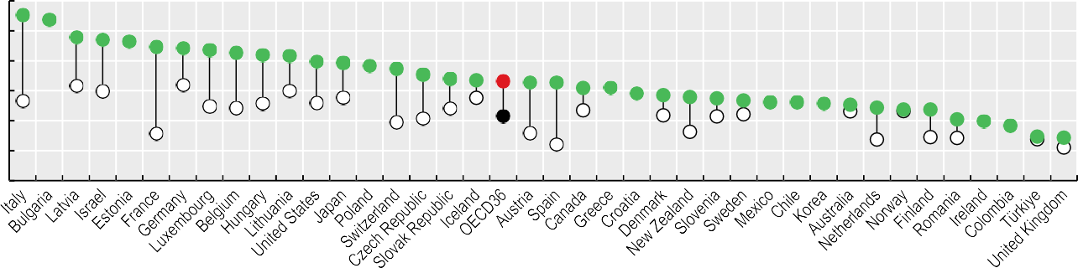

48 47 46 45 44 43 43

42 41 40 39 38 37

35 34 33 33 33 33 31 31

29 29 28 27 27 26 26 26 25 24 24 24

20 20 18

15 14



2000 2021

60

50

40

30

20

10

0

Source: OECD Health Statistics 2023.

*StatLink 2* <https://stat.link/3z7ive>

**Figure 8.7. Share of female doctors, 2000 and 2021 (or nearest year)**



2000 2021

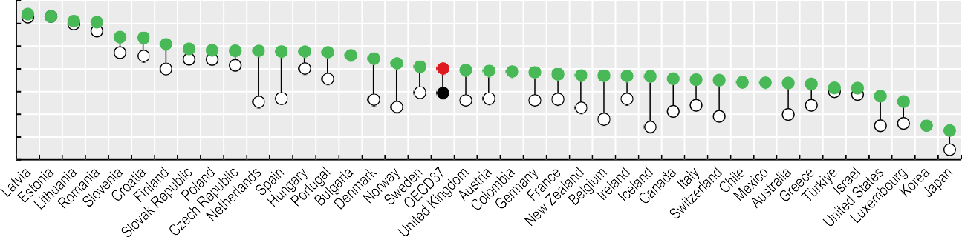

% 80

70

60

50

40

30

20

10

74 73 71 71

64 64 61 59 58 58 58 58 58 57

56 54 52 51

50 49 49 49 48 47 47 47 47 47 46 45 45 44 44 44 43

42 42 38 36

25 23

Source: OECD Health Statistics 2023.

*StatLink 2* <https://stat.link/rtolk2>

**Figure 8.8. Share of different categories of doctors, 2021 (or nearest year)**

%



General practitioners Specialists Other doctors¹

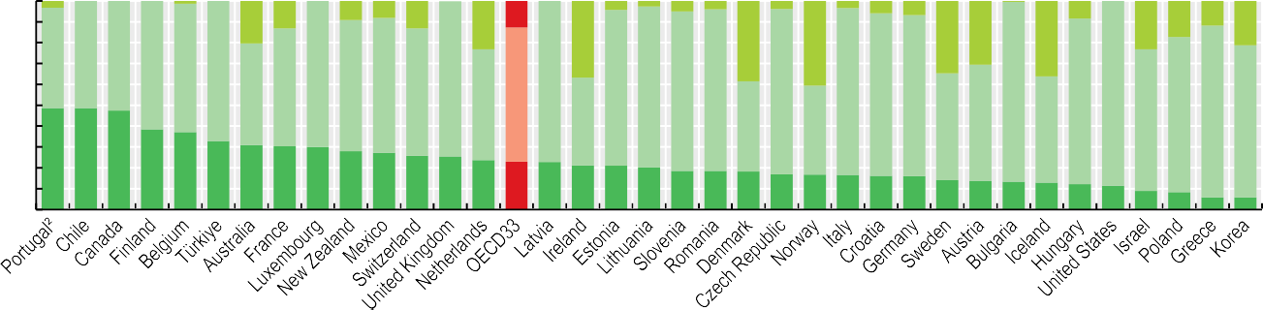

100

90

80

70

60

50

40

30

20

10

0

3

1

20

13

9 8

13

4 3 5 4

4

3 6

7

1

8

23

13

17 12

37

35 31

23

21

48 51 53 62 62 67

39 41

36

49 57

70

63 65 61 74

53 64

77

75 77 76 77

79 80 78 77

86 79 89

42

43

43

51 56

51

68 74 82 73

49 49 47

38 37 33 31 30 30 28 27 26 26 24 23 23 21 21 20

19 19 18 17 17 17 16 16 14 14 13 13 12 11

9 8 6 6

1. Includes non-specialist doctors working in hospitals and recent medical graduates who have not yet started postgraduate specialty training. 2. In Portugal, only about 30% of doctors employed by the public sector work as GPs in primary care – the other 70% work in hospitals.

Source: OECD Health Statistics 2023.

*StatLink 2* <https://stat.link/e9z31k>

**Geographic distribution of doctors**

Access to medical care requires a sufficient number and proper distribution of doctors in all parts of the country. A shortage of doctors in some regions can lead to inequalities in access to care and unmet needs. Difficulties in recruiting and retaining doctors in certain regions has been an important policy issue in many OECD countries for a long time, especially in countries with remote and sparsely populated areas.

The overall number of doctors per 1 000 population varies widely across OECD countries, from 2.5 or fewer in Türkiye, Colombia and Mexico to over 5 in Greece, Portugal, Austria and Norway (see section on “Doctors (overall number)”). Beyond these cross-country differences, the number of doctors per 1 000 population also often varies widely across regions within each country. The density of doctors is generally greater in metropolitan regions, reflecting the concentration of specialised services such as surgery, and physicians’ preferences to practise in densely populated areas. In 2021, disparities in the density of doctors between metropolitan and remote regions were highest in Lithuania, Latvia and the Slovak Republic. The distribution was more equal in Norway and Sweden. In Japan, there were more doctors per population outside metropolitan areas, although the number of doctors across all regions was lower than the OECD average (Figure 8.9).

In many countries, there is a particularly high concentration of doctors in national capital regions (Figure 8.10). This is the case notably in Austria, the Czech Republic, Denmark, Greece, Hungary, Portugal, the Slovak Republic and the United States.

Doctors may be reluctant to practise in rural regions due to concerns about their professional life (including their income, working hours, opportunities for career development and isolation from peers) and social amenities (such as educational options for their children and professional opportunities for

practice. By 2022, a total of 2 773 such health centres and homes were in operation. Various types of financial support are also provided for doctors to set up their practices in underserved areas. The government has also introduced monthly stipends for medical students and interns who agree to practise for a minimum duration in underserved areas on completing their training, although take-up of this programme has remained fairly limited (OECD/European Observatory on Health Systems and Policies, 2021[2]).

In the Czech Republic, the Ministry of Health offers special subsidies to GPs to open offices in underserved areas, and health insurers also provide higher payments to doctors serving less densely populated regions (OECD/European Observatory on Health Systems and Policies, forthcoming[3]).

**Definition and comparability**

Regions are classified in two territorial levels. The higher level (territorial Level 2) consists of large regions corresponding generally to national administrative regions. These broad regions may contain a mix of metropolitan regions and more rural and remote areas. The lower level (territorial Level 3) is composed of smaller regions classified as metropolitan regions (defined as regions with a population of over 250 000), regions located near a metropolitan region, and more remote regions (defined as regions far from metropolitan areas and regions near small urban areas with a population of fewer than 250 000). All data on geographic distributions come from the OECD Regional Database, which includes data from the Eurostat Database for territorial Level 2.

**References**

their partners). A range of policy levers can be used to influence the choice of practice location of physicians, including: 1) providing financial incentives for doctors to work in underserved areas; 2) increasing enrolment in medical education programmes of students from underserved areas or else decentralising the location of medical schools;

3) regulating the choice of practice location of doctors (for new medical graduates or foreign-trained doctors arriving in the country); and 4) reorganising service delivery to improve the working conditions of doctors in underserved areas (OECD, 2016[1]). Developments in telemedicine can also help overcome geographic barriers between patients and doctors (see section on “Digital health” in Chapter 5).

In France, successive governments have launched a number of initiatives over the past 15 years to address concerns about “medical deserts”. The main policy action to tackle this issue has been the creation of multidisciplinary health centres and homes, enabling GPs and other primary care providers to work in the same location, thereby avoiding the constraints of solo

OECD (2016), *Health Workforce Policies in OECD Countries: Right Jobs, Right Skills, Right Places*, OECD Health Policy Studies, OECD Publishing, Paris, https://doi.org/10.1787/9789264239517-en.

OECD/European Observatory on Health Systems and Policies (2021), *France: Country Health Profile 2021*, State of Health in the EU, OECD Publishing, Paris, https://doi.org/10.1787/7d668926-en.

OECD/European Observatory on Health Systems and Policies (forthcoming), *Czechia: Country Health Profile 2023*, State of Health in the EU, OECD Publishing, Paris.

[1]

[2]

[3]

Metropolitan areas Remote areas

Density per 1 000 population

7

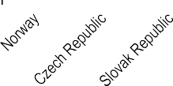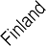

6.2

5.8

5.0

5.4

5.3

5.1

4.4

4.8

4.0

4.5

4.5

4.0

4.5

4.5

4.5

4.1

2.7

3.1

3.2

3.2

3.5

3.1

3.2

3.8

2.9

2.1

2.5 2.6

2.6

1.7

6

5

4

3

2

1

0

Source: OECD Regional Database 2023.

*StatLink 2* <https://stat.link/vfc8il>

**Figure 8.10. Physician density across regions, by territorial Level 2 regions, 2021 (or nearest year)**

Australia Austria Belgium

Canada Chile Colombia

Czech Republic

Denmark France Germany Greece Hungary Israel Italy Japan Korea Mexico

Netherlands New Zealand Norway Poland Portugal

Slovak Republic Slovenia

Spain

Sweden Switzerland Türkiye

United Kingdom

United States



Vienna

Brussels Capital Region

Prague

Copenhagen Region

Hamburg

Athens Region

Budapest

Mexico City

Utrecht

Warsaw

Metropolitan area of Lisbon Bratislava Region

Ankara Greater London

District of Columbia

0 1 2 3 4 5 6 7 8 9 10

Density per 1 000 population

Source: OECD Regional Database 2023.

*StatLink 2* <https://stat.link/t9h7ap>

**Remuneration of doctors**

The level of remuneration of doctors is an important factor in the attractiveness of the medical profession, and how remuneration differs across categories can be a criterion in deciding whether to pursue a career in general practice or in one of the various medical specialities. Differences in remuneration levels of doctors across countries can also act as a “push” or “pull” factor when it comes to physician migration (OECD, 2019[1]). In many countries, governments can determine or influence the level and structure of physician remuneration by regulating their fees or by setting salaries when doctors are employed in the public sector.

In all OECD countries, the remuneration of doctors (both GPs and specialists) is substantially higher than the average wage of a full-time employee across all economic sectors. In 2021, GPs generally earned between two and five times more than the average wage across OECD countries, while the income of specialists was at least twice, but in some cases up to six times, that of the average wage (Figure 8.11).

In most countries, specialists earned more than GPs. In Australia, Belgium and Korea, the income of self-employed specialists was at least double that of self-employed GPs. In Germany, the difference between self-employed specialists and self-employed GPs was much smaller, at about 12%.

In most countries, the remuneration of physicians has increased since 2011 in real terms (adjusted for inflation), but growth rates differ across countries as well as between GPs and specialists (Figure 8.12). The pay increases for both specialists and generalists have been particularly strong in Hungary and Chile. In Hungary, the government has raised the remuneration of both specialists and generalists substantially over the past decade in an effort to reduce emigration of doctors and address domestic shortages. The large increases in Chile are mainly due to successive pay rises for specialists and generalists between 2012 and 2016.

In about half of countries, the remuneration of specialists has risen faster than that of generalists since 2011, thereby increasing the remuneration gap between the two professional categories. This has been the case in Chile, in particular, and to a lesser extent in Hungary and Israel. However, in Poland, Austria, Germany, Belgium and the Netherlands, the remuneration gap has narrowed, as the income of GPs has grown more than that of specialists.

In some countries, including Portugal, Costa Rica and the United Kingdom, the remuneration of both GPs and specialists fell in real terms between 2011 and 2021. In Portugal, a substantial reduction occurred between 2011 and 2012; since then, doctors’ income has increased again, but the income level in 2021 remained below that of 2011 when taking inflation into account. In the United Kingdom, the remuneration of doctors has fallen slightly in real terms over the past decade. This was also the case for nurses and other NHS staff (The Health Foundation, 2021[2]).

When comparing doctors’ income, it is important to bear in mind that the remuneration of different categories of surgical or medical specialties can vary widely within a country. In France, for example, surgeons, anaesthetists and radiologists made at least twice as much as paediatricians and psychiatrists in 2020 (DREES, 2022[3]). Similarly, in Canada, ophthalmologists and many surgical specialists had at least twice the income of paediatricians and psychiatrists in 2018/19 (CIHI, 2020[4]). In many countries, the remuneration of paediatricians is close to that of GPs, reflecting similarities in their practices.

**References**

**Definition and comparability**

The remuneration of doctors refers to average gross annual income, including social security contributions and income taxes payable by the employee. It normally excludes practice expenses for self-employed doctors (except in Belgium, practice expenses are included). OECD data on physician remuneration make the distinction between salaried and self- employed physicians. In some countries this distinction is blurred, since some salaried physicians are allowed to have a private practice, and some self-employed doctors receive part of their remuneration through salaries. The OECD data also distinguish between GPs and all other specialists combined, although there can be wide differences in the income of different medical and surgical specialists.

A number of data limitations contribute to an underestimation of remuneration levels in some countries: 1) payments for overtime work, bonuses, other supplementary income or social security contributions are excluded in some countries (in Austria for GPs, and in Ireland and Italy for salaried specialists); 2) incomes from private practices for salaried doctors are not included in some countries (such as the Czech Republic, Hungary, Iceland, Ireland, Slovenia and Spain); 3) informal payments, which may be common in certain countries (such as Greece and Hungary), are not included; 4) data relate only to public sector employees, who tend to earn less than those working in the private sector, in Chile, Denmark, Greece, Hungary, Iceland, Ireland, Norway, the Slovak Republic and the United Kingdom; and

5) physicians in training are included in Australia.

The income of doctors is compared to the average wage of full-time employees in all sectors in the country. The average wage of workers in the economy comes from the OECD Employment Database.

CIHI (2020), *Physicians in Canada, 2019*, Canadian Institute for Health Information, Ottawa.

DREES (2022), *Le revenu libéral des médecins libéraux*, Direction de la recherche, des études, de l’évaluation et des statistiques, https://data.drees.solidarites- sante.gouv.fr/explore/dataset/ods_revenu-liberal- des-medecins-liberaux_prod2022/information/.

OECD (2019), *Recent Trends in International Migration of Doctors, Nurses and Medical Students*, OECD Publishing, Paris, https://doi.org/10.1787/5571ef48-en.

The Health Foundation (2021), *How has NHS staff pay changed over the past decade?*, The Health Foundation, London, https[://www.health.org.uk/news-and-](http://www.health.org.uk/news-and-)

comment/charts-and-infographics/how-has-nhs-staff- pay-changed-over-the-past-decade.

[4]

[3]

[1]

[2]

Salaried Self-employed

**General practitioners (GPs)**

|  |  |  |  |
| --- | --- | --- | --- |
|  |  | 1. | 7 |
|  |  | 3.1 |  |
|  |  | 2.6 |  |
|  |  | 2.7 |  |
|  |  | 2.6 |  |
|  |  | 2.3 |  |
|  |  | n.a. |  |
|  |  | n.a. |  |
|  |  | 3.1 1. | 7 |
|  |  | 2.0 |  |
|  |  | 3.0 |  |
|  | 5.0 |  |  |
|  |  | n. | a. |
|  |  | 3.5 |  |
|  |  | 2.0 |  |
|  |  | 3.0 |  |
|  |  | 2.3 | 1.5 |
|  |  | n.a. |  |
|  |  | 3.0 2.1 |  |
|  |  |  | 1.3 |
|  |  | 2.5 |  |
|  |  | 2.5 2.2 |  |
|  |  |  | n.a. |
|  |  |  | n.a. |
|  |  | 2.3 |  |
|  |  | 2.2 |  |
|  |  | n. | a. |
|  |  | 2.4 |  |
|  |  | 2.4 |  |
|  |  | 2.3 |  |
|  |  | 3.1 |  |
|  |  | 2.2 |  |
|  |  | 3.4 1.8 |  |

6 4 2

Australia¹ Austria Belgium² Canada Chile Costa Rica

Czech Republic Denmark Estonia Finland

France (2017) Germany Greece Hungary Iceland Ireland

Israel Italy Korea

Latvia (2018) Mexico Netherlands New Zealand Norway Poland Portugal

Slovak Republic Slovenia Spain Sweden Switzerland

Türkiye England (UK)

0

**Specialists**

|  |  |  |  |
| --- | --- | --- | --- |
|  |  | 3.8 |  |
|  |  | 4.5 |  |
|  | 2.4 |  | 5.8 |
|  |  | 4.2  4.4 |  |
|  | 2.6 |  |  |
|  | 2.6 |  |  |
|  | 2.5 |  |  |
|  | 2.3 |  |  |
|  | 2.7 |  |  |
|  | 2.2 | 5.1 |  |
|  | 3.4 | 5. | 6 |
|  | 2.6 | 4.7 |  |
|  |  |  |  |
|  | 2.1 |  |  |
|  | 3.4 |  |  |
|  | 3.3 | 4.0 |  |
| 1. | 2.6  7 | 4.4 | 6.8 |
|  | 3.2 |  |  |
|  | 3.2 3.3 |  |  |
|  | 2.8 |  |  |
|  | 1.8 |  |  |
| 1.4 |  |  |  |
|  | 2.2 |  |  |
|  | 2.6 |  |  |
|  | 2.5 |  |  |
|  | 2.7 |  |  |
|  | 2.2 |  |  |
|  | 3.2 |  |  |
|  | 3.2 |  |  |
|  | 3.3 |  |  |

0 2 4 6

Ratio to average wage in each country Ratio to average wage in each country

1. Includes physicians in training (resulting in an underestimation). 2. Includes practice expenses (resulting in an overestimation). Source: OECD Health Statistics 2023 and OECD Employment Database 2023.

*StatLink 2* <https://stat.link/zyg5p2>

**Figure 8.12. Growth in the remuneration of general practitioners and specialists (real terms), 2011-21**

GPs Specialists

Average annual growth rate (%, in real terms)

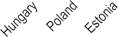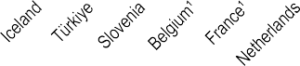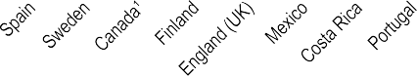

13

11

9

7

5

3

1

-1

-3

13.0

11.3

7.8

5.2

4.7

4.9

3.9

2.7

3.2

1.6

2.6

2.8

2.5 2.5

1.5

2.9

2.0 2.6

1.7 1.4 1.5

1.2 1.4

0.8

1.9

0.8

0.4

0.4 0.5 0.3

0.1

0.3

0.0

0.6

-0.2

-0.6

-0.7

-0.1

-0.3 -0.7 -0.4 -0.2

-1.6 -1.4 -1. -1.1

7

1. Growth rate is for self-employed GPs and specialists. Source: OECD Health Statistics 2023.

*StatLink 2* <https://stat.link/anp09i>

**Nurses**

Nurses play a central role in the provision of healthcare and are a core element of any patient-centred health system. Generally, they are the most numerous category of health workers in most OECD counties. While most nurses are employed in hospitals, many also work in long-term care facilities or in the community.

In 2021, there were 9.2 practicing nurses per 1 000 population on average across OECD member countries, up from 8.2 in 2011. The density of nurses in 2021 ranged from fewer than 3 per 1 000 population in Colombia, Türkiye and Mexico to over 18 per 1 000 in Finland, Switzerland and Norway (Figure 8.13). Among partner countries, South Africa, India and Indonesia have relatively few nurses – fewer than 2 per 1 000 population in 2021. The number is higher in China, where it has increased rapidly over the past decade, from

1.7 in 2011 to 2.9 in 2021.

The number of nurses per 1 000 population has grown in almost all OECD countries over the past decade, except in Latvia, the Slovak Republic and Sweden, where it fell slightly between 2011 and 2021. Switzerland, Norway, Australia and Korea are among those countries that have managed to increase the number of nurses substantially over the past decade. This increase has been driven to a large extent by an expansion of the number of students in nursing education programmes (see section on “Nursing graduates”). However, it is not enough to train more nurses: there is also a need to retain nurses in the profession once they have completed their studies. This requires an improvement in their working conditions. In Norway, the government adopted a five-year action plan in 2016 – the Competence Lift 2020 – to improve the competencies, pay and retention rates of nurses. This action plan was extended for another five years under the Competence Lift 2025. Although the number of nurses has increased, the dropout rate continues to be high, especially among nurses working in long-term care.

In Switzerland, the increase in the number of nurses has been driven to a large extent by a rise in the number of “associate professional nurses” (or “intermediate care workers”), who have lower qualifications than “professional nurses” (or “qualified nurses”). Between 2011 and 2021, the number of associate professional nurses increased almost three times faster than the number of professional nurses. As a result, the share of associate professional nurses among all nurses went

In several countries, many nurses have perceived a degradation in their working conditions, with more considering leaving their jobs during and after the COVID-19 pandemic (OECD, 2023[1]). Concerns about a “great resignation” of nurses and other health workers emerged in early 2021 in the United States, and a little later in 2021 and 2022 in the United Kingdom. In the United Kingdom, the number of nurses who left the NHS in England reached an all-time high in 2021/22, and more than half of leavers were aged under 40, and therefore still many years away from retirement (King's Fund, 2022[2]). However, at the same time, a record number of nurses joined the NHS in England in 2021/22, driven largely by international recruitment, so the overall number of nurses continued to increase at least slightly (OECD, 2023[1]).

Nurses outnumber physicians in most OECD countries. On average, there are 2.5 nurses for every doctor. The ratio of nurses per doctor ranges from about one nurse per doctor in Colombia, Mexico and Latvia to more than four in Finland, Japan, the United States and Switzerland (Figure 8.14).

**Definition and comparability**

The number of nurses includes those providing services directly to patients (“practising”) and in some cases also those working as managers, educators or researchers.

In countries where nurses can hold different levels of qualification or roles, the data include both professional nurses, who have a higher level of education and perform more complex or skilled tasks, and associate professional nurses, who have a lower level of education but are nonetheless recognised as nurses. Healthcare assistants (or nursing aides) who are not recognised as nurses are excluded (in some countries such as Spain and France, this represents a large category of workers). Midwives are excluded, except in some countries where they are included because they are considered specialist nurses or for other reasons (Australia, Ireland and Spain).

Greece reports only nurses working in hospitals, resulting in an underestimation.

**References**

up from 30% in 2011 to 36% in 2021. Despite the growth in these two categories, hospitals and other health and long-term care facilities continue to have difficulties recruiting nurses, and there are concerns about shortages in the coming years.

In some countries, recruitment of foreign-trained nurses has played an important role in increasing nurse numbers. Nearly half of all nurses in Ireland are foreign-trained, and over a quarter in New Zealand and Switzerland obtained their first nursing degree in another country (see section on “International migration of doctors and nurses”). In Switzerland, most foreign-trained nurses come from France and Germany, and to a lesser extent from Italy, and the numbers have increased substantially in recent years.

King’s Fund (2022), *The NHS nursing workforce: Have the floodgates opened?*, https://[www.kingsfund.org.uk/blog/2022/10/nhs-](http://www.kingsfund.org.uk/blog/2022/10/nhs-) nursing-workforce#vacancies-have-always-been- high.

OECD (2023), *Ready for the Next Crisis? Investing in Health System Resilience*, OECD Health Policy Studies, OECD Publishing, Paris, https://doi.org/10.1787/1e53cf80-en.

[2]

[1]

**Figure 8.13. Practising nurses per 1 000 population, 2011 and 2021 (or nearest year)**

Per 1 000 population

2011 2021

20 18.918.418.3

|  |  |  |  |  |  |  |  |  |  |  |  |  |  |  |  |  |  |  |  |  |  |  |  |  |  |  |  |  |  |  |  |  |  |  |  |  |  |  |  |  |  |  |  |  |  |  |  |  |  |
| --- | --- | --- | --- | --- | --- | --- | --- | --- | --- | --- | --- | --- | --- | --- | --- | --- | --- | --- | --- | --- | --- | --- | --- | --- | --- | --- | --- | --- | --- | --- | --- | --- | --- | --- | --- | --- | --- | --- | --- | --- | --- | --- | --- | --- | --- | --- | --- | --- | --- |
|  |  | |  | |  |  |  |  |  |  |  |  |  |  |  |  |  |  |  |  |  |  |  |  |  |  |  |  |  |  |  |  |  |  |  |  |  |  |  |  |  |  |  |  |  |  |  |  |  |
|  |  |  |  |  | 15.0 |  |  |  |  |  |  |  |  |  |  |  |  |  |  |  |  |  |  |  |  |  |  |  |  |  |  |  |  |  |  |  |  |  |  |  |  |  |  |  |  |  |  |  |  |
|  |  | |  | |  | 12.8 | 12.7 |  |  |  |  |  |  |  |  |  |  |  |  |  |  |  |  |  |  |  |  |  |  |  |  |  |  |  |  |  |  |  |  |  |  |  |  |  |  |  |  |  |  |
|  |  | |  | |  |  |  | 12.1 | 12.0 | 12.0 | 11.7 | 11.4 | 11.1 | 10.9 |  | 10.6 | 10.5 |  |  |  |  |  |  |  |  |  |  |  |  |  |  |  |  |  |  |  |  |  |  |  |  |  |  |  |  |  |  |  |  |
|  |  | |  | |  |  |  |  |  |  |  |  |  |  |  |  |  | 10.3 | 10.2 | 9.7 | 9.2 | 9.0 | 8.8 | 8.7 |  |  |  |  |  |  |  |  |  |  |  |  |  |  |  |  |  |  |  |  |  |  |  |  |  |
|  |  | |  | |  |  |  |  |  |  |  |  |  |  | 10.7 |  |  |  |  |  |  |  |  |  | 8.0 | 8.0 | 7.9 | 7.5 | 7.4 | 6.5 |  |  |  |  |  |  |  |  |  |  |  |  |  |  |  |  |  |  |  |
|  |  | |  | |  |  |  |  |  |  |  |  |  |  |  |  |  |  |  |  |  |  |  |  |  |  |  |  |  |  | 6.3 | 6.2 |  | 5.7 | 5.4 | 5.3 |  |  |  |  |  |  |  |  |  |  |  |  |  |
|  |  | |  | |  |  |  |  |  |  |  |  |  |  |  |  |  |  |  |  |  |  |  |  |  |  |  |  |  |  |  |  | 5.7 |  |  |  |  |  | 3.8 | 3.7 | 3.5 | 2.9 | 2.8 | 2.6 | 2.4 |  |  |  |  |
|  |  | |  | |  |  |  |  |  |  |  |  |  |  |  |  |  |  |  |  |  |  |  |  |  |  |  |  |  |  |  |  |  |  |  |  | 4.2 | 4.2 |  |  |  |  |  |  |  | 2.3 | 1.6 | 1.6 | 1.0 |
|  |  | |  | |  |  |  |  |  |  |  |  |  |  |  |  |  |  |  |  |  |  |  |  |  |  |  |  |  |  |  |  |  |  |  |  |  |  |  |  |  |  |  |  |  |  |  |  |  |

18  

16 

14

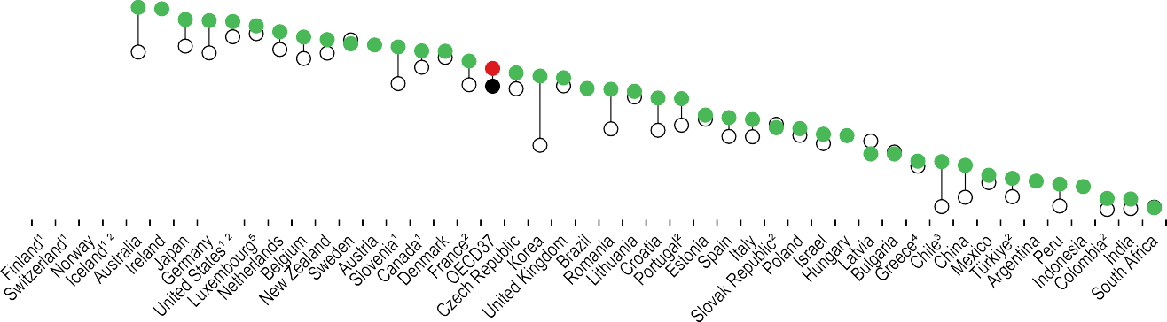

12

10

8

6

4

2

0

1. Associate professional nurses with a lower level of qualifications make up more than 50% of nurses in Slovenia, Croatia and Romania; between 33% and 50% in Greece, Iceland, Korea, Mexico and Switzerland; and between 15% and 30% in Australia, Canada, Finland, Japan, the United Kingdom and the United States. 2. Data include nurses working in the health sector as managers, educators, researchers and similar (e.g. for France, the number of practising nurses is overestimated by about 12%). 3. Data include all nurses licensed to practise. 4. Data only refer to nurses employed in hospitals. 5. Latest available data 2017.

Source: OECD Health Statistics 2023.

*StatLink 2* <https://stat.link/20d8bh>

**Figure 8.14. Ratio of nurses to doctors, 2021 (or nearest year)**

Ratio



6

5.2

5 4.7

4.3 4.1

4

3.9

3.7 3.5 3.5 3.4 3.4

3.2 3.2 3.1 3.1

3

2.9 2.7

2.7 2.7 2.5 2.5

2.3

2

2.1 2.0 2.0 1.9 1.8

1.8 1.7 1.6 1.6 1.6 1.6 1.5

1.4 1.4 1.3 1.3 1.3 1.2 1.2

1.0

1

0.7 0.7 0.7

0

1. For countries that have not provided data on practising nurses and/or practising doctors, numbers relate to the “professionally active” concept for both nurses and doctors (except Chile, where numbers include all nurses and doctors licensed to practise). 2. Ratio underestimated (professionally active nurses/all doctors licensed to practise). 3. Data refer to nurses and doctors employed in hospitals.

Source: OECD Health Statistics 2023.

*StatLink 2* <https://stat.link/a1ftp7>

**Remuneration of nurses**

Whether nurses are paid adequately has been a contested topic for many years. The COVID-19 pandemic and, more recently, the cost-of-living crisis, have brought further attention to the income of nurses, with concerns about whether remuneration is sufficient to attract and retain nurses in the profession.

On average across OECD countries, the remuneration of hospital nurses in 2021 was 20% above the average wage of all employees. However, in Switzerland, Finland, the United Kingdom and Latvia, nurses made less than the average worker, whereas in Mexico, Costa Rica, Chile, the Czech Republic, Belgium, Slovenia and Luxembourg, their income was at least 50% higher than the economy-wide average (Figure 8.15). In Slovenia, this was partly due to the inclusion of COVID-19 bonuses in 2021.

Figure 8.16 compares the remuneration of hospital nurses based on a common currency (USD), adjusted for differences in purchasing power to provide an indication of the relative economic well-being of nurses across countries, and the financial incentives to consider moving to another OECD country for a higher salary. In 2021, the income of nurses in Luxembourg was at least four times higher than those working in Lithuania and Latvia (although the latest data in these two countries relate to 2018 only). In general, nurses working in Central and Eastern European countries had the lowest levels of remuneration, explaining at least in part why many choose to migrate to other EU countries. Nursing income in the United States is higher than in most other OECD countries, explaining why the United States is able to attract several thousand nurses from other countries every year.

In most countries, the remuneration of nurses increased in real terms in the decade leading up to the pandemic. This was particularly the case in many Central and Eastern European countries (including Hungary, Poland, the Slovak Republic and the Czech Republic), where nurses obtained pay rises averaging 4-5% per year in real terms between 2010 and 2019, thereby narrowing the gap with other EU countries. Nurses in Türkiye, Iceland and Chile also obtained substantial pay rises between 2010 and 2019 (Figure 8.17).

In contrast, the remuneration of nurses decreased in real terms between 2010 and 2019 in Greece, Italy, Portugal, Finland and the United Kingdom. In the United Kingdom, nursing income increased in nominal terms, but it fell by over 3% in real terms between 2010 and 2019, mainly due to public sector pay

this phenomenon. In many countries, average real wages actually fell in 2021 due to inflation (OECD, 2022[2]).

For a comprehensive assessment of nursing income, it is also important to bear in mind that, in many countries, a large proportion of nurses and other health workers received one-off COVID-19 “bonuses” in 2020 and 2021 in recognition of the frontline role they played during the pandemic. However, these lump-sum bonuses have in most cases not been included in the regular wages reported here with a few exceptions (e.g. Slovenia).

**Definition and comparability**

The remuneration of nurses refers to average gross annual income, including social security contributions and income taxes payable by the employee. In most countries, the data relate specifically to nurses working in hospitals, although in Canada the data also cover nurses working in other settings. In some federal states, such as Australia, Canada and the United States, as well as in the United Kingdom, the level and structure of nurse remuneration is determined at the subnational level, which may contribute to variations across jurisdictions.

Data refer only to registered (“professional”) nurses in Canada, Chile, Ireland and the United States, resulting in an overestimation compared to other countries where lower- level (“associate professional”) nurses are also included. Data for New Zealand include all nurses employed by publicly funded district health boards, at all levels; they also include health assistants, who have a different and significantly lower salary structure than registered nurses.

The data relate to nurses working full time. The data for some countries do not include additional income such as overtime payments. Informal payments, which represent a significant part of total income in some countries, are not reported.

The income of nurses is compared to the average wage of full-time employees in all sectors in the country. It is also compared across countries based on a common currency (USD) and adjusted for differences in purchasing power.

**References**

policies implemented between 2011/12 and 2017/18. Between 2019 and 2021, the real average income of nurses increased slightly following the Agenda for Change pay deal for 2018-21 (Buchan, Shembavnekar and Bazeer, 2021[1]).

In 2020 and 2021, nurses in some countries obtained substantial pay rises in real terms – notably in Slovenia, Estonia, Hungary, the Czech Republic, the Slovak Republic and Poland, but also in Greece. In many other countries, the real remuneration of nurses only increased slightly in 2020 and 2021, due a large extent to rising inflation that eroded wage growth. Nurses were not the only occupation group affected by

Buchan, J., N. Shembavnekar and N. Bazeer (2021), *Nurses’ pay over the long term: what next?*, The Health Foundation, London, https://[www.health.org.uk/publications/nurses-pay-](http://www.health.org.uk/publications/nurses-pay-) over-the-long-term-what-next.

OECD (2022), *OECD Economic Outlook, Volume 2022 Issue 1*, OECD Publishing, Paris, https://doi.org/10.1787/62d0ca31-en.

[1]

[2]

**Figure 8.15. Remuneration of hospital nurses, ratio to average wage, 2021 (or nearest year)**

**Figure 8.16. Remuneration of hospital nurses, USD PPP, 2021 (or nearest year)**

Mexico Costa Rica

Chile¹ Czech Republic

Belgium Slovenia Luxembourg

Greece Spain Israel Hungary² Poland

Slovak Republic

Australia² OECD35

Türkiye Netherlands

Korea New Zealand²

Estonia United States¹ Germany (2018)

Ireland¹ Denmark Japan Canada¹ Norway Portugal³ Sweden France Iceland Italy

Latvia² (2018) United Kingdom

Finland Switzerland²

1.4

1.4

1.4

1.4

1.4

1.3

1.3

1.2

1.2

1.2

1.2

1.2

1.2

1.1

1.1

1.1

1.1

1.1

1.1

1.0

1.0

1.0

1.0

1.0

1.0

0.9

0.9

0.9

0.9

1.5

1.5

1.5

1.5

1.8

1.7

1.7

0 0.5 1 1.5 2

Luxembourg

Belgium United States¹ Netherlands Australia² Iceland Slovenia Denmark Germany (2018)

Canada¹ Norway Switzerland²

Israel New Zealand²

Spain Ireland¹ Korea OECD36

Chile¹ Costa Rica Sweden

Czech Republic United Kingdom

France Finland Poland Japan Italy Estonia Greece Türkiye Hungary²

Slovak Republic

Portugal³ Mexico Latvia² (2018)

Lithuania (2018)

0 25 50 75 100

|  |  |  |  |  |
| --- | --- | --- | --- | --- |
|  |  | 68 | 89  85  72  71 |  |
|  |  | 66 |  |  |
|  |  | 65 |  |  |
|  |  | 60 |  |  |
|  |  | 60 |  |  |
|  |  | 59 |  |  |
|  |  | 58 |  |  |
|  |  | 57 |  |  |
|  |  | 57 |  |  |
|  |  | 54 |  |  |
|  |  | 54 |  |  |
|  |  | 52 |  |  |
|  |  | 52 |  |  |
|  |  | 50 |  |  |
|  |  | 49 |  |  |
|  |  | 48 |  |  |
|  |  | 47 |  |  |
|  |  | 46 |  |  |
|  |  | 46 |  |  |
|  | 45 |  |  |  |
|  | 45 |  |  |  |
|  | 41 |  |  |  |
|  | 40 |  |  |  |
|  | 39 |  |  |  |
|  | 35 |  |  |  |
|  | 35 |  |  |  |
|  | 34 |  |  |  |
|  | 32 |  |  |  |
|  | 30 |  |  |  |
|  | 29 |  |  |  |
|  | 24 |  |  |  |
|  | 24 |  |  |  |

108

Ratio to average wage in each country

1. Data refer to registered (“professional”) nurses only (resulting in an overestimation). 2. Data include “associate professional” nurses, who have lower qualifications and revenues. 3. Data include only hospital nurses working in the National Health Service (public sector).

Source: OECD Health Statistics 2023.

*StatLink 2* <https://stat.link/a06suz>

USD PPP, thousands

1. Data refer to registered (“professional”) nurses only (resulting in an overestimation). 2. Data include “associate professional” nurses, who have lower qualifications and revenues. 3. Data include only hospital nurses working in the National Health Service (public sector).

Source: OECD Health Statistics 2023.

*StatLink 2* <https://stat.link/t6oqu9>

**Figure 8.17. Average annual growth in the remuneration of hospital nurses (real terms), 2010-19 and 2019-21 (or nearest years)**

%



20

17.3

15.4

15

12.0

11.3

10

9.1

6.7

5.7

5

3.9

0.5

1.1

1.4

1.2 0.9

1.1 1.3

1.5

2.6

2.6

0.9

0.5

1.2

0.6

0.1

0.9 0.8

0

-1.4

-0.6

-1.8

-1.4

-1.2 -1.3

-1.0

-5

2010-19 2019-21

1. The latest growth rate covers only 2019-20. 2. Data include only hospital nurses working in the National Health Service (public sector). Source: OECD Health Statistics 2023.

*StatLink 2* <https://stat.link/g23a4s>

**Hospital workers**

The number and composition of people working in hospitals in OECD countries varies depending on the roles and functions that hospitals play in health systems, as well as on how different types of support services in hospitals are provided and accounted for. The roles and functions of hospitals vary notably regarding the extent to which outpatient specialist services are provided in or outside hospitals. In most countries with universal health coverage funded by the tax system (national health service-type systems), outpatient specialist services are typically provided in public hospitals. This is the case, for example, in the United Kingdom, Nordic countries, Portugal and Spain. In other countries such as Australia, Austria, Belgium, Canada, France, Germany, Switzerland and the United States, most outpatient services are provided outside hospitals. In some Central and Eastern European countries (such as Estonia and Slovenia), most outpatient specialist services are provided in public hospitals, whereas these are provided in public multi-specialty clinics in others (such as Poland) or in private solo practices (as in the Czech Republic).

In 2021, the number of people working in hospitals relative to the overall size of the population was at least twice as high in Switzerland, the United Kingdom, Norway, Denmark, the United States, Iceland and France as in Mexico, Chile, Korea and Hungary (Figure 8.18). However, it is important to bear in mind that in the United States, 45% of people working in hospitals are non-clinical staff (administrative and other support staff), and this proportion is over 30% in Switzerland, France and Iceland.

In all countries, nurses represent the largest category of care providers in hospitals. Nurses and midwives account for 37% of all hospital employment on average across OECD countries. In some countries, including France, Portugal and Spain, healthcare assistants (or nursing aides) also represent a large category of hospital workers. Doctors account for one in seven (14%) hospital workers on average across OECD countries, although in several countries this number underestimates the number of doctors who work at least part time in hospitals, since self-employed doctors with dual practices outside and in hospital are not counted.

The number of full-time equivalent (FTE) nurses in hospitals is lower than the headcount because a significant proportion of nurses work part time. On average across OECD countries, the number of FTE nurses in hospitals is 13% lower than headcount. This gap is larger in some countries like the Czech Republic, Germany and Iceland, where FTE nurse numbers are about 25% lower than headcounts. Looking at trends over time, the ratio of FTE nurses to headcount remained relatively stable between 2011 and 2021 in many

In some countries like Canada, Germany and the United States, the number of nurses working in hospitals increased fairly steadily between 2011 and 2021, both before and after the pandemic. The growth started a few years later in Portugal and Spain, but picked up both before and during the pandemic years. By contrast, the increase was more modest in France before the pandemic, and there was no increase in the employment of hospital nurses during the pandemic. In Italy and the United Kingdom, there was no increase in the number of nurses working in hospitals between 2011 and 2019, but the number increased at least slightly in 2020 and 2021 (Figure 8.19).

The pandemic stimulated the development of new plans to increase recruitment of hospital staff and to improve working conditions to retain staff. For example, in France, the government introduced a new multiyear plan in July 2020 to strengthen public hospitals, including significant pay rises to increase staff recruitment and retention, especially for nurses (OECD/European Observatory on Health Systems and Policies, 2021[1]).

**Definition and comparability**

Hospital workers are defined as people working in hospitals, including wherever possible self-employed people under service contracts. In most countries, workers include both clinical and non-clinical staff. The data are reported in headcounts, although the OECD Health Database also includes data on FTE numbers for a more limited number of countries. FTE is generally defined as the number of hours worked divided by the average number of hours worked in full-time jobs, which may vary across countries.

Many countries do not count all or some self-employed workers working in hospitals. Australia, Chile, Denmark, Ireland, New Zealand and the United Kingdom only report data on employment in public hospitals, resulting in an underestimation.

For comparisons across countries, the number of hospital workers is related to the overall population size in each country. Another option would be to relate the number of workers more specifically to the number of hospital beds or hospital bed-days to take into account some measure of hospital activity across countries, although this would not include activities that do not require hospitalisation (such as consultations, examinations and day care).

**References**

countries (e.g. France, Lithuania, New Zealand and the United States), while it decreased in some countries (e.g. the Czech Republic, Estonia, Iceland and Israel), indicating that the average working time of hospital nurses has decreased. By contrast, in some other countries (e.g. Ireland, the Netherlands and Norway), this ratio increased, meaning that the average working time of nurses has increased, although it remains well below 100%.

OECD/European Observatory on Health Systems and Policies (2021), *France: Country Health Profile 2021*, State of Health in the EU, OECD Publishing, Paris, https://doi.org/10.1787/7d668926-en.

[1]

**Figure 8.18. Hospital workforce, 2021 (or nearest year)**

Physicians Nurses and midwives Healthcare assistants Other health service providers Other staff

Per 1 000 population

1. Data refer to FTE workers (rather than headcount), resulting in an underestimation. 2. Data cover only healthcare workers, excluding other staff (administrative, technical, etc.), resulting in an underestimation.



30

26.6

24.7

25

22.7 22.6

21.3 21.0

20.0

20

17.8 17.3 17.2 17.1 16.8 16.7

16.4 16.3 16.1 15.6 15.4 15.3

15

14.7 14.2 13.7

13.0 12.7 12.4 12.0 11.5 11.5

11.0 10.6 10.4 10.4

10

9.4 9.2

8.0

7.4 7.2

5

0

Source: OECD Health Statistics 2023.

*StatLink 2* <https://stat.link/smtr4w>

**Figure 8.19. Growth in number of hospital nurses, selected OECD countries, 2011-21 (or nearest year)**

Canada

United Kingdom

France

United States

Germany

Portugal

Italy

Spain

Index (2011=100)

135

130

125

120

115

110

105

100

95

2011 2012 2013 2014 2015 2016 2017 2018 2019 2020 2021

Note: Data cover nurses and midwives. Source: OECD Health Statistics 2023.

Index (2011=100)

135

130

125

120

115

110

105

100

95

2011 2012 2013 2014 2015 2016 2017 2018 2019 2020 2021

*StatLink 2* <https://stat.link/o6yui8>

**Medical graduates**

The number of new medical graduates is a key indicator to assess the number of new entrants into the medical profession who will be available to replace retiring doctors and to respond to any current or future shortages. The number of medical graduates in any given year reflects decisions made a few years earlier related to student admissions, either through explicit *numerus clausus* policies (the setting of quotas on student admissions) or other decision-making processes.

Overall, the number of medical graduates across OECD countries increased from 93 000 in 2000 to 114 000 in

2010 and to 160 000 in 2021. In 2021, the number of new medical graduates ranged from about 7 per 100 000 population in Israel, Japan and Korea to more than 20 per 100 000 in Latvia, Ireland, Denmark and Lithuania (Figure 8.20).

In Ireland, the high number of medical graduates is due to the large share of international medical students, who in recent years have made up about half of all students. Many of these international students in Irish medical schools come from Canada, the United States and the United Kingdom. In most cases, they leave Ireland after graduation – either because they prefer to complete their training and practise in their home country or because they cannot secure an internship in Ireland. This results in a paradoxical situation where Ireland needs to import doctors trained in other countries to address doctor shortages (OECD, 2019[1]).

In several Central and Eastern European countries, this internationalisation of medical education is also reflected in a growing number of international medical students and graduates. Many medical schools in Romania, Bulgaria, the

of the growth was driven by growing intakes of international students, near two-fold increases occurred in countries such as Italy and Canada, while the increase reached over 50% in the Netherlands, Spain, the United Kingdom and the United States. Growth was more modest in Japan, although the number of students admitted to medical schools has increased since 2008, resulting in increases in the number of medical graduates since 2014 (Figure 8.21).

Following the pandemic, most OECD countries that responded to a policy questionnaire administered to ministries of health in early 2022 reported that they had recently increased student intakes in medical education and training programmes in response to concerns about current or future shortages. Most countries also reported that they were providing some incentives to encourage more students to choose general practice for their postgraduate internship/residency training to address shortages of GPs more specifically (OECD, 2023[3]).

**Definition and comparability**

Medical graduates are defined as students who have graduated from medical schools in a given year. In nearly all countries, medical graduates include both domestic students and international students, with the exception of Israel and New Zealand, where international students are excluded (in Israel this is because in nearly all cases these international students do not stay in Israel after graduation).

**References**

Slovak Republic, the Czech Republic, Hungary and Poland are attracting a growing number of international medical students, often by offering programmes in English. In most cases, these international students do not stay in the country after graduation (OECD, 2019[1]).

In Israel, the low number of domestic medical graduates is compensated by the high number of foreign-trained doctors (about 60% of all doctors). A large share of these foreign- trained doctors are in fact Israeli-born doctors who have returned to Israel after completing their first degree abroad because of the limited number of places in Israeli medical schools (OECD, 2023[2]).

The number of new medical graduates per 100 000 population has increased in all OECD countries since 2000 in response to concerns about current or future shortages of doctors, but with varying growth rates. Leaving aside Ireland, where a large part

OECD (2023), *OECD Report on Medical Education and Training in Israel*, OECD, Paris, https[://www.oecd.org/health/OECD-report-on-](http://www.oecd.org/health/OECD-report-on-) medical-education-and-training-in-Israel.pdf.

OECD (2023), *Ready for the Next Crisis? Investing in Health System Resilience*, OECD Health Policy Studies, OECD Publishing, Paris, https://doi.org/10.1787/1e53cf80-en.

OECD (2019), *Recent Trends in International Migration of Doctors, Nurses and Medical Students*, OECD Publishing, Paris, https://doi.org/10.1787/5571ef48-en.

[2]

[3]

[1]

**Figure 8.20. Medical graduates, 2021 (or nearest year)**

Per 100 000 population

30



27.3

26.2

26.0

25

22.7

22.0

20.4

19.2

18.2

17.0

16.6

16.4

16.3

16.2

16.2

15.7

15.5

15.4

15.0

14.2

14.2

14.2

13.7

13.4

13.1

13.0

12.7

12.5

12.4

11.9

11.8

11.7

11.4

10.6

10.3

9.1

8.5

7.5

7.3

7.2

6.8

20

15

10

5

0

Note: A large number of medical graduates are international students in some countries (e.g. Romania, Ireland, Bulgaria, the Slovak Republic, the Czech Republic and Hungary). 1. Data exclude international students, resulting in an underestimation (about 15% of graduates in Israel and 5% in New Zealand were international students in 2021).

Source: OECD Health Statistics 2023.

*StatLink 2* <https://stat.link/c8ost4>

**Figure 8.21. Evolution in the number of medical graduates, selected OECD countries, 2000-21**

**Countries above OECD average in graduates per capita in 2021 Countries below OECD average in graduates per capita in 2021**

Ireland

Netherlands

Italy

Spain

Canada

United Kingdom¹

Japan

United States

Index (2000=100) Index (2000=100)

250

200

150

100

50



250

200

150

100

50

1. Index for the United Kingdom, 2002=100. Source: OECD Health Statistics 2023.

*StatLink 2* <https://stat.link/r761pj>

**Nursing graduates**

The number of new nursing graduates is a key indicator to assess the number of new entrants to the nursing profession who might be available to replace retiring nurses and to respond to any current or future shortages. The number of nursing graduates in any given year reflects decisions made a few years earlier (about three years) related to student admissions, although graduation rates are also affected by student dropout rates.

Overall, the number of nursing graduates across OECD countries increased from about 350 000 in 2000 to 520 000 in 2010 and 640 000 in 2021. In 2021, the number of new nursing graduates ranged from fewer than 20 per 100 000 population in Colombia, Luxembourg, Mexico, Italy and Türkiye to over 100 per 100 000 in Australia, Switzerland and Korea (Figure 8.22). The low numbers in Colombia, Mexico and Türkiye are related to the low numbers of nurses working in the health system (see section on “Nurses”). In Luxembourg, the low number of nursing graduates is offset by a large number of students from Luxembourg who get their nursing degree in a neighbouring country, as well as the capacity of the country to attract nurses from other countries through better pay and working conditions (see section on “Remuneration of nurses”).

The number of new nursing graduates per 100 000 population has increased in all OECD countries since 2000, but with varying growth rates. In Italy, the number of nursing graduates increased fairly rapidly in the 2000s but has decreased since 2013 (Figure 8.23). However, following the pandemic, the number of applications to nursing education programmes has increased, along with the number of students admitted, which should lead to an increase in nursing graduates if these

and graduating from nursing education programmes has also increased over the past decade, but at a more moderate rate than in Switzerland. A persistent issue in Norway, as in other OECD countries, is retaining new nursing graduates in the profession. The number of new nursing graduates in Israel tripled between 2011 and 2021, but it remains below the OECD average relative to the country’s population.

One persistent challenge across OECD countries is the need to attract more male students to nursing. The general perception remains that nursing is “women’s work”, and that the occupation has a low professional status and autonomy, along with limited career progression opportunities (Mann and Denis, 2020[2]). In most countries, at least 80% of students applying and admitted to nursing programmes continue to be female, reflecting the traditional gender composition of the nursing workforce.

**Definition and comparability**

Nursing graduates are defined as students who have obtained a recognised qualification required to become a licensed or registered nurse. They include graduates from both higher-level and lower-level nursing programmes in countries where this distinction exists. They exclude graduates from master’s or doctorate degrees in nursing to avoid double-counting nurses acquiring further qualifications.

**References**

students complete their studies (OECD, 2023[1]). In Spain, the number of nursing graduates also fell in the years before the pandemic, but it started to increase at least slightly in 2020 and 2021. Following the pandemic, the number of applications to nursing programmes increased strongly in Spain (by over 50% between 2019 and 2021), but the number of students admitted in these programmes increased only marginally (by 6%) due to persistent capacity constraints (OECD, 2023[1]).

In the United States, the number of nursing graduates doubled between 2000 and 2010 (from around 100 000 in 2000 to 200 000 in 2010). This was followed by a period of stability, but the number has started to go up again in recent years. In Switzerland, the number of new graduates has increased greatly over the past 15 years, driven to a large extent by an increase in the number of graduates from “associate professional nurse” (or “intermediate care worker”) programmes. In Norway, the number of students admitted to

Mann, A. and V. Denis (2020), *Can nursing thrive in the age of the coronavirus? What young people think about the profession*, The OECD Forum Network, https[://www.oecd-forum.org/posts/can-](http://www.oecd-forum.org/posts/can-) nursing-thrive-in-the-age-of-the-coronavirus-what- young-people-think-about-the-profession-dce5a659- cc6d-4914-b412-42e994be8197.

OECD (2023), *Ready for the Next Crisis? Investing in Health System Resilience*, OECD Health Policy Studies, OECD Publishing, Paris, https://doi.org/10.1787/1e53cf80-en.

[2]

[1]

**Figure 8.22. Nursing graduates, 2021 (or nearest year)**

Per 100 000 population



140

120

100

80

60

40

20

0

115.7

112.6

108.6

105.2

77.5

1. Latest available data 2017. 2. Data include only professional nursing graduates. Source: OECD Health Statistics 2023.

66.5

63.8

62.8

59.6

52.7

52.7

46.8

45.3

44.2

44.1

43.2

42.8

41.9

37.4

36.2

36.2

33.1

32.9

32.2

30.2

28.7

28.4

27.7

27.4

27.3

26.8

24.3

23.0

18.5

17.2

17.1

12.8

8.1

8.0

*StatLink 2* <https://stat.link/d6hail>

**Figure 8.23. Evolution in the number of nursing graduates, selected OECD countries, 2000-21**

**Countries above OECD average in graduates per capita in 2021 Countries below OECD average in graduates per capita in 2021**

Australia¹

Switzerland

Norway

United States

France

Italy²

Israel

Spain³

Index (2000=100) Index (2000=100)

350

300

250

200

150

100

50



350

300

250

200

150

100

50

1. Index for Australia, 2001=100. 2. Index for Italy, 2002=100. 3. In Spain, the sharp reduction in 2012-13 is due to a change in training duration (extended by one year). Source: OECD Health Statistics 2023.

*StatLink 2* <https://stat.link/h4xac7>

**International migration of doctors and nurses**

While it takes many years to train new doctors and nurses, recruiting them from abroad can provide a quicker solution to address immediate shortages, although it may exacerbate shortages in countries of origin. Several OECD countries, including Australia, Canada, Ireland, Israel, New Zealand, Switzerland, the United Kingdom and the United States, have traditionally relied on international recruitment of doctors and nurses. In some countries, this reliance has increased following the pandemic (OECD, 2023[1]).

In 2021, nearly one-fifth (19%) of doctors on average across OECD countries had obtained at least their first medical degree in another country (Figure 8.24), up from 15% a decade earlier. For nurses, on average almost 9% had obtained a nursing degree in another country in 2021 (Figure 8.25), up from 5% a decade earlier. These developments occurred in parallel with an increase in the numbers of domestically trained medical and nursing graduates in most OECD countries (see sections on “Medical graduates” and “Nursing graduates”), which indicates substantial growing demand for doctors and nurses.

In 2021, the share of foreign-trained doctors ranged from 3% or less in Lithuania, Italy and Poland to around 40% in Switzerland, Ireland, Norway and New Zealand, and nearly 60% in Israel. However, about half of foreign-trained doctors in Israel are Israeli students who went abroad to get their first medical degree before returning to Israel to complete their postgraduate residency training and work as doctors. A large proportion of foreign-trained doctors in Norway, Sweden and Finland are also doctors who were born in these countries and went abroad to study before returning to their home country. This reflects the internationalisation of medical education and a growing market for medical degrees (OECD, 2019[2]), rather than a “brain drain”.

In most OECD countries, the share of foreign-trained nurses is below 5%, and much lower than the share of foreign-trained doctors, but there are a few exceptions. Nearly 50% of nurses in Ireland are foreign-trained, while the shares are 25-30% in New Zealand and Switzerland, and about 18% in Australia and the United Kingdom.

The share of foreign-trained doctors increased between 2010 and 2021 in some of the main destination countries (Figure 8.26). In the United Kingdom, the share of foreign- trained doctors fell slightly between 2010 and 2015, but it has increased in recent years to reach over 30% in 2021. In Switzerland, the share of foreign-trained doctors has increased

In the United Kingdom, international recruitment of nurses reached an all-time high in 2021/22, but the countries of origin of foreign-trained nurses in the United Kingdom have changed greatly over the past decade. Between 2010 and 2016, foreign- trained nurses were mainly recruited from EU countries. Following the Brexit vote in 2016 and the introduction of new English language test requirements for nurses, recruitment from EU countries fell greatly; however, this reduction has been more than offset by recruitment from countries outside Europe – notably the Philippines and India, but also Nigeria, Ghana and Zimbabwe (OECD, 2023[1]).

International recruitment of foreign-trained nurses has also increased over the past decade in Germany and Canada. In Canada, it reached an all-time high in 2021, and it can be expected to continue to increase further as the federal and provincial governments are encouraging more foreign nurses to come to work in the country (OECD, 2023[1]).

**Definition and comparability**

The data relate to foreign-trained doctors and nurses – defined as the place where they obtained their first medical or nursing degree. They relate to the total stocks. The OECD Health Database also includes data on annual inflows, as well as by country of origin. The data sources in most countries are professional registries or other administrative sources.

The main comparability limitation relates to differences in the activity status of doctors and nurses. Some registries are updated regularly, making it possible to distinguish doctors and nurses who are still actively working in health systems, while others include all doctors and nurses licensed to practise, regardless of whether they are still active.

Data on foreign-trained nurses in Finland and Slovenia cover only professional nurses. Switzerland only reports data on foreign-trained nurses employed in hospitals (leading to a possible overestimation if the share of foreign- trained nurses is lower in nursing homes and in the community).

The data for Germany are based on nationality, not on the place of training.

**References**

steadily over the past decade, driven by the growing number of doctors trained in France, Germany, Austria and Italy. In France and Germany, the number and share of foreign-trained doctors has also increased steadily over the past decade, with the share nearly doubling from 7% of all doctors in 2010 to 12-14% in 2021.

The share of foreign-trained nurses has increased substantially since 2010 in Switzerland and the United Kingdom (Figure 8.27). In Switzerland, the increase has been driven mainly by the growing number of nurses trained in France and Germany, and to a lesser extent in Italy.

OECD (2023), *Ready for the Next Crisis? Investing in Health System Resilience*, OECD Health Policy Studies, OECD Publishing, Paris, https://doi.org/10.1787/1e53cf80-en.

OECD (2019), *Recent Trends in International Migration of Doctors, Nurses and Medical Students*, OECD Publishing, Paris, https://doi.org/10.1787/5571ef48-en.

[1]

[2]

**Figure 8.24. Share of foreign-trained doctors, 2021 (or nearest year)**

**Figure 8.25. Share of foreign-trained nurses, 2021 (or nearest year)**

Israel New Zealand

Norway Ireland Switzerland Australia

United Kingdom

Sweden United States³

Canada Chile Finland OECD28

Slovenia Germany¹ Belgium France Portugal² Denmark Hungary

Czech Republic

Austria Latvia Colombia Estonia Netherlands

Poland Italy Lithuania

25.0

24.0

23.4

19.5

18.9

15.8

13.8

13.2

12.3

12.0

9.5

8.2

7.6

6.8

5.9

5.5

4.2

3.6

2.7

0.9

0.6

32.2

31.9

30.2

42.1

42.1

40.5

38.4

57.8

Ireland New Zealand Switzerland Australia

United Kingdom

Austria Israel Germany¹ Canada OECD26

Norway United States

Slovenia

Italy Belgium Sweden France Latvia Chile Denmark Hungary

Netherlands

Finland Colombia Lithuania Estonia Poland

13.2

10.7

9.6

8.8

8.7

6.2

6.1

5.5

5.2

4.3

3.5

3.1

2.5

1.9

1.8

1.6

1.5

1.4

0.6

0.4

0.2

0.2

18.1

17.9

25.6

29.9

46.6

0 10 20 30 40 50 60

%

1. Data based on nationality (not on place of training). 2. Latest available data 2017. 3. Latest available data 2016.

Source: OECD Health Statistics 2023.

*StatLink 2* <https://stat.link/gyo9r0>

0 10 20 30 40 50

%

1. Data based on nationality (not on place of training). Source: OECD Health Statistics 2023.

*StatLink 2* <https://stat.link/9n2y34>

**Figure 8.26. Evolution in the share of foreign-trained doctors, selected OECD countries, 2010-21**

**Figure 8.27. Evolution in the share of foreign-trained nurses, selected OECD countries, 2010-21**

% %



40

30

20

10

0

France

Switzerland

Germany

United Kingdom



30

20

10

0

Canada

Switzerland

Germany

United Kingdom

Source: OECD Health Statistics 2023.

*StatLink 2* <https://stat.link/qtr1dh>

Source: OECD Health Statistics 2023.

*StatLink 2* <https://stat.link/f8szgq>

**196** 

1. **Pharmaceutical sector**

Pharmaceutical expenditure Pharmacists and pharmacies Pharmaceutical consumption Generics and biosimilars

Pharmaceutical research and development

In 2021, spending on retail pharmaceuticals (that is, excluding those used during hospital stays and in other health facilities) accounted for one-sixth of overall healthcare expenditure in OECD countries. While retail pharmaceuticals continued to represent the third largest component of health expenditure after inpatient and outpatient care, spending on these goods has increased at a slower pace than most other areas of the health system over the last decade (see section on “Health expenditure by type of service” in Chapter 7), due to cost- control measures and generic uptake.

Across OECD countries, governments and compulsory insurance schemes are the main payers of retail pharmaceuticals, financing 58% of total spending in 2021 (Figure 9.1). In countries such as France, Ireland and Germany, this share was even higher, with more than 80% of total costs covered by these schemes. Direct out-of-pocket payments by households (including cost-sharing for reimbursed medicines) were also a significant source of financing, representing an average of 39% of total pharmaceutical spending in 2021, albeit with much higher shares in countries such as Chile (78%), Poland (65%) and Latvia (59%). Out-of-pocket spending was also high in OECD accession countries Bulgaria and Romania. In contrast, voluntary health insurance schemes accounted for a relatively small proportion of total costs, at 7% or less in all but two OECD countries with comparable data (and averaging 3%). Canada and Slovenia are exceptions, where voluntary private health insurance accounted for 34% and 25%, respectively, of retail pharmaceutical spending.

A variety of factors influence the level of per capita spending on retail pharmaceuticals, including distribution, prescribing and dispensing; pricing and procurement policies; and patterns of uptake of novel and generic medicines. In 2021, per capita retail pharmaceutical expenditure in OECD countries averaged USD 614 (adjusted for differences in purchasing power) (Figure 9.2). Spending in the United States was more than double the OECD average, while the majority of OECD countries fell within a relatively narrow spending band of ±20% from the average. Per capita spending was lowest in Denmark, at less than half the OECD average. In that country, a comparably high proportion of medicines is dispensed as part of inpatient or outpatient treatments and thus outside

grown substantially, partly due to the advent of new high-cost treatments, particularly in oncology and immunology (IQVIA Institute for Human Data Science, 2021[2]). Hospital and other non-retail pharmaceutical spending increased more rapidly than retail medicines in most countries, with the highest growth rates in Germany, Spain and the Czech Republic (Figure 9.3).

**Definition and comparability**

Pharmaceutical expenditure covers spending on prescription medicines and self-medication (often referred to as OTC products). Some countries cannot report a breakdown, and their data may include medical non- durables (such as first aid kits, hypodermic syringes and facemasks). This typically leads to an overestimation by 5-10%, but during the COVID-19 pandemic the overestimation might have been higher. Retail pharmaceuticals are those provided outside hospital care, dispensed by a retail pharmacy or bought from a supermarket, and the prices should include wholesale and retail margins and value added tax (OECD/Eurostat/WHO, 2017[3]). Comparability issues exist regarding the administration and dispensing of pharmaceuticals for hospital outpatients. In some countries, the costs are included under curative care; in others, under pharmaceuticals.

Hospital and other non-retail pharmaceuticals include drugs administered or dispensed during an episode of hospital care or in another healthcare setting. The costs of pharmaceuticals consumed in hospitals and other healthcare settings are reported as part of the costs of inpatient or day-case treatment. Non-retail pharmaceuticals also include the costs of vaccines that are consumed as part of a vaccination campaign and that are not procured via retailers.

Total pharmaceutical spending refers to “net” spending: it is adjusted for rebates paid by manufacturers, wholesalers or pharmacies.

**References**

traditional retail channels.

Pharmaceutical spending has two main components: prescription medicines and over-the-counter (OTC) products. Across OECD countries, prescription medicines accounted for more than three-quarters of the total pharmaceutical retail bill. The split between prescriptions and OTC products is influenced by country-specific differences in the coverage of prescription medicines, as well as the prices and availability of different medicines. Poland was the only OECD country where spending on OTC products exceeded that of prescription medicines.

Analysing retail pharmaceutical spending only gives a partial picture of the cost of pharmaceuticals in the health system. Spending on medicines in the hospital sector and other settings can be significant – typically accounting for 20% or more on top of retail spending (Morgan and Xiang, 2022[1]). Over the last decade, hospital pharmaceutical spending has

IQVIA Institute for Human Data Science (2021), *Drug Expenditure Dynamics 1995-2020: Understanding Medicine Spending in Context*, https[://www.iqvia.com/insights/the-iqvia-](http://www.iqvia.com/insights/the-iqvia-) institute/reports/drug-expenditure-dynamics.

Morgan, D. and F. Xiang (2022), “Improving data on pharmaceutical expenditure in hospitals and other health care settings”*, OECD Health Working Papers*, No. 139, OECD Publishing, Paris, https://doi.org/10.1787/6c0d64a2-en.

OECD/Eurostat/WHO (2017), *A System of Health Accounts 2011: Revised edition*, OECD Publishing, https://doi.org/10.1787/9789264270985-en.

[2]

[1]

[3]

**Figure 9.1. Expenditure on retail pharmaceuticals by type of financing, 2021 (or nearest year)**

Government/compulsory schemes Voluntary health insurance schemes Out-of-pocket spending Other

%

1. Includes medical non-durables. Source: OECD Health Statistics 2023.



100

80

60

40

20

0

12 18 18 19

27 29 26 29 30 32 31 34 35 33 37 36 39 43 44 45

3

23

26

46

46 48

41 45

25

49 51 50 52 55 59

65

34

76 78

83 82 81 80 72 71 71 70 69 68 68 66 65 63 63 62

58 57 55 54 54 53 52 52 52 51 51 49 48 45 45

41 40 35 24 20

*StatLink 2* <https://stat.link/9vjb6d>

**Figure 9.2. Expenditure on retail pharmaceuticals per capita, 2021 (or nearest year)**

1 432

Prescription medicines Over-the-counter medicines Total (no breakdown)

USD PPP

1. Includes medical non-durables. Source: OECD Health Statistics 2023.



1 600

1 400

1 200

1 000

800

600

400

200

0

1 006

829

814

759

747

740

721

701

692

687

655

647

640

625

618

614

596

582

564

559

538

538

534

531

525

498

466

466

457

456

452

437

416

405

329

299

*StatLink 2* <https://stat.link/s62bo8>

**Figure 9.3. Annual average growth in retail and hospital and other non-retail pharmaceutical expenditure, in real terms, 2011-21 (or nearest years)**

Retail pharmaceuticals Hospital and other non-retail pharmaceuticals

%

9



7.8

7.6

6.9

5.4

6.2

4.6

4.4

4.1

2.7

3.8

3.9

3.5

2.5

3.3

0.2

0.3

1.1

0.9

1.5 1.1 1.5

2.4

1.0

0.4

-0.8

-0.4

-1.4

-1.9

7

5

3

1

-1

-3

1. Includes medical non-durables. Source: OECD Health Statistics 2023.

*StatLink 2* <https://stat.link/7v5pki>

Pharmacists are highly trained healthcare professionals whose key role is managing the distribution of medicines to consumers/patients and supporting their safe and efficacious use. Between 2011 and 2021, the number of practising pharmacists per capita increased in OECD countries by 20% on average, to 85 pharmacists per 100 000 inhabitants (Figure 9.4). However, the density of pharmacists varied widely across OECD countries, ranging from a low of 19 per 100 000 in Colombia to 199 per 100 000 in Japan. Among OECD countries, the highest growth rates in pharmacist density between 2011 and 2021 were observed in Chile and Colombia.

Most pharmacists work in community retail pharmacies, but many also work in hospitals and industry, as well as in research and academic settings. In Canada, for example, in 2021 more than 75% of practising pharmacists worked in community pharmacies, while 20% worked in hospitals and other healthcare facilities (Canadian Institute for Health Information, 2021[1]). In Japan, around 59% of pharmacists worked in community pharmacies in 2020 while around 19% worked in hospitals or clinics, and the remaining 22% in other settings (Ministry of Health, Labour and Welfare, 2020[2]).

In 2021, the number of community pharmacies per 100 000 people ranged from 9 in Denmark to 97 in Greece, with an average of 28 across OECD countries with comparable data (Figure 9.5). For most countries there has not been much change over time, although one exception is Denmark, where the community pharmacy density almost doubled between 2011 and 2021. The variation in community pharmacy density across countries can be explained in part by differences in common distribution channels. For example, some countries rely more on hospital pharmacies to dispense medicines to outpatients. Denmark has fewer community pharmacies, but these are often large, and include branch pharmacies and subsidiary pharmacy units attached to a principal pharmacy. In Australia, with an average of around 23 community pharmacies per 100 000 people, the minimum distance between pharmacies is regulated. The range of products and services provided by pharmacies also varies between countries. In most European countries, for example, pharmacies also sell cosmetics, food supplements, medical devices and homeopathic products.

The role of the community pharmacist has expanded in recent years. In addition to dispensing medications, pharmacists are increasingly providing direct care to patients (such as vaccinations, medicine adherence and chronic disease management support, and home medication review), both in community pharmacies and as part of integrated healthcare provider teams. In countries such as Belgium, Finland, Italy, Switzerland and the United Kingdom, pharmacists also play an enhanced role in health promotion and disease prevention, including in rural areas (OECD, 2020[3]). In many OECD countries, the scope of practice of community pharmacists has been further expanded in response to COVID-19 (OECD, 2021[4]).

**References**

**Definition and comparability**

Practising pharmacists are defined as pharmacists who are licensed to practise and provide direct services to clients/patients. They can be either salaried or self- employed, and work in community pharmacies, hospitals or other settings. Assistant pharmacists and other employees of pharmacies are normally excluded.

In Ireland, the figures include all pharmacists registered with the Pharmaceutical Society of Ireland, possibly including some pharmacists who are not working actively. Assistant pharmacists are included in Latvia.

Community pharmacies are premises that, in accordance with local regulations and definitions, may operate as a facility for the provision of pharmacy services in community settings. The number of community pharmacies reported is the number of premises where medicines are dispensed under the supervision of a pharmacist.

Canadian Institute for Health Information (2021), *Pharmacists in Canada, 2021 — Data Tables*, Ottawa, ON: CIHI, https[://www.cihi.ca/en/pharmacists](http://www.cihi.ca/en/pharmacists) (accessed on 14 July 2023).

Ministry of Health, Labour and Welfare (2020), *Summary of 2020 Survey of Physicians, Dentists and Pharmacists*, Health Statistics Office, Director- General for Statistics and Information Policy, Ministry of Health, Labour and Welfare, https://[www.mhlw.go.jp/toukei/saikin/hw/ishi/20/index](http://www.mhlw.go.jp/toukei/saikin/hw/ishi/20/index)

.html.

OECD (2021), “Strengthening the frontline: How primary health care helps health systems adapt during the COVID 19 pandemic”*, OECD Policy Responses to Coronavirus (COVID-19)*, OECD Publishing, Paris, https://doi.org/10.1787/9a5ae6da- en.

OECD (2020), *Realising the Potential of Primary Health Care*, OECD Health Policy Studies, OECD Publishing, Paris, https://doi.org/10.1787/a92adee4- en.

[1]

[2]

[4]

[3]

**Figure 9.4. Practising pharmacists, 2011 and 2021 (or nearest years)**



2011 2021

Per 100 000 population

200



199

131128126

112110109108105102

98 94 94

91 89 88

92

85 85 85 84 81 78 77 77 76 75

74 72 72 71

67 66

70

62 59 56

44

22 19

180

160

140

120

100

80

60

40

20

0

1. Refers to all pharmacists licensed to practise. 2. Also includes pharmacists working in the health sector as researchers, for pharmaceutical companies, etc. Source: OECD Health Statistics 2023.

*StatLink 2* <https://stat.link/me3jzc>

**Figure 9.5. Community pharmacies, 2021 (or nearest year)**

Per 100 000 population

100

90

80

70

60

50

40

30

20

10

0

97

47 45



44 41

40 38

36 35

33 33

31 31

30 28

28 27

24 23

23 23

21 21

20 18

16 16

15 15

14 11 9

Source: Pharmaceutical Group of the European Union database, or IQVIA or national sources for non-European countries.

*StatLink 2* <https://stat.link/2vkuc7>

**Pharmaceutical consumption**

Pharmaceutical consumption has been increasing for decades, driven by a growing need for medicines to treat age-related and chronic diseases, and by changes in clinical practice. This section examines the consumption of four categories of medicines used in selected chronic conditions: antihypertensives, lipid-modifying agents (such as cholesterol- lowering medicines), antidiabetic agents and antidepressants (Figure 9.6). These medicines address illnesses for which the prevalence has increased markedly across OECD countries in recent decades.

Consumption of antihypertensive medicines in OECD countries increased by around 8% on average between 2011 and 2021, but nearly tripled in Chile. It remained highest in Germany, which reported consumption levels almost five times those seen in Korea. These variations probably reflect both differences in the prevalence of hypertension and variations in clinical practice.

Much greater growth was seen in the use of lipid-modifying agents, with consumption in OECD countries increasing by almost 60% between 2011 and 2021 on average. Denmark, the United Kingdom and Norway reported the highest levels of consumption per capita in 2021, with over a five-fold variation in consumption levels across OECD countries.

The use of antidiabetic medications also grew dramatically, by 30% over the same period and more than doubled in Canada and Chile. The growth in countries may be explained in part by the rising prevalence of diabetes, which is largely linked to the increasing prevalence of obesity, a major risk factor for development of type 2 diabetes. In 2021, consumption of anti- diabetic medicines was highest in Canada and lowest in Austria and Latvia, with more than a two-fold variation.

Consumption of antidepressant medicines increased by nearly 50% in OECD countries between 2011 and 2021, more than tripling in Chile and doubling in Korea, Latvia and Estonia. As well as a potential increased burden of mental ill-health, this may also reflect improved recognition of mental health disorders and evolving clinical guidelines and availability of therapies, as well as longer-term prescribing (Bogowicz et al., 2021[1]; Madeira, Queiroz and Henriques, 2023[2]). There was significant variation between countries in 2021, Iceland reported the highest level of consumption, at a rate eight times that of Latvia.

More recently, pharmaceutical consumption in each of these four categories increased by around 10% in OECD countries on average between 2019 and 2021, except for antihypertensive medicines, where consumption remained relatively stable and even decreased in some countries. Increases were highest for lipid-lowering medicines in Lithuania and Türkiye, for antidiabetic medicines in Chile and Canada, and for antidepressants in Chile and Korea. These consumption patterns may in part reflect differences in the burden of the disease since the COVID-19 pandemic – for example, the increased prevalence of anxiety and depression (see section on “Mental health” in Chapter 3).

**References**

**Definition and comparability**

The defined daily dose (DDD) is the assumed average maintenance dose per day for a medicine used for its main indication in adults. DDDs are assigned to each active ingredient in a given therapeutic class by international expert consensus. For example, the DDD for oral aspirin is 3 grammes, which is the assumed maintenance daily dose to treat pain in adults. DDDs do not necessarily reflect the average daily dose actually used in a given country. They can be aggregated within and across therapeutic classes of the Anatomical Therapeutic Chemical (ATC) classification of the World Health Organization (WHO). For more detail, see [www.whocc.no/.](https://www.whocc.no/)

The volume of antihypertensive medicine consumption presented in Figure 9.6 refers to the sum of five ATC 2nd level categories, which may all be prescribed for hypertension (C02 – antihypertensives, C03 – diuretics, C07 – beta blocking agents, C08 – calcium channel blockers and C09 – agents acting on the renin-angiotensin system). ATC codes for other medicine classes are C10 – lipid-modifying agents, A10 – medicines used in diabetes (i.e. antidiabetic medicines, including insulins and analogues) and N06A – antidepressants. Comparisons of medicine consumption, however, should be treated with caution as variations may reflect differences in disease burden and clinical practice. Moreover, the same medicine can be used to treat multiple diseases, which may result in overreporting of consumption levels.

Data refer to outpatient consumption only, except for Chile, Costa Rica, Croatia, the Czech Republic, Denmark, Estonia, Finland, France, Italy, Korea, Lithuania, Luxembourg (since 2021), Norway, the Slovak Republic, Spain (since 2018) and Sweden, where data also include hospital consumption. For Canada, only data from provinces for which population-level data were available were included (British Columbia, Manitoba and Saskatchewan). Data for Spain refer to inpatient and outpatient consumption for prescribed medicines covered by the national health system (public insurance), while the data for Luxembourg refer to outpatient consumption and since 2021 also includes medicines delivered only by hospitals. Data for Luxembourg are underestimated due to incomplete consideration of products with multiple active ingredients.

Bogowicz, P. et al. (2021), “Trends and variation in antidepressant prescribing in English primary care: a retrospective longitudinal study”, *BJGP Open*, Vol. 5/4, p. BJGPO.2021.0020,

https://doi.org/10.3399/bjgpo.2021.0020.

Madeira, L., G. Queiroz and R. Henriques (2023), “Prepandemic psychotropic drug status in Portugal: a nationwide pharmacoepidemiological profile”, *Scientific Reports*, Vol. 13/1, https://doi.org/10.1038/s41598-023-33765-0.

[1]

[2]

**Figure 9.6. Consumption of medicines for selected chronic conditions, 2011, 2019 and 2021 (or nearest years)**



2011 2019 2021

Korea Türkiye Israel Luxembourg

Latvia Austria Australia Portugal Iceland Norway

New Zealand Netherlands

Greece Belgium Spain Costa Rica

France OECD31

Estonia Canada

Italy Slovenia

United Kingdom

Lithuania Slovak Republic

Sweden Croatia

Czech Republic

Chile Denmark Finland Hungary Germany

**Antihypertensives**

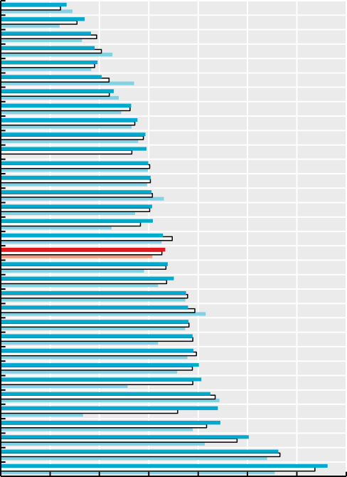

134

170

183

190

196

204

229

264

277

293

295

299

304

306

307

308

329

333

338

351

376

380

380

389

390

402

407

425

440

445

503

562

662

0 100 200 300 400 500 600 700

Defined daily doses per 1 000 people per day

Türkiye Costa Rica

Estonia Lithuania Austria Korea Iceland

Slovak Republic

France Luxembourg

Latvia Italy Croatia Hungary Israel Germany OECD31

Spain Netherlands

Portugal Canada Greece

New Zealand

Australia Sweden Chile Belgium Slovenia Finland

Czech Republic

Norway United Kingdom

Denmark

**Lipid-modifying agents**

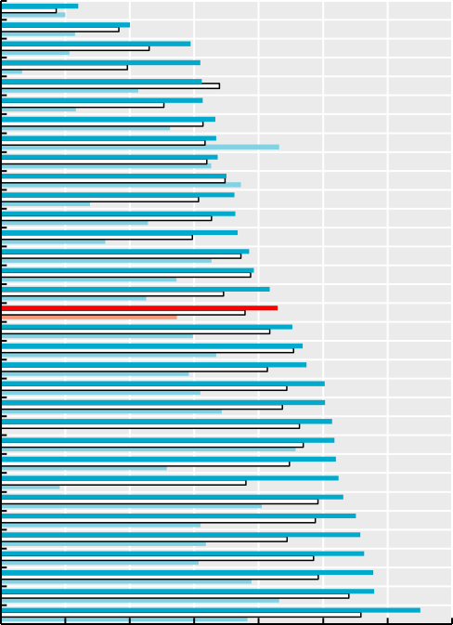

36

60

88

93

94

94

100

100

101

105

109

109

110

116

118

125

129

136

141

142

151

151

154

155

156

157

159

165

167

169

173

174

195

0 30 60 90 120 150 180 210

Defined daily doses per 1 000 people per day

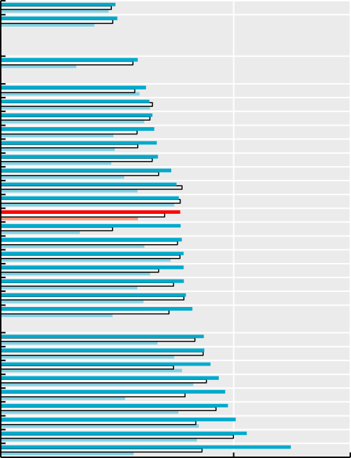Iceland Korea

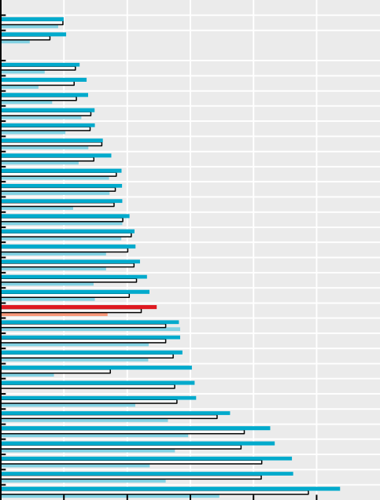

45

53

58

61

64

69

74

91

93

130

|  |  |  |  |  |  |  |  |  |  |  |
| --- | --- | --- | --- | --- | --- | --- | --- | --- | --- | --- |
|  | | **Antidiabetics** |  |  |  |  | **Antidepressants** |  | | |
| Austria  Latvia |  | 49  50  55 |  | Latvia  Hungary | 22 |  | 30  31 |  |  |  |
|  |  |  |  |  |  |  |  |  |  |  |
| New Zealand  Lithuania |  | 55  59 |  | Croatia  Lithuania |  |  | 37  37 |  |  |  |
| Israel |  | 60 |  | Estonia |  |  | 41 |  |  |  |
| Australia Luxembourg  Italy Norway Denmark Estonia  Sweden |  | 62  64  65  66  67  68  73 |  | Costa Rica  Italy Slovak Republic Netherlands  Türkiye Luxembourg  France |  |  | 42  45  49  57 |  |  |  |
| Croatia  Hungary |  | 76  76 |  | Israel  Norway |  |  | 58 |  |  |  |
| OECD31  Chile Belgium  Netherlands |  | 77  77  78  79 |  | Austria Germany Slovenia  Czech Republic |  |  | 64  66 |  |  |  |
| Korea  Portugal |  | 79  79 |  | Greece  OECD31 |  |  | 71 |  |  |  |
| Slovak Republic |  | 80 |  | Denmark |  |  | 85 |  |  |  |
| Costa Rica |  | 82 |  | Finland |  |  | 85 |  |  |  |
| Spain  Slovenia France  United Kingdom |  | 85  87  87  90 |  | Belgium  Chile New Zealand  Spain |  |  | 86  92 |  |  |  |
| Germany Türkiye  Czech Republic |  | 94  96  98 |  | Sweden Australia  Canada |  |  |  | 109 | 128 |  |
| Greece |  | 101 |  | United Kingdom |  |  |  |  | 138 |  |
| Finland |  | 106 |  | Portugal |  |  |  |  | 139 |  |
| Canada |  |  | 125 | Iceland |  |  |  |  |  | 161 |

0 50 100 150

Defined daily doses per 1 000 people per day

0 30 60 90 120 150 180

Defined daily doses per 1 000 people per day

Note: See the “Definition and comparability” box for a breakdown of ATC codes. Data labels correspond to 2021 data. Source: OECD Health Statistics 2023.

*StatLink 2* <https://stat.link/6icvb8>

**Generics and biosimilars**

All OECD countries view generic and biosimilar markets as an opportunity to increase efficiency in pharmaceutical spending, but many do not fully exploit their potential. In 2021, generics accounted for more than three-quarters of the volume of pharmaceuticals sold in Chile, Germany, New Zealand, the United Kingdom, the Netherlands, Canada and Latvia, but less than one-quarter in Switzerland and Luxembourg (Figure 9.7). In value, generics accounted for more than two-thirds of the pharmaceuticals sold in Chile in 2021, but on average only one-quarter across OECD countries. Differences in market structures (notably the number of off-patent medicines) and prescribing practices explain some cross-country differences, but generic uptake also depends on policies (OECD, 2018[1]). In Austria, for example, generic substitution by pharmacists is not permitted, while in Luxembourg, generic substitution by pharmacists is limited to selected medicines. In some countries, such as Ireland, generic penetration is low but originators and generics may be priced at the same level.

Many countries have implemented incentives for physicians, pharmacists and patients to boost generic markets. Over the last decade, France and Hungary, for example, have introduced incentives for general practitioners to prescribe generics through pay-for-performance schemes. In Switzerland, pharmacists receive a fee for generic substitution; in France, pharmacies receive bonuses if their substitution rates are high. In many countries, third-party payers fund a fixed reimbursement amount for a given medicine, allowing the patient a choice of the originator or a generic, but with responsibility for any difference in price (OECD, 2018[1]).

Biologicals are a class of medicines manufactured in, or sourced from, living systems such as microorganisms, or plant or animal cells. Most biologicals are very large, complex molecules or mixtures of molecules. Many are produced using recombinant DNA technology. When such medicines no longer have market exclusivity, “biosimilars” – follow-on versions of these products – can be approved. The market entry of biosimilars creates price competition, thereby improving affordability. However, the extent of biosimilar penetration in a country will depend on the reimbursement status of the biosimilar medicines. For example, in Ireland, only one of the five biosimilars licenced by the European Medicines Agency for epoetin alfa is available on the reimbursement list.

Biosimilar competition has led to both originator and biosimilar manufacturers of erythropoietins (used to treat anaemia) lowering their prices. During 2021-22, biosimilars accounted for 28% of the volume of the “accessible market” (see the “Definition and comparability” box) for erythropoietins, on

these data are based on list prices: they do not take into account any confidential discounts or rebates, which can be substantial (Barrenho and Lopert, 2022[2]).

**Definition and comparability**

A generic medicine is defined as a pharmaceutical product which has the same qualitative and quantitative composition in active substances and the same pharmaceutical form as the reference product, and whose bioequivalence with the reference product has been demonstrated. Generics may be branded (with a specific trade name) or unbranded (identified using the international non-proprietary name and name of the company). Countries are asked to provide data for the whole of their respective markets. However, many countries provide data covering only the community pharmaceutical market or the reimbursed pharmaceutical market (see figure notes). The share of generic market expressed in value can be the turnover of pharmaceutical companies, the amount paid for pharmaceuticals by third-party payers or the amount paid by all payers (third-party and consumers). The share of the generic market by volume can be expressed in DDDs or as a number of packages/boxes or standard units.

A biosimilar medicinal product (a biosimilar) is a product granted regulatory approval by demonstrating sufficient similarity to the reference medicinal product (biological) in terms of quality characteristics, biological activity, safety and efficacy. Biosimilar market shares are measured with respect to the “accessible market”, which is the market comprising originator products that no longer have market exclusivity, and their biosimilars. The accessible market for biosimilars is highly dynamic owing to the progressive loss of exclusivity of biological medicines over time. Market share is computed as the number of biosimilar treatment days as a share of the accessible market treatment days. Changes in price are measured with respect to the “total market”, which encompasses all products with the same ATC code, and is computed as the difference in price per treatment day in 2022 (June Moving annual total (MAT)) versus the year before biosimilar entry.) The TNF inhibitor accessible market includes adalimumab, infliximab and etanercept. The erythropoietin accessible market includes darbepoetin alfa, and epoetin alfa, beta, delta, theta and zeta.

**References**

average across 21 OECD countries with comparable data. These biosimilars accounted for more than 70% of the market in Greece and Italy (Figure 9.8). In all analysed countries except Belgium, list prices for the total market of erythropoietins have fallen, with an average decrease of 42% since biosimilar entry.

For tumour necrosis factor (TNF) inhibitors also known as anti- TNF alfas (used to treat a range of autoimmune and immune-mediated disorders), biosimilars represented over 90% of the accessible market in Denmark and Poland, but less than 40% in the Slovak Republic and Switzerland in 2021-22 (Figure 9.8). Price reductions since biosimilar entry have been similar to those for erythropoietins. However, for both medicine classes, actual price reductions are greater than those appearing in the figures shown here. This is because

Barrenho, E. and R. Lopert (2022), “Exploring the consequences of greater price transparency on the dynamics of pharmaceutical markets”*, OECD Health Working Papers*, No. 146, OECD Publishing, Paris, https://doi.org/10.1787/c9250e17-en.

OECD (2018), “Strategies to reduce wasteful spending: Turning the lens to hospitals and pharmaceuticals”, in *Health at a Glance: Europe 2018: State of Health in the EU Cycle*, OECD Publishing, Paris, https://doi.org/10.1787/health_glance_eur-2018-5- en.

[2]

[1]

**Figure 9.7. Share of generics in the total pharmaceutical market, 2021**

Value Volume

% 90

60

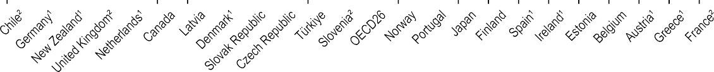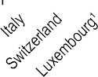

90

83 83

80

79 78 77

65

67

64 63

54

58

46

55 54 53

50 50

49

46

44

29

35

38

36 36

25

22

29

31

18

22

21

25

28 31

29

27

17

22

19

20

22

18

17

13 13

19 23

9

18

5

30

0

1. Reimbursed pharmaceutical market, i.e. the sub-market in which a third-party payer reimburses medicines. 2. Community pharmacy market. Source: OECD Health Statistics 2023.

*StatLink 2* <https://stat.link/w74906>

**Figure 9.8. Biosimilar market share in treatment days for erythropoietins and tumour necrosis factor inhibitors, 2021-22**

**Erythropoietins**

Share of biosimilars in accessible market Price change / year of biosimilar entry in total market

100 %

80

|  |  |  |  |  |  |  |  |  |  |  |  |  |  |  |  |  |  |  |  |  |  |  |  |  |  |  |  |  |  |  |  |  |  |  |  |  |  |  |  |  |  |  |  |  |  |  |  |  |  |  |  |  |  |  |  |  |  |
| --- | --- | --- | --- | --- | --- | --- | --- | --- | --- | --- | --- | --- | --- | --- | --- | --- | --- | --- | --- | --- | --- | --- | --- | --- | --- | --- | --- | --- | --- | --- | --- | --- | --- | --- | --- | --- | --- | --- | --- | --- | --- | --- | --- | --- | --- | --- | --- | --- | --- | --- | --- | --- | --- | --- | --- | --- | --- |
|  | | |  | | |  |  |  |  | | |  | | |  | | |  | | |  | | |  | | |  |  | | |  |  | | |  | | |  | | |  | | |  | | |  |  | | |  | | |  |  |  |  |
|  | | |  | | |  |  |  | | |  | | |  | | |  | | |  | | |  | | |  |  | | |  |  | | |  | | |  | | |  | | |  | | |  |  | | |  |  |  |  |  |  |  |
|  | | |  |  |  |  |  |  |  |  |  |  |  |  |  |  |  | | |  | | |  | | |  |  | | |  |  | | |  | | |  | | |  | | |  | | |  |  |  |  |  |  |  |  |  |  |
|  |  |  |  |  |  |  |  |  |  |  |  |  |  | | |  |  |  |  |  |  | 1.4 |  | | | 1.5 |  |  |  |  | | |  |  |  |  | | |  | | | 0.7 |  |  |  |  | 0.0 | 2.9 | 6.3 | 2.2 |
|  |  |  |  |  |  |  |  |  |  |  |  |  |  |  |  |  |  |  |  |  |  |  |  |  |  |  |  |  |  |  |  |  |  |  |  |  |  |  |  |  |  |  |  |  |  |  |
|  | | |  | | |  | | |  | | |  | | |  | | |  | | |  | | |  | | |  |  | | |  |  | | |  | | |  | | |  | | |  | | |  |  | | |  | | |  |  |  |  |
|  | | |  | | |  | | |  | | |  | | |  | | |  | | |  | | |  | | |  |  | | |  |  | | |  | | |  | | |  | | |  | | |  |  | | |  | | |  |  |  |  |
|  | | |  | | |  | | |  | | |  | | |  | | |  | | |  | | |  | | |  |  | | |  |  | | |  | | |  | | |  | | |  | | |  |  | | |  | | |  |  |  |  |
|  | | |  | | |  | | |  | | |  | | |  | | |  | | |  | | |  | | |  |  | | |  |  | | |  | | |  | | |  | | |  | | |  |  | | |  | | |  |  |  |  |

60

40

20

0

-20

-40

-60 

-80

 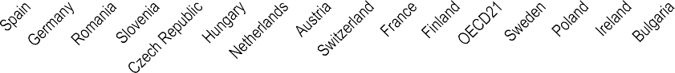 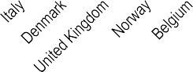

**Tumor necrosis factor inhibitors**

Share of biosimilars in accessible market Price change / year of biosimilar entry in total market

% 100

80

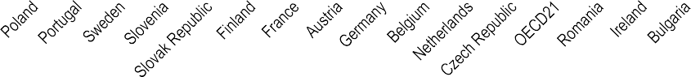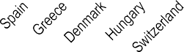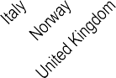

60

40

20

0

-20

-40

-60

-80

-100

Note: See “Definition and comparability” box for an explanation of “accessible” and “total” market. Data for Greece reflect only retail panel data. Source: IQVIA MIDAS® MAT June 2022.

*StatLink 2* <https://stat.link/bamdtz>

**Pharmaceutical research and development**

Pharmaceutical research and development (R&D) is funded via a mix of private and public sources. Governments typically fund basic and early-stage research through budget allocations, research grants and public ownership of research and higher education institutions. The pharmaceutical industry funds R&D across all phases and most pre-registration clinical trials, but mostly contributes to translating and applying knowledge to develop products, with some support from R&D subsidies or tax credits. In 2021, governments in 35 OECD countries for which data are available, collectively budgeted USD 69 billion for health-related R&D. While this figure goes beyond pharmaceuticals, it understates total government support, as it excludes most tax incentives and funding for higher education and publicly owned enterprises. About two-thirds of this was spent in the United States (USD 45 billion), which also spent the most as a share of gross domestic product (GDP) (Figure 9.9). Since 2010, government-allocated budgets for health-related R&D have increased by 45%.

The pharmaceutical industry spent USD 129 billion on R&D in 2021, with the majority again spent in the United States. Business-based pharmaceutical R&D expenditure (BERD) has increased by 39% in real terms since 2010. Most of this growth occurs in OECD countries, specifically driven by the United States (69% of the OECD total). However, the non- OECD share is increasing. Notably, R&D expenditure in partner country the People’s Republic of China increased from USD 4.9 billion (in constant 2015 PPPs) to USD 14.2 billion in 2019 (189%) – a higher growth rate than any OECD country (OECD, 2021[1]).

The pharmaceutical industry is more R&D intensive than other, similar industries. Among OECD countries, it spends over 30% of its gross value added on R&D – more than the electronics and optical industry (23.5%), air and spacecraft industry (14.7%) and manufacturing as a whole (8.4%) (Figure 9.10). This is a notable increase, as R&D intensity of the pharmaceutical industry was only 13.3% in 2018: below that of the electronics and optical industry (16%) and near the air and spacecraft industry (13.1%).

Actual R&D activity can be observed through the number of products or medicines in development by therapeutic class and indication of treatment. Between 2011 and 2020, the total number of product-indication combinations that were in active development worldwide nearly doubled, to reach 28 643

changed dramatically since 2011. Cancer has accounted for the largest share of product indications in development in every year since 2011, and has increased steadily – from 27% of all product-indication pairs in 2011 to 38% in 2020.

**Definition and comparability**

Government budget allocations for R&D (GBARD) capture R&D performed directly by the government and amounts paid to other institutions for R&D. Health-related R&D refers to GBARD aimed at protecting, promoting and restoring human health, including all aspects of medical and social care, but excluding spending by public corporations or general university funding subsequently allocated to health.

Direct subsidies to the pharmaceutical industry for R&D consist of funding from non-industry entities such as governments and their agencies, higher education institutions, and private non-profit entities, such as philanthropic organisations.

Business enterprise expenditure on R&D (BERD) covers R&D by corporations regardless of the source of funding. BERD is recorded in the country where the R&D activity takes place. National statistical agencies collect data primarily through surveys and according to the OECD Frascati Manual, but there is some variation in national practices. Pharmaceutical R&D refers to BERD by businesses classified in the pharmaceutical industry.

The gross value added of a sector equals gross output less intermediate consumption. It includes wage costs, consumption of fixed capital and taxes on production. The OECD averages in Figure 9.10 show unweighted means of R&D intensity, based on 17 countries with data available for air and spacecraft; and on 31-34 countries for all other industries.

Figure 9.11 includes the number of product-indication pairs in active development identified in the proprietary AdisInsight database curated by Springer Nature, which tracks commercial product development projects from discovery to market launch worldwide based on publicly available information.

**References**

(Figure 9.11), although this was driven in part by products with multiple indications. In any given year, the majority of active development projects are pre-existing projects that remain in active development. However, the number of new projects that enter active pre-clinical or clinical development has also increased – from 2077 in 2012 to 8 227 in 2020. In terms of disease focus, product development priorities have not

OECD (2021), *Analytical Business Enterprise R&D (ANBERD) and Main Science and Technology Indicators (MSTI) Databases*, https://stats.oecd.org/.

[1]

**Figure 9.9. Business enterprise expenditure on pharmaceutical R&D and government budgets for health-related R&D, 2021 or latest year available**

USD billion

|  |  |  |  |  |  |  |  |  |  |
| --- | --- | --- | --- | --- | --- | --- | --- | --- | --- |
|  |  |  |  | | |  | | |  |
|  |  |  |  | | |  | | |  |
|  |  |  | | |  | | |  |
|  |  |  | | |  | | |  |
|  |  |  | | |  | | |  |
|  |  |  | | |  | | |  |
|  |  | 21.2 | | |  | | |  |
|  |  |  | | | 12.7 | | |  |
|  | 0.1 |  |  | 1.8 |  |  | 0.0 | 2.8 0.0 |
|  |  |  |  |  |  |  |  |

Business R&D expenditure, pharma

% of GDP

Direct government R&D budgets, health

100

90

80

70

60

50

40

30

20

10

0

92.2

United States Europe Japan Other OECD

0.45

0.40

0.35

0.30

0.25

0.20

0.15

0.10

0.05

0.00

|  |  |  |  |  |  |  |  |  |  |  |  |  |  |  |  |
| --- | --- | --- | --- | --- | --- | --- | --- | --- | --- | --- | --- | --- | --- | --- | --- |
| 0.40 | | | |  | | | |  | | | |  | | | |
|  |  |  | |  | | | |  | | | |  | | | |
|  |  | |  | | | | 0.25 | | | |  | | | |
|  |  | |  | | | |  | | | |  | | | |
|  | 0.19 | | 0.15 | | | |  |  |  | |  | | | |
|  |  |  |  | | | |  |  | |  | | | |
|  |  |  |  | 0.07 | |  | 0.09 | | 0.06 | | | |
|  |  |  |  |  |  |  |  | 0.04 | | | |
|  |  |  |  |  |  |  |  |  |  |  |

United States Europe Japan Other OECD

Note: Europe includes 21 EU Member States that are also OECD countries. Source: OECD R&D Statistics.

*StatLink 2* <https://stat.link/mplt94>

**Figure 9.10. R&D intensity by industry: Business enterprise expenditure on R&D as a share of gross value added, 2019 (or nearest year)**

% BERD/GVA 50

|  |  |  |  |  |  |  |  |  |
| --- | --- | --- | --- | --- | --- | --- | --- | --- |
| United | States 49.0 |  |  |  |  |  |  |  |
| Jap | an 42.9 |  |  |  |  |  |  |  |
| **OECD Aggr**  **30.1** | **egate** |  |  |  |  |  |  |  |
|  | 23.5 |  |  |  |  |  |  |  |
|  |  | 14. | 7  8.4 |  |  |  |  |  |
|  |  |  |  | 0.6 | 0.9 | 0.4 | 0.3 | 0.2 |



40

30

20

10

0

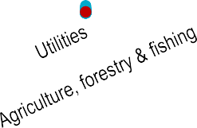

 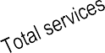

Source: OECD Analytical Business Enterprise R&D (ANBERD), Structural Analysis (STAN) and System of National Accounts (SNA) databases.

*StatLink 2* <https://stat.link/wpmaf0>

**Figure 9.11. Top health categories for product-indication pairs in active development, 2011-20**

Oncology Infectious diseases Neurology EMBID Musculoskeleteal disorders Others

Number of product-indication pairs 30 000

25 000

20 000

15 000

10 000

5 000

0

2011 2012 2013 2014 2015 2016 2017 2018 2019 2020

Note: Oncology includes malignant neoplasms; EMBID includes endocrine, metabolic, blood and immune disorders; infectious diseases also include parasitic diseases; musculoskeletal disorders include musculoskeletal and connective tissue disorders.

Source: AdisInsight.

*StatLink 2* <https://stat.link/czml93>

**208** 

1. **Ageing and long-term care**

## Demographic trends

Life expectancy and healthy life expectancy at age 65 Self-rated health and disability at age 65 and over Dementia

Safe long-term care Access to long-term care Informal carers

Long-term care workers Long-term care settings

Long-term care spending and unit costs End-of-life care

In recent decades, the share of the population aged 65 and over has doubled on average across OECD countries, increasing from less than 9% in 1960 to 18% in 2021. Declining fertility rates and longer life expectancy (see section on “Life expectancy at birth” in Chapter 3) have meant that older people make up an increasing proportion of the population in OECD countries. Across the 38 OECD member countries, more than 242 million people were aged 65 and over in 2021, including more than 64 million who were at least 80 years old. These demographic developments highlight the importance of ensuring that health systems are equipped to meet the changing needs of an older population.

Across OECD member countries on average, the share of the population aged 65 and over is projected to continue increasing in the coming decades, rising from 18% in 2021 to 27% by 2050 (Figure 10.1). In five countries (Korea, Japan, Italy, Greece and Portugal), the share of the population aged 65 and over will exceed one-third by 2050. At the other end of the spectrum, the population aged 65 and over in Israel, Mexico, Australia and Colombia will represent less than one-fifth of the population in 2050, owing to higher fertility and migration rates.

While the rise in the share of the population aged 65 and over has been striking across OECD countries, the increase has been particularly rapid among the oldest group – people aged 80 and over. Between 2021 and 2050, the share of the population aged 80 and over is predicted to double on average across OECD member countries, from 4.8% to 9.8%. At least one in ten people may be 80 and over in nearly half (18) of these countries by 2050, while in five countries (Korea, Japan, Italy, Greece and Portugal), more than one in eight people may be 80 and over.

While most OECD partner countries have a younger age structure than many member countries, population ageing will nonetheless occur rapidly in the coming years, and sometimes at a faster pace than among member countries. In China, the share of the population aged 65 and over will increase much more rapidly than in OECD member countries – more than doubling from 12.6% in 2021 to 30.1% in 2050. The share of the Chinese population aged 80 and over will rise even more quickly, increasing more than four-fold from 2.3% in 2021 to 10.3% in 2050. Partner country Brazil – whose share of the

Because of longer life expectancy than men, women tend to predominate among the older age cohorts. On average across OECD countries, women represented 56% of the population aged 65 and over in 2021, a slight decrease from 59% in 2000 (Figure 10.2). In Latvia, Lithuania and Estonia, women made up more than 65% of the population aged 65 and over in 2021, while at the other end of the spectrum, they made up just 52% of the population aged 65 and over in Iceland.

One of the major implications of rapid population ageing is the decline in the potential supply of labour in the economy, despite recent efforts by countries to extend working lives. Moreover, in spite of the gains in healthy life expectancy seen in recent years (see section on “Life expectancy and healthy life expectancy at age 65”), health systems will need to adapt to meet the needs of an ageing population, which are likely to include greater demand for labour-intensive long-term care (LTC) and a greater need of integrated, person-centred care. Between 2015 and 2030, the number of older people in need of care around the world is projected to increase by 100 million (ILO/OECD, 2019[1]). Countries such as the United States are already facing shortages of LTC workers, and in the coming years more will find themselves under pressure to recruit and retain skilled LTC staff (see section on “Long-term care workers”). More recently, the COVID-19 crisis has put the spotlight on the workforce shortcomings of the LTC sector. While the total number of LTC workers has increased in a number of countries, it has not kept pace with population ageing. As a result, the supply of LTC workers per 100 elderly people (aged 65 and over) has stagnated in most countries since 2011 (OECD, 2020[2]).

**Definition and comparability**

Data on the population structure have been extracted from the OECD Historical Population Data and Projections (1950-2060) Database. The projections are based on the most recent “medium-variant” population projections from the United Nations World Population Prospects – 2019 Revision.

**References**

population aged 65 and over was only around half the OECD average in 2021 – will see similarly rapid growth, with nearly 22% of the population projected to be aged 65 and over by 2050. The speed of population ageing has varied markedly across OECD countries, with Japan in particular experiencing rapid ageing over the past three decades. In the coming years, Korea is projected to undergo the most rapid population ageing among OECD member countries, with the share of the population aged 80 and over nearly quintupling – from below the OECD average in 2021 (3.9% versus 4.8%) to well above it (16.5% versus 9.8%) by 2050. Among OECD partner countries, the speed of ageing has been slower than among member countries, although rapid ageing in large countries including Brazil and China will accelerate in the coming decades.

ILO/OECD (2019), “New job opportunities in an ageing society”, OECD, Paris, <http://www.oecd.org/g20/summits/osaka/ILO-OECD-> G20-Paper-1-3-New-job-opportunities-in-an-ageing- society.pdf.

OECD (2020), *Who Cares? Attracting and Retaining Care Workers for the Elderly*, OECD Health Policy Studies, OECD Publishing, Paris, https://doi.org/10.1787/92c0ef68-en.

[1]

[2]

**Figure 10.1. Share of the population aged 65 and over and 80 and over, 2021 and 2050**



2021 2050

Korea Japan Italy Greece Portugal Lithuania Latvia Bulgaria Spain Slovenia Romania Poland Croatia China

Slovak Republic

Estonia Finland

Czech Republic

Germany Hungary Austria France OECD38

Norway Luxembourg Switzerland Belgium

United Kingdom

Chile Netherlands

Ireland Denmark Sweden Canada

New Zealand United States

Iceland Brazil Costa Rica Türkiye Colombia Australia Argentina Mexico Indonesia

Israel India

South Africa

**Population aged 65 years and over**

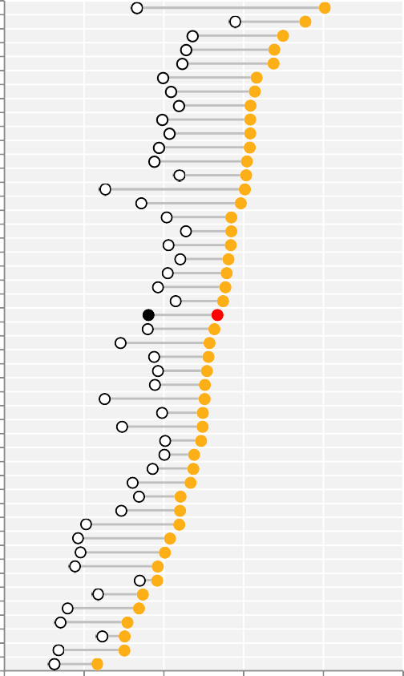

16.6

28.9

23.6

22.8

22.3

19.9

20.9

21.9

19.8

20.7

19.4

18.8

21.9

12.6

17.1

20.3

22.7

20.5

22.0

20.4

19.2

21.4

18.0

14.5

12.5

14.7

17.9

18.7

19.2

18.8

19.7

20.1

20.0

18.5

16.0

16.8

14.6

10.2

9.2

9.5

8.8

16.9

11.7

7.9

7.0

12.2

6.7

6.2

0 10 20 30 40 50

**%**

Korea Japan Italy Greece Portugal Lithuania Germany Finland Latvia Slovenia Spain Austria France Croatia

Switzerland

Norway China Netherlands Romania Belgium Estonia OECD38

Denmark Poland Bulgaria

United Kingdom

Canada Sweden

Slovak Republic

Chile Luxembourg New Zealand Czech Republic

Hungary United States

Ireland Iceland Australia Brazil Costa Rica Colombia Türkiye Israel Argentina Mexico India Indonesia

South Africa

**Population aged 80 years and over**

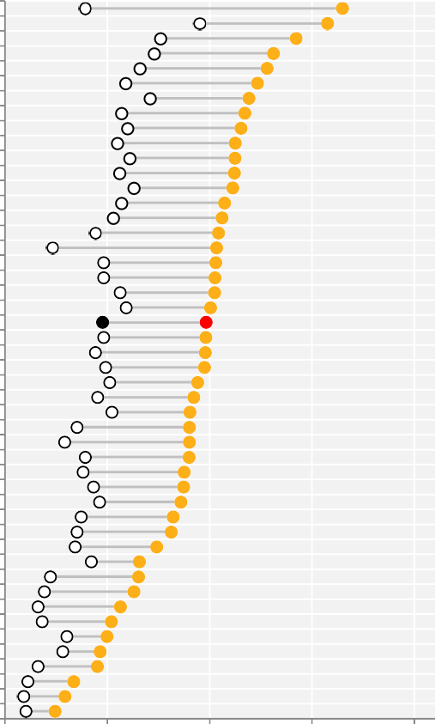

3.9

9.5

7.6

7.3

6.6

5.9

7.1

5.7

6.0

5.5

6.1

5.6

6.3

5.7

5.3

4.4

2.3

4.8

4.8

5.6

5.9

4.8

4.8

4.4

4.9

5.1

4.5

5.2

3.5

2.9

3.9

3.8

4.3

4.6

3.7

3.5

3.4

4.2

2.2

1.9

1.6

1.8

3.0

2.8

1.6

1.1

0.9

1.0

0 5 10 15 20 **%**

Sources: OECD Health Statistics 2023, OECD Historical Population Data and Projections (1950-2060) database.

*StatLink 2* <https://stat.link/ctk9vs>

**Figure 10.2. Women as a share of the population aged 65 and over, 2000 and 2021**

% 80

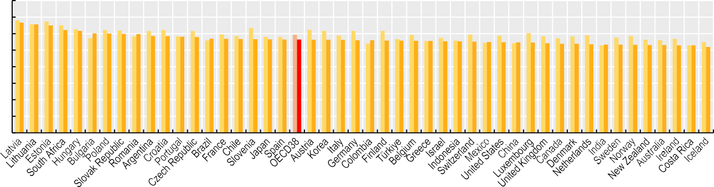

70

60

50

40

30

20

10

0

62

58 58

57 57

52

53

53

53

53

53

53

53

54

54

54

54

55

55

55

55

55

55

55

56

56

56

56

56

56

56

56

56

56

56

57

57

57

58

59

60

60

60

60

62

65

66

67



2000 2021

Source: OECD Historical Population Data and Projections (1950-2060) Database, 2023.

*StatLink 2* <https://stat.link/nsfcul>

**Life expectancy and healthy life expectancy at age 65**

All OECD countries have experienced tremendous gains in life expectancy at age 65 for both men and women in recent decades, although these gains have been diminished by the impact of COVID-19. On average across OECD countries, life expectancy at age 65 increased by 6 years between 1970 and 2021, and by 2.1 years between 2000 and 2021. Five countries (Korea, Ireland, Chile, Australia and Portugal) enjoyed gains of a least 3 years between 2000 and 2021; five countries (United States, Poland, Latvia, Hungary and the Slovak Republic) experienced an increase of less than 1 year over the period, and one country (Mexico) experienced a slight decrease of 0.3 years (Figure 10.3). In Lithuania, life expectancy at age 65 remained unchanged between 2000 and 2021.

On average across OECD countries in 2021, people at age 65 could expect to live a further 19.5 years. Life expectancy at age 65 is around 3.3 years higher for women than for men. This gender gap has not changed substantially since 2000, when life expectancy at age 65 was 3.5 years higher for women than men. Among OECD countries, life expectancy at age 65 in 2021 was highest for women in Spain (23.5 years) and for men in Iceland (20.5 years). It was lowest for women in the Slovak Republic (17.1 years) and for men in Latvia (12.7 years) (Figure 10.4).

While almost all OECD countries experienced gains in life expectancy at age 65 between 2000 and 2021, not all additional years are lived in good health. The number of healthy life-years at age 65 varies substantially across OECD countries (Figure 10.4). In the European Union (EU), an indicator of disability-free life expectancy known as “healthy life-years” is calculated regularly, based on a general question about disability in the EU Statistics on Income and Living Conditions (EU-SILC) survey. On average across OECD countries participating in the survey, the number of healthy life-years at age 65 was 10 years for women and 9.6 for men in 2021 – a noticeably smaller difference between men and women than that for general life expectancy at age 65. Healthy life expectancy at age 65 was close to or above 14 years for both men and women in Norway and Sweden; for men, this was nearly 2 years above the next-best performing countries (Iceland and Ireland). Healthy life expectancy at 65 was around 5 years or less for both men and women in the Slovak Republic and Latvia. In these countries, women spend nearly three-quarters of their additional

countries (the Slovak Republic, Poland, Latvia, Lithuania, the Czech Republic, Estonia, Hungary, Greece and the United States), while it increased slightly in eight countries (Japan, Mexico, New Zealand, Costa Rica, Iceland, Korea, Australia and Chile). As population ageing continues, OECD countries will need to anticipate health challenges that can disproportionately affect older people, and make structural changes to strengthen resilience.

**Definition and comparability**

Life expectancy measures how long on average a person of a given age can expect to live if current death rates do not change. However, the actual age-specific death rate of any particular birth cohort cannot be known in advance. If rates are falling, as has been the case over recent decades in OECD countries, actual life spans will be higher than life expectancy calculated using current death rates. The methodology used to calculate life expectancy can vary slightly between countries. This can change a country’s estimates by a fraction of a year. Data for life expectancy at age 65 come from Eurostat for EU countries. For non-EU OECD countries the data come from OECD Health Statistics 2023, where the OECD Secretariat calculates life expectancy at age 65 for all OECD countries, using an unweighted average of life expectancy of men and women.

Disability-free life expectancy (or “healthy life-years”) is defined as the number of years spent free of activity limitation. In Europe, this indicator is calculated annually by Eurostat for EU countries and some European Free Trade Association countries. The disability measure is based on the global activity limitation indicator (GALI) question in the EU-SILC survey: “For at least the past six months, have you been hampered because of a health problem in activities people usually do? Yes, strongly limited / yes, limited / no, not limited”. While healthy life-years is the most comparable indicator to date, there are still problems with translation of the GALI question, although it does appear to reflect other health and disability measures satisfactorily (Jagger et al., 2010[2]).

**References**

life-years in poor health, compared to one-third or less in Norway and Sweden.

The COVID-19 pandemic had a significant effect on life expectancy, especially among older populations, who are at a higher risk of developing severe symptoms and dying because of underlying health conditions and frailty. More than 90% of all cumulative COVID-19 deaths were among people aged 60 and over, and more than 50% were among those aged 80 and over on average across 22 OECD countries by April 2022 (OECD, 2023[1]). Between 2019 and 2021, life expectancy at age 65 declined in all 26 OECD countries with available data, falling by an average of 6 months. Life expectancy at age 65 declined by more than 1 year in nine

Jagger, C. et al. (2010), “The Global Activity Limitation Index measured function and disability similarly across European countries”, *Journal of Clinical Epidemiology*, Vol. 63/8, pp. 892-899, https://doi.org/10.1016/j.jclinepi.2009.11.002.

OECD (2023), *Ready for the Next Crisis? Investing in Health System Resilience*, OECD Health Policy Studies, OECD Publishing, Paris, https://doi.org/10.1787/1e53cf80-en.

[2]

[1]

**Figure 10.3. Life expectancy at age 65, 2000, 2019 and 2021 (or nearest year)**

2000 2019 2021

Years 25

20

15

22.3

21.7

21.6

21.5

21.4

21.4

21.2

20.9

20.9

20.9

20.8

20.8

20.7

20.6

20.6

20.5

20.5

20.4

20.4

20.3

20.2

19.6

19.6

19.6

19.5

19.5

19.3

19.3

19.2

18.7

18.4

17.7

17.5

16.7

16.4

16.3

16.1

15.6

15.5

15.4

14.6

13.6

10

5

0

Sources: Eurostat Database and OECD Health Statistics 2023.



*StatLink 2* <https://stat.link/bdo90r>

**Figure 10.4. Life expectancy and healthy life-years at age 65, by sex, 2021 (or nearest year)**

Healthy life years

Life expectancy with activity limitation

**Women Men**

Spain France Switzerland Luxembourg Belgium Italy

23.5 56%

23.3 46%

23.0 53%

22.2 50%

22.1 49%

22.1 52%

22.1 48%

22.1 33%

22.0 66%

21.9 46%

21.8 40%

21.8 32%

21.2 46%

21.1 46%

21.1 54%

21.1 50%

20.9 51%

20.8 52%

20.8 53%

20.7 63%

19.6 61%

18.6 56%

18.4 52%

18.2 64%

18.1 71%

17.6 72%

17.3 55%

17.1 70%

16.4 76%

15.5 42%

44% 19.2

41% 19.2

42% 20.1

44% 19.0

41% 18.5

43% 18.9

45% 18.6

26% 19.6

54% 18.3

36% 20.5

36% 19.2

22% 19.8

42% 17.2

43% 17.8

48% 18.0

46% 18.9

48% 18.3

46% 17.4

49% 18.2

57% 17.6

57% 14.5

52% 14.5

45% 14.0

61% 13.2

65% 14.4

65% 12.7

46% 13.2

64% 13.3

68% 12.5

34% 11.6

Finland Sweden Portugal Iceland Ireland Norway Slovenia Germany Austria

United Kingdom Denmark OECD26

Netherlands Greece Estonia

Czech Republic Poland Lithuania Croatia Latvia Hungary

Slovak Republic Romania Bulgaria

|  |  |  |  |  |  |  |  |
| --- | --- | --- | --- | --- | --- | --- | --- |
| 30 | 20 | 10 | 0 | 0 | 10 | 20 | 30 |
| Years |  |  |  |  |  |  | Years |

Note: Data comparability is limited because of cultural factors and different formulations of the GALI question in the EU-SILC survey. 1. Data for Iceland and the United Kingdom refer to 2018 2. Data for Norway refer to 2020.

Source: Eurostat Database.

*StatLink 2* <https://stat.link/eqso85>

**Self-rated health and disability at age 65 and over**

Even as life expectancy at age 65 has increased across OECD countries, not all older adults spend their remaining years in good health (see section on “Life expectancy and healthy life expectancy at age 65”). In 2021, less than half the population aged 65 and over in 36 OECD countries reported being in good or very good health (Figure 10.5). Excluding countries whose data are not directly comparable (see the “Definition and comparability” box), more than three-fifths of older respondents reported being in good or very good health in only five countries (Costa Rica, Ireland, Norway, Sweden and Switzerland). On average, fewer than half of older adults (45.9%) reported being in good or very good health across 36 OECD countries. Fewer than 30% of older adults reported being in good health in 11 OECD countries, including six – Croatia, Estonia, Korea, Latvia, Lithuania and Portugal – in which fewer than 25% reported being in good or very good health. Men are slightly more likely to report being in good health than women: 48% of men reported their health to be good or very good on average across OECD countries in 2021, compared to 45% of women. Excluding New Zealand, Canada and the United States (whose results are biased upward, see Definition and Comparability box), the highest rates of good health were reported in Switzerland for both men (72%) and women (67%).

In all OECD countries with available data, older people in the lowest income quintile are more likely to rate their health as poor than those in the highest quintile (Figure 10.6). Across 27 OECD countries on average, one in four (24.4%) people in the lowest income quintile reported their health to be poor or very poor in 2021, compared to one in nine (10.9%) among those in the highest income quintile. In eight countries, people in the lowest income quintile were at least two and a half times as likely as those in the highest quintile to report having poor or very poor health, while in five countries – Iceland, Ireland, the Netherlands, Norway and Switzerland – people in the poorest quintile were more than three times as likely to report living in poor health. In eight countries (Finland, Greece, Italy, Latvia, Luxembourg, Poland, the Slovak Republic and Slovenia), older adults in the poorest income quintile were less than twice as likely to report being in poor health.

Across 27 European OECD countries in 2021, around half (48%) of people aged 65 and over reported having at least some limitations in their daily activities: 33% reported some limitations and a further 16% reported severe limitations (Figure 10.7). Many of the countries reporting the lowest rates of self-rated good health also reported some of the highest rates of limitations in daily activities. In Latvia, 70% of adults aged 65 and over reported at least some limitations to activities of daily living, while in Estonia, Lithuania and Portugal, at least 60% of adults aged 65 and over reported at least some

limitations. In eight countries – Estonia, Greece, Iceland, Germany, Portugal, the Slovak Republic, Türkiye and the United Kingdom, at least 20% of adults aged 65 and over reported experiencing severe limitations in their daily life.

**Definition and comparability**

Self-reported health reflects people’s overall perception of their own health, including both physical and psychological dimensions. Typically, survey respondents are asked a question such as: “How is your health in general? Very good

/ good / fair / poor / very poor”. OECD Health Statistics provide figures related to the proportion of people rating their health to be good or very good combined.

Data comparability is limited, and caution is required in making cross-country comparisons of perceived health status for at least two reasons. People’s rating of their health is subjective and can be affected by cultural factors. There are also variations in the categories used to measure perceived health across surveys/countries. In particular, the response scale used in Australia, Canada, New Zealand and the United States is asymmetrical (skewed on the positive side), including response categories: “Excellent / very good / good / fair / poor”. By contrast, in most other OECD countries, the response scale is symmetrical, with response categories “Very good / good / fair / poor / very poor”. The data reported from these countries refer to two, rather than three, positive categories. This difference in response categories may introduce an upward bias in the results from those countries that use an asymmetrical scale.

Perceived health status by income quintile is based on Eurostat data with response categories “Very good / good / fair / poor / very poor”. Data for income-based inequalities in perceived health status looked at the difference in the proportion of adults 65 and over reporting their health to be poor or very poor, and did not include individuals who perceived their health status to be fair.

The category of limitations in daily activities is measured by the GALI question in the EU-SILC survey: “For at least the past six months, have you been hampered because of a health problem in activities people usually do? Yes, strongly limited / yes, limited / no, not limited”. People in institutions are not surveyed, resulting in an underestimation of disability prevalence. Again, the measure is subjective, and cultural factors and different formulations of the question may affect survey responses.



Total Female Male

% reporting to be in good or very good health

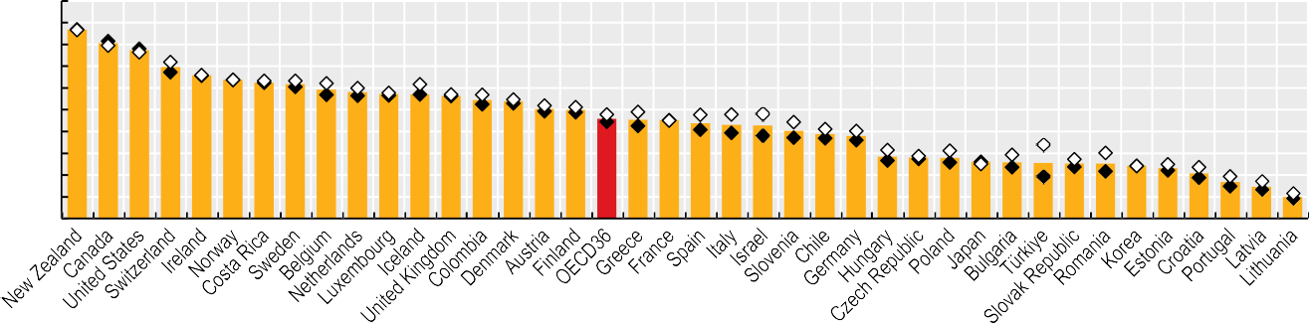

100

90

80

70

60

50

40

30

20

10

0

87

81

77

70

66

64

63

62

59

58

57

57

56

55

54

50

50

46

45

45

44

43

43

40

39

38

29

28

28

26

26

26

25

25

24

23

21

17

15

10

Note: Data for New Zealand, Canada and the United States are biased upwards relative to other countries, and so are not directly comparable. Source: OECD Health Statistics 2023.

*StatLink 2* <https://stat.link/6lrx5d>

**Figure 10.6. Adults aged 65 and over rating their own health as poor or very poor, by income, 2021 (or nearest year)**



Total Lowest quintile Highest quintile

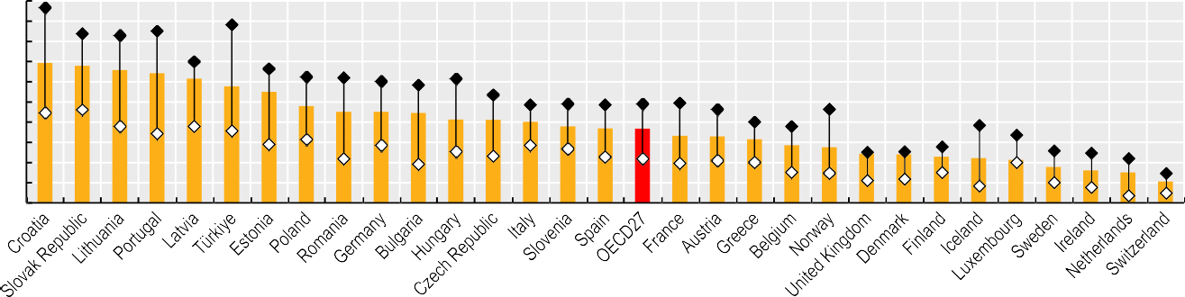

50 % reporting to be in poor or very poor health 45

40

35

30

25

20

15

10

5

0

Source: Eurostat Database.

*StatLink 2* <https://stat.link/jvdw2e>

**Figure 10.7. Limitations in daily activities in adults aged 65 and over, 2021 (or nearest year)**



Severe limitations Some limitations

% 80

7

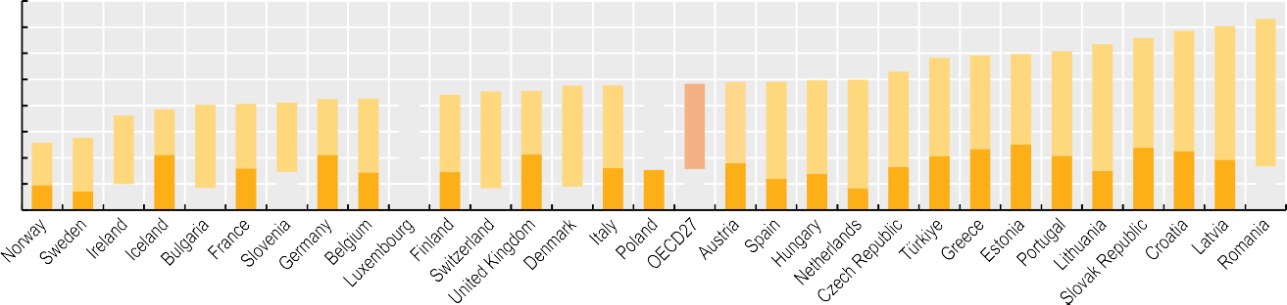

0

0

0

0

0

0

0

0

6

5

15 33

35

42

46

51

56

4

21

10 34

24

32

33

31

36

37

38

36

40

49

3

26

17

32

25

27

28

30

37

39

37

42

2

10 16

7 21

15

16

23

25

24

17

1

10

21

9

16

21

14

15

8

21

9

16

18

12

14

8

16

21

21

15

23

19

Source: Eurostat Database.

*StatLink 2* <https://stat.link/unmpq3>

**Dementia**

One of the greatest challenges of population ageing across the world, dementia describes a variety of brain disorders, including Alzheimer’s disease, which progressively lead to brain cells and cause a gradual deterioration of a person’s functional capacity and social relations. Years of research and billions of dollars invested in dementia-related disorders have only recently begun to pay off, with the first treatment for Alzheimer’s disease in decades approved in the United States in July 2023. Even with these promising medical advances, there is no cure, and even disease-modifying treatments are only likely to slow the progression of the condition, with the possibility of concerning side-effects.

More than 21 million people in OECD countries were estimated to have dementia in 2021. If current trends continue, this number could rise by almost 50% by 2040, to nearly 32 million people across OECD countries. Age remains the greatest risk factor for dementia; as countries age, the number of people living with dementia will also increase – particularly as the proportion of the population aged over 80 rises. Already, OECD countries with some of the oldest populations – including Japan, Italy and Germany – also have the highest prevalence of dementia. Across OECD countries on average, 15 people per 1 000 population were estimated to have dementia in 2021 (Figure 10.8). In nine OECD countries, more than 18 people per 1 000 population are living with a dementia disorder. Without further prevention and medical advancements, by 2040, 12 OECD member countries (the Czech Republic, Estonia, Finland, Hungary, Italy, Japan, Latvia, Lithuania, Poland, Portugal, the Slovak Republic and Slovenia) will have a dementia prevalence of at least 25 people per 1 000 population, while in three countries (Japan, Latvia, Slovenia), more than 30 people per 1 000 will be living with the condition.

Even though treatment is not available in most OECD countries, there is much that health and social care systems can do to improve care for and the quality of life of people living with dementia and their families. In recent years, at least 25 OECD countries have developed or announced national plans or strategies for dementia. Increasing attention is being paid to reducing stigma around dementia, and to adapting communities and care facilities to meet the needs of people with the condition (OECD, 2018[1]).

The recent approval of Leqembi (also known as Lecanemab) by the Food and Drug Administration in the United States – and possible future approval of the same treatment, as well as others in the pipeline, in other OECD countries – also drives home the need for countries to ensure that people living with dementia are given a high-quality diagnosis, to enable them to receive treatments that could benefit them. While helping to

ethical issues of antipsychotic medication – means that they are only recommended as a last resort. However, inappropriate use of these drugs remains widespread, and reducing their overuse is a policy priority for many OECD countries. Across 15 OECD countries with comparable data, on average more than 5% of adults aged 65 and over received a prescription for antipsychotic medicines. This masks the wide variation in prescribing rates between countries. Excluding Latvia, which has very low figures, antipsychotic prescribing varies by a factor of more than five across most OECD countries, from just 16 prescriptions per 1 000 people aged 65 and over in Sweden to more than 90 prescriptions per 1 000 in Ireland. Moreover, age-standardised rates of antipsychotic prescribing were higher for women than for men in every OECD country. On average across 19 OECD countries, women were 25% more likely to be prescribed antipsychotic medication than men (Figure 10.9).

**Definition and comparability**

Dementia prevalence estimates are taken from the Institute for Health Metrics and Evaluation (IHME) Global Burden of Disease Study. Estimates of future dementia prevalence are based on modelling the future prevalence of dementia that can be attributed to key risk factors for dementia (high body mass index, smoking and high fasting plasma glucose), while the prevalence of dementia that cannot be attributed to risks within the Global Burden of Diseases, Injuries and Risk Factors Study (2019) is estimated using a linear regression model that also considers education (Nichols et al., 2022[2]).

Antipsychotics are defined consistently across countries using the Anatomical Therapeutic Chemical (ATC) classification of the World Health Organization (WHO). The numerator includes all patients on the medications register with a prescription for a drug within ATC subgroup N05A. The denominator is the total number of people on the register. Most countries are unable to identify which prescriptions relate to people with dementia, so the antipsychotics indicator covers all people aged 65 and over. Some caution is needed when making inferences about the dementia population, since it is not certain that a higher rate of prescribing among all those aged 65 and over translates into more prescriptions for people with dementia. Nonetheless, measuring this indicator, exploring the reasons for variation and reducing inappropriate use can help to improve the quality of dementia care.

**References**

slow progression of Alzheimer’s disease among people in the early stages of dementia or mild cognitive impairment, the treatment’s resource-intensive method of administration and needs to monitor patients – including biweekly intravenous administration, as well as brain scans to monitor for brain bleeding – also underscores the need for health systems to take stock of how prepared they are both to care for people living with dementia today and to deliver and pay for treatments as they come onto the market in the near future.

Although antipsychotic drugs can reduce the behavioural and psychological symptoms that affect many people with dementia, the availability of effective non-pharmacological interventions – as well as the associated health risks and

Nichols, E. et al. (2022), “Estimation of the global prevalence of dementia in 2019 and forecasted prevalence in 2050: an analysis for the Global Burden of Disease Study 2019”, *The Lancet Public Health*, Vol. 7/2, pp. e105-e125, https://doi.org/10.1016/s2468-2667(21)00249-8.

OECD (2018), *Care Needed: Improving the Lives of People with Dementia*, OECD Health Policy Studies, OECD Publishing, Paris, https://doi.org/10.1787/9789264085107-en.

[2]

[1]

**Figure 10.8. Estimated prevalence of dementia, 2011, 2021 and 2040**

2011 2021 2040

People with dementia per 1 000 population 50

45



43.7

40

30.9

27.5

32.0

35

24.7

25.0

28.7

26.6

23.1

23.3

24.0

27.7

25.5

28.7

28.8

26.9

25.7

24.8

29.2

30

22.3

20.6

18.1

16.2

18.0

22.1

22.9

22.0

23.6

18.8

22.1

24.1

24.0

25

4.9

7.1

6.5

8.1

9.9

12.7

13.2

15.3

15.3

16.6

11.1

11.7

16.3

14.4

19.2

17.8

18.3

20

15

10

5

0

Note: Estimates for 2021 and 2040 are forecasts using a reference scenario.

Source: Institute for Health Metrics and Evaluation (IHME). Used with permission. All rights reserved. Global Burden of Disease Study 2019.

*StatLink 2* <https://stat.link/q1boiy>

**Figure 10.9. Antipsychotic prescribing, by sex, 2021 (or nearest year)**

Women Men

Per 1 000 people aged 65 and over

120

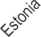

102.3

92.8

81.1

69.9

70.8

71.7

55.4

57.2

58.4

60.0

75.7

47.7

74.0

27.6

33.5

35.1

55.0

48.0

6.3

17.4

3.8

14.1

31.3

30.1

21.8

38.3

44.2

47.6

51.7

51.6

58.0

62.4

100

80

60

40

20

0

    

1. 2017 data.

Source: OECD Health Statistics 2023.

*StatLink 2* <https://stat.link/34mt7a>

**Safe long-term care**

OECD populations are ageing rapidly. The demand on the LTC sector to provide care for more, and older, people with complex conditions and heightened needs for expert care is increasing as a result. This puts an enormous strain on LTC systems – a strain that is projected to increase in the coming years as OECD populations continue to age (see section on “Demographic trends”).

LTC entails safety risks, which were made evident by the rapid spread of COVID-19 among residents and health workers in LTC settings. The advanced age of many residents, lack of sufficient personal protective equipment, and poor infection control meant that many LTC facilities experienced outbreaks that spread rapidly (OECD, 2020[1]). Another significant concern for LTC safety is healthcare‐acquired infections with antibiotic-resistant bacteria, which can lead to infections that are difficult or even impossible to treat (see section on “Major public health threats” in Chapter 3). These infections are also generally considered to be preventable through standard prevention and hygiene measures. Safety risks amongst people in LTC facilities due to medicines also exist, as is the case with benzodiazepines and polypharmacy more in general.

For older people, most guidelines advise complete avoidance (that is, an ideal rate of 0%) of benzodiazepines because of the associated risks of dizziness, confusion and falls. Even so, benzodiazepines continue to be prescribed for older adults for anxiety and sleep disorders. Long-term use of benzodiazepines can lead to adverse events (overdoses), tolerance, dependence, and dose escalation. Long-acting (as opposed to short-acting) benzodiazepines are furthermore discouraged for use in older adults because they take longer for the body to eliminate (OECD, 2017[2]).

Use of benzodiazepines varies greatly, but – on average – declined between 2011 and 2021 in OECD countries. Chronic use of benzodiazepines across OECD countries fell from 39 patients per 1 000 population aged 65 and over in 2011, to

28.2 per 1 000 in 2021, on average. Figures ranged from

below 1 patient per 1 000 population aged 65 and over in Italy and Türkiye to 87.5 per 1 000 in Iceland. For long-acting benzodiazepines, the OECD average figure fell from 76 patients per 1 000 population aged 65 and over in 2011, to

almost 44 per 1 000 in 2021. Rates were again relatively low in Italy and Türkiye, and also Latvia, at less than 2 patients per 1 000 population aged 65 and over, whereas in Spain and Korea rates were above 110 per 1 000 (Figure 10.10). The

medication error and harm – resulting in falls, episodes of confusion and delirium.

Across a selection of 15 OECD countries with broader data coverage, the proportion of adults aged 75 and over taking at least five medications at the same time increased from 47.7% of the population in 2012 to 50.1% in 2021. Countries such as Denmark, Estonia and Finland reported the lowest rates in 2021, at less than 28%, while Luxembourg reported the highest rates at 86.6%, followed by Portugal, Italy, Korea and Ireland at more than 62% (Figure 10.11). These large variations are explained in part by the establishment of targeted polypharmacy initiatives in some countries, including related reimbursement and prescribing policies. Over time, Denmark, Australia and Canada have seen a decrease of 10% or more in the proportion of adults aged 75 and over taking at least five medications at the same time (which corresponds to a reduction of between 5 and 6 percentage points), while Estonia had an increase of 63.1% and Finland an increase of 56.7% (both increased by 10.1 percentage points). Slovenia, Sweden and Iceland also exhibited an increase in polypharmacy.

**Definition and comparability**

Data on trends in benzodiazepines for chronic and long- acting use, and data on the proportion of people aged 75 and over taking more than five medications concurrently, are collected throughout the OECD Healthcare Quality and Outcomes (HCQO) data collection biannually. Data shown in these indicators correspond to the latest HCQO data collection (2022-23).

Denominators comprise the population aged 65 and over for data on trends in benzodiazepines for chronic and long- acting use, and the population aged 75 and over for data on the proportion of the population taking more than five medications concurrently, rather than the general population. Further information on sources and methods is available at OECD.Stat.

See the “Definition and comparability” box in the section on “Safe prescribing in primary care” in Chapter 6 for additional details regarding the definition and comparability of prescription data across countries.

**References**

largest declines in chronic use occurred in Australia, Denmark, and Canada, while Sweden, Denmark and Iceland experienced the largest decline in use of long-acting benzodiazepines. The wide variation is explained in part by different reimbursement and prescribing policies for benzodiazepines, as well as by differences in disease prevalence and treatment guidelines.

Ageing and multimorbidity often require older patients to take multiple medicines (polypharmacy) for long periods of their lives. While polypharmacy is in many cases justified for the management of multiple conditions, inappropriate polypharmacy increases the risk of adverse drug events,

OECD (2020), “Workforce and safety in long-term care during the COVID-19 pandemic”*, OECD Policy Responses to Coronavirus (COVID-19)*, OECD Publishing, Paris, https://doi.org/10.1787/43fc5d50- en.

OECD (2017), *Tackling Wasteful Spending on Health*, OECD Publishing, Paris, https://doi.org/10.1787/9789264266414-en.

[1]

[2]

**Figure 10.10. Trends in benzodiazepine use in adults aged 65 and over: chronic and long-acting use, 2011 and 2021 (or nearest years)**

2011 2021

**Chronic benzodiazepine use Long-acting benzodiazepine use**

Per 1 000 population aged 65 years and over

140

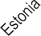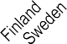

120

100

80

0.0

0.3

2.1

8.2

10.0

10.2

11.0

13.6

16.5

17.7

23.9

28.2

38.9

43.6

48.0

50.9

51.4

60

40

20

0

Per 1 000 population aged 65 years and over

250



200

74.6

87.5

0.1

1.2

1.6

5.6

6.8

8.0

11.5

17.1

23.6

29.5

43.9

45.2

58.0

58.9

62.5

87.1

94.2

95.9

112.3

115.4

150

100

50

0

1. Most recent data point corresponds to 2016. 2. Most recent data point corresponds to 2017. Source: OECD Health Statistics 2023.

*StatLink 2* <https://stat.link/ch6fui>

**Figure 10.11. Proportion of adults aged 75 and over taking more than five medications concurrently, 2012-21 (or nearest years)**

2012 2021

% of population aged 75 years and over 100

80

60

40

20

0



1. Most recent data point corresponds to 2017. Source: OECD Health Statistics 2023.

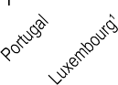

*StatLink 2* <https://stat.link/x673be>

**Access to long-term care**

Across OECD countries, an average of 11.5% of people aged 65 and over received LTC, either at home or in LTC facilities, in 2021 (Figure 10.12). More than 20% of people aged 65 and over received LTC services in four OECD countries (Lithuania, Israel, Switzerland and Germany), while fewer than 4% received LTC services in eight countries (Canada, the Slovak Republic, Ireland, Japan, Portugal, the United States, Poland and Latvia). Cultural norms around the degree to which families look after older people may also be an important driver of the use of formal services (see section on “Informal carers”).

**Definition and comparability**

LTC recipients are defined as people receiving LTC from paid providers, including non-professionals receiving cash payments under a social programme. They also include recipients of cash benefits such as consumer choice programmes, care allowances or other social benefits granted with the primary goal of supporting people with LTC needs. LTC can be delivered in facilities (institutions) or at home. LTC institutions refer to nursing and residential care facilities that provide accommodation and LTC as a package. LTC at home is defined as people with functional restrictions who receive most of their care at home. Home care also applies to the use of institutions on a temporary basis, community care and day-care centres, and specially designed living arrangements. Data for Latvia, Poland, the United States, Japan, Ireland, the Slovak Republic and Canada are only available for people receiving LTC in institutions, so the total number of recipients will be underestimated. For the Slovak Republic, even though data was available for LTC recipients at home in 2021, only data for institutions was used to ensure comparability with 2011.

Data on LTC services are difficult to collect in many countries, and there are some known limitations of the figures. Data for some countries refer only to people receiving publicly funded care, while other countries include people who are paying for their own care. Because data on people receiving care outside public systems are more difficult to collect and may be underreported, figures for countries that rely more heavily on privately funded care may be artificially low. For the indicator on unmet LTC needs, the data relate to the population aged 65 and over, based on wave 8 of the Survey of Health, Ageing and Retirement in Europe (SHARE), referring to 2019 and 2020. It is important to highlight that the COVID-19 pandemic may have affected the field work conducted for the survey in 2020. While there is no internationally accepted definition of unmet LTC needs, SHARE facilitates estimation of the share of older people reporting limitations in daily activities (ADL and IADL) who did not receive formal home care or sufficient informal care. Data for Portugal represent only the activity observed in institutions within the National Health Service. Private institutions supported by the Social Security are not included.

Many people in need of LTC care wish to remain in their homes for as long as possible. In response to these preferences – and the high costs of facility-based LTC – many OECD countries have developed services to support home-based care for older adults. Between 2011 and 2021, the proportion of LTC recipients who received care at home increased slightly, from 67% to 69% (Figure 10.13). Increases were particularly large in Australia, Switzerland, Finland, Korea and Germany. In Australia, reforms expanding financing for aged care and increasing the number of home care packages available led to increases in the number of recipients. In Germany, reforms in 2017 led to increasing numbers of recipients due to the introduction of a new assessment system (with lower entry barriers) which significantly expanded the range of persons entitled to long-term care insurance benefits.

While the proportion of LTC recipients living at home has increased over the past decade in most OECD countries, it has declined significantly in Estonia, where there has been an increase in the availability of institutional general care, and the number of added home service users has increased at a slower pace compared to 24-hour services in the social welfare system. In Lithuania, an ageing population and increasing access to LTC services have led to an increase in the number of recipients in institutions. In Switzerland, the increase in the number of LTC recipients at home in the last few years is explained by an increase in providers (which correlates with the increase in recipients) of some types of home services.

Even where people live with limitations in activities of daily living (ADL) and in instrumental activities of daily living (IADL), they may not always receive sufficient formal LTC support. Among people aged 65 and over across 22 European countries, half of individuals living at home with at least one ADL or IADL limitation – and nearly two in five (37%) people living with three or more ADL/IADL limitations – reported that they either did not receive sufficient informal LTC help, or did not receive formal LTC support (Figure 10.14).

**Figure 10.12. Share of adults aged 65 and over receiving long-term care, 2011 and 2021 (or nearest year)**



45 %

40

35

30

25

20

15

10

5

0

9.4

10.0

10.7

10.9

11.0

11.4

11.5

11.5

11.7

12.4

12.7

13.0

13.1

14.1

14.3

14.6

15.7

20.5

24.2

27.8

36.2

2011 2021

1. These values include only recipients of long-term care in institutions. Data for the United States, Slovenia, New Zealand, the Netherlands and Belgium refer to 2020. Source: OECD Health Statistics 2023.

0.4

0.8

1.7

1.7

2.7

2.9

3.0

3.5

*StatLink 2* <https://stat.link/g87yhw>

**Figure 10.13. Long-term care recipients aged 65 and over receiving care at home, 2011 and 2021 (or nearest year)**

%



100

90

80

70

60

50

40

30

20

10

0

2011 2021

34

55

58

58

60

60

60

64

64

66

69

69

72

74

74

75

76

77

78

79

81

83

[95](https://stat.link/87r2m5)

83

95

Source: OECD Health Statistics 2023.

*StatLink 2* <https://stat.link/actqdz>

**Figure 10.14. Unmet long-term care needs among people aged 65 and over living at home, 2019-20**

% 80

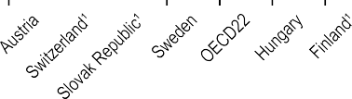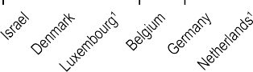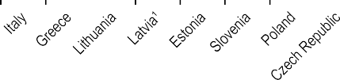

Unmet LTC needs among those with at least one ADL/IADL limitation Unmet LTC needs among those with at least three ADL/IADL limitations

64

65

70

70

70

53

55

54

56

51

57

60

58

60

55

58

58

60

44

45

48

48

50

47

53

50

37

39

39

41

41

42

34

42

37

40

27

26

27

30

15

18

20

11

10

13

10

0

1. Low sample size.

Source: SHARE, wave 8 (2019-20).

*StatLink 2* <https://stat.link/87r2m5>

**Informal carers**

Informal carers are a major – and often the only – source of care for people with LTC needs across OECD countries. Among analysed 19 OECD countries, about 60% of older people reported receiving only informal care (Rocard and Llena-Nozal, 2022[1]). Informal care is provided by family members, friends and people in social networks to individuals who need support with everyday tasks. Due to the informal nature of care, comparable data are difficult to obtain. The data discussed in this section stem from international and national surveys. There are differences in the definition of informal care across these surveys, which affects the comparability of the data (see the “Definition and comparability” box).

Across 25 OECD countries with comparable data, more than one in eight (13%) people aged 50 and over provided informal care, ranging from 6% in Latvia to more than 20% in Austria and Belgium (Figure 10.15). Care intensity varied among these countries. On average, 8% of survey respondents across 25 OECD countries indicated that they provide informal care on a daily basis, compared to 6% providing care on a weekly basis. The percentage share of those caring daily was highest in Austria (13%), and lowest in the Slovak Republic (3%) and Latvia (3%). Among OECD countries, the share of those providing weekly care was highest in Belgium (14%), and lowest for Greece, Hungary and Latvia (2% each).

Informal carers are predominantly women. Across 25 OECD countries, 60% of informal carers were women, ranging from 37% in Switzerland to 80% in Hungary (Figure 10.16). The share of women was particularly high in South and Southeastern European OECD countries, with more than 70% of daily informal carers being women in Greece, Spain and Hungary. On average across 23 OECD countries, 29% of daily carers reported being employed or self-employed (outside the informal care they also provide), ranging from almost half of informal carers in Switzerland and the Netherlands to 10% or fewer in Latvia and Hungary (Figure 10.17).

Intense provision of informal care is associated with negative effects on mental health and labour market attainment, such as a reduction of hours worked and earlier retirement. At the same time, labour market activation policies can reduce the amount of informal care provided (Carrino, Nafilyan and Avendano, 2022[2]). About two-thirds of OECD countries have introduced policies to support informal workers and to alleviate the burden of informal care – such as cash benefits paid to carers, those in need of care, or both. In addition, about half of OECD countries offer some form of paid leave for informal carers, although this does not necessarily make up for forgone wages, and may be particularly insufficient where the duration of caring is long (Rocard and Llena-Nozal, 2022[1]). The degree to which countries can depend on informal care as a dominant provider of LTC is likely to decline in the future. Demand for LTC is going to increase due to population ageing and subsequent increases in LTC needs (see section on “Demographic trends’”). At the same time, declines in family size, increases in geographical mobility and increasing female labour market participation are leading to reductions in the supply of informal carers. Countries will therefore have to expand their formal LTC sector to compensate for unmet care needs.

**References**

**Definition and comparability**

Informal carers are defined as people providing any help to older family members, friends and people in their social network, living inside or outside their household, who require help with everyday tasks. The data presented here relate only to the population aged 50 and over, and are based on national surveys for Australia (Survey of Disability, Aging and Carers – SDAC), the United Kingdom (English Longitudinal Study of Ageing – ELSA), the United States (Health and Retirement Survey – HRS) and an international survey for other European countries (SHARE).

Questions about the intensity of care vary between surveys. In SHARE, carers are asked about how often they provided care in the last year; this indicator includes people who provided care at least weekly. It is important to highlight that the COVID-19 pandemic might have made people realise their role, and identify as informal caregivers. In ELSA, people are asked whether they have provided care in the last week, which may be broadly comparable with “at least weekly”. Questions in HRS and SDC are less comparable with SHARE. Carers in HRS are included if they provided more than 200 hours of care in the last year. In SDAC, a carer is defined as a person who provides any informal assistance, in terms of help or supervision, to people with disability or older people (65 years and over). The assistance must be ongoing, or likely to be ongoing, for 6 months or more. People caring for disabled children are excluded in European countries but included in data for the United States and Australia. However, the US data only include those caring for someone outside their household, while Australia considers all informal carers together (and only primary carers). As a result, data for Australia and the United States may not be comparable with other countries’ data.

Carrino, L., V. Nafilyan and M. Avendano (2022), “Should I Care or Should I Work? The Impact of Work on Informal Care”, *Journal of Policy Analysis and Management*, Vol. 42/2, pp. 424-455, https://doi.org/10.1002/pam.22457.

Rocard, E. and A. Llena-Nozal (2022), “Supporting informal carers of older people: Policies to leave no carer behind”*, OECD Health Working Papers*,

No. 140, OECD Publishing, Paris, https://doi.org/10.1787/0f0c0d52-en.

[2]

[1]

Total Weekly carers Daily carers

% among population aged 50 years and over

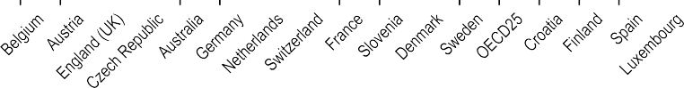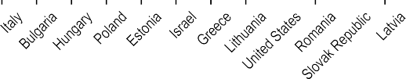

25

20

15

10

5

0

14

10

9

9

19

9

9

7

4

9

10

6 5

8

4

7

9

13

10

9

7

6

8

10

5

4

7 8

4

8

5

3 3 2

8 8 8

4 4

6 6

3 2

7 7

3

5

7 2 3

5 3

2

3

19

Note: The definition of informal carers differs between surveys (see the “Definition and comparability” box).

Source: SHARE, wave 8 (2019-20); SDAC (2018) for Australia; ELSA, wave 9 (2018-19) for the United Kingdom; HRS, wave 14 (2018-19) for the United States.

*StatLink 2* <https://stat.link/eovg59>

**Figure 10.16. Share of women among informal daily carers (among the population aged 50 and over), 2019 (or nearest year)**

% of women

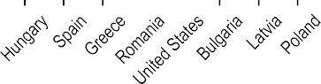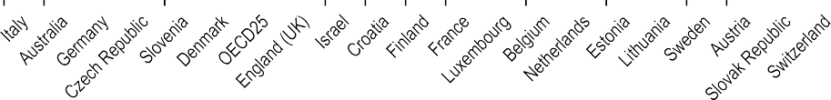

90

80

70

60

50

40

30

20

10

0

80

76

73

71

69

68 67

65 65 65

64 64 64 62

60 60

58 57 57 56

56 55

55

54 54 54 53

44

37

Note: The definition of informal carers differs between surveys (see the “Definition and comparability” box).

Source: SHARE, wave 8 (2019-20); SDAC (2018) for Australia; ELSA, wave 9 (2018-19) for the United Kingdom; HRS, wave 14 (2018-19) for the United States.

*StatLink 2* <https://stat.link/51iab7>

**Figure 10.17. Share of informal daily carers that report working in addition to caring, 2019 (or nearest year)**

% of daily carers

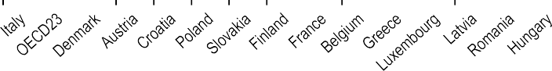

60

50

40

30

20

10

0

48 48

46

42

40

37

36

36 36 35

33

32 31

29

28

27

25 25 24

23

22

20

20

17

10 10 9

Note: The definition of informal carers differs between surveys (see the “Definition and comparability” box). Source: SHARE, wave 8 (2019-20); ELSA, wave 9 (2018-19) for the United Kingdom.

*StatLink 2* <https://stat.link/7pr8fd>

**Long-term care workers**

All OECD countries offer some degree of formal LTC to assist people in need of care in their daily activities. Care is provided by LTC workers, who are defined as paid staff – typically nurses and personal carers – providing care and/or assistance to people limited in their daily activities at home or in institutions, excluding hospitals.

In 2021, there were on average 5.7 LTC workers per 100 people aged 65 and over across the 23 OECD countries for which data were available, ranging from 12 in Norway to 0.8 in Portugal (Figure 10.18). While almost all countries have seen an increase in LTC workers in terms of headcounts, the number of LTC workers per 100 people aged 65 and over has, on average, slightly decreased over time, from 5.9 per 100 in 2011 to 5.7 per

100 in 2021. This trend was observed in just under half of countries with time trend data, with decreases over 20% in the Netherlands, Estonia, the United States, Hungary and Ireland. This is indicative of increased supply of LTC workers not keeping pace with greater demand caused by rapidly ageing populations. In contrast, 13 of the OECD countries with available data saw an increase in LTC workers per 100 population aged 65 and over, with the largest increases in Portugal and Korea.

The demand for LTC workers will increase in the years to come due to population ageing and changing patterns of informal care. At the same time, the LTC sector is facing longstanding difficulties in meeting demands for supply. The COVID-19 pandemic has exacerbated these shortages. The LTC sector is characterised by poor working conditions, including low wages, high physical and mental risks, non-standard employment, as well as low recognition (OECD, 2023[1]).

LTC workers are predominantly women: a share of 80% or higher are female, and earn on average 20% less than the economy-wide average wage (OECD, 2023[1]). Non-standard employment is common in the LTC sector. In 31 OECD countries that reported data, the share of LTC workers in part-time employment amounted to 37% on average, with 66% of the LTC workforce in Korea, Iceland, Germany, the Netherlands and Australia working in part-time arrangements. Moreover, every eighth worker across 31 OECD countries worked on a fixed-term contract basis (Figure 10.19). This is particularly common in Australia, Spain and Sweden, where more than one-quarter of the LTC workforce works under fixed-term contracts.

Low salaries among personal care workers have long been identified as a major challenge for recruitment and retention in the sector. Across 28 OECD countries in 2018, both care

quality of care delivered. Beyond low salaries and employment instability, limited access to training and education and career prospects might lower the attractiveness of the LTC profession. Several countries have introduced policies to improve the skills match between LTC workers and the tasks they perform to address this (OECD, 2020[2]).

**Definition and comparability**

LTC workers are defined as paid workers who provide care at home or in institutions (outside hospitals). They include qualified nurses and personal care workers providing assistance with ADL and other personal support. Nurses include both professional and associate professional nurses – International Standard Classification of Occupations 2008 (ISCO-08) classifications 2 221 and 3 221. Personal care

workers (ISCO-08 classifications 5 321 and 5 322) include various categories of workers, who may be called different names in different countries. Because personal care workers may not be part of recognised occupations, it is more difficult to collect comparable data for this category of LTC workers across countries. Data from OECD Health Statistics 2023 also include family members or friends who are employed under a formal contract by the care recipient, an agency or public and private care service companies. They exclude nurses working in administration. The numbers are expressed as headcounts, not full-time equivalents. Some LTC workers might hold multiple part- time positions.

Average hourly wages are calculated for personal care workers, referring to those included in ISCO-08 category 53, which groups together personal care workers and childcare workers. Nomenclature of Economic Activities (NACE) sectors are 85 – education, 86 – healthcare, 87 – residential care and 88 – non-residential care. For the United States, the category home health and personal care aides (SOC 31-1 120) identifies personal care workers. Calculations are based on 2018 EU Structure of Earnings Survey (SES) data, and 2021 Occupational Employment and Wage Statistics (OEWS) Survey data for the United States (OECD, 2023[1]). For some countries, the sample size is small, affecting the comparability of the data.

**References**

workers in facilities and those working in personal homes made substantially less than the average wage, with workers in facilities earning just 71% of the average gross hourly wage, and home-based care workers earning just 67% of the average gross hourly wage (Figure 10.20). Wages were highest in the Netherlands, where care workers earned more than 90% of the country’s average gross hourly wage regardless of the location of their work, and lowest in the United States, where care workers earned just half (51%) of the country’s average gross hourly wage.

Educational and training requirements are particularly low for personal care workers, while a mismatch between education and skills needed – such as specific geriatric training, health monitoring and co-ordinating care – can negatively affect the

OECD (2023), *Beyond Applause? Improving Working Conditions in Long-Term Care*, OECD Publishing, Paris, https://doi.org/10.1787/27d33ab3- en.

OECD (2020), *Who Cares? Attracting and Retaining Care Workers for the Elderly*, OECD Health Policy Studies, OECD Publishing, Paris, https://doi.org/10.1787/92c0ef68-en.

[1]

[2]

2011 2021

Per 100 people aged 65 and over 14



12.0 11.7 11.2

8.3

7.5 7.4

7.3

6.8 6.8

8.2

5.7 5.5

4.9 4.8

4.3 4.1

3.8

3.6

5.2

2.4

4.5

1.8 1.7

1.3

0.8

0.2

12

10

8

6

4

2

0

Note: For New Zealand, latest data refer to 2018. Source: OECD Health Statistics 2023.

*StatLink 2* <https://stat.link/pnuacr>

**Figure 10.19. Share of long-term care workers who work part time or on fixed-term contracts, 2021 (or nearest year)**

Part time Fixed-term contract

% of LTC workforce



100

90

80

70

60

50

40

30

20

10

0

Source: OECD Health Statistics 2023.

*StatLink 2* <https://stat.link/omb8lx>

**Figure 10.20. Average hourly wages of personal care workers, as share of economy-wide average wage, 2018**

Residential (facility-based) care Home-based care

%

Note: Personal care workers are those included in ISCO-08 category 53, which groups together personal care workers and childcare workers. Source: OECD calculations based on 2018 EU-SES data, and 2021 OEWS Survey data for the United States.

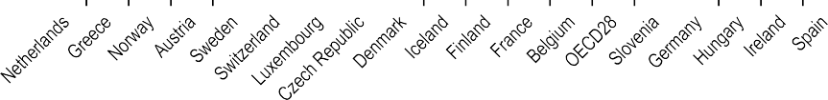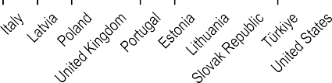

100

90

80

70

60

50

40

*StatLink 2* <https://stat.link/jpqgil>

**Long-term care settings**

Many people receiving LTC wish to remain at home for as long as possible, and most countries have increasingly taken steps in recent years to support this preference and promote community and home-based care. However, depending on individual circumstances, a move to LTC facilities may – at least eventually – be the most appropriate option. For example, people living alone and requiring round-the-clock care and supervision, or people living in remote areas with limited home care support, may find it difficult to manage at home as their needs increase, and will at some point require LTC services that cannot be delivered at home. It is therefore important that countries retain an appropriate level of residential LTC capacity. The number of beds in LTC facilities and in LTC departments in hospitals offers a measure of the resources available for delivering LTC services to individuals outside their home.

Across OECD countries, there were an average of 46 beds per 1 000 people aged 65 and over in 2021 (Figure 10.21). The vast majority of beds – 42 per 1 000 people aged 65 and over – were located in LTC facilities, while just 4 beds per 1 000 were located in hospitals. The proportion of LTC beds in hospitals exceeded 10% of all LTC beds in just six OECD countries, with Korea (56%), Japan (23%) and the Czech Republic (21%) reporting the highest proportions. Among OECD countries reporting both facility-based and hospital-based LTC beds, the number of beds available per capita varied enormously, with a more than seven-fold difference between the highest and lowest proportions. Luxembourg, the country with the highest number of beds, reported almost 80 beds per 1 000 people aged 65 and over, compared to almost 11 beds per 1 000 in Poland.

Between 2011 and 2021, OECD countries reduced the number of LTC beds in facilities by an average of 4.7 beds per 1 000 people aged 65 and over (Figure 10.22). In some cases, the number of LTC beds per 1 000 people 65 and over may have fallen even as the absolute number of beds increased, due to population ageing that outpaced the growth in hospital beds. However, the change in the number of beds varied significantly between OECD countries. Over the decade, nine countries reduced the number of LTC beds by about 10 or more, with Finland reducing the number of LTC beds by 24 per 1 000 people aged 65 and over. In contrast, in Luxembourg and Korea the number of LTC beds increased by more than 10 per 1 000 people aged 65 and over between 2011 and 2021. These substantial changes were largely driven by changes in

policies over the period. The increase of 10 facility-based LTC beds per 1 000 people aged 65 and over in Korea, for example, came about following the introduction of a public LTC insurance scheme in 2008, while in Sweden, declines (a drop of 11.9 beds per 1 000 people aged 65 and over) were driven by growing home-based care in ordinary housing, in addition to nursing homes.

Residents of LTC facilities were badly hit during the COVID-19 pandemic: across 25 OECD countries, more than 40% of COVID-19 deaths occurred among nursing home residents. Moreover, containment measures – including strict bans on visitation in most countries – dramatically affected the well- being of many residents, even beyond the direct health impact of the virus. Developing and applying models of care that respect the resident’s wishes and promote dignity and autonomy is a critical aspect of high-quality care. This includes ensuring that staff working in LTC facilities are appropriately trained, and that facilities receive the support they need to deliver high-quality care, reduce high turnover and facilitate the recruitment and retention of high-quality care workers (see section on “Long-term care workers”).

**Definition and comparability**

LTC facilities refer to nursing and residential care facilities that provide accommodation and LTC as a package. They include specially designed facilities or hospital-like settings where the predominant service component is LTC for people with moderate to severe functional restrictions. They do not include beds in adapted living arrangements for people who require help, while guaranteeing a high degree of autonomy and self-control. For international comparisons, they should also not include beds in rehabilitation centres.

However, there are variations in data coverage across countries. Several countries only include beds in publicly funded LTC facilities, while others also include private facilities (both for-profit and not-for-profit). Some countries also include beds in treatment centres for addicted people, psychiatric units of general or specialised hospitals, and rehabilitation centres.

Institutions Hospitals

Per 1 000 population aged 65 years and over



100

90

80

70

60

50

40

30

20

10

0

79.6

77.1

67.4

63.9

62.4

57.3

53.9

53.4

52.2

50.6

50.2

49.7

49.6

49.2

48.6

47.9

47.6

45.6

45.4

45.1

44.2

44.2

41.3

40.8

40.7

37.3

34.5

29.8

21.8

19.5

16.0

15.2

14.9

10.9

9.5

2.6

2.5

0.1

1. Number of LTC beds in hospitals are not available in these countries. 2. Number of LTC beds in hospital excluding psychiatric beds. Source: OECD Health Statistics 2023.

*StatLink 2* <https://stat.link/gtalmc>

**Figure 10.22. Trends in long-term care beds in institutions and hospitals, 2011-21 (or nearest year)**

Change per 1 000 people aged 65 and over



35

25

15

5

-5

-15

-25

-35

24.3

10.7

10.0

3.6

3.6

2.9

2.2

1.1

0.9

0.6

1. Number of LTC beds in hospitals are not available in these countries. 2. Number of LTC beds in hospital excluding psychiatric beds. 3. Break in time-series in 2012 and 2022, so changes between 2011 and 2021 need to be interpreted with care.

-1.8

-1.8

-2.1

-2.2

-4.3

-4.3

-4.7

-5.5

-6.0

-7.3

-7.7

-8.0

-8.2

-8.3

-8.4

-8.5

-9.3

-9.7

-9.9

-10.1

-11.4

-11.9

-12.9

-13.5

-14.9

-24.0

Source: OECD Health Statistics 2023.

*StatLink 2* <https://stat.link/fzup4g>

**Long-term care spending and unit costs**

While LTC spending has been growing at a slower pace than overall health spending in most OECD countries since the pandemic, LTC was the healthcare activity with the highest growth rate leading up to this health emergency. It is probable that LTC spending growth will outpace health spending growth again in the years to come, driven by a number of factors. Population ageing will lead to more people needing ongoing health and social care, rising incomes increase expectations of quality of life in old age, the supply of informal care is likely to shrink, and productivity gains are difficult to achieve in such a labour-intensive sector. All these factors create upward cost pressures, and substantial further increases in LTC spending in OECD countries are projected for the coming years.

In 2021, 1.8% of gross domestic product (GDP) was allocated to LTC (including both the health and social components) across OECD countries (Figure 10.23). At 4.4% of GDP, the highest spender was the Netherlands, followed by the Nordic countries of Norway (3.5%), Sweden (3.4%) and Denmark (3.2%). In contrast, Greece, Poland and Latvia only spent around 0.5% of GDP or less on LTC services. This variation partly mirrors differences in the population structure, but mostly reflects the stage of development of formal LTC systems, as opposed to more informal arrangements based mainly on care provided by unpaid family members. Some level of underestimation can exist for those countries unable to record spending on social LTC. Across OECD countries, four out of five dollars spent on LTC come from public sources.

The way LTC is organised in countries affects the composition of LTC spending and can also have an impact on overall spending. Across OECD countries, around half of health and social LTC spending in 2021 occurred in nursing homes (Figure 10.24). In most OECD countries, these providers account for the majority of LTC spending. On average, around one-fifth of all LTC spending was used for professional (health) care provision at home. Other LTC providers include hospitals, households – if a care allowance exists that remunerates the informal provision of such services – and LTC providers with a clear social focus. These service providers each account for around one-tenth of total LTC spending across OECD countries. The importance of these modes of provision varies widely across countries, reflecting differences in the organisation of LTC and policy priorities.

on other sources such as savings, assets or support from family and friends to finance the care they need. Public social protection systems are crucial in ensuring that older people can access necessary care without falling into poverty. Thanks to these support systems, the actual costs faced by older people are significantly lower than those depicted in Figure 10.25 for a majority of countries (Oliveira Hashiguchi and Llena-Nozal, 2020[1]).

**Definition and comparability**

LTC spending comprises both health and social services provided to LTC-dependent people who need care on an ongoing basis. Based on the System of Health Accounts, the health component of LTC spending relates to nursing care and personal care services (help with ADL). It also covers palliative care and care provided in LTC institutions (including costs for room and board) or at home. LTC social expenditure primarily covers help with IADL. Progress has been made in improving the general comparability of LTC spending in recent years, but there is still some variation in reporting practices between the health and social components of some LTC activities. In some countries, social LTC is (partly) included under health LTC; in others, only health LTC is reported. There is also some variation in the comprehensiveness of reporting for privately funded LTC expenditure. Further, LTC providers can offer additional services to their main activity, notably in the Netherlands where around 20% of expenditure allocated to nursing homes is for homecare service provision.

LTC institutions refer to nursing and residential care facilities that provide accommodation and LTC as a package. They are specially designed institutions where the predominant service component is LTC for dependent people with moderate to severe functional restrictions. An older person with severe needs is defined as someone who requires

41.25 hours of care per week. A detailed description of their needs can be found in Muir (2017[2]).

**References**

Public schemes play a crucial role in ensuring the affordability of LTC costs for individuals aged 65 and over with LTC needs. Without public financial support, the total costs of LTC would be higher than median incomes among older people in most OECD countries. On average across OECD countries, institutional care for severe needs would cost more than twice the median income among older people (Figure 10.25). Among countries that provided data in 2022, institutional care for older individuals with severe needs was more than four times their median income in the Netherlands, Denmark, Finland and Sweden. Only in Slovenia and Hungary can an older person earning the median income afford the total cost of institutional care for severe needs solely from their income and without public support. In addition to income, older individuals may rely

Muir, T. (2017), “Measuring social protection for long-term care”*, OECD Health Working Papers*, No. 93, OECD Publishing, Paris, https://doi.org/10.1787/a411500a-en.

Oliveira Hashiguchi, T. and A. Llena-Nozal (2020), “The effectiveness of social protection for long-term care in old age: Is social protection reducing the risk of poverty associated with care needs?”*, OECD Health Working Papers*, No. 117, OECD Publishing, Paris, https://doi.org/10.1787/2592f06e-en.

[2]

[1]

% of GDP



5

4.5

4

3.5

3

2.5

2

1.5

1

0.5

0

1. Countries not reporting spending for LTC (social). In many countries this component is therefore missing from total LTC, but in some countries it is partly included under LTC (health). 2. Country not reporting spending for LTC (health).

Source: OECD Health Statistics 2023.

*StatLink 2* <https://stat.link/fobxem>

**Figure 10.24. Total long-term care spending by provider, 2021 (or nearest year)**

Nursing home Hospital Home care Households Social providers Other



100%

80%

60%

40%

20%

0%

1. Countries not reporting social LTC. The category “Social providers” refers to providers where the primary focus is on help with IADL or other social care. Source: OECD Health Statistics 2023.

*StatLink 2* <https://stat.link/dgi1tf>

**Figure 10.25. Costs of institutional long-term care for people aged 65 and over with severe needs, as share of median income, 2022 (or nearest year)**

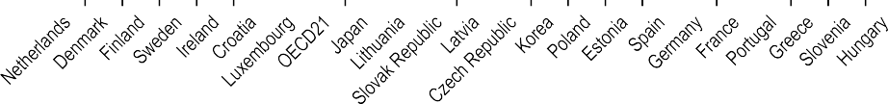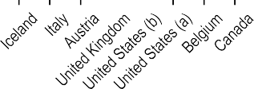

% 500

400

300

200

100

0

486 485

**Subnational level**

429 428

383 383

345

279

210 198 166

266 236 234

158 155 143 143 136 128 115 113 112 111 105

218 205 172

144

81

56

Note: Subnational data for Belgium refer to Flanders, for Iceland refer to Reykjavik, for Canada refer to Ontario, for Austria refer to Vienna, for the United States refer to (a) California and (b) Illinois, for Italy refer to South Tyrol, and for the United Kingdom refer to England.

Source: OECD Long-Term Care Social Protection Questionnaire (2022) and OECD Income Distribution Database (2022).

*StatLink 2* <https://stat.link/tnxm9o>

**End-of-life care**

End-of-life care refers to the care provided to people who are near the end of life. It involves all the services providing physical, emotional, social and spiritual support to the dying person, including management of pain and mental distress. Emotional support and bereavement care for the dying person’s family are also part of end-of-life care. Because of population ageing and an associated increase in prevalence of chronic conditions across OECD countries, the number of people in need of end-of-life care is growing and expected to reach 10 million people by 2050, up from 7 million in 2019. However, fewer than half of those who need end-of-life care are currently receiving it, meaning that many people die without adequate care (OECD, 2023[1]). Measuring the quality of end- of-life care is not straightforward, but exploring where people die and what type of care they receive in their last months of life are considered good proxies.

End-of-life care can be delivered in a number of settings, including hospitals, hospices, nursing homes and patients’ homes. Although personal characteristics, beliefs and other cultural factors can influence preferences for care at the end of life, existing literature shows that most people would prefer to spend the end of their lives in their homes. Hospitals are the most common place of death across OECD countries, although the share of deaths happening in hospitals has decreased in many countries in the past decade. As of 2021, 50% of deaths across 35 OECD countries occurred in a hospital. The Netherlands, Norway, Switzerland and New Zealand record the lowest shares, with only around one-third of deaths or fewer happening in hospitals. This is likely to be linked to the role of nursing homes, hospices or other LTC facilities, which in Sweden, Switzerland and the Netherlands represent the most prevalent place of death (OECD, 2023[1]). In the Czech Republic, Hungary, Japan and Korea, 65% of deaths or more take place in hospitals.

The share of deaths occurring in hospitals decreased between 2011 and 2021 in most countries, with the largest reductions in Denmark (16 percentage points), Japan and Finland (14 percentage points), the United States (13 percentage points), Mexico (12 percentage points) and Ireland (11 percentage points) (Figure 10.26). This change was driven in part by an increase in the share of deaths taking place at home during the COVID-19 pandemic due to a lack of service availability during the crisis, yet this trend had already started before the pandemic. A decrease in the share of deaths in

minority of people experienced more than one unplanned/urgent admission during the last 30 days of their life in 2021, ranging from nearly none (0.2%) in Switzerland to 11% in Norway. New Zealand, Slovenia, the Czech Republic, Israel and Denmark recorded much higher shares of deceased people who had experienced more than one unplanned/urgent admission during the last 30 days of their life, ranging from 45% in New Zealand to 59% in Israel.

Furthermore, in at least six OECD countries the share of people experiencing more than one unplanned/urgent inpatient admission in the last 30 and last 180 days of life are very similar, suggesting that unplanned/urgent admissions are more likely to happen in the last month of life. Unplanned admissions at the end of life also vary within countries. Across all OECD countries with available data, people who died due to cancer and chronic respiratory conditions were more likely to experience at least one unplanned/urgent admission in the last 30 days of life, compared to people who died due to cardiovascular diseases and dementia (Figure 10.27).

**Definition and comparability**

Data on the share of deaths in hospitals refer to deaths happening for any cause of death, excluding external causes of mortality such as accidents and injuries – all International Classification of Diseases, tenth revision (ICD-10) codes except V00-Y99. Data refer to years 2011 and 2021 or the nearest years available. Caution is needed in cross-country comparisons, as data might refer to different years. The share of deaths in hospitals has been calculated by the OECD Secretariat, based on the available data.

The data shown in Figure 10.27 classify deaths based on the ICD-10 codes used to identify the primary cause of death. Cancer refers to neoplasms (C00-D49); cardiovascular diseases refer to selected cardiovascular diseases, excluding stroke (I00-I52); chronic respiratory conditions refer to conditions codified as J40-J47 and J96; while dementia refers to Alzheimer’s and other dementias (F00-F03, G30, R54).

**References**

hospitals does not necessarily translate into better quality of end-of-life care if it is not supported by adequate care available at home.

Understanding when people are approaching the end of life can be difficult. Not recognising when death is near can result in overtreatment and delays in palliative care, and people might receive aggressive care until the very end of their lives, even when it is not likely to provide any curative benefit. Delayed referral to palliative care can compromise the end-of-life experience (Sallnow et al., 2022[2]). The care people receive in the last months of life varies widely across OECD countries. In

8 out of 15 countries for which data are available, only a

OECD (2023), *Time for Better Care at the End of Life*, OECD Health Policy Studies, OECD Publishing, Paris, https://doi.org/10.1787/722b927a-en.

Sallnow, L. et al. (2022), “Report of the Lancet Commission on the Value of Death: bringing death back into life”, *The Lancet*, Vol. 399/10327, pp. 837- 884, https://doi.org/10.1016/s0140-6736(21)02314- x.

[1]

[2]

2011 2021

%

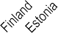

90

80

70

60

50

40

30

20

10

0

59 62 63 64 65

67 68

36 39 40 41 42

44

53 53 54 54 55 56 57 58 59

45 46 48 48 49 49 50 51 51

23 27

31 32 35 36

1. Latest data refer to the pre-pandemic period.

Note: Data for Belgium refer to the Flanders region. Data for the Czech Republic, Finland, Poland and Portugal might include deaths that occurred in other non-hospital inpatient institutions. Data from Finland, Greece, Hungary, Italy, Mexico, Poland and Portugal come from the EOLinPLACE Project funded by the European Research Council under the EU’s Horizon 2020 Research and Innovation Programme, using data from national providers.

Source: OECD Health Statistics 2023, EOLinPLACE for Finland, Greece, Hungary, Italy, Mexico, Poland, Portugal, [www.eolinplace.com/.](http://www.eolinplace.com/)

*StatLink 2* <https://stat.link/4m3pak>

**Figure 10.27. Share of deceased people who, during their last 30 days of life, experienced more than one unplanned or urgent inpatient admission, by cause of death, 2021 (or nearest year)**

Cancer Cardiovascular diseases Chronic respiratory conditions Dementia

% 80

Note: Data for New Zealand refer to 2018. Source: OECD Health Statistics 2023.

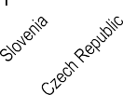

70

67

62

61

60

50

56 56

51

51

54

57

53

59

53 53

50

40

42

38

47

42

40

36

30

29 28

22

13

30 31

30

24

27

29

22

20

10

0 0 0 0

3 3 4

0

4 3

2 1

6 3 5

2

8 5 6 8

1

9 12

4 6 3 6

18

14

8

7

2

2

0

*StatLink 2* <https://stat.link/gpm9so>

**Health at a Glance 2023**

**OECD INDICATORS**

*Health at a Glance* provides a comprehensive set of indicators on population health and health system performance across OECD members and key emerging economies. These cover health status, risk factors for health, access to and quality of healthcare, and health system resources. Analysis draws from the latest comparable official national statistics and other sources.

Alongside indicator‑by‑indicator analysis, an overview chapter summarises the comparative performance

of countries and major trends. This edition also has a special focus on digital health, which measures the digital readiness of OECD countries’ health systems, and outlines what countries need to do accelerate the digital health transformation.

**PRINT ISBN 978-92-64-95793-0**

**PDF ISBN 978-92-64-94896-9**

9 T QE a

